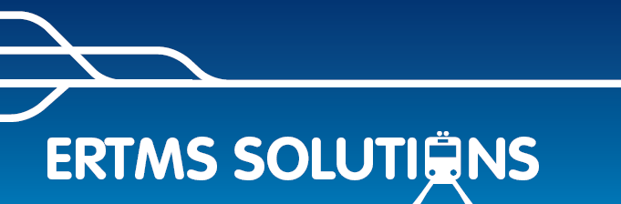
ERTMSFormalSpec Workbench
Track Conditions Implementation

To help in understanding this document, the relevant section of Subset-026 is provided here.

3.12.1 Track Conditions
3.12.1.1 The Track Condition function is used to inform the driver and/or the train of a condition in front of the train.
3.12.1.2 A Track Condition shall be given as profile data (e.g. non-stopping area), i.e. start and end of the data is given, or location data (e.g. change of traction system) i.e. start location given, depending on the type of track condition.
3.12.1.2.1 The starting point of a profile type track condition shall be evaluated taking into account the max safe front end of the train, the end of the profile taking into account the min safe rear end of the train. Location type data shall be evaluated taking into account the max safe front of the train.
3.12.1.2.1.1 Note: The timing of output data to control train equipment (e.g. pantograph) is application specific.
3.12.1.2.1.2 Exception 1: The starting point of a Big Metal Mass type track condition shall be evaluated taking into account the max safe antenna position, the end of the profile taking into account the min safe antenna position.
3.12.1.2.1.3 Exception 2: The end of the Powerless section shall be evaluated taking into account the min safe front end of the train.
3.12.1.2.1.4 Exception 3: The start and end of a tunnel stopping area and of a sound horn track condition shall be evaluated taking into account the estimated front end of the train.
3.12.1.3 The types of track conditions to be covered by this function are:
- Powerless section, lower pantograph (initial state: no powerless section, i.e. pantograph not to be lowered)
- Powerless section, switch off main power switch (initial state: no powerless section, i.e. main power switch not to be switched off)
- Air tightness (initial state: no request for air tightness)
- Sound horn (initial state: no request for sound horn)
- Non stopping area (initial state: stopping permitted)
- Tunnel stopping area (initial state: no tunnel stopping area)
- Change of traction system, switch traction system on-board, used for train capable of handling several traction systems (initial state: no initial state – keep the current setting)
- Change of allowed current consumption, limit current consumed by the train, used to adapt the maximum current consumption of the train to the maximum current allowed by the trackside (initial state: no initial state – keep the current setting)
- Big metal masses, ignore onboard integrity check alarms of balise transmission. (initial state: alarms not ignored)
- Radio hole, stop supervision of the loss of safe radio connection (initial state: loss of safe radio connection supervised)
- Switch off regenerative brake (initial state: regenerative brake on)
- Switch off eddy current brake for service brake (initial state: eddy current brake on for service brake)
- Switch off eddy current brake for emergency brake (initial state: eddy current brake on for emergency brake)
- Switch off magnetic shoe brake (initial state: magnetic shoe brake on).
- Station platforms, enable passenger doors with or without steps according to platform location, side and height (initial state: not enabled).
3.12.1.3.1 Note: In case of regenerative brake switch off or magnetic shoe brake switch off, the deceleration of the emergency brake might be affected if the effect of these brakes was included in the calculation of the deceleration value.
3.12.1.3.2 Note: In case of eddy current brake switch off the deceleration of the service brake or emergency brake might be affected if the effect of these brakes was included in the calculation of the deceleration value.
3.12.1.3.3 Note: in case of powerless section the deceleration of the service brake or emergency brake might be affected if the effect of a regenerative brake not independent from the presence of voltage in the catenary was included in the calculation of the deceleration value.
3.12.1.4 Intentionally deleted.
3.12.1.5 The following actions shall be performed at receiving a track condition:
a) Indicate on DMI (see chapter 5, procedure “Indication of track conditions”), except “Station platforms”, “Change of allowed current consumption” and “Big metal masses”.
b) Send information with the remaining distance to an ERTMS/ETCS external function, with the exception of big metal mass track condition, sound horn track condition, non stopping area, tunnel stopping area and supervision of radio transmission which are handled inside the ERTMS/ETCS on-board equipment.

3.12.1.5.1 Note: Whether some information shall be filtered (not shown to the driver or not sent to an ERTMS/ETCS external function) is outside the scope of ERTMS/ETCS.

Implementation of the Track Conditions

General idea and motivation
The handling of the information received in a TRACK_CONDITIONS packet was designed to reorganize it from the sections with a start and an end into points where the track conditions change, as illustrated
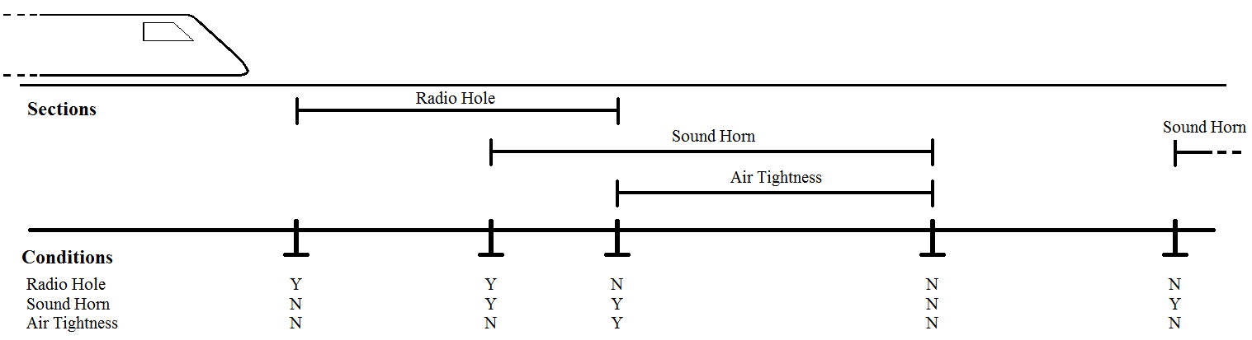
On the top of this picture, we see the sections the train receives in a packet, beneath that the points where the conditions change.

The reason for the conversion was that track conditions are used in the calculation of breaking parameters. There needed to be an easy way to determine if one or more types of brakes had been disabled and over what distance. By storing the track condition profile as a collection of points, we can easily consider a subset of the conditions.
The variable TCProfile in Kernel.TrackDescription.TrackConditions.General is a collection of structures containing a Distance (the location of the particular point) and the values of all the considered track conditions. For most of them, the value is a Boolean “Applied/Not”.
At any time, the track conditions are given by the most recent point in TCProfile. The function ProfileAtDistance returns the most recent profile point at a given distance (provided as the parameter).

Handling new track conditions
When a message containing a TRACK_CONDITIONS packet is received, the procedure TrackConditionReceived is called and the following steps are taken:
- The start location of the new conditions is determined by the function NewProfileStartLocation
This implements requirement 3.7.3.1.g “New track condition information of at least one of the types listed here […] shall replace all stored track condition information of the listed types from the start location of the first element of the new information”. Previous track condition profile points with a distance greater than the start location are deleted.
- For each section received
  - The end of the section is added to TCProfile
Since the end of the section is the point where the new track condition is reset, it is made to be a copy of the previous point in the profile. Condition 3.12.1.2.1 states “The starting point of a profile type track condition shall be evaluated taking into account the max safe front end of the train, the end of the profile taking into account the min safe rear end of the train”. The end of the section is determined by using the EndSectionDistance function, which makes it so that all ends of section are evaluated at the front of the train instead of the rear. By doing this, all profile points are evaluated at the front of the train and we do not need to differentiate between them once they have been added to the profile.
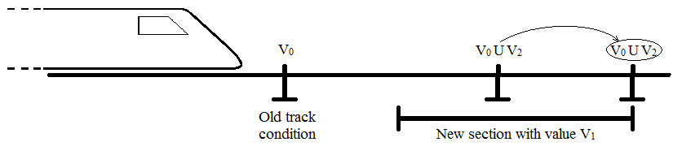
  - The start of the section is added
Add a point to the profile where the track condition starts which is a copy of the previous point with the new condition added.
Note: if there is already a profile point at the distance where a start or end of section would be placed, the new point’s effect is simply added to the existing profile point. There is never more than one point at any location, but a single point may change the state of multiple conditions.
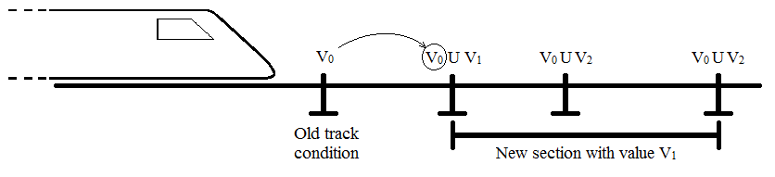
  - Add the track condition to all existing points between the start and end points
Since each point independently defines the track conditions from that location, all existing points between the start and the end of the section need to be updated to have the new condition enabled.
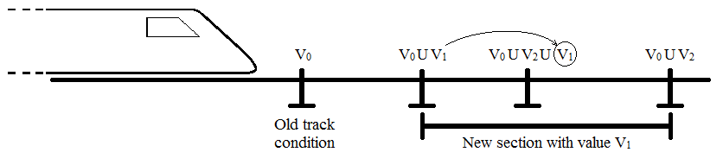

Finding the current conditions
The manipulation in step 2 makes us evaluate the start and end of section at the max safe front end and the min safe front end respectively. When the latest profile point is behind the min safe front end, that is the current profile for the train, but if a profile point is in-between the max and min safe front ends of the train the profile is less obvious.
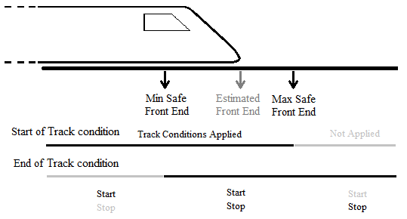
The max and min safe front ends of the train are indicated on the top of the figure. Beneath them, the two lines show in black if a track condition is applied or not, depending on the location of the relevant profile point (the top line is for a point where the conditions starts and the bottom line for a conditions that stops).

In this picture, a point is in-between the max and min safe front ends of the train. Because all profile points are stored in the same way, we do not know if this point is the start of a section, the end of a section, or even both (one section ends and another starts at the same place).
If the point is an end of a profile, the condition remains in application until the min safe rear end of the train passes the point, so it is still in application in that situation.
If the point is the start of a section, it enters applicability from when the max safe front end of the train passes it, so it has recently entered application.
In both cases, the condition is applied. To handle these cases, the function CurrentConditions was created. It returns the current track condition profile of the train. The function takes the most recent profile points at the max safe front end and at the min safe front end (so they will not be the same point if there is a point between them) and, for each condition, returns it as “True” if at least one of the profile has it. This combines the conditions that have recently been applied and the ones that are almost done.

Function dictionary

CombineConditions takes two sets of conditions and returns their union (if a particular condition is true in either set, the return set will be true for that condition).

CurrentConditions returns the conditions that are currently applied.

EndSectionDistance returns the location of the front end of the train when a new condition exits applicability. This is used because some conditions end when the front of the train passes the end location and other end when the rear does.

HandleTCPwhenEnteringGivenModeX when the train changes mode, some track conditions are reset. These functions handle that.

IsInsideRadioHole tells if the train is currently affected by the ‘Radio Hole’ track condition.

MakeTCProfilePoint uses the information contained in a packet to make a new profile point.

NewInfoStartLocation returns the earliest point of application of the track conditions contained in a packet.

ProfileAtDistance returns the conditions in application when the train is at the provided distance.

ProfileStartLocation for a given distance, returns the location where the profile in effect at that distance started

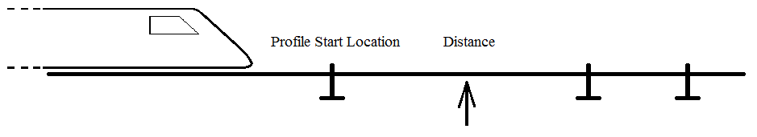
Illustration of the function ProfileStartLocation

UpdatedTCProfile handles the addition of track conditions in step 4.

