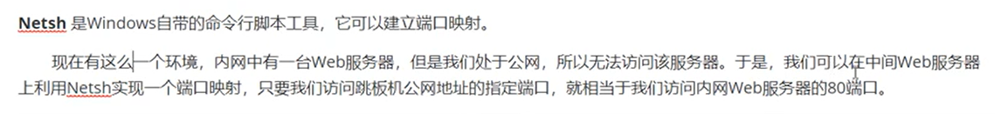
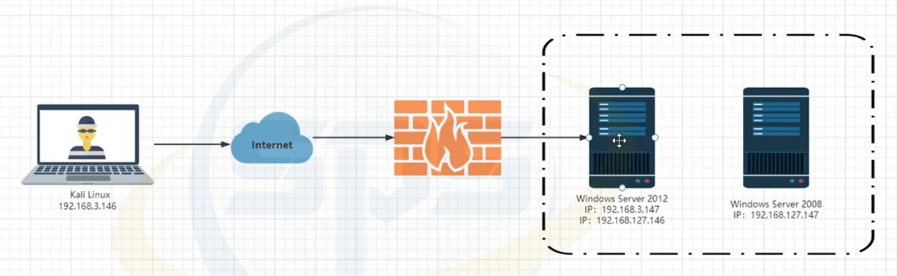
端口转发：
shell netsh intertace pertproxy add v4tov4 listenaddress=192.168.3.147 listenport=8080 connectaddress=192.168.127.147 connectport=3389
端口转发规则配置完成，访问
远程桌面连接：rdesktop 192.168.3.147:8080
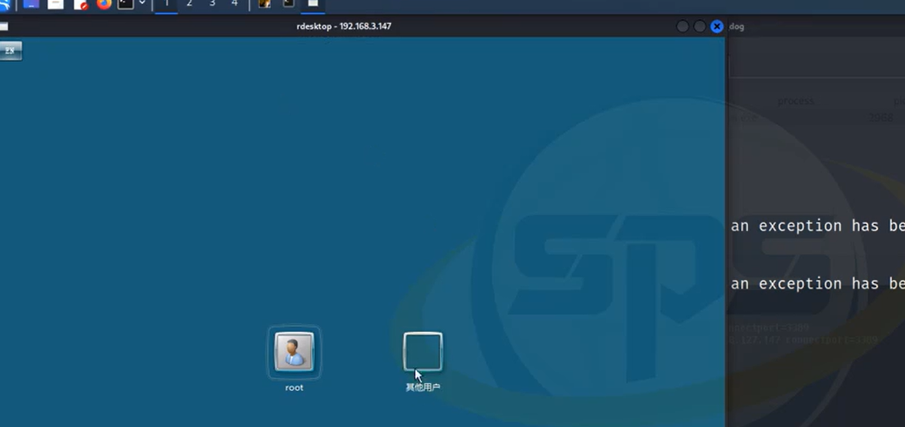
查看端口映射规则：shell netsh interface portproxy show all
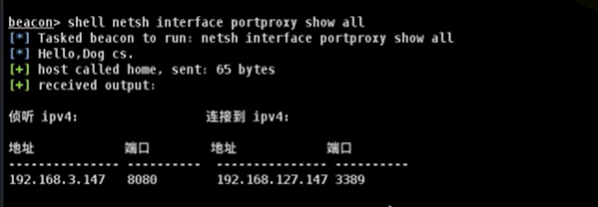
删除端口映射：shell netsh interface portporxy delete v4tov4 listenaddress=192.168.3.147 listenport=8080
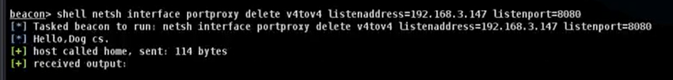
查看端口映射规则：shell netsh interface portproxy show all
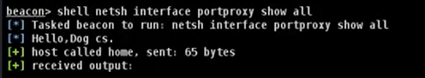

netsh本地端口转发
访问192.168.3.147远程桌面连接：rdesktop 192.168.3.147
访问失败，3389端口被拦截
shell netsh interface portproxy add v4tov4 listenaddress=192.168.3.147 listenport=13389 connectaddress=192.168.3.147 connectport=3389
访问13389端口远程桌面连接：rdesktop 192.168.3.147:13389
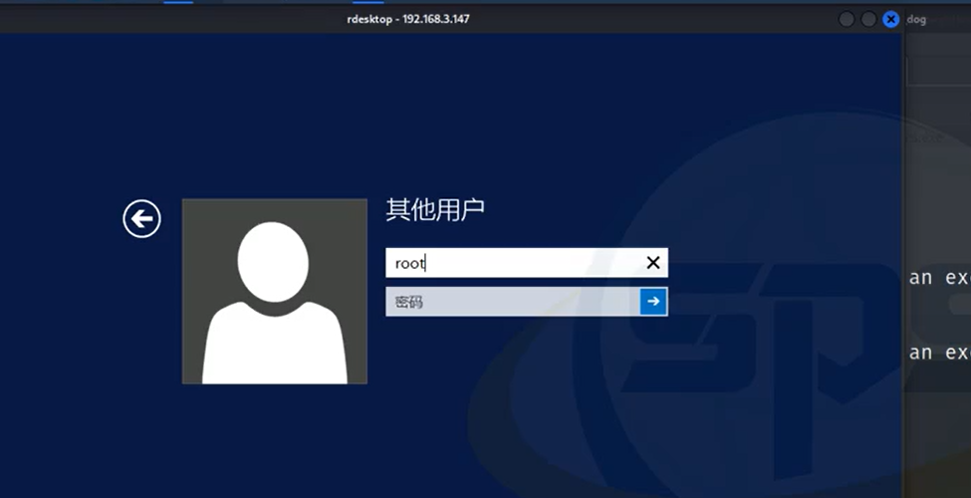
删除端口映射：shell netsh interface portporxy delete v4tov4 listenaddress=192.168.3.147 listenport=13389

