**Thesis**

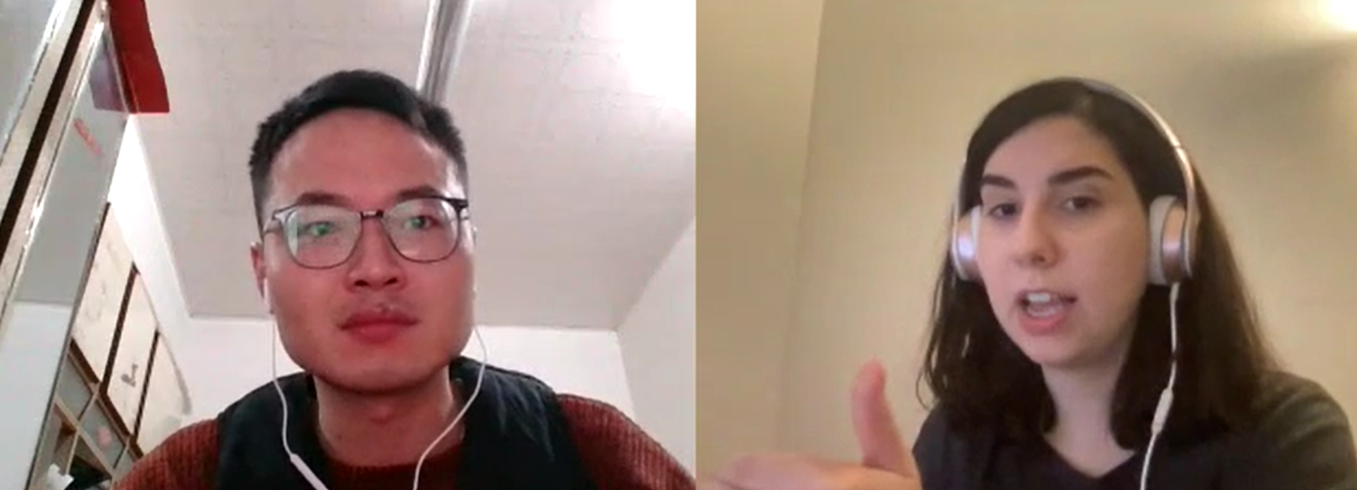

[proquest.com](https://www.proquest.com/)

dissertation = thesis

(1) introduction, (2) literature review, (3) research question, (4) methods, (5) results, (6) discussion, (7) conclusion

appendices

do you have other thesis-es

or dissertations

or dissertations

from former students?

Useful to see the structure