## 20220727

### 英国John



https://www.cambly.com/en/student/tutors/61a4e3f6a9aa0b64160a24dd

口语视频：

<https://www.cambly.com/en/student/lessonSummary?chatId=62e0e9116881ac10cad2ff0d>

#### 收获：

Interview is not difficult. You should be prepared for it more practice .

### 意大利Suky

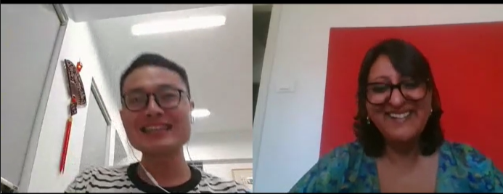

<https://www.cambly.com/en/student/tutors/612805f7251f712326c137f1?lang=en>

27年的人事HR经历Human being ,recruiter colleage

She worked for government, private companies

Enjoy life, not work and work, earn money

口语视频：

<https://www.cambly.com/en/student/lessonSummary?chatId=62e0e9116881ac10cad2ff0d&lang=en>

#### 收获：

Suky told me about Italy

Italian life style is slowly and relax. T

1. Italian are not polite. If you say their word wrong, Italian will directly to say it “you are wrong, you donot say that, ”. May be you feel them rude. However, it it culture.

frustrated, kindness, gentile, shoot

(2)Italian has the non-congestion transportation, their GPS map / google map is bad (guidance the wrong way) for guidance travelers to reach the right destination. You will get lost. She used the  [Airbnb (online car-hailing) to send her from origin to destination.](https://www.airbnb.cn/)

(3)The Italian has many local languages such as Chinese.

(4)Italian food is not spicy, onion, garlic, ginger like Asian. Italian food is simple three ingredients (材料). taste simply

only has several kinds: such as pizza, pasta

1. History, [architecture](javascript:;)/beauty building, culture
2. Europe life is huge different compared with Asian.
3. Rome has many local language
4. Rome has the multi-culture environment, you will meet different cultural people
5. She lived every city has Chinese shop /supermaket , doufu, noodles. However, Chinese restaurant is not suit for Italian, for Asian.



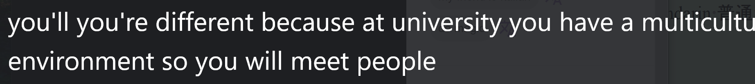



**Advise me**

1. When you speak to your tutor, you should speak more slowly and clearly. Tell the Italian professor, it is important opportunity for me, please be gentile with me or please excuse me. I am a little bit nervous you cannot say that.

If my candidate say that “I am nervous”, it was my job to make them feel comfortable, then I would say it’s okay. There’s nothing to be. Donot worry.

You have two weeks for preparing the interview. I can teach you about grammar, conversation skill, you need practice .

Colleagues

1. Mandarin 普通话， Cantonese 广东话
2. Italian professor

My pronounce has heavy accent.

She can understand my sentences everythin I am saying

()\

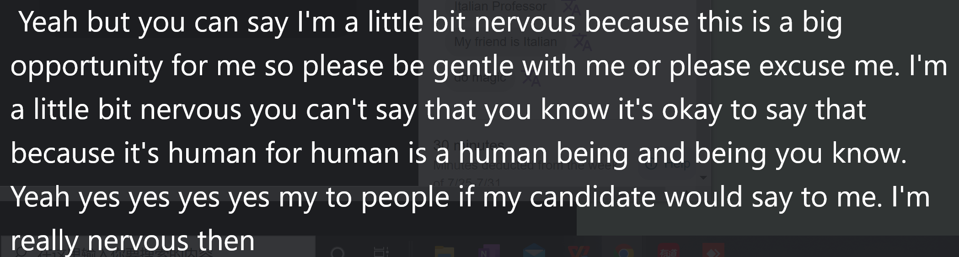

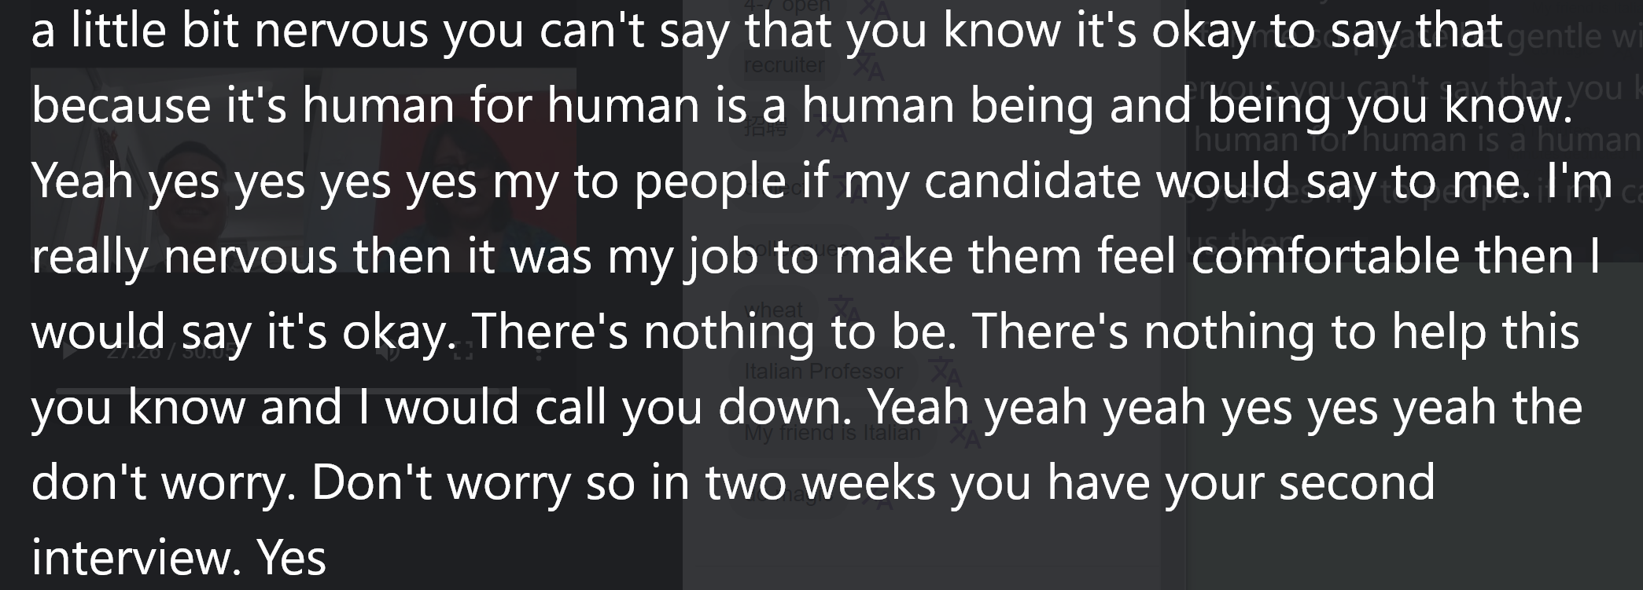

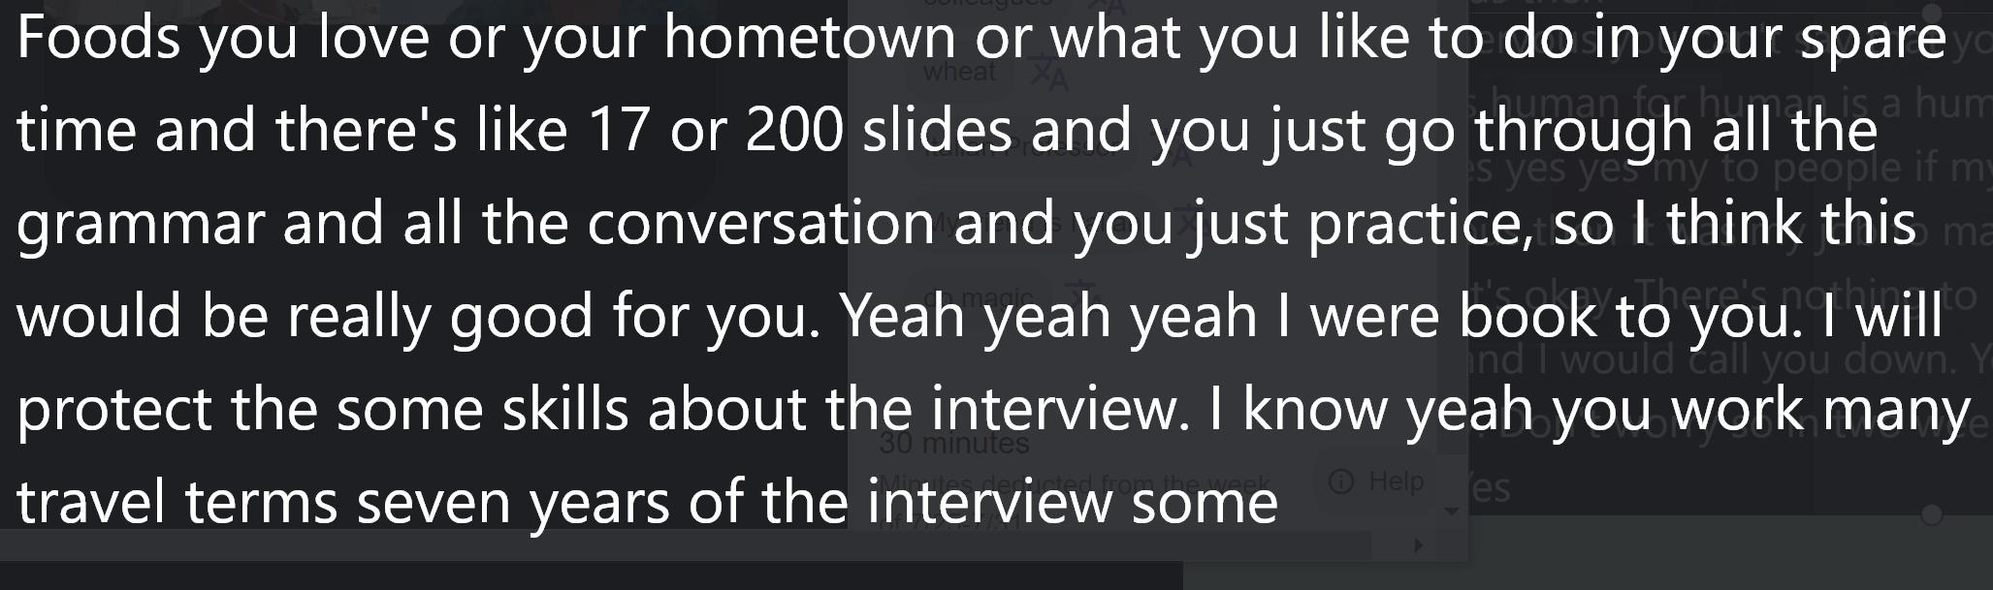

### 英国Laurence

https://cloudarchives2.camblychina.com/62e66bef1f5136cbde57f3c1/f9e778c52d48904123e9ffac35c130f2_cambly_62e66bef1f5136cbde57f3c1_0.mp4?auth_key=1659286370-7319198410e011ed883036f4c2d965c7-0-fe3361bcd83aa6207cd799d460d131e6

