# Danie: 9:00-9:30 PM

blob:https://www.cambly.com/38cff893-9a75-481b-98a8-2422918b4b3f

Danie

Location: Rome

Lesion: sports

Reading

Answer the question

Issues:

1. ~~Speak fastly, make the listener feel difficult to understand, and even become boring.~~
2. ~~Speak discontinue, staccato, and pause for too long, which makes it difficult for listener to follow and understand.~~
3. ~~Some issues in sentence~~
4. answer too freely and complicating, not the directly answer. In the exam, interview, the listener want to check your ability by your answer, rather than your freely chat.

*For example, Do you like any sport? Why?*

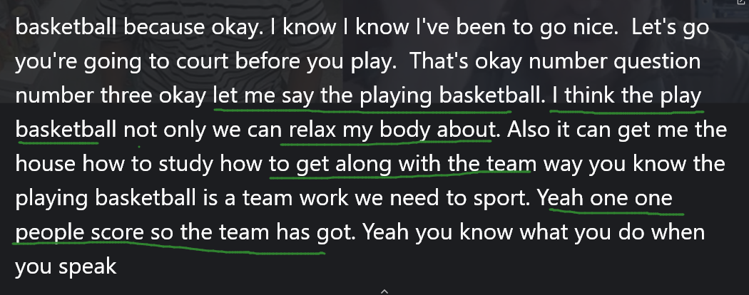

Suggestion:

1. ~~Speak slowly and clearly, which can let the listener understand, at the same time,~~

~~you have some time to think/ organize the logic of the next sentence.~~

~~(2) Speak continuously~~

~~(3) Simulation of the interview, let me suit the feeling of the applicant.~~

(4) You need directly and simple answer, let the listen receive the worth information.

My favorite sport is basketball because I paly it can strength my body, and relax the pressure, operate the team work.

