# Asa: 8:00-9:30 PM (20220805)



<https://cloudarchives2.camblychina.com/62ed09f26e6b1b5c525a7995/e4551b0aca45b785349f5ca74e3a55b2_cambly_62ed09f26e6b1b5c525a7995_0.mp4?auth_key=1659713819-ae152d0214c311eda066a2b868e75f8d-0-20cfee8c1fdc284f6e58c26351685460>

**Draft:**

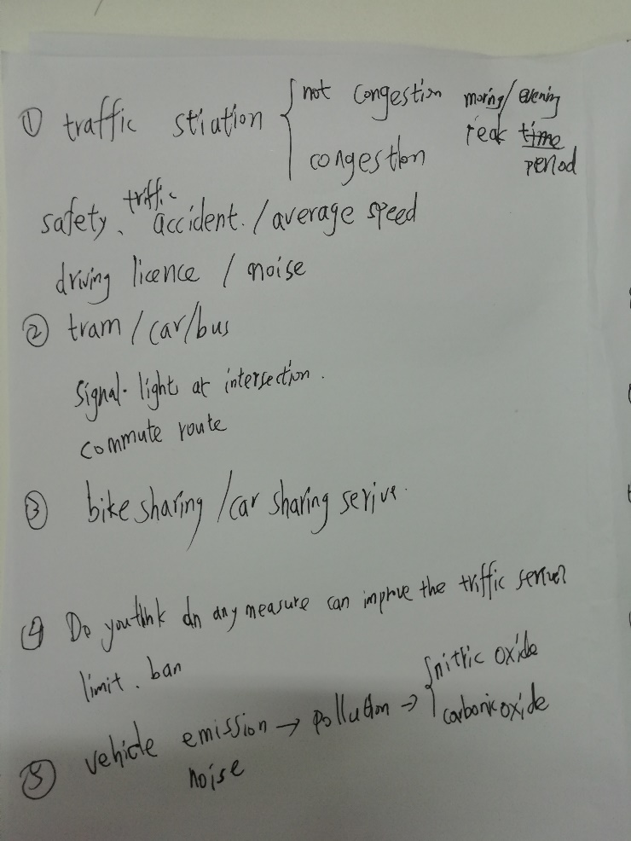

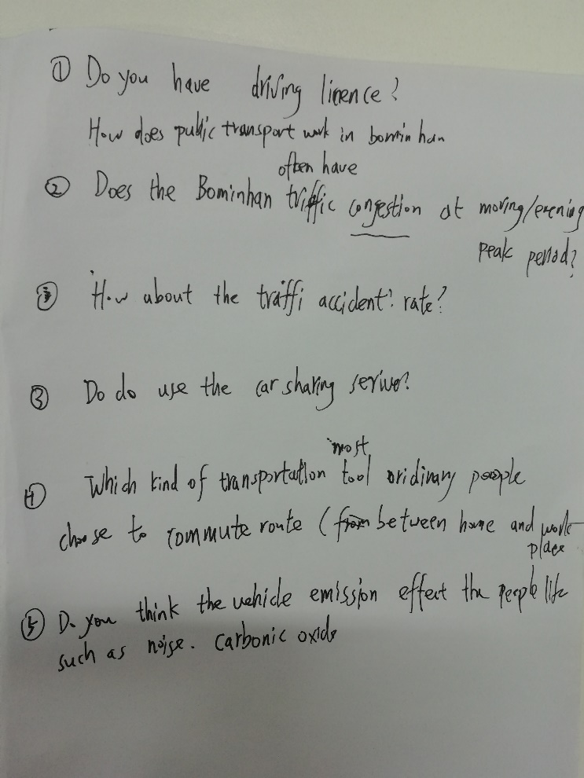

Kai: Do you have a driving license?

Asa: I have a provisional(temporary) license.

You can drive with a licensed driver.

Kai: How does the public transportation in your city?

Is it often happen congestion or traffic accidents?

Asa: We have tramp, train, bus, and personal car.

Our traffic does not often happen congestion.

Kai: How many people live in your city?

Asa: Our population has 1.1 million. Birmingham is the second city in United Kingdom (Britain)

Kai: I think your city population is smaller than the city in a developing country.

Asa: Even in peak time (morning or evening), our transportation does not happen congestion.

~~Kai: Which kind of transportation tool is people a most choice for commute route between home place and work place?~~

Asa: What types of transportation are most popular for commuters to travel on?

Asa: I think the first is train, which is cheap and fast. The second is bus. Then is personal car.

The tramp is new transportation tool, fewer people choice it to travel.

Asa: How about Nanjing?

Kai: I think the first choice is the subway, which is fast and on time, comfortable. Then is the car-sharing service, third is bus.

Asa: The car-sharing service is expensive.

Kai: Yes. I choose the car-sharing service if I am hurry and the distance within 5 kilometres.

If the distance is over than 5 kilometres, I will choose the subway. I seldom take the bus.

Asa: How about bike-sharing service?

Kai: When the distance within 2 kilometres, I choose it. For example, I use the bike-sharing serve from my college door to the nearly subway station.

Kai: Do you buy the monthly tickets?

Asa: monthly pass. You take the train more times, you choose the month tickets cheaper.

Asa: Do you think public transportation is important to environment?

Kai: Yes. I think to choose the public transportation, such as ride a bike, it is friendly-environment way. In our country, the government advices people to use the electric car rather than the car using oil or gas.

Asa: Is there a high percent/ proportion of electric vehicles?

Kai: Small. I think the percent/percentage of electric vehicles is smaller than vehicles using gas or oil. Because the electric vehicle has the bigger/higher travel cost than gas or oil car. However, I think, in the future, with the technology developing, the electric vehicle will be more cheaper.

Kai: I think to choose public transportation can decrease emission, such as noise, CO, and NO.

Carbonic oxide, nitric oxide.

Asa: Do you know the Nancy Pelosi visited the Taiwan?

Kai: Yes. I know. Chinese don’t like her.

Asa: How do you think your country will deal with / handle the Taiwan issue?

Kai: In the history, the Taiwan is the part of China. Duo to the Taiwan has the army, I guess we need a war to solve this issue.

**Chat:**

provisional license

= you can drive with a licensed driver

commonwealth games: 英联邦运动

Commonwealth of Nations：英联邦国家

The Commonwealth Games, often referred to as the Friendly Games, is a quadrennial international multi-sport event among athletes from the Commonwealth of Nations. The event was first held in 1930, and, with the exception of 1942 and 1946, have successively run every four years since.

commonwealth nations

5-7pm

7-9am

1.1m

grow some crops

wheat

wheat farmer

uber, ola, bolt

have you been to china?

What types of transportation are most popular for commuters to travel on?

the first choice is the subway

monthly pass

more cheap = cheaper

16.30 yuan

ride a bike

carbon dioxide

Co2

nitrogen

nitric oxide

nancy pelosi

they don't have a peaceful way to solve the issues

they will aid taiwan / they will equip taiwan