# 上课

<https://www.cambly.com/api/chats/62f64c206b58c181b2b81126/video>

https://www.cambly.com/api/chats/62f5195fa3872d2d31b4afbc/video

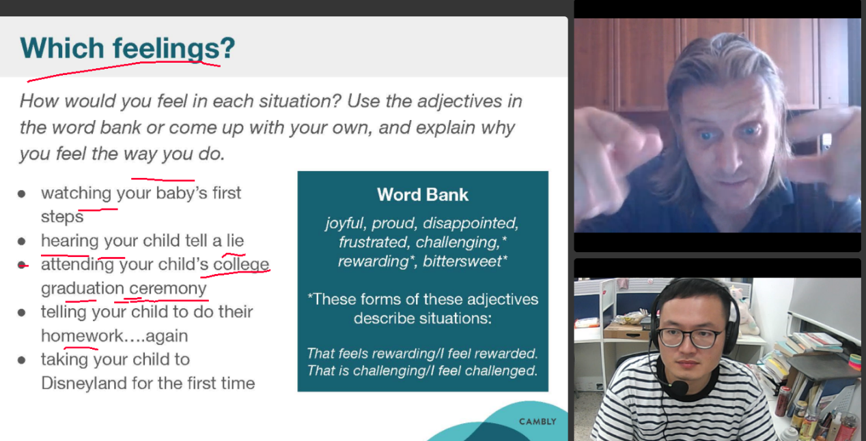

|  |  |  |
| --- | --- | --- |
|  |  |  |
| passage | /ˈpæsɪdʒ/  pas sej | 经过 |
| passenger | /ˈpæsɪndʒə(r)/ | 乘客 |
| used | /juːst/ | 结尾”s”清辅音，ed发“t” |
| looked | /lʊkt/ | 结尾”k”清辅音，ed发“t” |
| wanted | /ˈwɒntɪd/ | 以t,d结尾 ed发“ɪd” |
| graduation | /ˌɡrædʒuˈeɪʃ(ə)n/ |  |
| college | ˈkɒlɪdʒ/ | campus ˈkæmpəs/ |
| ceremony | ˈserəməni/ | [service](javascript:;) 庆典 |
| hearing | /ˈhɪərɪŋ/ | e不发音 |

Suggestion:

Speak slowly and clearly, let listener hear every word.

I have some issues about the pronunciation of fixed letter combinations of word,

so I need to study the method of phonics of English.英语自然拼读

Campus /ˈkæmpəs/ college

Residential /ˌrezɪˈdenʃ(ə)l/ living apartment

Authority /ɔːˈθɒrəti/ government

App /æp/ sofeware

Although /ɔːlˈðəʊ/

Doubt /daʊt/

Announced /əˈnaʊnst/ 宣布

Awful /ˈɔːf(ə)l/ bad

Route /ruːt/ path

英语ed结尾的发音规律

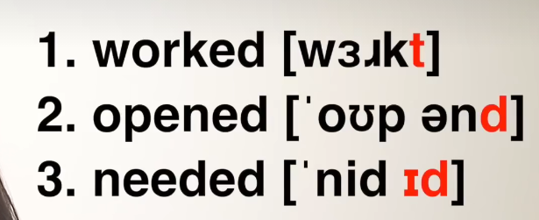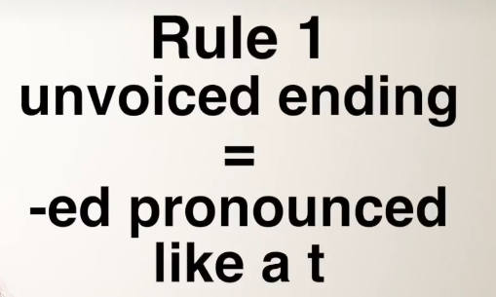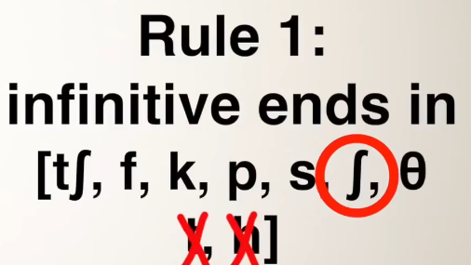

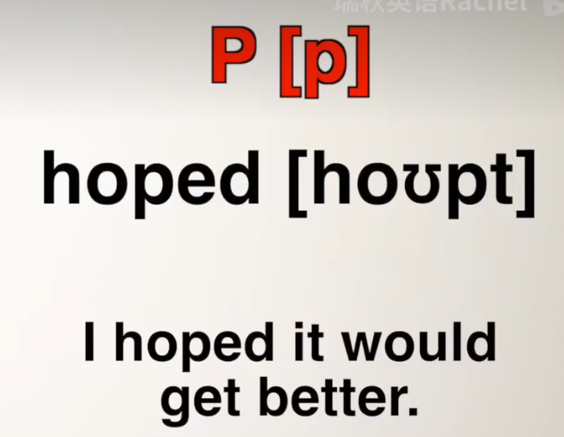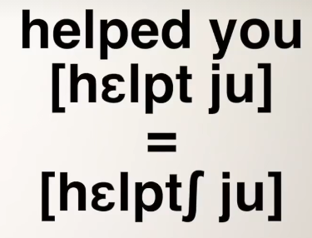

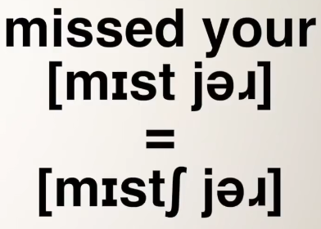

|  |  |  |  |  |  |  |  |
| --- | --- | --- | --- | --- | --- | --- | --- |
| **辅 音** | 爆破音 | 清辅音 | [p] | [t] | [k] |  |  |
| 浊辅音 | [b] | [d] | [g] |  |  |
| 摩擦音 | 清辅音 | [f] | [s] | [ʃ] | [θ] | [h] |
| 浊辅音 | [v] | [z] | [ʒ] | [ð] |  |
| 破擦音 | 清辅音 | [tʃ] | [tr] | [ts] |  |  |
| 浊辅音 | [dʒ] | [dr] | [dz] |  |  |
| 鼻音 | （浊辅音） | [m] | [n] | [ŋ] |  |  |
| 舌则音 | （浊辅音） | [l] [l] | [r] |  |  |  |
| 半元音 | （浊辅音） | [w] | [j] |  |  |  |

# -ed规律

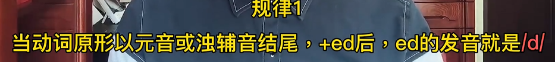

**浊辅音结尾+ 浊辅音“d” (声带震动)**

|  |  |  |  |  |  |
| --- | --- | --- | --- | --- | --- |
| 摩擦浊辅音 | [b] | [d] | [g] |  |  |

|  |  |  |  |  |  |
| --- | --- | --- | --- | --- | --- |
| 破擦浊辅音 | [v] | [z] | [ʒ] | [ð] |  |
| 鼻音 | （浊辅音） | [m] | [n] | [ŋ] |  |  |
| 舌则音 | （浊辅音） | [l] [l] | [r] |  |  |  |
| 半元音 | （浊辅音） | [w] | [j] |  |  |  |



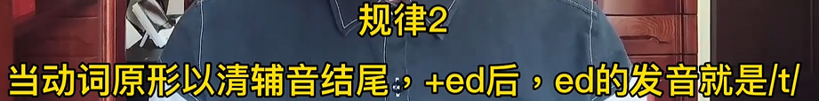

**清辅音结尾+ 清辅音“t” (声带不震动)**

|  |  |  |  |  |  |  |
| --- | --- | --- | --- | --- | --- | --- |
| 爆破音 | 清辅音 | [p] | [t] | [k] |  |  |
| 摩擦音 | 清辅音 | [f] | [s] | [ʃ] | [θ] | [h] |
| 破擦音 | 清辅音 | [tʃ] | [tr] | [ts] |  |  |



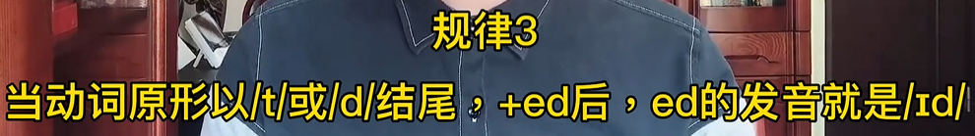



# 辅音

<https://www.bilibili.com/video/BV1Yt4y1U7fP?spm_id_from=333.337.search-card.all.click&vd_source=0e043ce42c7c7cfd9aa8501f8e3aeca0>

清辅音： 声带不震动

浊辅音： 声带震动

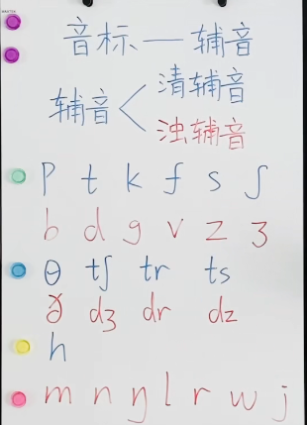

# 元音

<https://www.bilibili.com/video/BV1R541147Sr?spm_id_from=333.999.0.0&vd_source=0e043ce42c7c7cfd9aa8501f8e3aeca0>

|  |  |  |  |  |  |  |  |
| --- | --- | --- | --- | --- | --- | --- | --- |
| **元 音** | 单元音 | 前元音 | [i:] | [i] | [e] | [æ] |  |
| 中元音 | [ʌ] | [ə:] | [ə] |  |  |
| 后元音 | [u:] | [u] | [ɔ:] | [ɔ] | [a:] |
| 双元音 | 开合双元音 | [ei] | [ai] | [ɔi] | [əu] | [au] |
| 集中双元音 | [iə] | [εə] | [uə] |  |  |

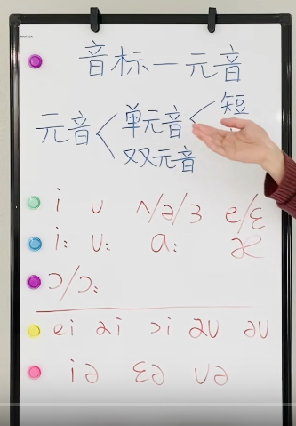

|  |  |  |  |
| --- | --- | --- | --- |
| 单 短元音 | good /ɡʊd/ |  |  |
| 单 长元音 | school /skuːl/ | car: /kɑː(r)/ | apple /ˈæp(ə)l/ |
|  | hot /hɒt/ |  |  |
| 组合元音 |  | boy /bɔɪ/ |  |
| 组合元音 |  |  |  |

短元音：嘴型固定，声音从胸腔发出，短

长元音： 嘴型开的较大，发音较长

# 组合发音

<https://www.bilibili.com/video/BV1Fq4y1H7gF?spm_id_from=333.337.search-card.all.click&vd_source=0e043ce42c7c7cfd9aa8501f8e3aeca0>

# 音标 -在线 发音

https://www.jiwake.com/yinbiaofayin/

|  |  |  |  |  |  |  |  |
| --- | --- | --- | --- | --- | --- | --- | --- |
| 48个英语音标（国际音标） | | | | | | | |
| **元 音** | 单元音 | 前元音 | [i:] | [i] | [e] | [æ] |  |
| 中元音 | [ʌ] | [ə:] | [ə] |  |  |
| 后元音 | [u:] | [u] | [ɔ:] | [ɔ] | [a:] |
| 双元音 | 开合双元音 | [ei] | [ai] | [ɔi] | [əu] | [au] |
| 集中双元音 | [iə] | [εə] | [uə] |  |  |
| **辅 音** | 爆破音 | 清辅音 | [p] | [t] | [k] |  |  |
| 浊辅音 | [b] | [d] | [g] |  |  |
| 摩擦音 | 清辅音 | [f] | [s] | [ʃ] | [θ] | [h] |
| 浊辅音 | [v] | [z] | [ʒ] | [ð] |  |
| 破擦音 | 清辅音 | [tʃ] | [tr] | [ts] |  |  |
| 浊辅音 | [dʒ] | [dr] | [dz] |  |  |
| 鼻音 | （浊辅音） | [m] | [n] | [ŋ] |  |  |
| 舌则音 | （浊辅音） | [l] | [l] | [r] |  |  |
| 半元音 | （浊辅音） | [w] | [j] |  |  |  |

英语音标—对应单词

<https://www.bilibili.com/video/BV1Kf4y1j7Ap?spm_id_from=333.337.search-card.all.click&vd_source=0e043ce42c7c7cfd9aa8501f8e3aeca0>

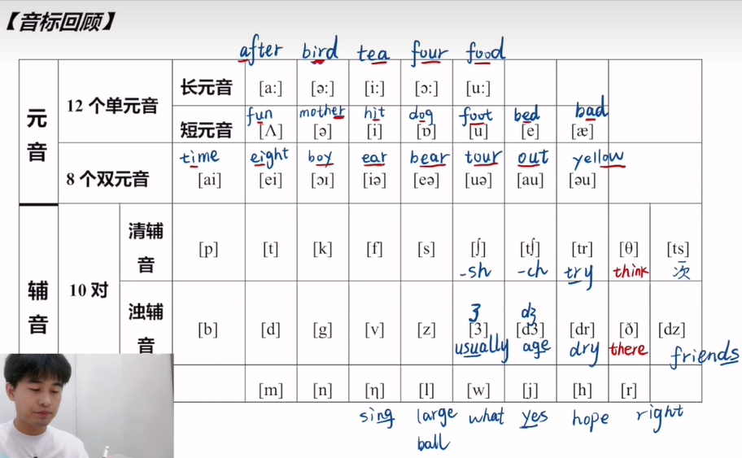

|  |  |  |  |
| --- | --- | --- | --- |
| [θ]： 舌头顶住牙床，发音 | | [ts] | 次 |
| [ð]：舌头伸出，  牙齿轻咬舌尖，发音 | | [tr] | try |
| [n] | 舌头不动发音 | [tʃ] | -ch |
| [ŋ] | 舌头绷直发音 sing | [ʃ] | -sh |
| [l] | 放在首部，发音“了”：Large;  放在尾部，发音“哦”：ball |  |  |
| [w] | what |  |  |
| [j] | yes |  |  |
| [h] | Hope |  |  |
| [r] | right |  |  |

元音音素：  
/i:/ he she me bee key fee see deep jeep leave meet  
/i/ bill big bit sit hit kit kiss dig dislike give pit  
/e/ echo bet beg bell desk get let met net pet  
/æ/ apple bad bag bat cat dash fat fan gap hat lantern  
/ə:/ bird burger cur her fur dirty earth girl jerk curl purse first  
/ə/ rubber ruler breakfast dollar daughter mother father better doctor loser  
/∧/ bus but bug bubble basket cut dump mother son sun  
/a:/ bar basket bar barbecue car dark far father pass salon  
/כ/ boss god cock cocktail doll dollar dolphin doctor dog got  
/כ:/ ball football basketball baseball ... board sport call door daughter law  
/u/ book cook full good goodbye could hook look put wood  
/u:/ cool school ruler do fool food goose whose who loose  
/ei/ base bake cake case date fake face fame gate game  
/ai/ I Hi my by Mike bike like fly sky try  
/כi/ boy noise joy soy toy voice coin join boil soil  
/əu/ go no boat coat note show oh so hope joke  
/au/ how now shout doubt mouse mouth cow wow count found  
/iə/ ear here tear dear bear fear gear near clear steer  
/εə/ there hair bear dare fare fair care pear pair stair  
/uə/ sure cure durable furious Jura jewel jewelry tourist lure mure  
辅音音素：  
/p/ put purse pass piece pipe pay play pingpong police polite push  
/b/ bag bad bake bare bear bus but bird ...  
/t/ it hit meet take ...  
/d/ dig did do duck...  
/k/ cook could school make...  
/g/ guess get engage gap hug bug ...  
/f/ fur flower fly fool wolf soft...  
/v/ love glove dove village vollyball voice veichel vocation...  
/s/ school sit see s...  
/z/ zip zero zebra nose bees keys birds hers his theirs yours  
/θ/ there this that those the then than them they mother  
/δ/ think thin thick thirsty three third thirty birth earth thank  
/∫/ she shirt shoe dash mushroom show shake shadow shame shaft  
/з/ pleasure leisure  
/h/ hope hole how who whose hat ...  
/r/ red read ruler rubber rat race ...  
/t∫/ chose chair chain ch...  
/dз/ huge large japan january june july j...  
/tr/ tree trousers tr...  
/dr/ dress address dr...  
/ts/ hats cats fats ...ts  
/dz/ birds ...ds  
/m/ money mother monkey mouth mouse m...  
/n/ nose note no noise n...  
/ŋ/ hang gang bang English king thing ...ng  
/l/ like loud low ball l... ...l  
/w/ we will want what why w...  
/j/ yes yesterday yeah yammy young you your