<https://www.cambly.com/api/chats/62f90e62cad2daf00e4ae4b4/video>

<https://www.cambly.com/api/chats/62f9125b006c7b24e972037d/video>

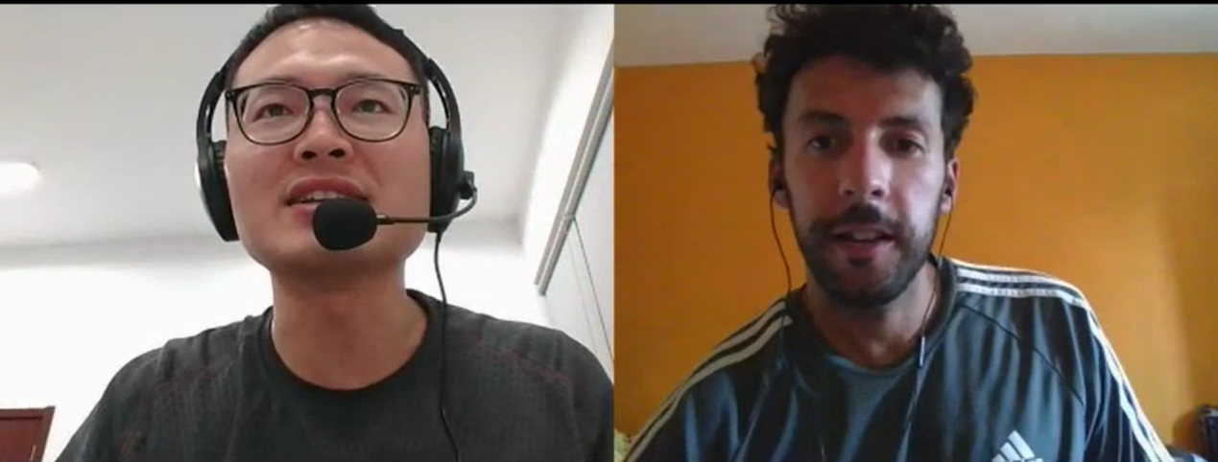

|  |  |
| --- | --- |
| Getting up early regularly |  |
| productive |  |
| Foodie /ˈfuːdi/ | a person devoted to refined sensuous enjoyment (especially good food and drink) |
| Cuisine /kwɪˈziːn/ |  |
| cancel /ˈkæns(ə)l/ |  |
| Would have joined us | We will go hiking |
| She would not  wouldn’t |  |
| Wake up early |  |
| Early bird  Night owl aʊl |  |
| Asks /ɑːsks/ |  |

Zhangjiajie National Park

getting up early regularly

productive

If i can choose what i have for lunch tomorrow i will have....

what to have for lunch tomorrow i will have ...

foodie

would have joined us...

if you didn't have to work..

what would you do?

she wouldn't be too tired tomorrow

would not = wouldn't

Lottery /ˈlɒtəri/

Wake up

Early bird / night owl

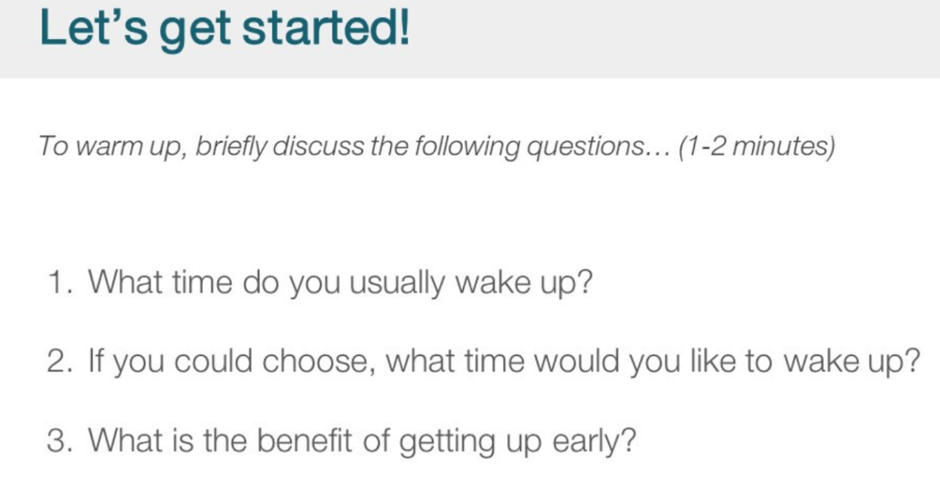usually /ˈjuːʒuəli/

Wake up

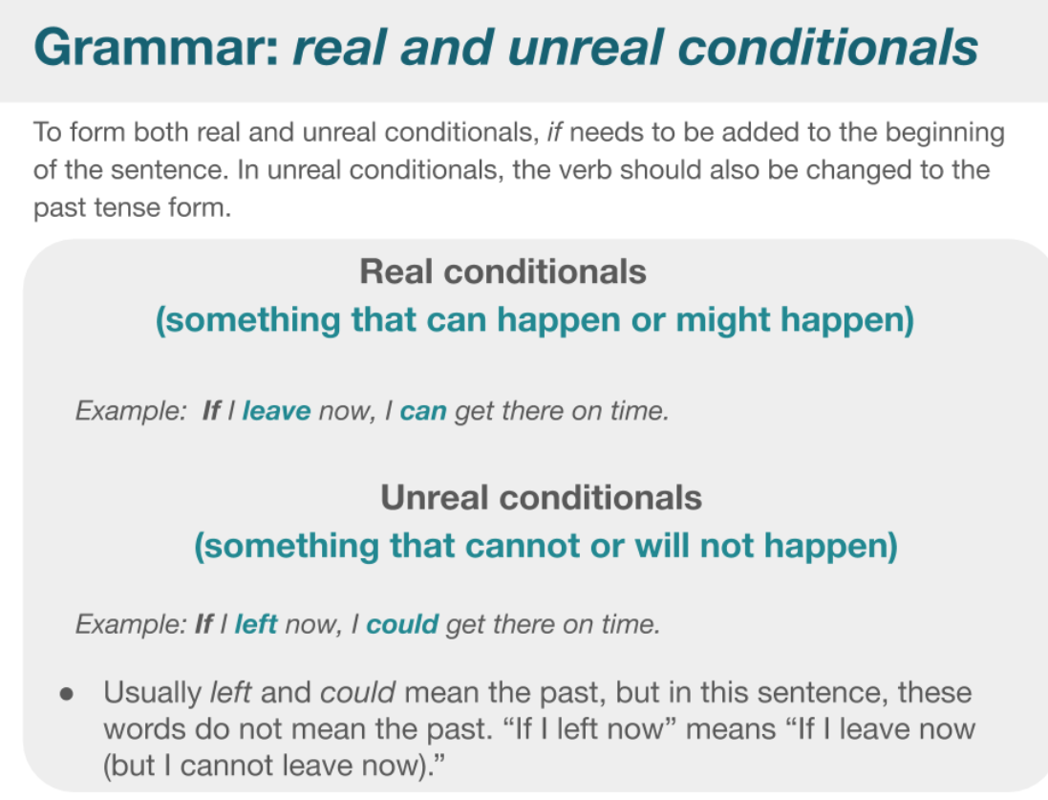

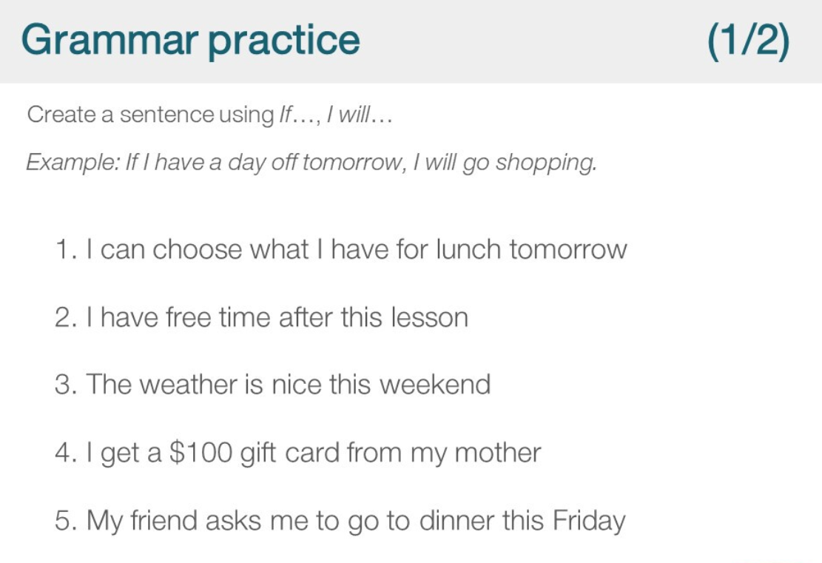

If My friend asks me to go dinner this Friday, I will cancel the lesson book at Carmbly website.

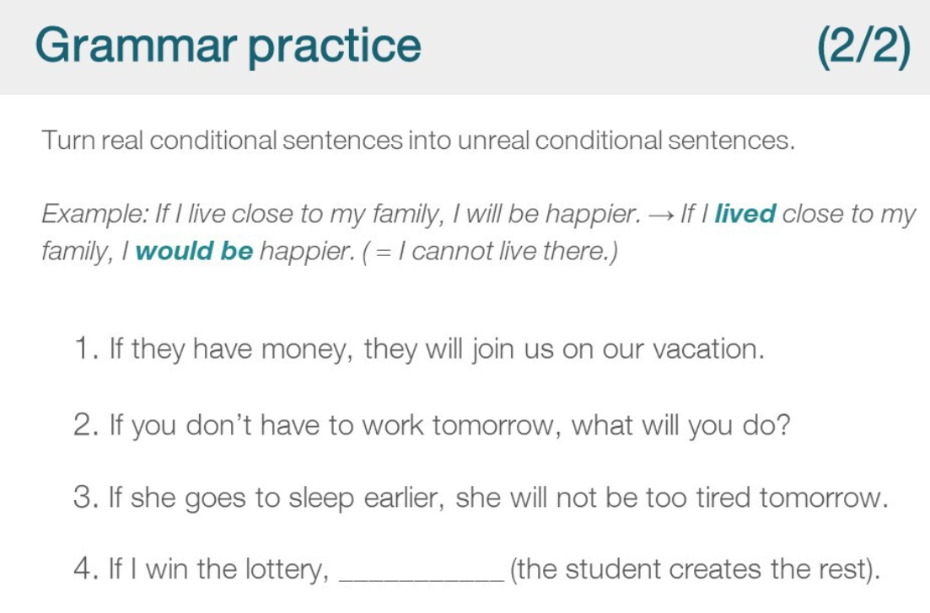

If I won the lottery, I would donate all money to people in need.

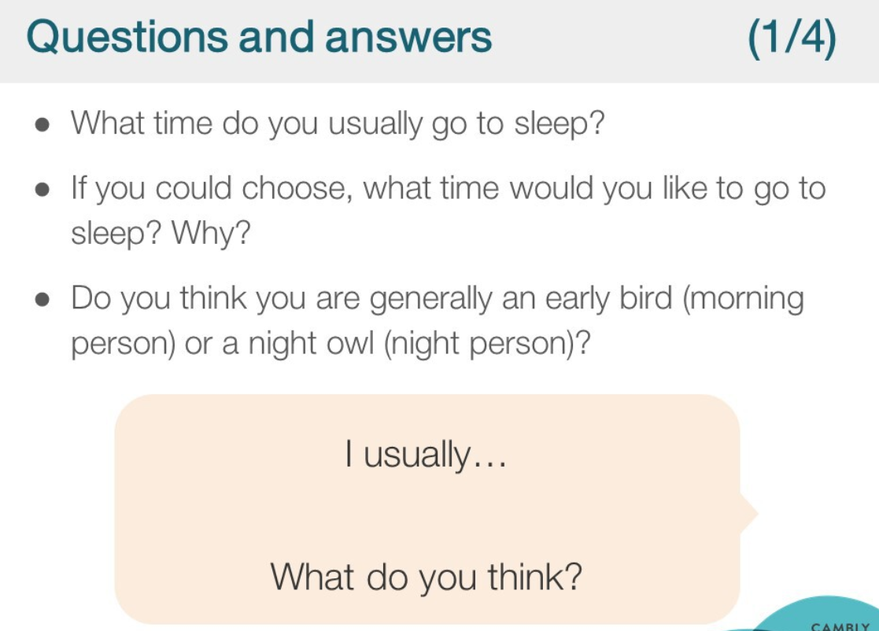

Early bird / night owl