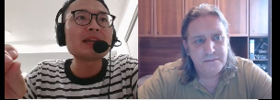

<https://www.cambly.com/api/chats/62fe1ad19fa6db5a6e76a240/video>

<https://www.cambly.com/api/chats/62fe22ef3e5d18776e19c75a/video>

## Reading 1- Lucas go to school

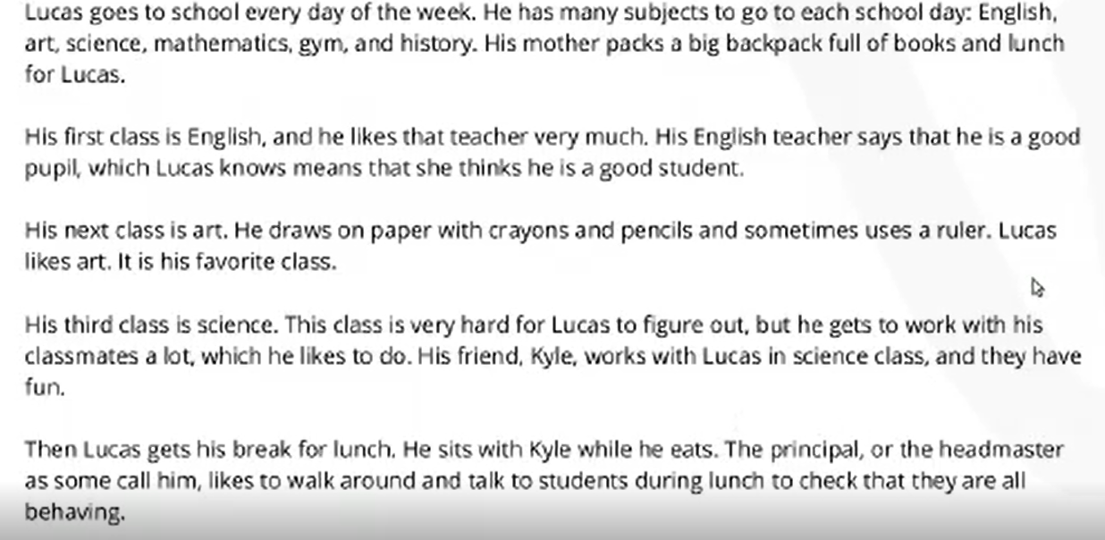

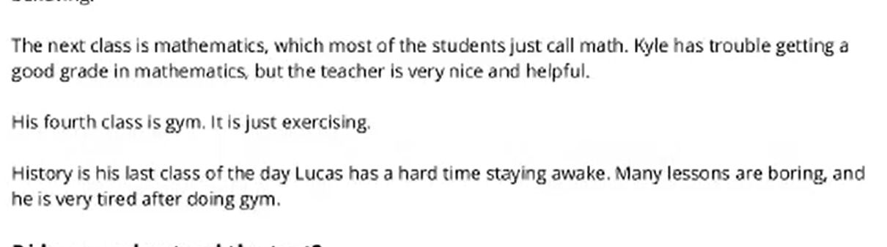

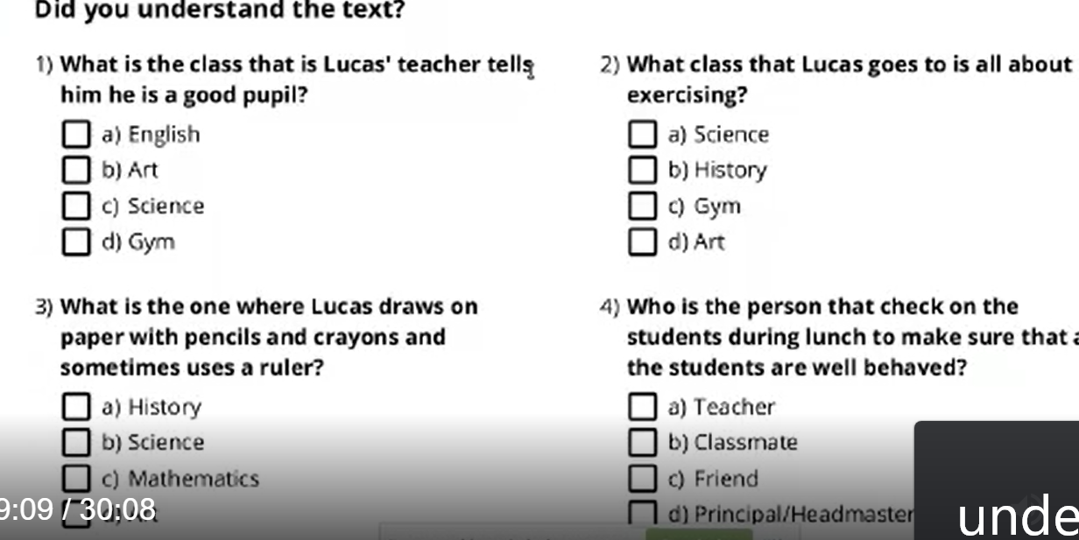

|  |  |  |  |
| --- | --- | --- | --- |
|  |  |  |  |
| (1)reading | |  |  |
| science | /ˈsaɪəns/ | exercise | ˈeksəsaɪz |
| mathematics | ˌmæθəˈmætɪks | tells |  |
| pupil | /ˈpjuːp(ə)l/ | figure | ˈfɪɡə(r) |
| crayons | ˈkreɪənz 蜡笔 | break | breɪk |
| uses | /ˈjuːzɪz/ | ruler | ˈruːlə(r)/ 尺子 |
| behaved | /bɪˈheɪvd |  |  |

## Reading 2

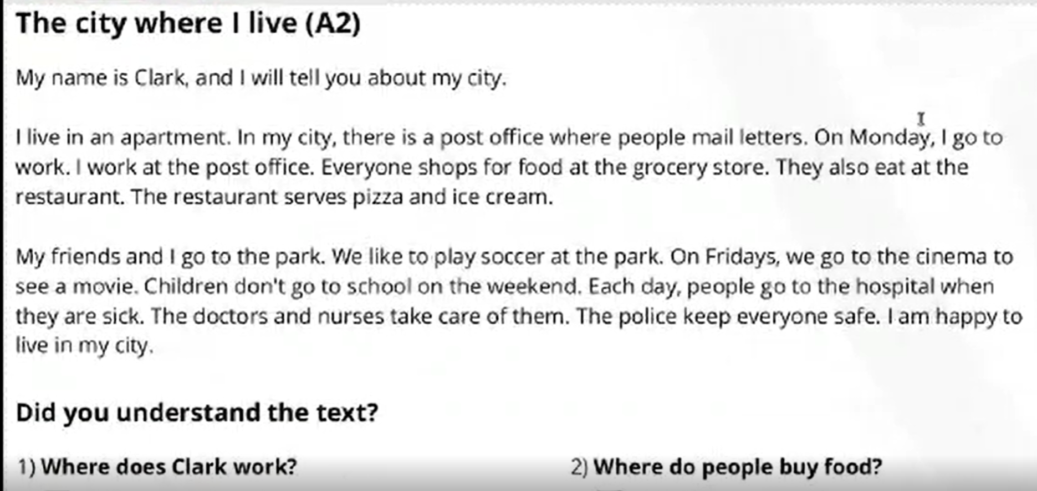

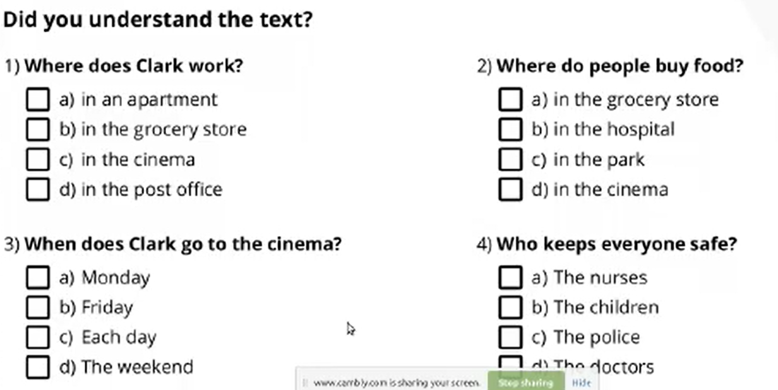

|  |  |  |  |
| --- | --- | --- | --- |
|  |  |  |  |
| (1)reading | |  |  |
| apartment | əˈpɑːtmənt | soccer | Football /ˈsɒkə(r) |
| mail | /meɪl | cinema | /ˈsɪnəmə/ |
| grocery | /ˈɡrəʊsəri/ 杂货店 | Police  office |  |
| serves | sɜːrvz/ 服务 no e | hospital |  |
| uses | /ˈjuːzɪz/ | did |  |
|  |  |  |  |
|  |  |  |  |

1. The Clark works in the post office.
2. Clark goes to the cinema at the weekend / on the weekends
3. Clark feels happy about his city.

## Reading 3- days of the week

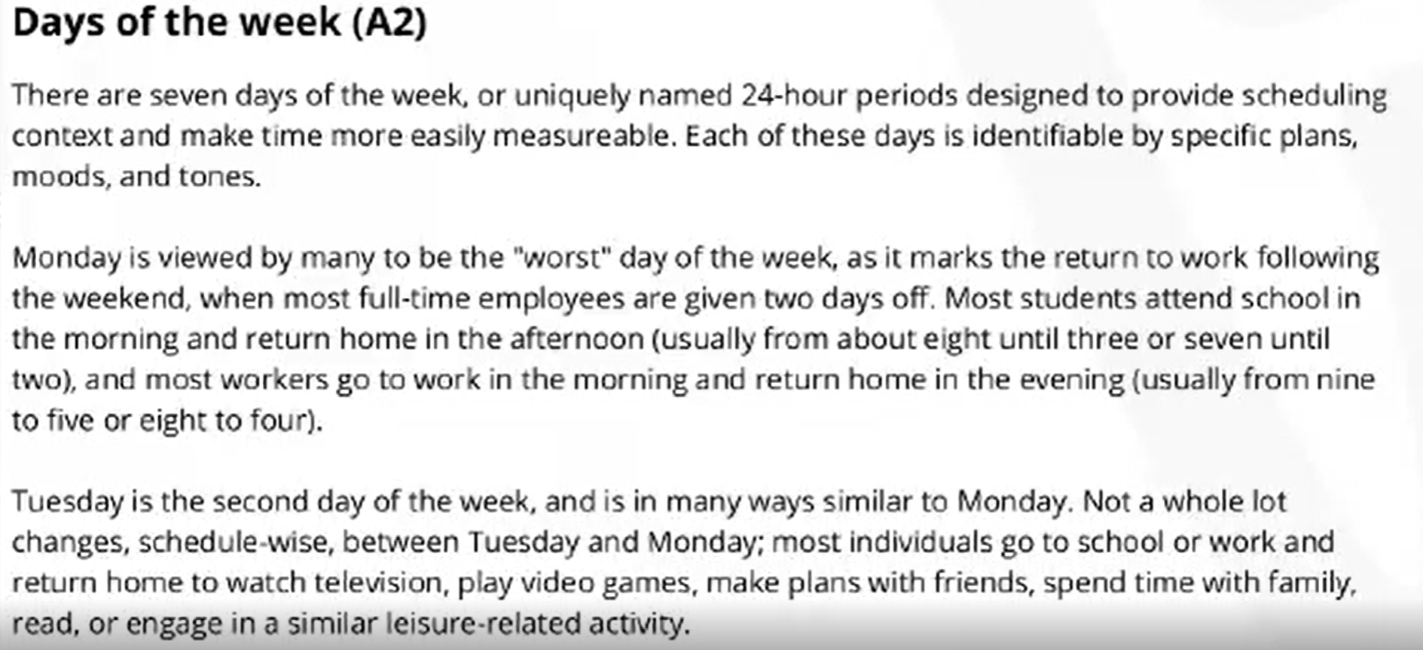

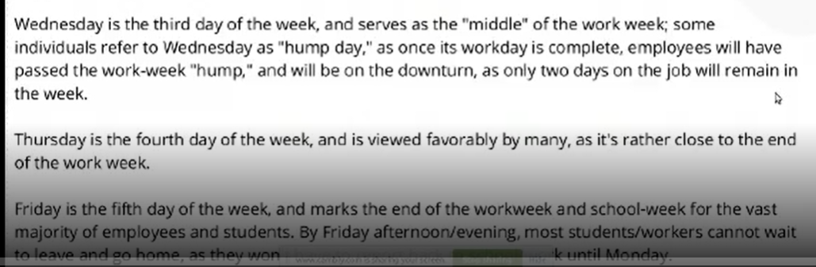

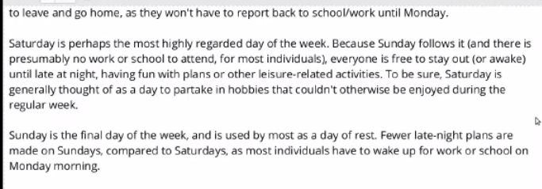

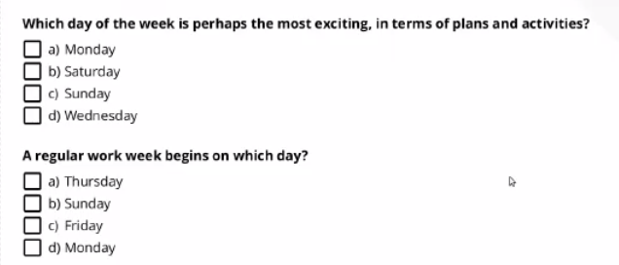

Saturday is perhaps the most exciting day.

|  |  |  |  |
| --- | --- | --- | --- |
|  |  |  |  |
| (1)reading | |  |  |
| uniquely  uni-quely | /juˈniːkli/ 独一无二 | usually | ˈjuːʒuəli |
| measurable | ˈmeʒərəbl 显著的 | Tuesday | ˈtjuːzdeɪ |
| identifiable  iden-tifiable | aɪˌdentɪˈfaɪəb 可辨认的 | hump day  love day | ju 驼峰日 周三 |
| specific | /spəˈsɪfɪk 明确的 | engage | /ɪnˈɡeɪdʒ 参加，雇佣 |
| tone | /təʊn/ 语气 | favorably  fa-vo-ra-bly | feivərəbli 顺利地 |
| employees | ˌemplɔɪˈi:z | serves | sɜːrvz/ 服务  第二个e不发音 |
| third | /θɜːd/ |  |  |
| individuals  indi-viduals | /ˌɪndɪˈvɪdʒuəlz/ person | Presumably  Preum-ably  Possible | prɪˈzjuːməbli |
| downtown | urban center | Leisure  Le-isure | /ˈleʒə(r)/  闲暇 |
| regular | /ˈreɡjələ(r)/ |  |  |

## Reading 3- days of the week

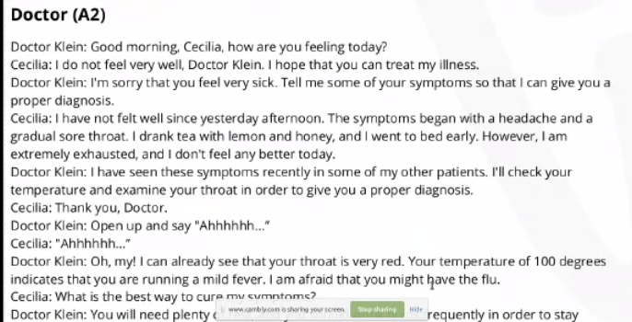

|  |  |  |  |
| --- | --- | --- | --- |
|  |  |  |  |
| (1)reading | |  |  |
| How  h-ow | /haʊ/ | patients | /'peɪʃ(ə)nts |
| Cecilia  Ce-ci-lia |  | throat | θrəʊt |
| Symptom  Sym-ptom | /ˈsɪmptəm | Fever  flu | ˈfiːvə(r) |
| Diagnosis  Diag-no-sis | /ˌdaɪəɡˈnəʊsɪs/ 诊断 | fluids | ˈflʊɪd/ |
| hydrated  Hu-dra-ted | haɪdreɪtɪd/ | prescribe  Pre-s-cri-be | /prɪˈskraɪb/ |