Lesson video: <https://www.cambly.com/api/chats/62ff79be7a1685b3022a220c/video>

Lesson metrial: https://www.thoughtco.com/ask-and-answer-questions-1210033

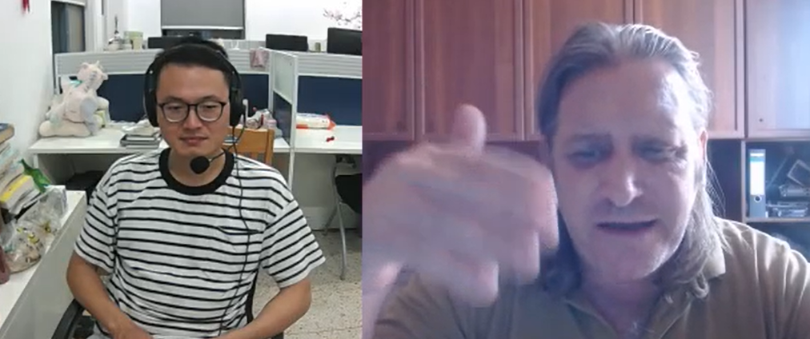

|  |  |  |  |
| --- | --- | --- | --- |
|  |  |  |  |
| vs  versus | ˈvɜːsəs  compare | marital status? | mærɪtl  whether marry |
| wh- question words | Why, what, where  Which, when | plumber  [electrician](javascript:;) | ˈplʌmə(r)/ /ɪˌlekˈtrɪʃ(ə)n/ |
| 123@gmail.com | dot |  |  |
| on the 6th of march 1997 |  |  |  |
| compass  campus | /ˈkʌmpəs/  point south  /ˈkæmpəs/ |  |  |

