

<https://www.cambly.com/api/chats/630229f82cbb9c2c50b88df7/video>

Question: Personal information and family

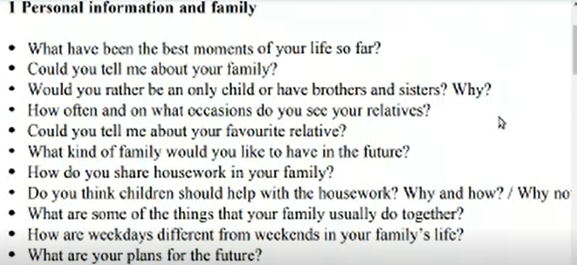

Answer:

1. What have been the best moments of your life so far?

The best moments of my life is when my family members go to together.

1. My family has four members, grandfather, dad, ma, and I.
2. I would rather have brothers or sisters because it let me not alone
3. I see my relatives 2 times a year on special festivals.
4. My favorite relative is grandfather because he gives me more love when I was a child.
5. I hope to have a warm-heart wife, 2 or 3 children in the future.
6. Yes, I help my mother to cook and clean the house.
7. Yes, I think children should help with the housework because the family give them love and material, they should do something for family, they will study duty.
8. In our family, we usually have lunch together.
9. We work on weekday, and we relax on weekends.
10. In the future, I hope to be a teacher in the university. /campus

Question: Man and society

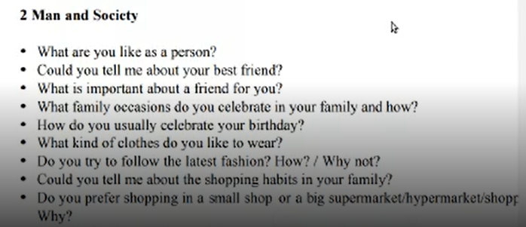

Answer:

1. I am an honest, reliable and hard working person.
2. My best friend is Weili, he is funny, have more social skills than me. We have more than 25 years friendship.
3. I think the important about a friend is trust and reliable.
4. The occasions (Spring festival) we celebrate in my family
5. I will eat the delicious food to celebrate my birthday.
6. The kind of clothes I like is sports style.
7. No, I like the traditional style.
8. my family is diligent and thrifty because we only buy something that it is necessary.
9. I prefer shopping in a s small shop because it is so near to my house or office.