Teacher Daniel



Puppet: is controlled by hidden others

social skills

half cast: Eurasian: a person of mixed European and Asian descent (gene / blood)

prime minister

Clown 小丑: a rude or vulgar fool

Nato 北欧（North Atlantic Treaty Organization）

un

roc

1950

ROC

1950s

Crime problem

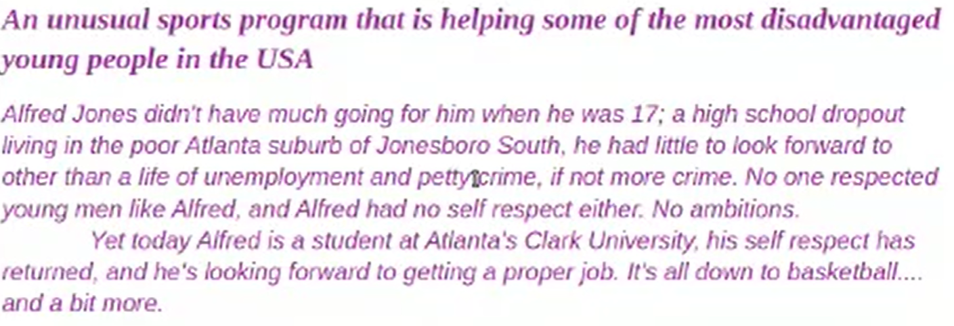

## immigration problem

half cast (father is black, mother is white) .

Eurasian: a person of mixed European and Asian descent (gene / blood)

Ob is puppet，he is organized by financial companies.

Joh is clown, he is assistance of BB..

Tru has built a long wall in the bound between US and Mexico, in order to prevent the immigrates that people want to illegal entry.

Tru is the second of American president who doesn’t wage the war.

The reason of United Kingdom escape from European Unit, this country not want to receive many immigrates from the pool countries, such as African.

They think these immigrates will damage they society, they will crime or Take place jobs from locals.

Develop countries accept immigrates with high knowledge and skills, not poor immigrates without skills or refugees (难民)

refugees :an exile who flees for safety due to hungry, war.

## Population problem

Russia — 17,098,250 km² Canada — 9,879,750 km² China — 9,600,013 km² United States — 9,525,067 - 9,831,510 km² Brazil — 8,515,770 km² Australia — 7,741,220 km² India — 3,287,260 km²

The population of Chinese is 1,425,887,337

The population of India is 1,417,173,173

The China is the third largest land area country in the world, in the same time, She has the largest population than other countries.

Daniel said the young hope the old die fast, then they can get the heritage (遗产) , house.

China has the culture to respect the old man, the young has the duty to take care the old in the family.