

<https://cloudarchives2.camblychina.com/630a232bd8d9b6a85f6ccbaa/a51a5977f7447b9f4f565ea65643f692_cambly_630a232bd8d9b6a85f6ccbaa_0.mp4?auth_key=1661619749-4529a928261911ed91d7c69675e4ee91-0-2a348c44db5e755c9a3dbb984084fbb1>

## 1 words

|  |  |  |
| --- | --- | --- |
|  |  |  |
| Evergrande | HengDa company |  |
| Managed | Manag d | The e silent |
| The, a, an |  |  |
| articles | /ˈɑːtɪk(ə)l/ | nonfictional prose forming an independent part of a publication |
| Christmas | Cris mas | period extending from Dec. 24 to Jan. 6  Christmas is an annual festival commemorating [the birth](https://en.wikipedia.org/wiki/Nativity_of_Jesus) of [Jesus Christ](https://en.wikipedia.org/wiki/Jesus_Christ), observed primarily on December 25 as a religious and cultural celebration among billions of people [around the world](https://en.wikipedia.org/wiki/Observance_of_Christmas_by_country). |
| mass |  | a large number or amount or extent  民众的，大量的 |
| atheist | /ˈeɪθiɪst/ | someone who denies the existence of god |
| Ordinal number  25th | Ordinal number | On 25th december |
|  |  |  |

|  |  |  |
| --- | --- | --- |
| Metropolis  metropolis | /məˈtrɒpəlɪs/  Metro-po-lis | a large and densely populated urban area  a large and densely populated urban area |
| **Exterior,**  **interior** | /ɪkˈstɪəriə(r)/ | Out  In |
| Michigan | /ˈmɪʃɪɡən/ | a midwestern state in north central United States in the Great Lakes region |
| landmarks | /ˈlændˌmɑrk/ | a mark showing the boundary of a piece of land;  an event marking a unique or important historical change of course or one on which important developments depend |
| monuments | /ˈmɒnjumənt/ | an important site that is marked and preserved as public property  National monument  Historic monument |
| baseball | /ˈbeɪsbɔːl/ | 棒球 |
| Not only, but also |  |  |
| Stadium  Sta-dium  enter-train-ment | ˈsteɪdiəm/ | a large structure for open-air sports or entertainments /ˌentəˈteɪnmənt/ |
| Fans, cubs | A score of 5-4 |  |
| Survived | /səˈvaɪv/ | He survived the cancer against all odds. |
| **Leisurely** stroll  Lei-sure-ly stroll | /ˈleʒəli/ /strəʊl/ | Wonderful walk |
| Architecture and  replicas | /ˈɑːkɪtektʃə(r)/  /ˈreplɪkə/ | the profession of designing buildings .  copy that is not the original; something that has been copied |
| Skyscraper  Sky-scra-per | /ˈskaɪskreɪpə(r)/ | a very tall building in the city, such as the landmark  From the rooftop, he received a gorgeous view of the city’s skyline with Lake Michigan in the background. |

|  |  |  |
| --- | --- | --- |
|  |  |  |
| Exterior,  interior | /ɪkˈstɪəriə(r)/ | Out  In |
| Signifying  symbolic | /ˈsɪɡnɪfaɪɪŋ/ /sɪmˈbɒlɪk/ | [representation](javascript:;)  [emblematic](javascript:;) [indicative](javascript:;) |
| regardless | /rɪˈɡɑːdləs/ | [regardless of](javascript:;) 不顾 |
| Legend, hefty, jolly | /ˈledʒənd/ 传说  /ˈhefti/ strong  /ˈdʒɒli/ happy |  |
| presumably | prɪˈzjuːməbli/ | [probablypossiblymaybe](javascript:;) |
| A lump of coal | /lʌmp/ | Block coal |
| Magical reindeer | /ˈreɪndɪə(r) 驯鹿 |  |
| Mythically | i | 神话地 |
| chimney | /ˈtʃɪmni/ | a vertical flue that provides a path through which smoke from a fire is carried away through the wall or roof of a building |
| decorated | /ˈdekəreɪtɪd/ | provided with something intended to increase its beauty or distinction |
| Ornament  ornament | /ˈɔːnəmənt/ | something used to beautify |
| fabric | /ˈfæbrɪk/ | cotton fabric 棉布  cotton fabric |
| accompanied | /əˈkʌmp(ə)nid/ | [attended](javascript:;)  there were lone gentlemen and gentlemen accompanied by their wives |

## 2 Summary of the usage of articles A, an and the 冠词a、 an、the用法总结

https://zhuanlan.zhihu.com/p/58678600

**不定冠词：a, an**

**a用于辅音音素或半元音音素开头的单词前，**

**an用于元音音素开头的单词前。**

I have a pen.

1. 单数
2. 单数名词不能单独放，前面需要加冠词

|  |  |
| --- | --- |
| have a look 看一看  have a walk 散步  take a rest 休息一下  take a break 休息一下 | a great deal of 大量  a kind of 一种  catch a cold 感冒  a good/great many 大量 |

**定冠词: the 定冠词就是the，用来表示“特指”。**

特定的东西， special, I have the pen.

1. 复数
2. 独一无二的东西， 星球, 组织，地理特征
3. 表示做那件事

|  |  |
| --- | --- |
| Pick up the phone  See the doctor  Go to the toilet  Go to the supermarket  Go to the gym | The Yellow River  The middle east中东  All the time  At the age of |

I have the/a/this/that/my/your/his/one/every/each pen.

## 3 Article -Chicago

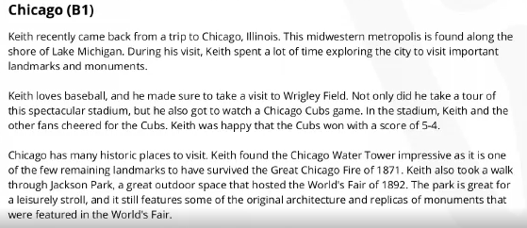

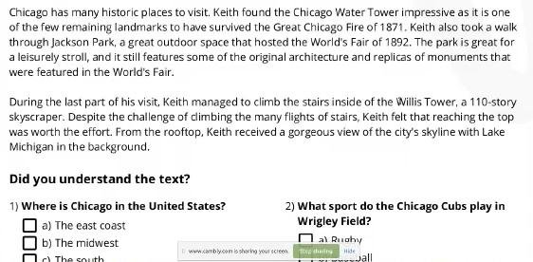

Exterior, interior

|  |  |  |
| --- | --- | --- |
| Metropolis  metropolis | /məˈtrɒpəlɪs/  Metro-po-lis | a large and densely populated urban area  a large and densely populated urban area |
| **Exterior,**  **interior** | /ɪkˈstɪəriə(r)/ | Out  In |
| Michigan | /ˈmɪʃɪɡən/ | a midwestern state in north central United States in the Great Lakes region |
| landmarks | /ˈlændˌmɑrk/ | a mark showing the boundary of a piece of land;  an event marking a unique or important historical change of course or one on which important developments depend |
| monuments | /ˈmɒnjumənt/ | an important site that is marked and preserved as public property  National monument  Historic monument |
| baseball | /ˈbeɪsbɔːl/ | 棒球 |
| Not only, but also |  |  |
| Stadium  Sta-dium  enter-train-ment | ˈsteɪdiəm/ | a large structure for open-air sports or entertainments /ˌentəˈteɪnmənt/ |
| Fans, cubs | A score of 5-4 |  |
| Survived | /səˈvaɪv/ | He survived the cancer against all odds. |
| **Leisurely** stroll  Lei-sure-ly stroll | /ˈleʒəli/ /strəʊl/ | Wonderful walk |
| Architecture and  replicas | /ˈɑːkɪtektʃə(r)/  /ˈreplɪkə/ | the profession of designing buildings .  copy that is not the original; something that has been copied |
| Skyscraper  Sky-scra-per | /ˈskaɪskreɪpə(r)/ | a very tall building in the city, such as the landmark  From the rooftop, he received a gorgeous view of the city’s skyline with Lake Michigan in the background. |

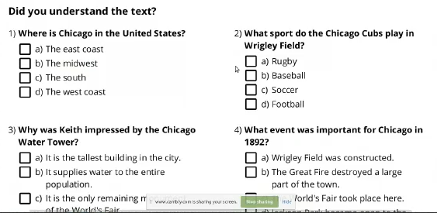

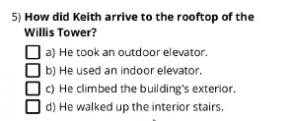

## 3 Article - Christmas

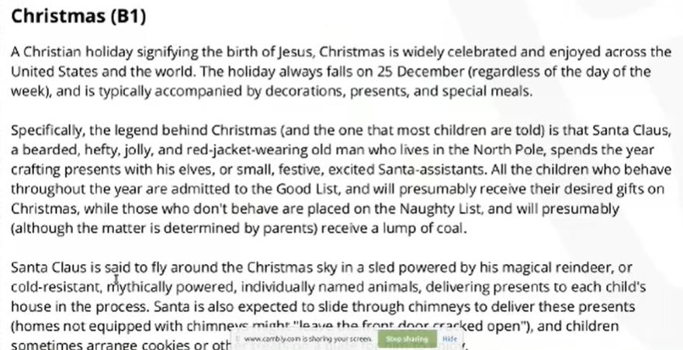 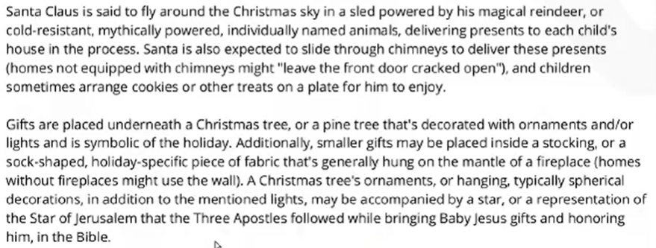

Exterior, interior

|  |  |  |
| --- | --- | --- |
|  |  |  |
| Exterior,  interior | /ɪkˈstɪəriə(r)/ | Out  In |
| Signifying  symbolic | /ˈsɪɡnɪfaɪɪŋ/ /sɪmˈbɒlɪk/ | [representation](javascript:;)  [emblematic](javascript:;) [indicative](javascript:;) |
| regardless | /rɪˈɡɑːdləs/ | [regardless of](javascript:;) 不顾 |
| Legend, hefty, jolly | /ˈledʒənd/ 传说  /ˈhefti/ strong  /ˈdʒɒli/ happy |  |
| presumably | prɪˈzjuːməbli/ | [probablypossiblymaybe](javascript:;) |
| A lump of coal | /lʌmp/ | Block coal |
| Magical reindeer | /ˈreɪndɪə(r) 驯鹿 |  |
| Mythically | i | 神话地 |
| chimney | /ˈtʃɪmni/ | a vertical flue that provides a path through which smoke from a fire is carried away through the wall or roof of a building |
| decorated | /ˈdekəreɪtɪd/ | provided with something intended to increase its beauty or distinction |
| Ornament  ornament | /ˈɔːnəmənt/ | something used to beautify |
| fabric | /ˈfæbrɪk/ | cotton fabric 棉布  cotton fabric |
| accompanied | /əˈkʌmp(ə)nid/ | [attended](javascript:;)  there were lone gentlemen and gentlemen accompanied by their wives |