<https://cloudarchives2.camblychina.com/630b74320b0ec1a2248dd58b/7755f6f4d74bc9800de92c8fd4a19902_cambly_630b74320b0ec1a2248dd58b_0.mp4?auth_key=1661706346-e529ea2226e211edbb913e3b6b56fd21-0-359e989c99e44d7e5bf7db3595f2cff8>

|  |  |  |  |
| --- | --- | --- | --- |
| Homemakerˈhəʊmmeɪkə(r)/ | | a wife who manages a household while her husband earns the family income | |
| Caretaker /ˈkeəteɪkə(r)/ | | a custodian who is hired to take care of something (property or a person) | |
| **dedication** ˌdedɪˈkeɪʃ(ə)n/ | | Loyal,complete and wholehearted fidelity | |
| Qualifications /kwɒlɪfɪˈkeɪʃ(ə)nz/ | Qua-li-fi-cations  Special skills or experience that help you do your job well | |
| Attainable /əˈteɪnəb(ə)l/ | Dual with, a-ttai-na-ble  Able to be accomplished or achieved | |
| Professional growth /prəˈfeʃənl/ | Getting better at your job and progressing in your career through learning new things | |
| Specialist /ˈspeʃəlɪst/ | A person who has deep knowledge of a particular job or field from university or company | |
| Generalist /ˈdʒenrəlɪst/ | A person who knows something about many jobs or fields | |

1. I am bit of both. The specialist I got from university are using programming languages. The generalist I studied by network is magical trick.
2. (qualification is the license that you need to pass the exam)The master degree is my most proud of qualification.
3. The biggest role model is mother, and the biggest professional model is my high school teacher.

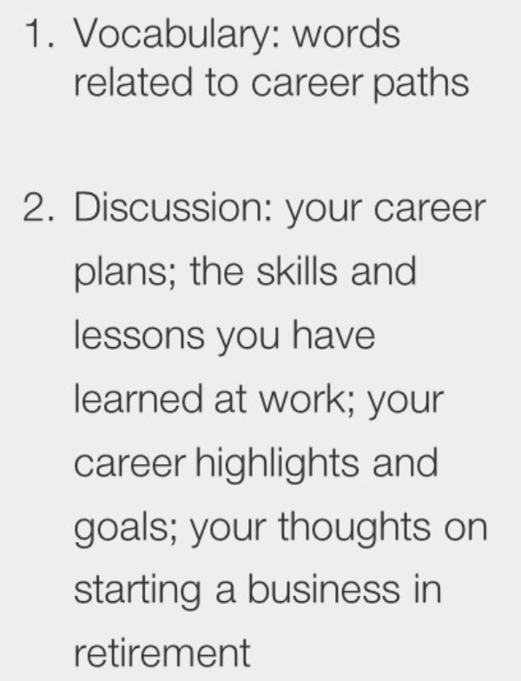

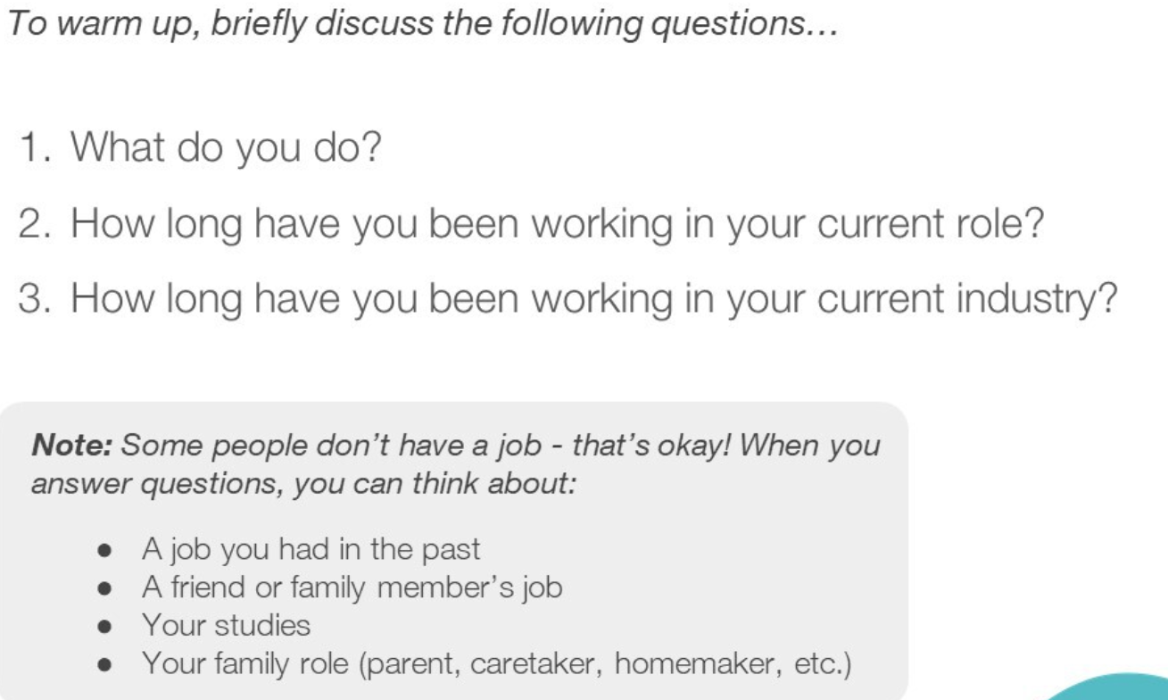

|  |  |
| --- | --- |
| Homemakerˈhəʊmmeɪkə(r)/ | a wife who manages a household while her husband earns the family income |
| Caretaker /ˈkeəteɪkə(r)/ | a custodian who is hired to take care of something (property or a person) |
| **dedication** ˌdedɪˈkeɪʃ(ə)n/ | Loyal,complete and wholehearted fidelity |

1. I am a student, my major is transport engineering at Southeast University.
2. I have been studied three years in this university.

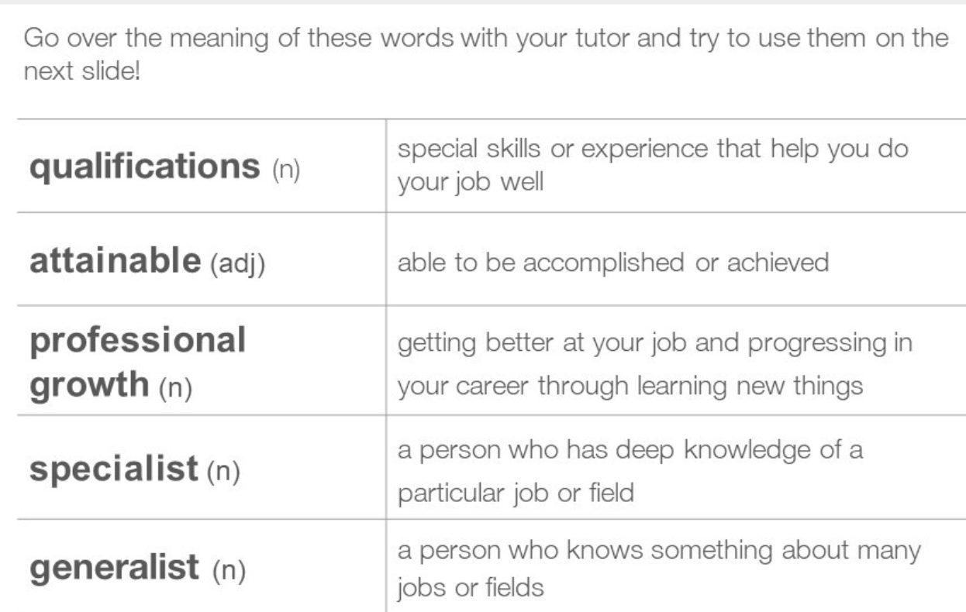

|  |  |
| --- | --- |
| Qualifications /kwɒlɪfɪˈkeɪʃ(ə)nz/ | Qua-li-fi-cations  Special skills or experience that help you do your job well |
| Attainable /əˈteɪnəb(ə)l/ | Dual with, a-ttai-na-ble  Able to be accomplished or achieved |
| Professional growth /prəˈfeʃənl/ | Getting better at your job and progressing in your career through learning new things |
| Specialist /ˈspeʃəlɪst/ | A person who has deep knowledge of a particular job or field from university or company |
| Generalist /ˈdʒenrəlɪst/ | A person who knows something about many jobs or fields |

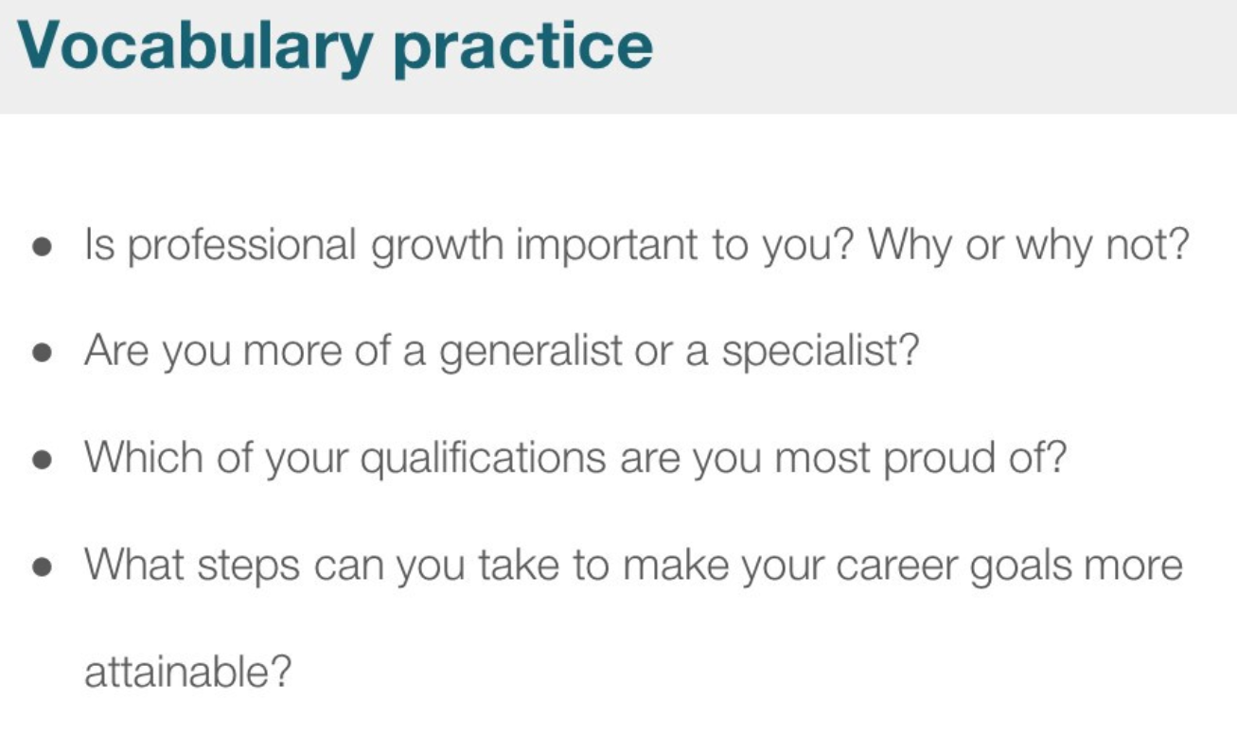

1. The professional growth important to me is the leader ability because I study it and have the ability to organize the team work.
2. I am bit of both. The specialist I got from university are using programming languages. The generalist I studied by network is magical trick.
3. (qualification is the license that you need to pass the exam)The master degree is my most proud of qualification.
4. Long plan, work hard, **dedication** and focus on aim.

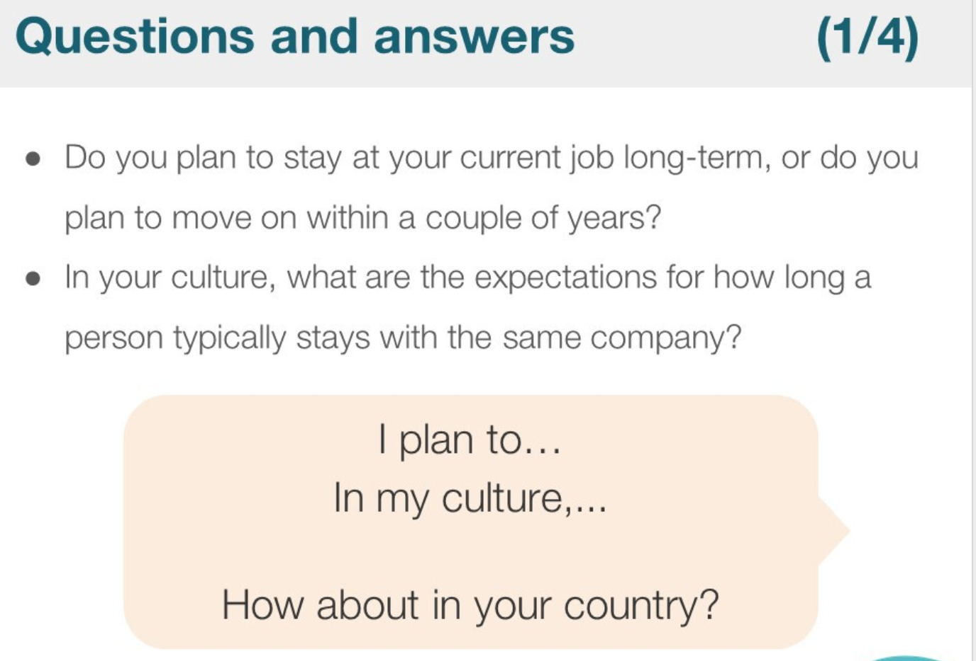

1. Yes, I plan to stay at my current job long-term. In the future, if I find a new interesting job I will plan to move on within a couple of years.
2. In my culture, people usually dedication themselves to the company until retired.

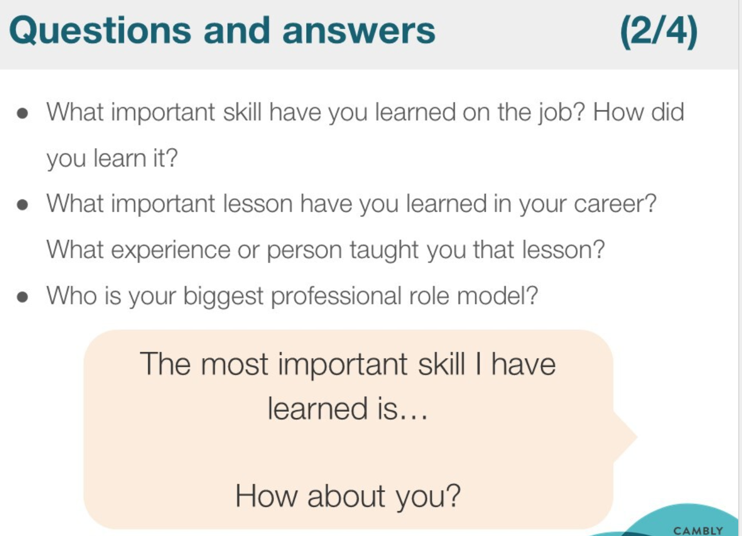

1. I got the important skill from university is leadership. I studied it from my tutor, when he organized students and teachers to together to do the program.
2. I think the important lesson I have learned in university is , if you want to take the opportunity, you need to do it positively.

For example, I remembered I got the chance even the conference out of date by my positively behaviour.

1. The biggest role model is mother, and the biggest professional model is my high school teacher.

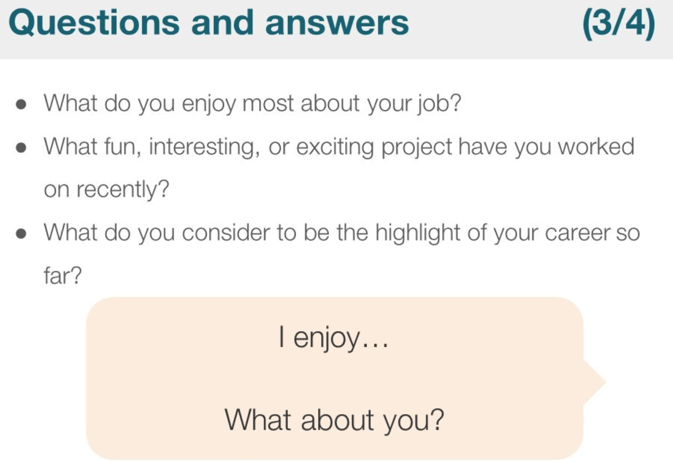

1. I enjoy most about my job is creating new thing that is interesting.
2. I find the cheap and effective way to study oral English from Carmbly websity.
3. The worth work that can benefit to society.

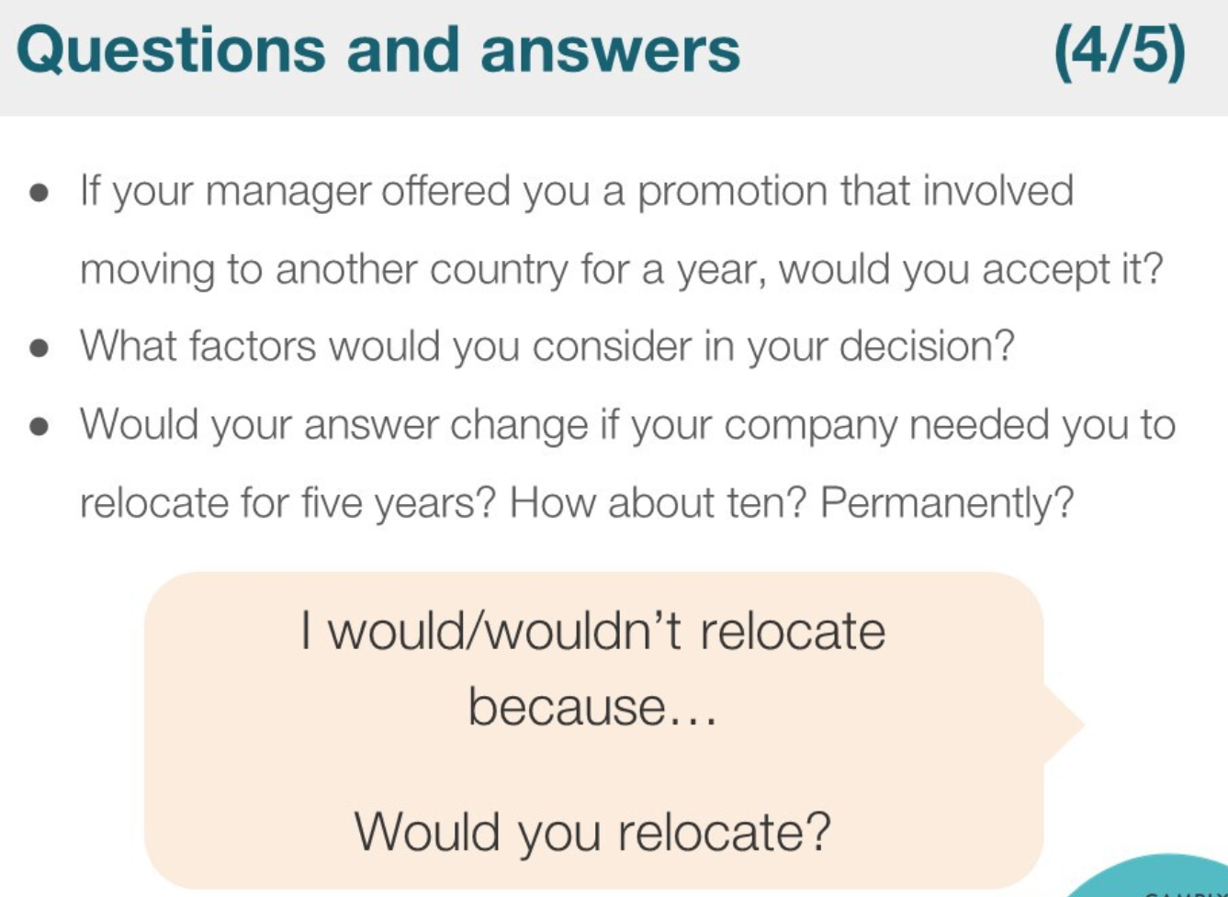

1. Yes. I will accept it. Because I like to challenge the new things, such new cultures, it can let me study many new knowledge.
2. I think the most factor is feasibility that I have the ability to do it in the future.
3. Relocate 调动

No, I don’t like relocate. I have friends in the original region.