## Prof. Gentile jenteely , Sapienza

## 20220725-Suky told me about Italy

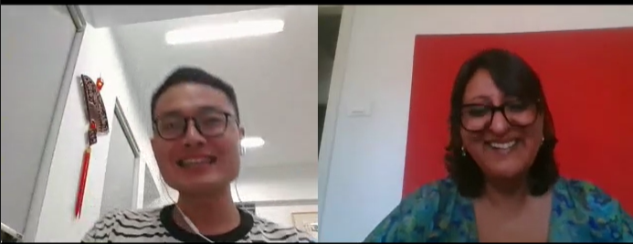

Italian life style is slowly and relax.

1. Italian are not polite. If you say their word wrong, Italian will directly to say it “you are wrong, you donot say that, ”. May be you feel them rude. However, it it culture.

frustrated, kindness, gentile, shoot

(2)Italian has the non-congestion transportation, their GPS map / google map is bad (guidance the wrong way) for guidance travelers to reach the right destination. You will get lost. She used the  [Airbnb (online car-hailing) to send her from origin to destination.](https://www.airbnb.cn/)

(3)The Italian has many local languages such as Chinese.

(4)Italian food is not spicy, onion, garlic, ginger like Asian. Italian food is simple three ingredients (材料). taste simply (ingredients)

only has several kinds: such as pizza, pasta

1. History, [architecture](javascript:;)/beauty building, culture
2. Europe life is huge different compared with Asian.
3. Rome has many local language
4. Rome has the multi-culture environment, you will meet different cultural people
5. She lived every city has Chinese shop /supermaket , doufu, noodles. However, Chinese restaurant is not suit for Italian, for Asian.

**Advise me**

1. When you speak to your tutor, you should speak more slowly and clearly. Tell the Italian professor, it is important opportunity for me, please be gentile with me or please excuse me. I am a little bit nervous you cannot say that.

If my candidate say that “I am nervous”, it was my job to make them feel comfortable, then I would say it’s okay. There’s nothing to be. Donot worry.

You have two weeks for preparing the interview. I can teach you about grammar, conversation skill, you need practice .

Colleagues

1. Mandarin 普通话， Cantonese 广东话
2. Italian professor

My pronounce has heavy accent. /ˈæksent/

She can understand my sentences everythin I am saying

## 20220731-handsome

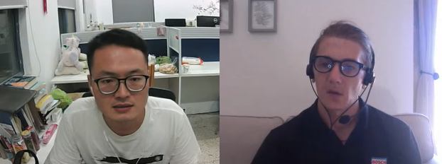

I like adventure yeah.

I like freedom.

**1# In order to understand to say**

**对于非母语的英语者，我说的太快了，导致他们不能理解。（建议我对非母语的英语者，说慢点，把字咬清楚）**

I understand what you're saying Kai, but I'm used to working with non Native English speakers. Because I don't live in england…

**You're very fast, I understood but I think when speaking with others you need to slow down.**

They just do one word answers, you expand well, create sentences and ask questions. It's brilliant.

**2、Know the lift of Italian**

Do you speak any Italian?

This is bad, my girlfriend and I have been together for 4 years... And I haven't learned any Italian.

She's a translator, so she has 5 languages, her English is pretty good.

So next week I go to Italy, to find a house with her. So then I need to start learning because I might live there...

Italian is only useful in Italy, it's not like Spanish or French where other's speak it.

**3、The Future Plan**

I like to ask questions that people don't ask you, make you think, create, be thoughtful.

Let's imagine you are 50 years old.

So when you're 50, tell me 3 things you'd have liked to have done, seen, visited or achieved? It can be anything it's your answer..

Hug a koala in Australia? Go to the moon?

Happiness with family.

Strong body!

**4 sports**

Who's your team in the NBA?

I like CP3, Phoenix Suns.

Devin Booker, Ayton.

He was at Houston, with Harden. Never won a championship though,

Do you have a position in basketball?

Position- means where you play on the court.

SG, PG, C, SF, PF- 5 positions.

## 20220801-02-Daniel

Daniel, Location: Rome

The current situation in Italian

1. Ordinary people only speak Italian, not English, because their English is very poor.
2. If you stay in Italy, you need to study simple Italian in order to live (buy food, take cars, road signals)

**Issues:**

1. Nervous
2. Speak fastly, make the listener feel difficult to understand, and even become boring.
3. Speak discontinue, staccato /stəˈkɑːtoʊ/, and pause for too long, which makes it difficult for listener to follow and understand.
4. Some issues in sentence

**Suggestion:**

1. Relax.
2. **Speak slowly and clearly**, which can let the listener understand, at the same time,

you have some time to think/ **organize the logic of the next sentence**.

(3) Speak continuously

(4) **Simulation of the interview**, let me suit the feeling of the applicant.

(5) You need **directly and simple answer,** **let the listen receive the worth information**.

My favorite sport is basketball because I paly it can strength my body, and relax the pressure, operate the team work.

## 20220803-Daniel

Sport topics (the endurance and explosive of your sport strength)

Patience, endurance, stamina

Tram 电车

Q: Do you think your country people do enough exercise? /ˈeksəsaɪz/

A: I do not think our country people do enough exercise because they work long hours or study long hours.

Q: Do you think children should play some sports after school?

A: I think children should play some sports because it keeps children strong and healthy (energetic)

Q: Do you like any sports? Why?

A: I like playing basketball because I like the feeling (the best experience is ) when I scored the winning basket.

Q: Do you think children should do the competitional sports at the early age?

A: Yes, I think children should do that because the competitional sports make them study the team work.

Q: Do you think sports as a career or as a fun?

A:I think less people can become the professional sporter.

Most people do sports keep them strong and health.

1. I will be nervous when I speak the new/unknown sentences.

Daniel says the fear is the killer. I need to study the relax.

1. The dog is the loyal friend of people, it gives his master the unconditional love.
2. I played basketball one hour ago. My throat is dry (dehydration, /ˌdiːhaɪˈdreɪʃ(ə)n/, 脱水), I need to drink much water.
3. Image /ˈɪmɪdʒ/ imagine /ɪˈmædʒɪn/想象
4. I have a hundred percent sure you can do it much better.
5. All mistakes are good for study a new thing. That’s part of learning. If you are not making mistakes, you are not learning. In other words, negative feedback.

## ---20220805-Asa: discuss the city transportation



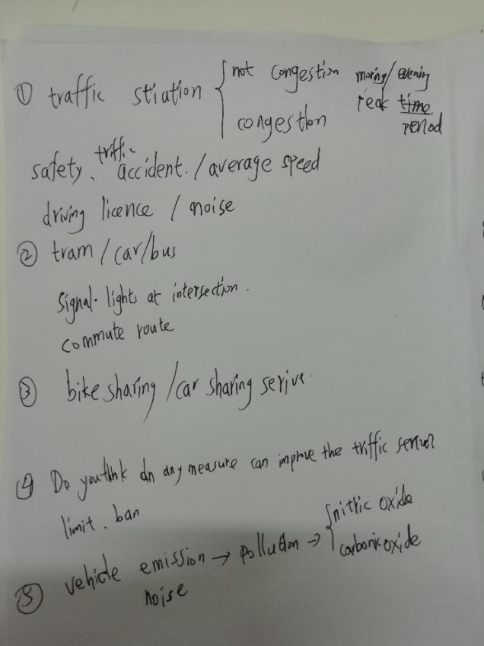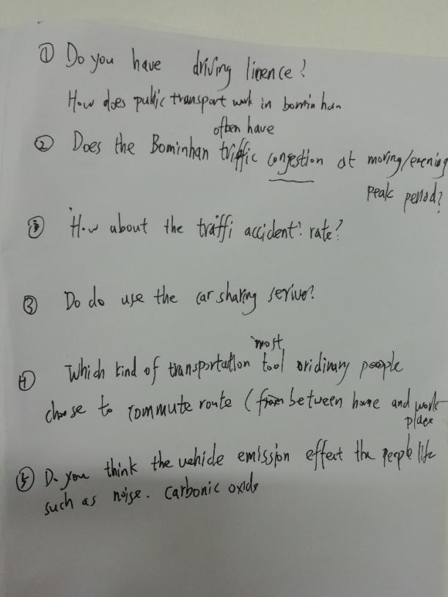

Kai: Do you have a driving license?

Asa: I have a provisional(temporary) license.

You can drive with a licensed driver.

Kai: How does the public transportation in your city?

Is it often happen congestion or traffic accidents?

Asa: We have tramp, train, bus, and personal car.

Our traffic does not often happen congestion.

Kai: How many people live in your city?

Asa: Our population has 1.1 million. Birmingham is the second city in United Kingdom (Britain)

Kai: I think your city population is smaller than the city in a developing country.

Asa: Even in peak time (morning or evening), our transportation does not happen congestion.

~~Kai: Which kind of transportation tool is people a most choice for commute route between home place and work place?~~

Kai: What types of transportation are most popular for commuters to travel on?

Asa: I think the first is train, which is cheap and fast. The second is bus. Then is personal car.

The tramp is new transportation tool, fewer people choice it to travel.

Asa: **How about Nanjing?**

Kai: I think the first choice is the subway, which is **fast** and **on time**, comfortable. Then is the car-sharing service, third is bus.

Asa: The **car-sharing service** is expensive.

Kai: Yes. It is convenient and fast, you can choose where to get on and where to get off, so it is expensive. I choose the car-sharing service if I am hurry and the distance within 5 kilometers.

If the distance is over than 5 kilometers, I will choose the subway. I seldom take the bus.

Asa: How about bike-sharing service?

Kai: It is convenient. When the distance within 2 kilometers, I choose it. For example, I use the bike-sharing serve from my college door to the nearly subway station.

Kai: Do you buy the monthly tickets?

Asa: monthly pass. You take the train more times, you choose the month tickets cheaper.

Asa: Do you think public transportation is important to **environment**?

Kai: Yes. I think to choose the public transportation, such as ride a bike, it is **friendly-environment** way. In our country, the government advices people to use the **electric car** rather than the car using oil or gas.

Asa: Is there a high percent/ proportion of electric vehicles?

Kai: Small. I think the percent/percentage of electric vehicles is smaller than vehicles using gas or oil. Because, nowadays, the electric vehicle has the bigger/higher travel cost than gas or oil car. However, I think, in the future, with the technology developing, the electric vehicle will be more cheaper.

Kai: I think to choose public transportation can decrease emission, such as noise, CO, and NO.

Carbonic oxide, nitric oxide.

## 20220811- Danile- Speak slowly and clearly, separate each word

Suggestion:

Speak slowly and clearly, let listener hear every word.

I have some issues about the pronunciation of fixed letter combinations of word,

so I need to study the method of phonics of English. 英语自然拼读

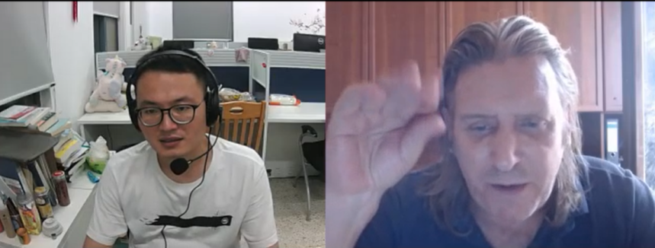

Campus /ˈkæmpəs/ college

Residential /ˌrezɪˈdenʃ(ə)l/ living apartment

Authority /ɔːˈθɒrəti/ government

App /æp/ sofeware

Although /ɔːlˈðəʊ/

Doubt /daʊt/

Announced /əˈnaʊnst/ 宣布

Awful /ˈɔːf(ə)l/ bad

Route /ruːt/ path

## 20220815- Alexander- Getting up early regularly

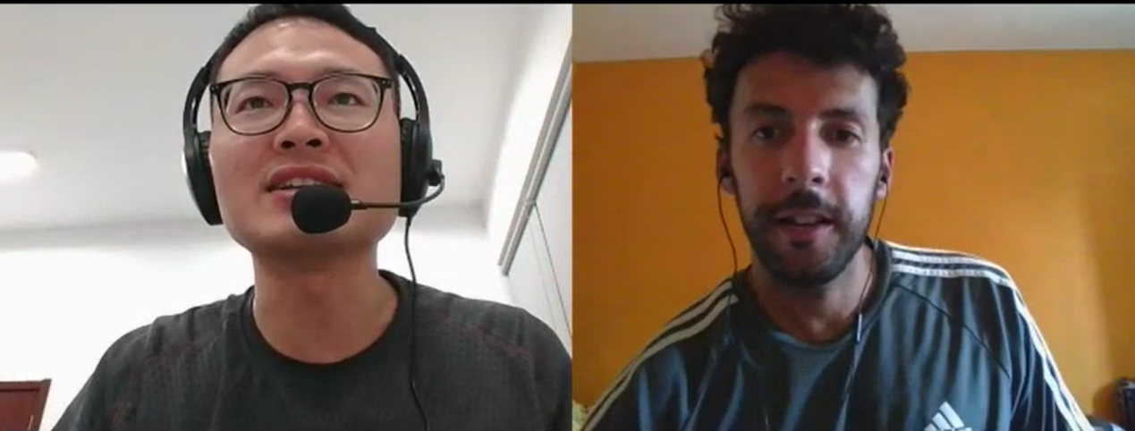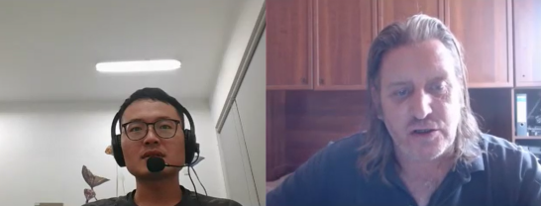

If I won the lottery, I would donate all money to people in need.

If My friend asks me to go dinner this Friday, I will cancel the lesson book at Carmbly website.

|  |  |
| --- | --- |
| Getting up early regularly |  |
| productive |  |
| Foodie /ˈfuːdi/ | a person devoted to refined sensuous enjoyment (especially good food and drink) |
| cuisine /kwɪˈziːn/ |  |
| cancel /ˈkæns(ə)l/ |  |
| would have joined us | We will go hiking |
| She would not  wouldn’t |  |
| wake up early |  |
| early bird  Night owl aʊl |  |
| Asks /ɑːsks/ |  |

### Daniel-Beauty is in the eye of the beholder

|  |  |  |
| --- | --- | --- |
| We will  We’ll | Used d  Looked t  Wanted id | get-together  party |
| These theez | Leisure /ˈleʒə(r)/ |  |
| Between  Be tween | Isolated /ˈaɪsəleɪtɪd/ |  |

1 The activity I like doing outside of work is playing basketball because it can relax my pressure.

1. The hobby I like to do with other people is playing basketball because it can relax our stress and enrich our relationship.
2. Most of my friends have the same interests and hobbies as me, such as play basketball because we like physical activities.

1 I believe the online gaming is a social activity because we can chat with other players.

2 In my opinion, I think the social activities are popular among adults because they can escape from the daily stress.

(1) In my opinion, I think old people and young people not enjoy the same types of social activities. Because the young like the physical activities, however, the old like the relaxing activities.

(2) In my opinion, the social activities are important because it can escape people from daily stress, most time, it can enrich the friendship with friends.

1. In my opinion, I think the modern lifestyles not give people enough leisure time to spend with others. Because work hours are too long.
2. I think people in our country, they are interested in social activities because it can escape them from daily stress. / relax their work pressure.

In my opinion, I support the above opinion that computers will make people more isolated and decrease their social skills. Because the surfing the Internet increase spaces between people and people. In addition, people have less opportunity to face to face to do something, that can decrease their social skills.

## 20220818-

|  |  |
| --- | --- |
| vs  versus | ˈvɜːsəs  compare |
| wh- question words | Why, what, where  Which, when |
| 123@gmail**.**com | dot |
| on the 6th of march 1997 |  |
| compass  campus | /ˈkʌmpəs/  point south  /ˈkæmpəs/ |

## -20220820-English corner

|  |  |  |  |  |
| --- | --- | --- | --- | --- |
| English Reading8.20 | | | | |
| Content | Key Words | phonetic symbol | synonym | pronounce |
| Page 227-228 | painted median | /ˈpeɪntɪd/ |  | pain-ted |
|  | raised median | /reɪzd/ | enhance | rai-sed |
|  | signalized | /ˈsɪɡnəˌlaɪz/ |  | sig-na-liz-d |
|  | elements | /ˈelɪmənts/ | basic | e-le-ments |
|  | G = green | G is equals green |  |  |
|  | complete | /kəmˈpliːt/ | whole | com-ple-te |
|  | the amount of time | /əˈmaʊnt/ | sum |  |
|  | illumination | /,lu:mi'neiʃən/ | light | i-llu-mi-nation |
|  | alerts | /əˈlɜːts/ | warning |  |
|  | clearance | /ˈklɪərəns/ | removel | clea-ren-ce |
|  | allow | /əˈlaʊ/ | let, afford |  |
|  | arrow | /ˈærəʊ/ | direction |  |
|  | entered | /ˈentəd/ |  |  |
|  | steadily | /ˈstedəli/ | gradually | stea-di-ly |
|  | phase | /feɪz/ | stage |  |
|  | simultaneously | /ˌsɪm(ə)lˈteɪniəsli/ | in the same time , parallel | si-mul-ta-neou-sly |
|  | frequently | /ˈfriːkwəntli/ | often |  |
|  | definition | /ˌdefɪˈnɪʃn/ | an explanation of the meaning of a word or phrase |  |
|  | categorizing | /ˈkætəɡəraɪzɪŋ/ | classification, ranging, assorting | cate-go-ri-zing |
|  | permitted | /pəˈmɪtɪd | allowed |  |
|  | opposing | /əˈpəʊzɪŋ/ | anti, relative, challenging |  |
|  | geometric | /ˌdʒiːəˈmetrɪk/ | Geometric or geometrical patterns or shapes consist of regular shapes or lines |  |

## --20220821- Daniel-Question: Personal information and family

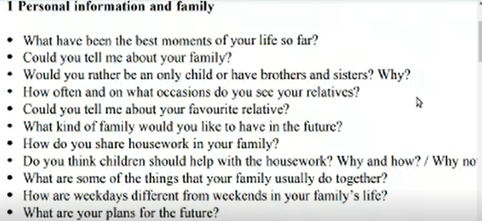

Answer:

1. What have been the best moments of your life so far?

The best moments of my life is when my family members go to together.

1. My family has four members, grandfather, dad, ma, and I.
2. I would rather have brothers or sisters because it let me not alone
3. I see my relatives 2 times a year on special festivals.
4. My favorite relative is grandfather because he gives me more love when I was a child.
5. I hope to have a warm-heart wife, 2 or 3 children in the future.
6. Yes, I help my mother to cook and clean the house.
7. Yes, I think children should help with the housework because the family give them love and material, they should do something for family, they will study duty.
8. In our family, we usually have lunch together.
9. We work on weekday, and we relax on weekends.
10. In the future, I hope to be a teacher in the university. /campus

Question: Man and society

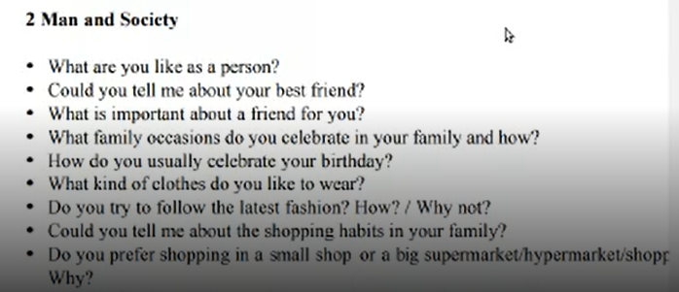

Answer:

1. I am an honest, reliable and hard working person.
2. My best friend is Weili, he is funny, have more social skills than me. We have more than 25 years friendship.
3. I think the important about a friend is trust and reliable.
4. The occasions (Spring festival) we celebrate in my family
5. I will eat the delicious food to celebrate my birthday.
6. The kind of clothes I like is sports style.
7. No, I like the traditional style.
8. my family is diligent and thrifty because we only buy something that it is necessary.
9. I prefer shopping in a s small shop because it is so near to my house or office.

## 20220827- Daniel-life words

|  |  |  |
| --- | --- | --- |
|  |  |  |
| Evergrande | HengDa company |  |
| Managed | Manag d | The e silent |
| The, a, an |  |  |
| articles | /ˈɑːtɪk(ə)l/ | nonfictional prose forming an independent part of a publication |
| Christmas | Cris mas | period extending from Dec. 24 to Jan. 6  Christmas is an annual festival commemorating [the birth](https://en.wikipedia.org/wiki/Nativity_of_Jesus" \o "Nativity of Jesus) of [Jesus Christ](https://en.wikipedia.org/wiki/Jesus_Christ" \o "Jesus Christ), observed primarily on December 25 as a religious and cultural celebration among billions of people [around the world](https://en.wikipedia.org/wiki/Observance_of_Christmas_by_country" \o "Observance of Christmas by country). |
| mass |  | a large number or amount or extent  民众的，大量的 |
| atheist | /ˈeɪθiɪst/ | someone who denies the existence of god |
| Ordinal number  25th | Ordinal number | On 25th december |
|  |  |  |

|  |  |  |
| --- | --- | --- |
| Metropolis  metropolis | /məˈtrɒpəlɪs/  Metro-po-lis | a large and densely populated urban area  a large and densely populated urban area |
| **Exterior,**  **interior** | /ɪkˈstɪəriə(r)/ | Out  In |
| Michigan | /ˈmɪʃɪɡən/ | a midwestern state in north central United States in the Great Lakes region |
| landmarks | /ˈlændˌmɑrk/ | a mark showing the boundary of a piece of land;  an event marking a unique or important historical change of course or one on which important developments depend |
| monuments | /ˈmɒnjumənt/ | an important site that is marked and preserved as public property  National monument  Historic monument |
| baseball | /ˈbeɪsbɔːl/ | 棒球 |
| Not only, but also |  |  |
| Stadium  Sta-dium  enter-train-ment | ˈsteɪdiəm/ | a large structure for open-air sports or entertainments /ˌentəˈteɪnmənt/ |
| Fans, cubs | A score of 5-4 |  |
| Survived | /səˈvaɪv/ | He survived the cancer against all odds. |
| **Leisurely** stroll  Lei-sure-ly stroll | /ˈleʒəli/ /strəʊl/ | Wonderful walk |
| Architecture and  replicas | /ˈɑːkɪtektʃə(r)/  /ˈreplɪkə/ | the profession of designing buildings .  copy that is not the original; something that has been copied |
| Skyscraper  Sky-scra-per | /ˈskaɪskreɪpə(r)/ | a very tall building in the city, such as the landmark  From the rooftop, he received a gorgeous view of the city’s skyline with Lake Michigan in the background. |

|  |  |  |
| --- | --- | --- |
|  |  |  |
| Exterior,  interior | /ɪkˈstɪəriə(r)/ | Out  In |
| Signifying  symbolic | /ˈsɪɡnɪfaɪɪŋ/ /sɪmˈbɒlɪk/ | [representation](javascript:;)  [emblematic](javascript:;) [indicative](javascript:;) |
| regardless | /rɪˈɡɑːdləs/ | [regardless of](javascript:;) 不顾 |
| Legend, hefty, jolly | /ˈledʒənd/ 传说  /ˈhefti/ strong  /ˈdʒɒli/ happy |  |
| presumably | prɪˈzjuːməbli/ | [probablypossiblymaybe](javascript:;) |
| A lump of coal | /lʌmp/ | Block coal |
| Magical reindeer | /ˈreɪndɪə(r) 驯鹿 |  |
| Mythically | i | 神话地 |
| chimney | /ˈtʃɪmni/ | a vertical flue that provides a path through which smoke from a fire is carried away through the wall or roof of a building |
| decorated | /ˈdekəreɪtɪd/ | provided with something intended to increase its beauty or distinction |
| Ornament  ornament | /ˈɔːnəmənt/ | something used to beautify |
| fabric | /ˈfæbrɪk/ | cotton fabric 棉布  cotton fabric |
| accompanied | /əˈkʌmp(ə)nid/ | [attended](javascript:;)  there were lone gentlemen and gentlemen accompanied by their wives |

## 20220827- -transport words-English Corner

|  |  |  |  |  |
| --- | --- | --- | --- | --- |
| English Reading8.27 Page 228-2229 | | | | |
|  | Key Words | phonetic symbol | synonym | pronounce |
|  | movement | /ˈmuːvmənt/ |  |  |
|  | conflicting | /kənˈflɪktɪŋ/ | in disagreement |  |
|  | circle / cycle | /ˈsɜːk(ə)l/ /ˈsaɪk(ə)l/ |  |  |
|  | adjacent | /əˈdʒeɪs(ə)nt/ | nearby, neighbor |  |
|  | characteristics | /ˌkærəktəˈrɪstɪks/ | role | cha-ra-cter-ris-tics |
|  | implemented | /ˈɪmplɪmentɪd/ | applied, performed | im-ple-mented |
|  | analyze | /ˈænəlaɪz/ | break down |  |
|  | cabinet | /ˈkæbɪnət/ | box, ambry | ca-bi-net |
|  | sophisticated | /səˈfɪstɪkeɪtɪd/ | complicated, experienced | so-phi-s-ticated |
|  | flexibility | /ˌfleksəˈbɪləti/ | elasticity | fle-xi-bility |
|  | semi-actuated | /ˈsemi ˈæktʃuːeɪtɪd/ |  | semi actu-a-ted |
|  | detection | /dɪˈtekʃ(ə)n/ | exploration, discovery, find |  |
|  | necessary | /ˈnesəsəri/ | essential, requirement | ne-ce-ssa-ry |
|  | pavement-embedded | /ˈpeɪvmənt ɪmˈbedɪd/ | pedestrian |  |
|  | inductance | /ɪnˈdʌktəns/ | induction coefficient, self-induction | in-duc-tance |
|  | minor, major | /ˈmaɪnə(r)/ /ˈmeɪdʒə(r)/ | secondary, primary |  |
|  | allocated | ˈæləkeɪtɪd | assigned | a-llo-ca-ted |
|  | substantial variation | /səbˈstænʃ(ə)l/ /ˌveəriˈeɪʃn/ | huge change | sub-stan-tial va-ri-a-tion |

## --20220828- -discuss Career- Question & answer

|  |  |  |  |
| --- | --- | --- | --- |
| Homemakerˈhəʊmmeɪkə(r)/ | | a wife who manages a household while her husband earns the family income | |
| Caretaker /ˈkeəteɪkə(r)/ | | a custodian who is hired to take care of something (property or a person) | |
| dedication ˌdedɪˈkeɪʃ(ə)n/ | | Loyal,complete and wholehearted fidelity | |
| Qualifications /kwɒlɪfɪˈkeɪʃ(ə)nz/ | Qua-li-fi-cations  Special skills or experience that help you do your job well | |
| Attainable /əˈteɪnəb(ə)l/ | Dual with, a-ttai-na-ble  Able to be accomplished or achieved | |
| Professional growth /prəˈfeʃənl/ | Getting better at your job and progressing in your career through learning new things | |
| Specialist /ˈspeʃəlɪst/ | A person who has deep knowledge of a particular job or field from university or company | |
| Generalist /ˈdʒenrəlɪst/ | A person who knows something about many jobs or fields | |

1. I am bit of both. The specialist I got from university are using programming languages. The generalist I studied by network is magical trick.
2. (qualification is the license that you need to pass the exam)The master degree is my most proud of qualification.
3. The biggest role model is mother, and the biggest professional model is my high school teacher.
4. I am a student, my major is transport engineering at Southeast University.
5. I have been studied three years in this university.
6. The professional growth important to me is the leader ability because I study it and have the ability to organize the student team work.
7. I am bit of both. The specialist I got from university are using programming languages. The generalist I studied by network is magical trick.
8. (qualification is the license that you need to pass the exam)The master degree is my most proud of qualification.
9. Long plan, work hard, **dedication** and focus on aim.
10. Yes, I plan to stay at my current job long-term. In the future, if I find a new interesting job I will plan to move on within a couple of years.
11. In my culture, people usually dedication themselves to the company until retired.
12. I got the important skill from university is leadership. I studied it from my tutor, when he organized students and teachers to together to do the program.
13. I think the important lesson I have learned in university is , **if you want to take the opportunity, you need to do it positively.**

For example, I remembered I got the chance even the conference out of date by my positively behaviour.

1. The biggest role model is mother, and the biggest professional model is my high school teacher.
2. I enjoy most about my job is creating new thing that is interesting.
3. I find the cheap and effective way to study oral English from Carmbly websity.
4. The worth work that can benefit to society.
5. Yes. I will accept it. Because I like to challenge the new things, such new cultures, it can let me study many new knowledge.
6. I think the most factor is feasibility that I have the ability to do it in the future.
7. Relocate 调动

No, I don’t like relocate. I have friends in the original region.

## 20220901- Living your Best life

The **fossil fuel** can generate electricity continuously.

1. For general, I think it means that people have a happy life and a great career.
2. For me, I think the living my best life includes a happy life, a steady job, a good health, and good hobbies.

You should try living the best life possible.

I just had the most delicious meal ever in my life.

|  |  |  |
| --- | --- | --- |
| postmodifier  fire  fair | /ˌpəʊstˈmɒdɪfaɪə(r)/  /ˈfaɪə(r)/  /feə(r)/ equally, balance |  |
| hospice | /ˈhɒspɪs/ | a program of medical and emotional care for the terminally ill  The house take people going to die.  They will rethink what they have done in their life. |
| Elon Musk | /mʌsk/ | spaceX  Tesla /ˈteslə/ |
| Nikola Tesla |  | Famous inventor ɪnˈventə(r)/  Electrical engineer  Wireless lighting  Alternating current 交流电 |
| Edison | /ˈedis(ə)n/ |  |
| Charles Darwin | * /tʃɑːlz/ /ˈdɑːwɪn/ | Biological  Theory of biological evolution  《On the origin of Species》 |
| free will |  |  |

|  |  |  |
| --- | --- | --- |
| coolest | /ˈkuːlɪst/ | Good |
| fascinating | /ˈfæsɪneɪtɪŋ/ | Amazing  A fascinating story |
| fantasy | /ˈfæntəsi/ | imagination unrestricted by reality;  visional  Fancy  Illusion  imagine |
| imaginable | ɪˈmædʒɪnəbl/ | Possible  feasible |
| vacation | veɪˈkeɪʃn | holiday |
| meaningful |  | Worth /wɜːθ/ |
| **invention** | ɪnˈvenʃn/ | the creation of something in the mind |
| exercise my mind | /ˈeksəsaɪz/ |  |
| centimeters | sɛntɪˌmiːtəz/ |  |
| **daily routine** | /ˈdeɪli ruːˈtiːn/ | Daily routine 日常工作 |
| attire | /əˈtaɪə(r)/ | formal attire / cloth  clothing of a distinctive style or for a particular occasion 着装 |

## 20220903-transport words-English Corner

|  |  |  |  |  |
| --- | --- | --- | --- | --- |
| English Reading0903 Page 229-230 | | | | |
|  | Key Words | phonetic symbol | synonym | pronounce |
|  | movement | /ˈmuːvmənt/ |  |  |
|  | actuated control | /ˈæktʃuːeɪtɪd/ /kənˈtrəʊl/ |  | actu-a-ted con-trol |
|  | pretimed | /pri taɪm/ |  |  |
|  | expense | /ɪkˈspens/ | rich |  |
|  | responsive | /rɪˈspɒnsɪv/ | answering, reaction |  |
|  | expected value | /ɪkˈspektɪd/ /ˈvæljuː/ | prospective, | expected value |
|  | demands | /dɪˈmɑːndz/ | meet one's demands | Origin-destination demand |
|  | significantly | /sɪɡˈnɪfɪkəntli/ | maningfully, expressively | sig-ni-fi-can-tly |
|  | chapter | /ˈtʃæptə(r)/ | the 6th chapter of the 4th volume |  |
|  | signalized | /ˈsɪɡnəˌlaɪz d/ |  | sig-na-lized |
|  | utilize | /ˈjuːtəlaɪz/ | use, apply, implement | u-ti-li-ze |
|  | motorcycle | /ˈməʊtə saɪk(ə)l |  |  |
|  | allows | /əˈlaʊz/ | permission |  |
|  | lowers | /'ləuə/ |  | lower level/price |
|  | detection technology | /dɪˈtekʃ(ə)n/ | find, deicovery, exploration |  |
|  | inductance loop detector | /ɪnˈdʌktəns/ /luːp/ | self-induction, induction coil |  |
|  | decades | /ˈdekeɪdz/ | ten years | over the past decade |
|  | embedded software | /ɪmˈbedɪd/ |  |  |
|  | electrical current | /ɪˈlektrɪk(ə)l/ /ˈkʌrənt/ | electrical flow | 电流 |
|  | monitored control system | /ˈmɒnɪtəd/ | guided, coached |  |
|  | altered | /ˈɔːltəd/ | change |  |
|  | sensitivity analysis | /ˌsensəˈtɪvəti/ | detection sensitivity | sen-si-ti-vi-ty |
|  | tuned | /tjuːnd/ | adjust |  |
|  | prohibitively expensive | /prəˈhɪbətɪvli/ | very rich | pro-hi-bi-tive-ly |
|  | vedio imaging processing | /ˈɪmɪdʒɪŋ/ /ˈprəʊsesɪŋ/ |  |  |
|  | components | /kəmˈpəʊnənts/ | parts and components | an abstract part of something |
|  | video digitization | /ˌdɪdʒɪtaɪˈzeɪʃn/ | numeralization, quantization | di-gi-ti-za-tion |
|  | virtual detectors | /ˈvɜːtʃuəl/ /dɪˈtektər/ | dummy, pseudo | virtual machine |
|  | processing unit | /ˈjuːnɪt/ | per unit, control unit |  |
|  | digital format | /ˈdɪdʒɪt(ə)l/ /ˈfɔːmæt/ | data format, standard format |  |
|  | determine | /dɪˈtɜːmɪn/ | condition, conclude |  |
|  | additional measures | /əˈdɪʃən(ə)l/ /ˈmeʒəz/ |  |  |
|  | control strategies | /ˈstrætədʒiz/ | response strategies | instructional strategies |
|  | responsiveness | /rɪˈspɒnsɪvnəs/ | corporate social responsiveness | re-spon-sive-ness |

## --20220905- Preparing Interview

https://www.youtube.com/results?search_query=transport+academic+interview+Ph.D.

https://www.youtube.com/watch?v=yZXGU0D0YQg&list=PLIfNzIyhq0S0KbLgkPSrN8RoXGrTLtYgp

|  |  |  |
| --- | --- | --- |
| Asia  Europe  Italy | /ˈeɪʒə/  /ˈjʊərəp/  /ˈɪtəli/ |  |
| Show / demonstrate  Confidence / believe  ability | /ˈdemənstreɪt/  /ˈkɒnfɪdəns/ |  |
| Express myself |  |  |
| recommend | /ˌrekəˈmend/ | Suggestion / advise |
| recruitment department | /rɪˈkruːtmənt/ | HR (human resources) |
| reputation  credit | /ˌrepjuˈteɪʃ(ə)n/  /ˈkredɪt/ | good reputation  the state of being held in high esteem and honor |
| undergraduate  Postgraduate  Ph.D. candidate /student | /ˌʌndəˈɡrædʒuət/  /ˌpəʊstˈɡrædʒuət/  /ˈkændɪdət/ |  |
| Supervisor relationship  tutor | /ˈsuːpəvaɪzə(r)/ /ˈtjuːtə(r)/ |  |
| embarrassed  awkward | /ɪmˈbærəst/  /ˈɔːkwəd/ | Feel embarrassed  feeling or caused to feel uneasy/ uncomfortable and self-conscious |
| promoting | /prəˈməʊtɪŋ/ | Promote cooperation  contribute to the progress or growth of |
| passion  enthusiasm | /ˈpæʃ(ə)n/  /ɪnˈθjuːziæzəm/ | strong feeling or emotion  a feeling of excitement  Passion for / enthusiasm for |
| Contribute this research in our field |  |  |

Questions

1. Why do you want to visit my research group?

You are the famous expert in our field, I know some of your work. I hope to cooperate in your group to do some interesting and worth work.

1. What is your long term career?

To be a expert in our field, and design the efficient algorithms to deal with traffic problems.

1. Why did you choose Italy?
2. Why should we offer this visit opportunity to you?

I have confident to do some interesting work with you.

I have published several papers, I can use C++, python, Java code programming language. In addition, I can use some mathematical optimal methods, such gradient projection, ADMM, benders decomposition.

1. What are your advantage / disadvantage? Strengths or weaknesses?
2. What are your training and development needs?

What are you need me to do?

I hope to cooperate work in your group, together to do the interesting research, then to publish several papers.

1. What have you selected this topic?

I have spend 3 threes years to research the parallel computing methods to solve large-scale static traffic assignment problem.

I hope to do new test. I want to do some dynamic traffic assignment work.

1. What do you plan to do in this visiting year?

I have do the schedule of this year, first, second, third

## ---20220905- Stuart- Introduce myself

<https://www.cambly.com/api/chats/6315abc8665e75116e541a67/video>

Stuart E

Hi, I am Zhang Kai, you can call me Kai. I am twenty-eight years.

I lived in Nanjing city, I am 3rd year PHD, majoring in transport engineering, southeast university in China.

**My research** includes using parallel technology to calculate the traffic assignment problem, in addition, using machine learning to analyse transport data.

In addition, I can use several programming language, such as C++, Java, Python .Recently, I studied a new programming language named JavaScript, and it has a simple style, I can see the result from the browser (/ˈbraʊzə(r)/) when I run the code.

I have the experience of working in a group and leading a student group,

My friends often say I am easy to get along.

I am an honest, reliable and hard working person.

**In my spare time**, I like playing basketball, run long-distance, hiking. In additional, I like magic trick, I often show the magic card trick for my friends.

My hometown is Xian city, in the middle of china. My hometown has many famous historical place and many beautiful building (Architecture) tourist, such Xi’an city wall, mountain Hua. Our city is similar as the Rome city.

**The Sapienza University of Rome** was founded is one of the [largest European universities by enrollments](https://en.wikipedia.org/wiki/List_of_largest_universities_by_enrollment" \o "List of largest universities by enrollment) and [one of the oldest in history](https://en.wikipedia.org/wiki/List_of_oldest_universities_in_continuous_operation" \o "List of oldest universities in continuous operation), founded in 1303, has more than 700 years history.

Today Sapienza, with 140,000 students and 8,000 among academic and technical and administrative staff, is the largest university in Italy.

Sapienza has more than 12 Nobel prize winners.

Prof. Gentile work in the Faculty of Civil and Industrial Engineering