# Notes

|  |  |  |
| --- | --- | --- |
| Negotiation | /nɪˌɡəʊʃiˈeɪʃn/ | a discussion intended to produce an agreement;  business negotiation;  contract negotiation;  negotiation skill |
| Enthusiasm  En-thu-si-a-sm | /ɪnˈθjuːziæzəm/ | A feeling of excitement  Be in enthusiasm  Curb your enthusiasm 抑制热情  Arouse the enthusiasm of 调度积极性 |
| Rhetorical  ..rhe-to-ri-cal | /rɪˈtɒrɪk(ə)l/ | Rhetorical question |
|  |  |  |

|  |  |  |
| --- | --- | --- |
| Outcome | /ˈaʊtkʌm/ | The final result of an activity or process;  Learning outcome 学习效果 |
| motivation | /ˌməʊtɪˈveɪʃ(ə)n/ | Enthusiasm for doing something;  Arouse the enthusiasm of;  Motivation research |
| strategy  strategic  strategize | /ˈstrætədʒi/  /strəˈtiːdʒɪk/  /ˈstrætɪˌdʒaɪz/ | A plan that you use to achieve something;  Control strategy;  Marketing strategy |
| memorable  memory  memorabilia  memorability  memorial纪念碑 | /ˈmemərəb(ə)l/ /ˈmeməri/  /ˌmemərəˈbɪliə/  /ˌmemərəˈbɪlɪti/  /məˈmɔːriəl/ | Something you will remember for a long time;  A memorable day;  The most memorable person  Obvious  Noted  outstanding |
| To affect  affective  affection | /əˈfekt/ /əˈfektɪv/ /əˈfekʃn/ | To have an influence on someone or something, or to cause them to change;  …sth enough to affect my |
| To create  Creative  creativity |  | Create folder / directory |

|  |  |  |
| --- | --- | --- |
| Quotation  Cite  Reference  credit | /kwəʊˈteɪʃn/  /ˈkredɪt/ | 引语a short note recognizing a source of information or of a quoted passage;  Price quotation |
| Call to action |  |  |
| prediction |  | Linear prediction  Prediction model |
| Rhetorical question |  | Are you kidding me?  What are you waiting for? |

# Lesson – courseware

rhetorical - a question you ask to make people think, you are not looking for an answer from them.

Area

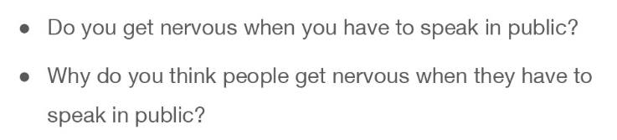

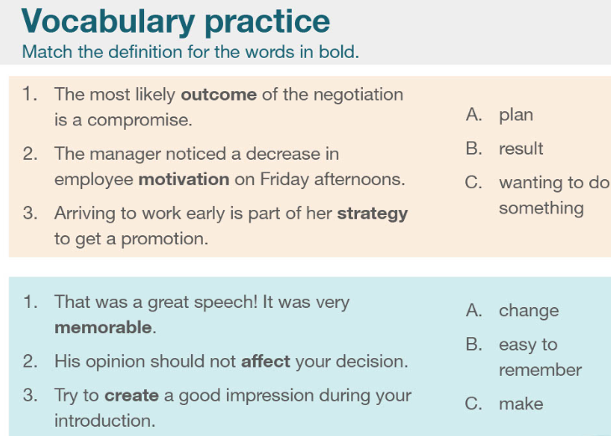

|  |  |  |
| --- | --- | --- |
| Outcome | /ˈaʊtkʌm/ | The final result of an activity or process;  Learning outcome 学习效果 |
| motivation | /ˌməʊtɪˈveɪʃ(ə)n/ | Enthusiasm for doing something;  Arouse the enthusiasm of;  Motivation research |
| strategy  strategic  strategize | /ˈstrætədʒi/  /strəˈtiːdʒɪk/  /ˈstrætɪˌdʒaɪz/ | A plan that you use to achieve something;  Control strategy;  Marketing strategy |
| memorable  memory  memorabilia  memorability  memorial纪念碑 | /ˈmemərəb(ə)l/ /ˈmeməri/  /ˌmemərəˈbɪliə/  /ˌmemərəˈbɪlɪti/  /məˈmɔːriəl/ | Something you will remember for a long time;  A memorable day;  The most memorable person  Obvious  Noted  outstanding |
| To affect  affective  affection | /əˈfekt/ /əˈfektɪv/ /əˈfekʃn/ | To have an influence on someone or something, or to cause them to change;  …sth enough to affect my |
| To create  Creative  creativity |  | Create folder / directory |

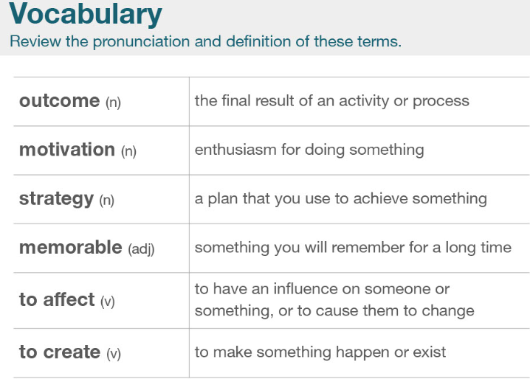

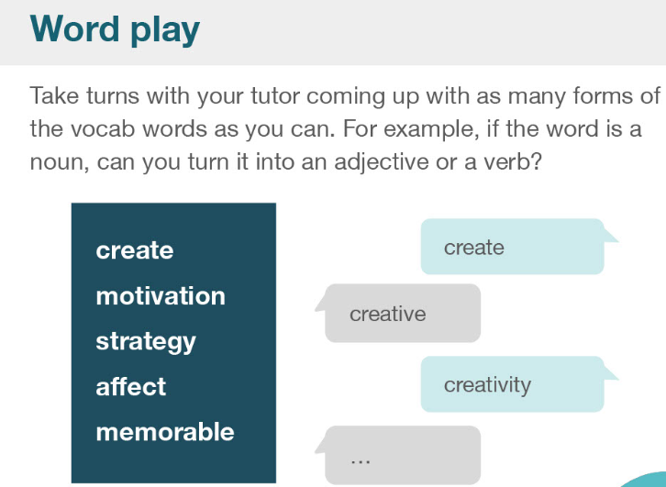

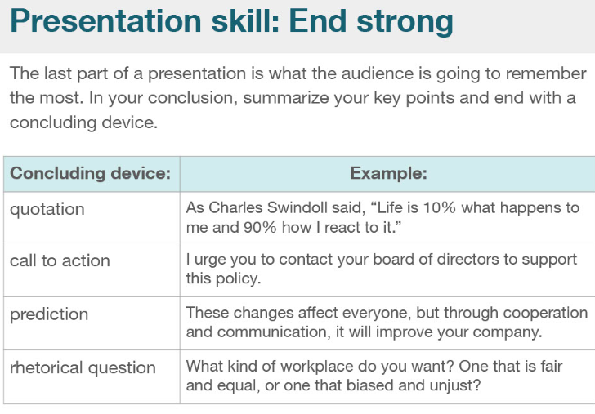

|  |  |  |
| --- | --- | --- |
| Quotation  Cite  Reference  credit | /kwəʊˈteɪʃn/  /ˈkredɪt/ | 引语a short note recognizing a source of information or of a quoted passage;  Price quotation |
| Call to action |  |  |
| prediction |  | Linear prediction  Prediction model |
| Rhetorical question |  | Are you kidding me?  What are you waiting for? |

What are you waiting for? 你还在等什么

Just do it

