## Notes-adopt pets

## lessons

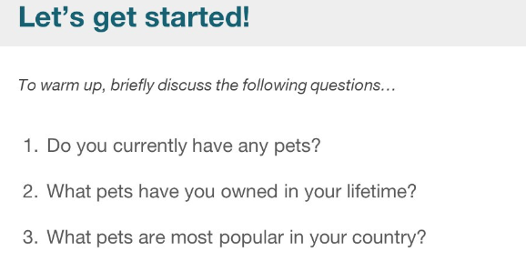

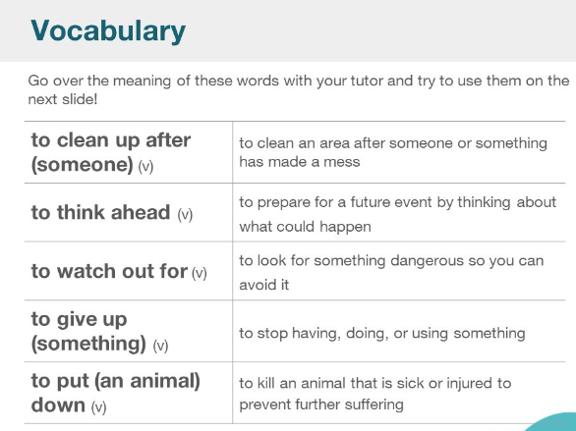

|  |  |  |
| --- | --- | --- |
| To clean up after |  | To clean an area after pet has poop/shit/pee |
| To think ahead |  | To prepare for a future event by thinking about what could happen |
| To watch out for | When passengers pass the intersection, they need to see the running vehicles. | To look for something dangerous so you can avoid it |
| To give up |  | To stop having, doing, or using something |
| To put (an animal) down |  | To kill an animal that is sick or injured to prevent further suffering |
| prevent | /prɪˈvent/ | prevent from doing something or being in a certain state  Prevent from  Prevent and control congestion |
| Sick / ill  Injured / hurt  suffering | not feeling good  /ˈɪndʒəd/  /ˈsʌfərɪŋ/ | Prevent further suffering |
| Spontaneous  Auto  Natural  Initiative /ɪˈnɪʃətɪv/  Mechanical /məˈkænɪkl/ | /spɒnˈteɪniəs/ /spɒnˈteɪniəs/  spontaneous sounds like spon tay nee us | Happening or arising without apparent external cause |
| exotic | /ɪɡˈzɒtɪk/  sounds like ex ot tic | Wild, undomesticated  being or from or characteristic of another place or part of the world  Exotic plant  Exotic dancer |
|  |  | maybe when they are sleeping, that you don't step on them. Or be careful they will not bite. |

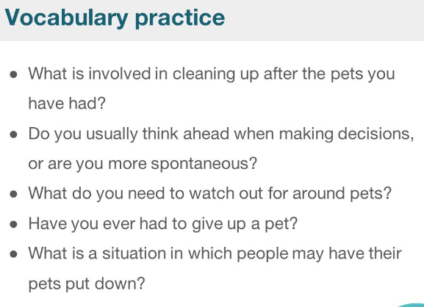

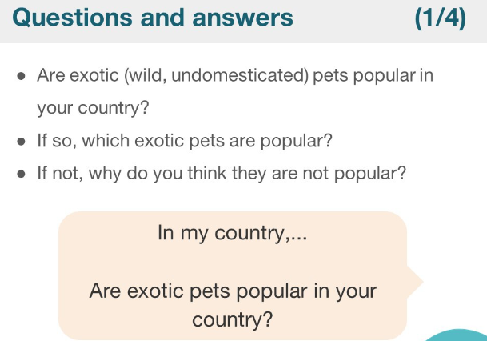

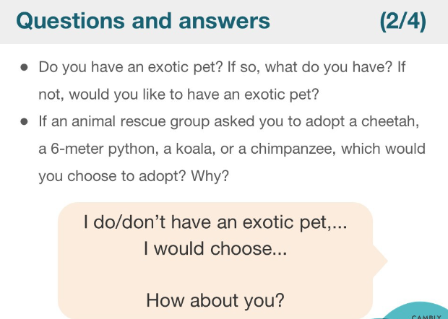

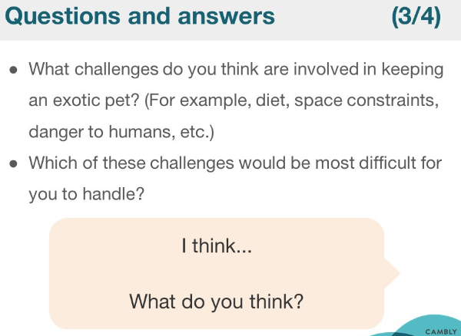

|  |  |  |
| --- | --- | --- |
| Exotic  Wild undomesticated |  |  |
| Adopt exotic pet |  | Diet  Space constraints  Danger to humans |
| illegal pet | /ɪˈliːɡ(ə)l/ | prohibited by law or by official or accepted rules;  illegal immigration |
| immigration | /ˌɪmɪˈɡreɪʃ(ə)n/ |  |
| Prohibited  Ban  Disbarred  unallowed | /prəˈhɪbɪtɪd/ | Prohibited area |
| Cheetah / dangerous cat  Python / long snake  Koala / lovely bear  Chimpanzee / smart monkey | /ˈtʃiːtə/  /kəʊˈɑːlə/ /ˌtʃɪmpænˈziː/ |  |

