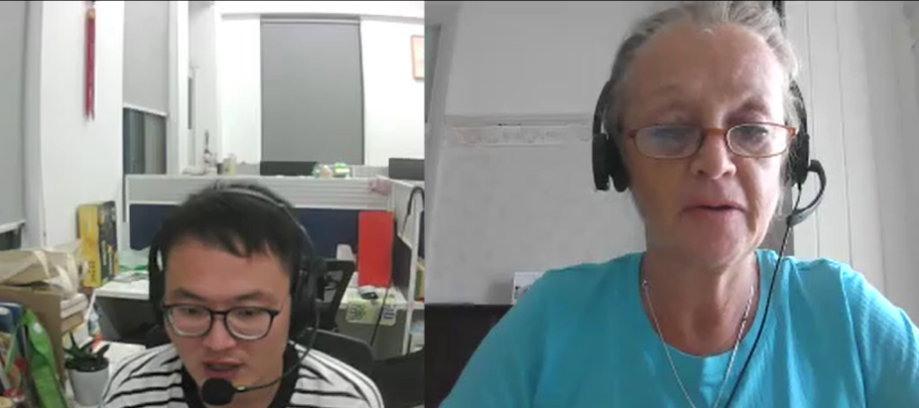

<https://www.cambly.com/api/chats/6325e0d3441f42d68d9fb40f/video>

## Notes

|  |  |
| --- | --- |
| I will also ~~to~~ use | I will always use |
| Maybe several hours ago |  |
| Who was the audience |  |
| colleagues /ˈkɒliːɡz/  Audience /ˈɔːdiəns/ | Team member  Getting to know new colleagues  Among colleagues |
| ~~In~~ recently | recently |
| Has improved |  |
| Has become clearer | will continue to increase |
| But then there will be dip in the level |  |
| Continue to increase slowly |  |
| Cannot to improve | I can’t improve quickly |
| contractions /kənˈtrækʃ(ə)nz/ 缩写  will not  can not | won’t /wəʊnt/  can’t /kɑːnt/ |
| sales /ˈseɪlz/ |  |
| amount /əˈmaʊnt/ |  |
| grew /ɡruː/ | Grow up  Grow old |
| ubstantial /səbˈstænʃ(ə)l/  massive /ˈmæsɪv/  Extensive | won by a substantial margin  以巨大的优势获胜 |
| Presentation /ˌprez(ə)nˈteɪʃ(ə)n/ |  |
| Bar graph  Pie graph  Line graph /laɪn ɡræf/ |  |
| consequences |  |
| **[certificate](javascript:;)** /səˈtɪfɪkət/  certificate  license | a document attesting to the truth of certain stated facts  Graduation certificate;  Qualification certificate; /ˌkwɒlɪfɪˈkeɪʃ(ə)n/  Registration certificate /ˌredʒɪˈstreɪʃn/ |
| illustrate/ˈɪləstreɪt/  explain | Clarify by giving an example of  Illustrate with |
| grammar  pronunciation |  |

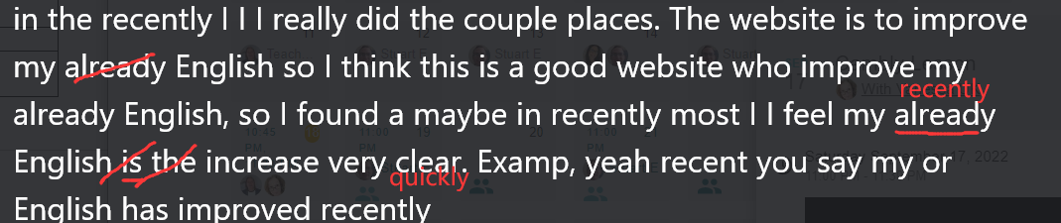

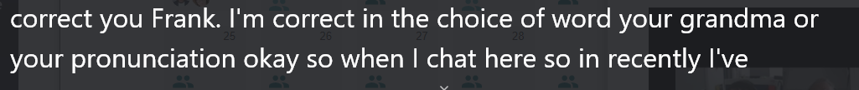

## Lesson

