# Describing Change: History

## Notes

|  |  |  |
| --- | --- | --- |
| Pulling your leg |  |  |
| Scales |  |  |
| Agriculture |  |  |
| vase |  |  |
| religion |  |  |
| Free masons |  |  |
| Sewer system |  |  |

## lesson

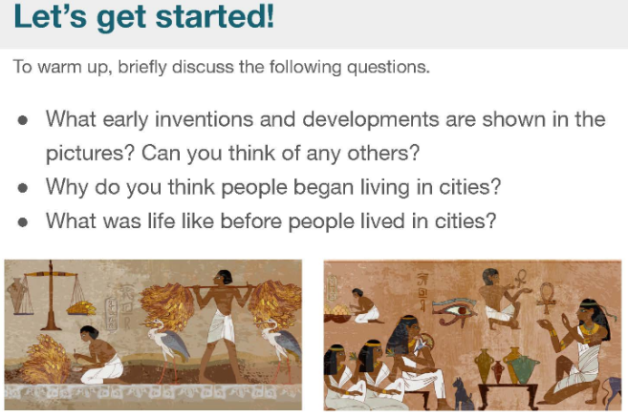

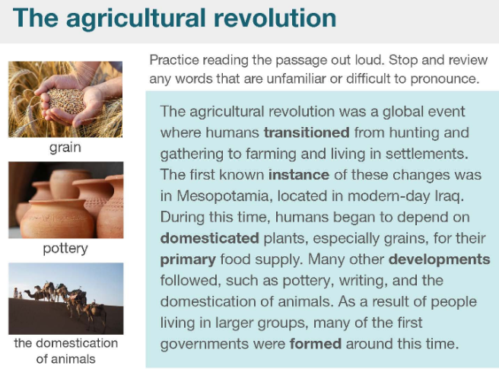

|  |  |  |
| --- | --- | --- |
| To transition |  |  |
| Agricultural revolution |  |  |
| Hunting and gathering |  |  |
| Settlement |  |  |
| instance |  |  |
| Iraq |  |  |
| Domesticated  Food and animal |  |  |
| Primary food supply |  |  |
| Pottery |  |  |
| form |  |  |

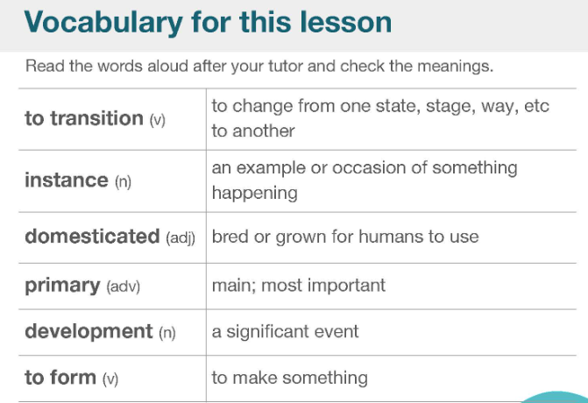 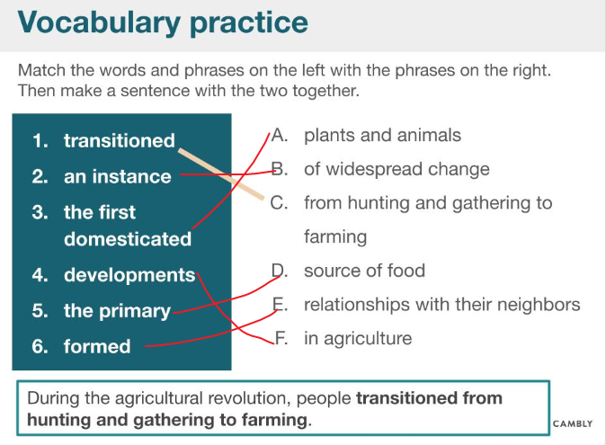 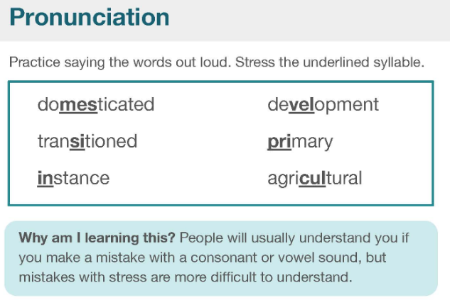 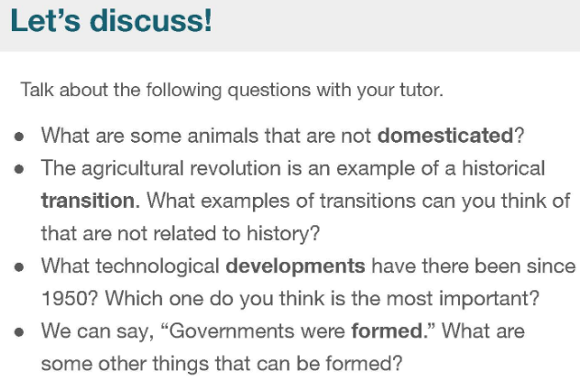 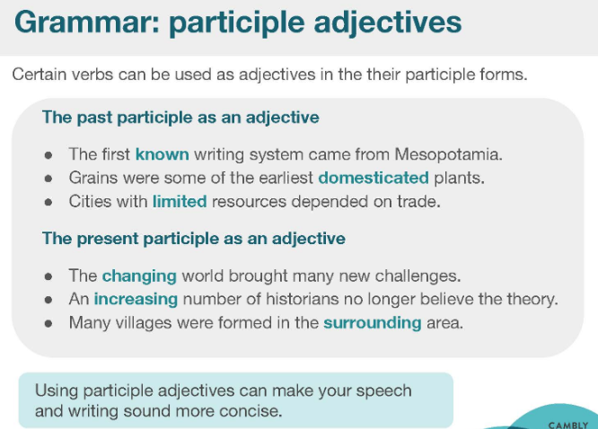 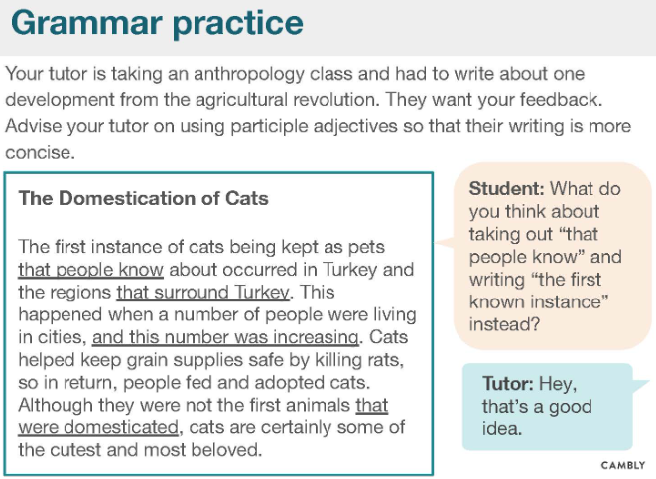 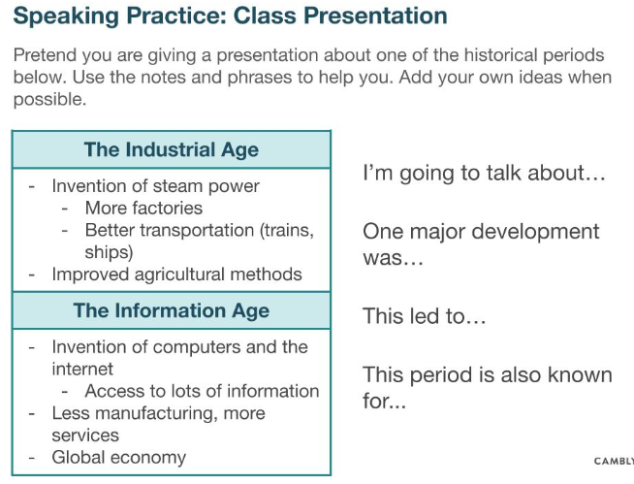

# Data, Charts, & Numbers: Business

<https://www.cambly.com/en/student/courses/5fa1de81b728c84f4ccaaa2f/60f1fc5e873ad0c4361bc569>



shift work

stricter

**the most/the largest/the biggest is...... followed by.... then followed by.... then we have..... lastly is .........**

GDP/disposable income; population; growth; shipping costs from point of manufacture

Manufactured

"adibas" fake trainers

## Notes

|  |  |  |
| --- | --- | --- |
| Would you be willing to assist me with my research? |  |  |
| Open the new store | location  Many things for sale  lower prices than competitors  reputation for selling good/reliable products | |
| chain store  McDonald's, KFC  starbucks |  |  |
|  |  |  |
|  |  |  |
|  |  |  |
|  |  |  |
| etcetera |  |  |
| eleven thousand, five hundred |  |  |
| one dollar  two dollars  ten dollars |  |  |
| midday  11pm - 12 am  11 am - 12pm |  | |
| The number of customers is highest in the afternoon. | From my point of view..... |  |
| The company value of Amazon is 4 times greater than that of Walmart.  ...but by 2015 the value of Amazon surpassed Walmart. | | |
| food chains |  |  |
| buy in bulk |  |  |

## lesson

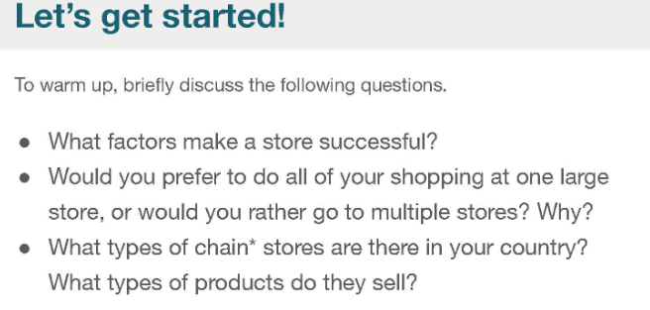

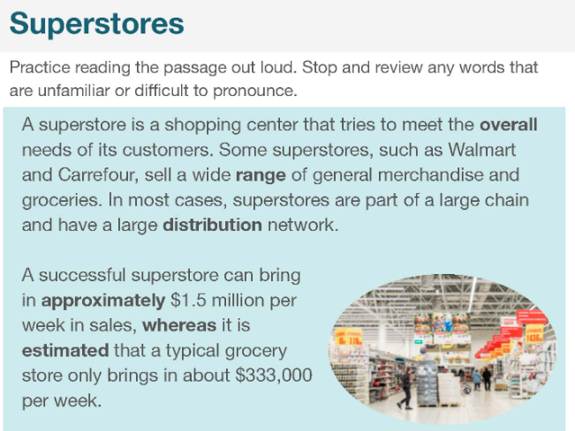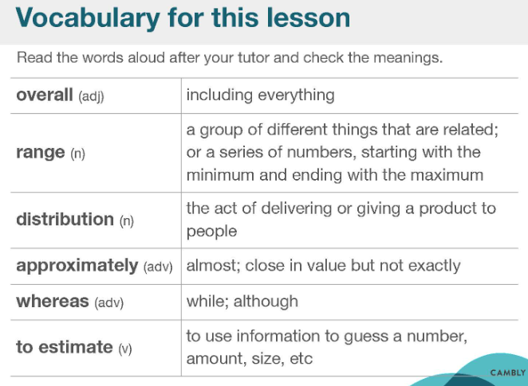

|  |  |  |
| --- | --- | --- |
| Approximately  Around  almost | /əˈprɒksɪmətli/ | Approxi-mately  Is approximately equal to;  Close in value but not exactly |
| To estimate | /ˈestɪmət/ |  |
| overall |  |  |
| Range |  |  |
| distribution |  |  |
| whereas |  |  |
| 11,500 | 11 thousand, comma, 500  11 thousand and 5 hundred |  |
| 12,300 | 12 thousand, comma, 300  12 thousand and 5 hundred |  |

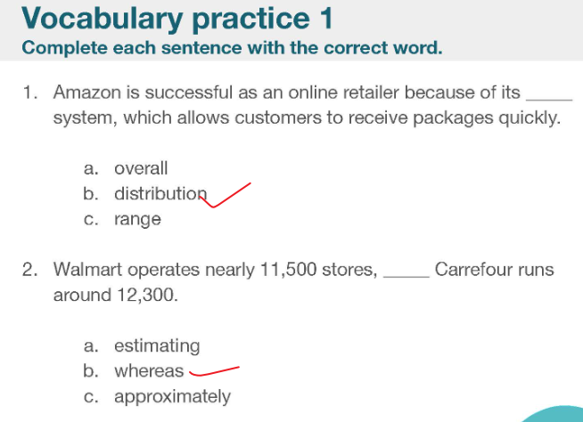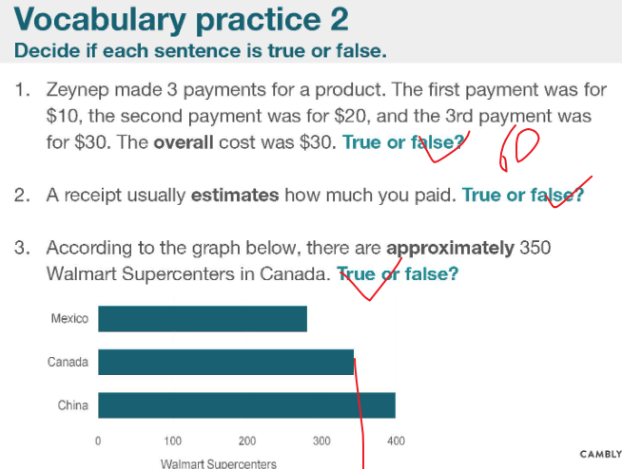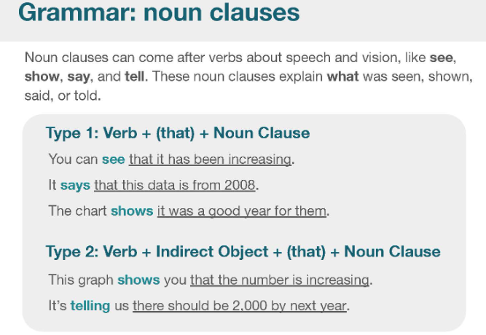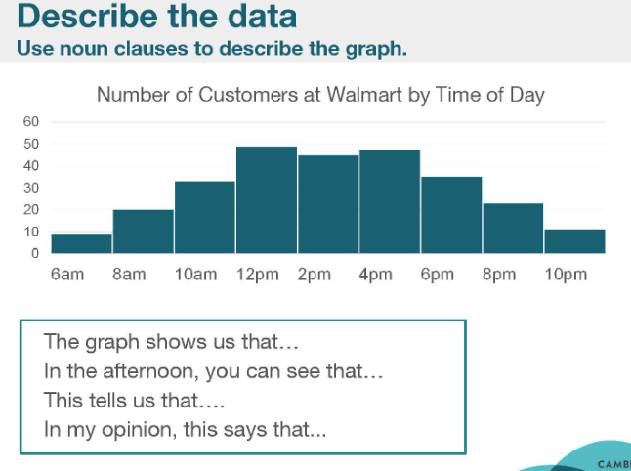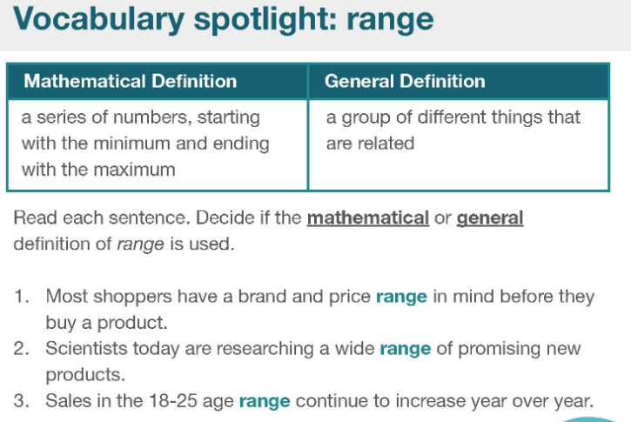

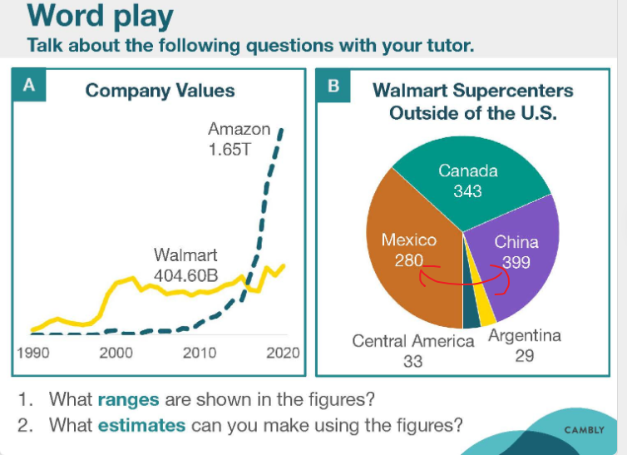



|  |  |  |
| --- | --- | --- |
| Surpass  Overcome  Exceed  More than  Greater, bigger | /səˈpɑːs/  Surpass the advanced | be or do something to a greater degree  **her performance surpasses that of any other student I know** |
| Air conditioner |  |  |



