# Internet

<https://www.cambly.com/en/student/courses/5e0e8b212ac750e7dc9886ac/5e3980de5719a74fdff01c3b>

## Notes

|  |  |  |
| --- | --- | --- |
| Coherence | /kəʊˈhɪərəns/ | 连贯性  the situation in which all the parts of sth fit together well |
| Revolutionized | /ˌrevəˈluːʃənaɪzd/ | Changed completely |
| anonymous | /əˈnɒnɪməs/ | not named or identified |
| Access | /ˈækses/ | The right to enter;  Internet access  Have access to |
| security | /sɪˈkjʊərəti/ | Free from danger;  Social security  Public security  Security system |
| Face to face interactions | /ˌɪntərˈækʃ(ə)n/ |  |
| threat | /θret/ | Someone or sth that could cause trouble or harm |

## lesson

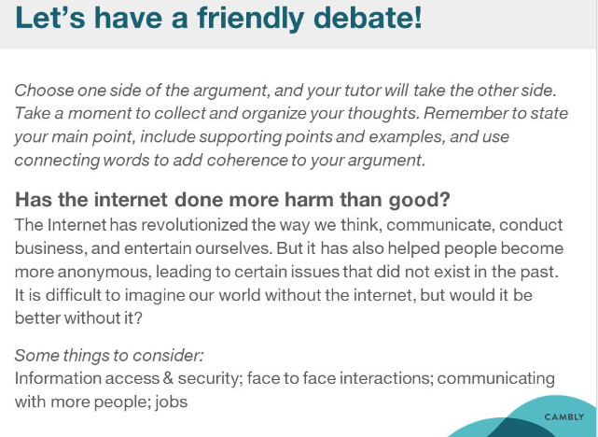

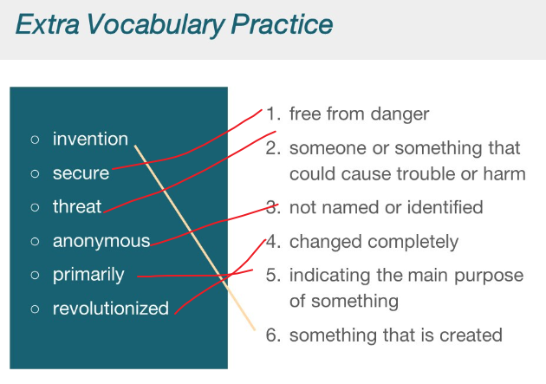

|  |  |  |
| --- | --- | --- |
| Coherence | /kəʊˈhɪərəns/ | 连贯性  the situation in which all the parts of sth fit together well |
| Revolutionized | /ˌrevəˈluːʃənaɪzd/ | Changed completely |
| anonymous | /əˈnɒnɪməs/ | not named or identified |
| Access | /ˈækses/ | The right to enter;  Internet access  Have access to |
| security | /sɪˈkjʊərəti/ | Free from danger;  Social security  Public security  Security system |
| Face to face interactions | /ˌɪntərˈækʃ(ə)n/ |  |
| threat | /θret/ | Someone or sth that could cause trouble or harm |

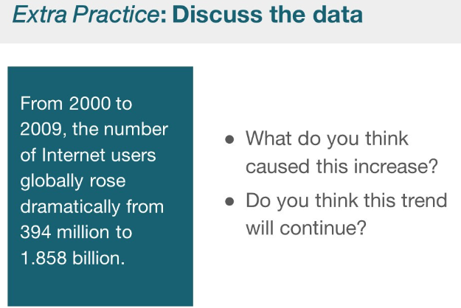

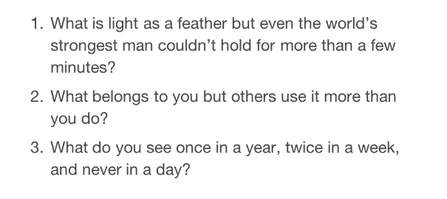

# Social media

<https://www.cambly.com/en/student/courses/5e0e8b212ac750e7dc9886ac/5e419381dc337f63cfe0bf52>

## Notes

|  |  |  |
| --- | --- | --- |
| Former  latter | hou/ˈfɔːmə(r)/ | Existing in the past  Prior;past |
| Harmful | /ˈhɑːmf(ə)l/ | Causing damage or harm |
| Dismantling  Decomposition  dissolution | /dɪsˈmæntlɪŋ/ | To take apart so that it’s in separate pieces |
| Participate in | /pɑːˈtɪsɪpeɪt/ | To take part in or be involved |
| recommend | /ˌrekəˈmend/ |  |
| To value |  | To be considered important or beneficial  Theorical value; Practical value;  Reference value |

## lesson

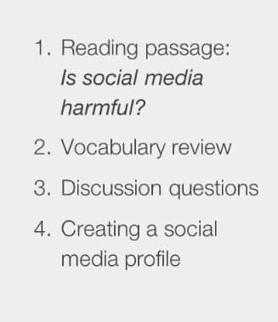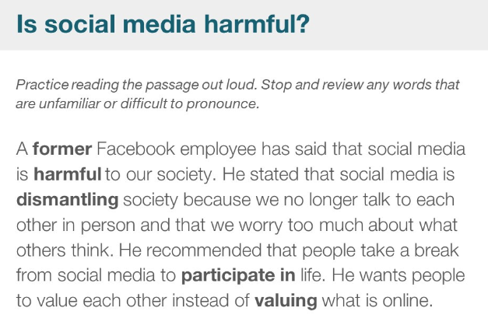

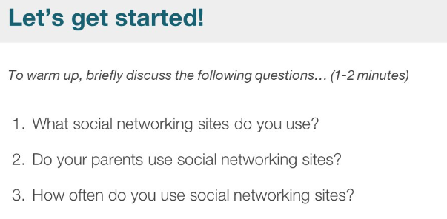

|  |  |  |  |  |
| --- | --- | --- | --- | --- |
| Former  latter | hou/ˈfɔːmə(r)/ | | Existing in the past  Prior;past | |
| Harmful | /ˈhɑːmf(ə)l/ | | Causing damage or harm | |
| Dismantling  Decomposition  dissolution | /dɪsˈmæntlɪŋ/ | | To take apart so that it’s in separate pieces | |
| Participate in | /pɑːˈtɪsɪpeɪt/ | | To take part in or be involved | |
| recommend | /ˌrekəˈmend/ | |  | |
| To value |  | | To be considered important or beneficial  Theorical value; Practical value;  Reference value | |
| Crush | | /krʌʃ | | 压坏，挤压变形；捣碎，碾成粉末；  拥挤的人群 crowd  Get a crush on 迷恋 |
| She values time spent with her family because she doesn’t see them a lot. | | | | |
| Surf the web | | To spend time looking at different pages on the Internet | | |
| Down to the wire  Close to the deadline | | 等到最后一刻才开始做事  Until the last possible second | | |
| Get your wires crossed | | 发生了误会  When there is a misunderstanding | | |
| Political polarization | | /pəˈlɪtɪk(ə)l/ /ˌpoʊlərəˈzeɪʃn/ | | 政治社会化 |
| polarization | |  | | Linear polarization  the phenomenon in which waves of light or other radiation are restricted in direction of vibration |
| preference | | /ˈprefrəns/ | | Preference for |
| **Facilitates** mass cultural exchange | | /fəˈsɪlɪteɪts/ | | Help;  Advangate  fosters |
| Intercultural communication | | /ˌɪntəˈkʌltʃərəl/ | |  |
| maintain | | /meɪnˈteɪn/ | | Maintain world peace |

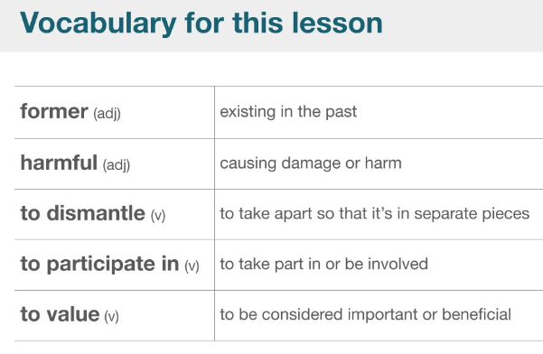

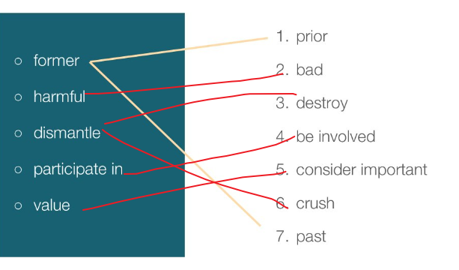

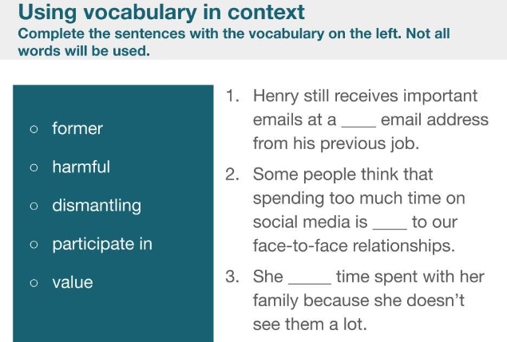 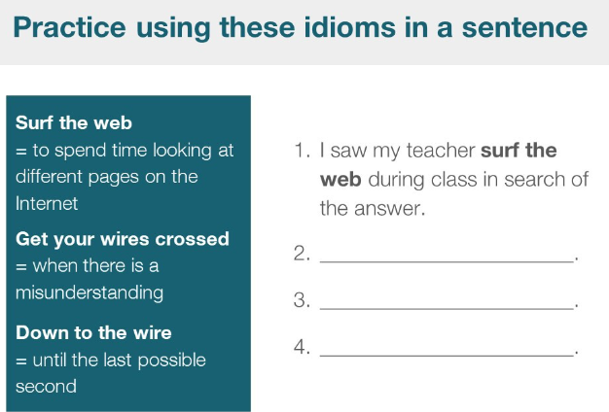

|  |  |  |
| --- | --- | --- |
| Crush | /krʌʃ | 压坏，挤压变形；捣碎，碾成粉末；  拥挤的人群 crowd  Get a crush on 迷恋 |
| She values time spent with her family because she doesn’t see them a lot. | | |
| Surf the web | To spend time looking at different pages on the Internet | |
| Down to the wire  Close to the deadline | 等到最后一刻才开始做事  Until the last possible second | |
| Get your wires crossed | 发生了误会  When there is a misunderstanding | |

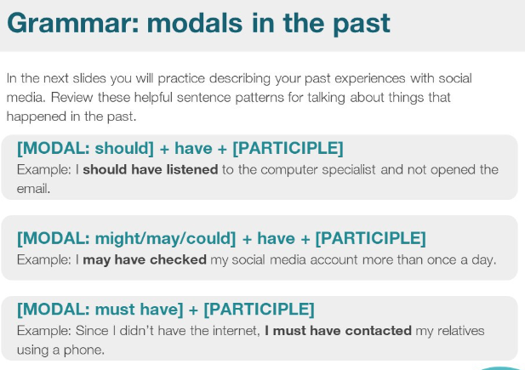

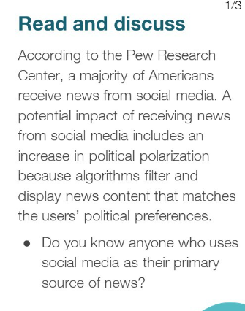

|  |  |  |
| --- | --- | --- |
| Political polarization | /pəˈlɪtɪk(ə)l/ /ˌpoʊlərəˈzeɪʃn/ | 政治社会化 |
| polarization |  | Linear polarization  the phenomenon in which waves of light or other radiation are restricted in direction of vibration |
| preference | /ˈprefrəns/ | Preference for |
| **Facilitates** mass cultural exchange | /fəˈsɪlɪteɪts/ | Help;  Advangate  fosters |
| Intercultural communication | /ˌɪntəˈkʌltʃərəl/ |  |
| maintain | /meɪnˈteɪn/ | Maintain world peace |

