https://www.cambly.com/en/student/courses/5e0e8b212ac750e7dc9886ac/5e41b7400db1cb68840647df

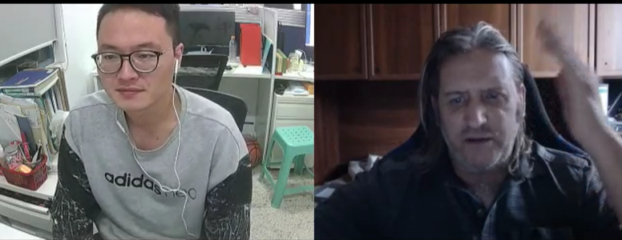

|  |  |  |
| --- | --- | --- |
| in brackets  parenthesis | /pəˈrenθəsɪs/ | a category falling within certain defined limits  All translated words should be enclosed in brackets.  Publication dates are given in brackets after each title. |
| not my cup of tea |  | 不是我的菜 |
| depends on my mood |  |  |
| Gameplay | /ˈɡeɪmpleɪ/ | The way a video game is played.  There are so many events in the game quest. |
| **Mission**  task | /ˈmɪʃn/ | an organization  an operation that is assigned by a higher headquarters;  a special assignment that is given to a person or group  使命，重要任务；职责，天职； |
| To live stream | 爱 | To record and broadcast media in real life |
| To gain |  | To obtain or get more of something |
| subscription | səbˈskrɪpʃ(ə)n/ | A fee paid regularly to belong to a group or to support someone |
| sponsor | /ˈspɒnsə(r)/ | A person or organization that gives money to a person in return for the right to use that person for advertising |
| Daily viewers  Broadcaster offer |  | 每天的观众  广播公司提供 |
| Tournaments  game | /ˈtɜːrnəmənt/ | Open tournament  Invitational tournament  a sporting competition in which contestants play a series of games to decide the winner;  a series of jousts between knights contesting for a prize |
| Hypothetical situation  Theoretical  If-then | /ˌhaɪpəˈθetɪk(ə)l/ | a hypothetical possibility, circumstance, statement, proposal, situation, etc.;  based primarily on surmise rather than adequate evidence |
| Participate in  Take part in  Go through  Partake in | /pɑːˈtɪsɪpeɪt/ | Participate in social activities  become a participant; be involved in |

