

<https://www.cambly.com/en/student/courses/62cdf57ec3dbcad11563a640/62cdfee421f269f18c876981#>

|  |  |  |
| --- | --- | --- |
| to reach out –  to contact someone |  | To try to communicate with a person or a group of people, usually in order to help or involve them  联系某人 |
| dedicated |  | a dedicated dancer,dedicated teachers,dedicated to the proposition that all men are created equal |
| To touch base |  | To make contact with some about something |
| feedback |  |  |
| Expectations  expect |  | A strong believe |
| aligned |  | The same as or similar to something else |
| In the loop |  | To be informed or participate in something, such as a project |

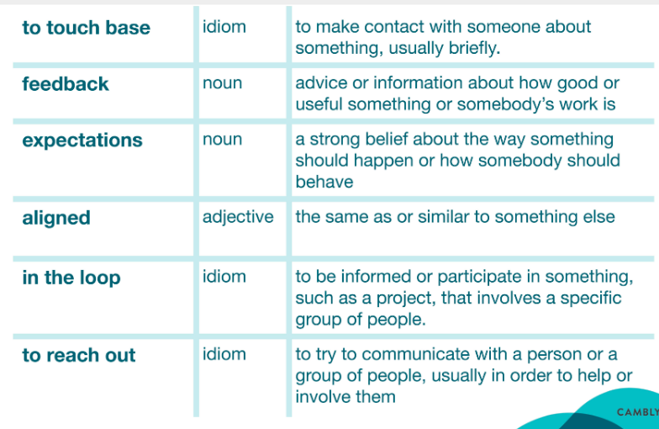

Dedicated

