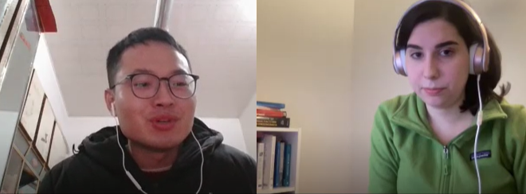

You got up earlier today

Traditional custom

grandmother

acknowledgements

memes

cartoons

Look up motivational quotes

fireworks