# MapMatching2GMNS

Please send your comments to [xzhou74@asu.edu](mailto:xzhou74@asu.edu) if you have any suggestions and questions.

Based on input network and given GPS trajectory data, the map-matching program of MapMatching4GMNS aims to find the most likely route in terms of node sequence in the underlying network, with the following data flow chart.

[GMNS: General Modeling Network Specification (GMNS) ](https://github.com/zephyr-data-specs/GMNS)

1. **Read standard GMNS network files** node and link files
2. **Read GPS trace.csv** file

* Note: the M2G program will convert trace.csv to input_agent.csv for visualization in NeXTA.

1. **Construct 2d grid system** to speed up the indexing of GSP points to the network. For example, a 10x10 grid for a network of 100 K nodes could lead to 1K nodes in each cell.
2. **Identify the related subarea** for the traversed cells by each GPS trace, so only a small subset of the network will be loaded in the resulting shortest path algorithm.
3. **Identify the origin and destination** nodes in the grid for each GPS trace, in case, the GPS trace does not start from or end at a node inside the network (in this case, the boundary origin and destination nodes will be identified). The OD node identification is important to run the following shortest path algorithm.
4. **Estimate link cost** to calculate a generalized weight/cost for each link in the cell, that is, the distance from nearly GPS points to a link inside the cell.
5. Use **likely path finding algorithm** selects the least cost path with the smallest generalized cumulative cost from the beginning to the end of the GPS trace.
6. **Identify matched timestamps** of each node in the likely path
7. **Output agent file** with **map-matched node sequence** and time sequence
8. **Output link performance** with **estimated link travel time and delay** based on free-flow travel time of each link along the GPS matched routes
9. **Data flow**

|  |  |
| --- | --- |
| **Input files** | **Output files** |
| node.csv | agent.csv |
| link.csv |  |
| input_agent.csv |  |

1. **Input file description**

* **File node.csv** gives essential node information of the underlying (subarea) network in GMNS format, including node_id, x_coord and y_coord.

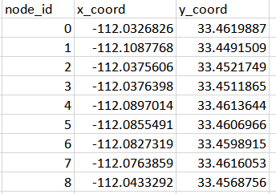

**File link.csv** provides essential link information of the underlying (subarea) network, including link_id, from_node_id and to_node_id.

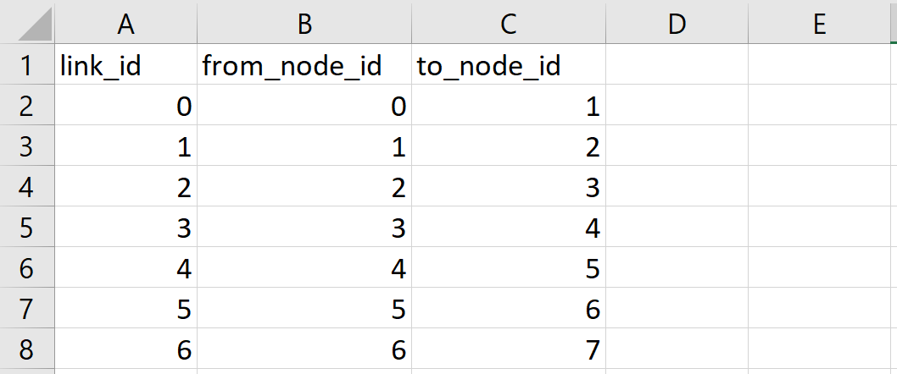

**Input trace file** as

The agent id is GPS trace id, x_coord and y_coord should be consistent to the network coordinate defined in node.csv and link.cvs. Fields hh mm and ss correspond the hour, minute and second for the related GPS timestamp. We use separate columns directly to avoid confusion caused by different time coding formats.

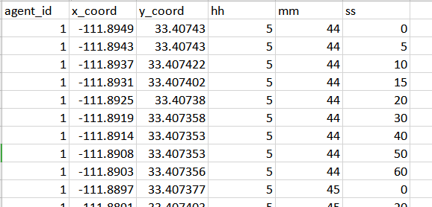

Another format of trace file is input_agent.csv, which could come from the [grid2demand](https://github.com/asu-trans-ai-lab/grid2demand) program. The geometry field describes longitude and latitude of each GPS point along the trace of each agent. In the following example there are exactly 2 GPS points as the origin and destination locations, while other examples can include more than 2 GPS points along the trace. The geometry field follows the WKT format.

https://en.wikipedia.org/wiki/Well-known_text_representation_of_geometry

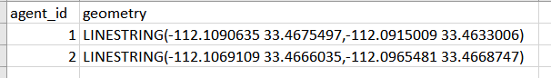

1. **Output file description**

* **File agent.csv** describes the most-likely path for each agent based on input trajectories.



The original input_agent.csv and resulting agent.csv can be visualized through NeXTA.

1. Load the network node.csv and click on the following 4 buttons or menu check box.

* 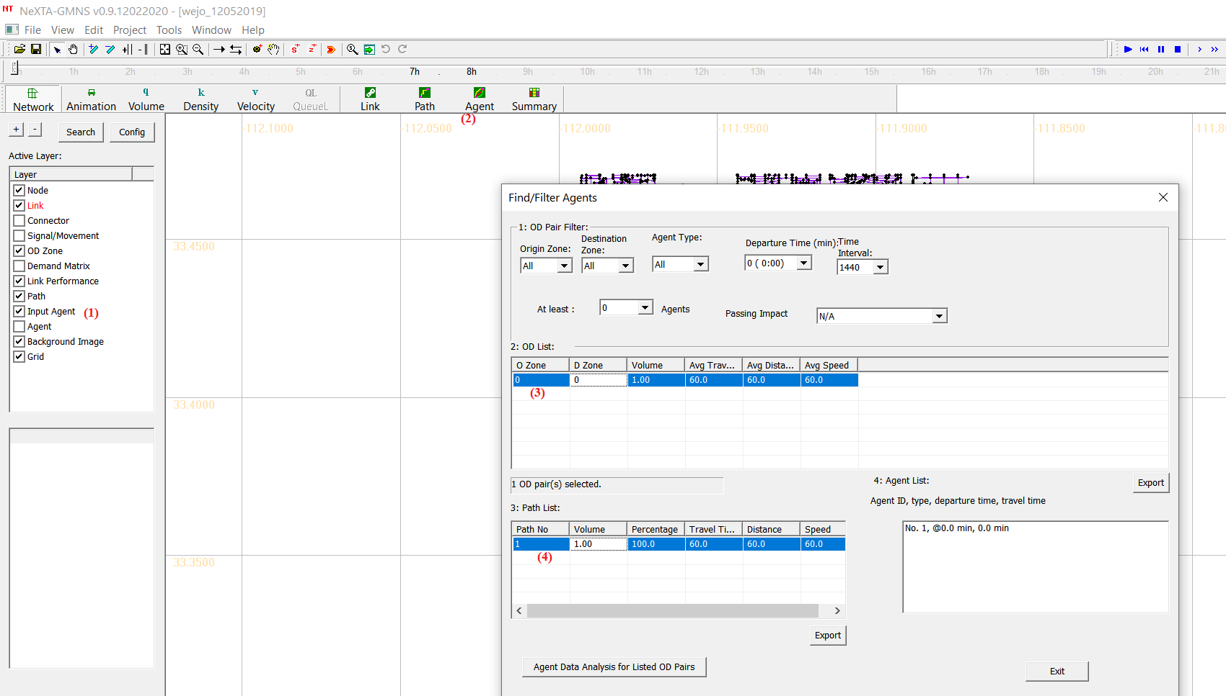

1. The original GPS trace is shown in green and the map-matched route in the network is displayed in purple. The user can use the scroll wheel of the mouse to zoom in the focused area.

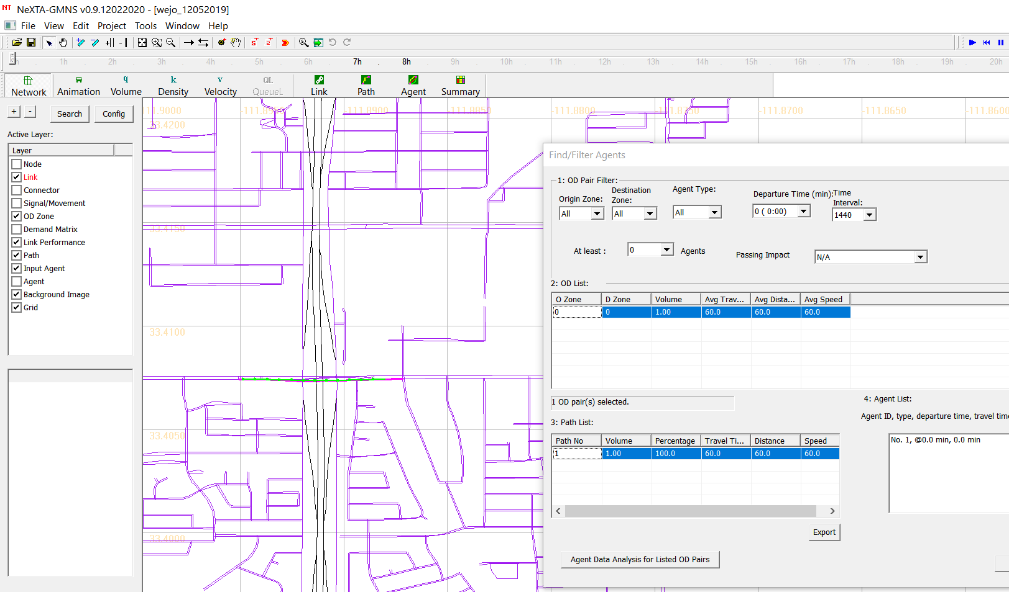

**Reference:**

This code is implemented based on a published paper in Journal of Transportation Research Part C:

Estimating the most likely space–time paths, dwell times and path uncertainties from vehicle trajectory data: A time geographic method

https://www.sciencedirect.com/science/article/pii/S0968090X15003150