CO395 Coursework 1 report
rz4217@ic.ac.uk
jf2618@ic.ac.uk
mz3718@ic.ac.uk
xc4718@ic.ac.uk

Introduction
In this project, we aim to use supervised learning to predict location in the room according to the observed wifi signal. Decision tree algorithm is explored in detail. We focus on the comparison between decision tree forming with and with out pruning. The results are evaluate by various criteria and discussed in detail.

1 Implementation

This section explain in detail about how to build a tree from data (decision_tree_learning), how to evaluate the performance of a built tree (evaluation, evaluate_ten_fold_cross_validation), how to use validation data to prune a tree (pruning), and how to visualize a tree (visualization). The implementation idea is presented as pseudo codes.

1.1.1

function decision_tree_learning(data, depth)
as described in the specification
return tree, depth

1.1.2

function find_split(training_date)
for each attribute do
for each unique value between the max and min of that attribute do
calculate the information gain
choose the attribute and split value with the largest information gain

WHY NOT USE EFFICIENT ALGORITHM IN SPECIFICATION FOR SPLITTING DATA

We haven’t implemented the algorithm proposed in the PDF. As we found that after sorting the value of the attribute, the one value may corresponds to different classification, in this case, it will be hard to find the clear split value. In order to improve the accuracy of classification, we decide to test the every unique value of each attribute.

1.2.1

function evaluation(tree_dictionary, test_data)
for each data sample in test_data do
predict the class according to the tree_dictionary
count the number of misclassified sample as total error
return total error / size of test_data

1.2.2

function evaluate_ten_fold_cross_validation(data)
split whole dataset into 10 folds, use 9 folds for training, and the rest for testing
from 1 to 10 do
build tree1 with the 9-fold training data
build tree2 with 80% of the 9-fold training data and pruning using the rest 20%
evaluate tree1 as classification_rate1
evaluate tree2 as classification_rate2
calculate the average performance of classification_rate1 and classification_rate2, which indicates the performance without and with pruning

1.3

function pruning(current_node, training_data, validation_data)
for current node in the tree do
if this node is a leaf, return this node
if left child and the right child of this node are leaf
use the validation data to check whether to prune this pattern
and return the original node or a new leaf
if at least one of the children is not leaf do
pruning the left child, and update the left child
pruning the right child, and update the right child
if both the updated child nodes are leaf do
use the validation data to check whether to prune this pattern
and return the original node or new leaf
else do
update this node

1.4

function visualization(tree)
visit through each node in the tree_dictionary
calculate the gap for each level according to the depth if the tree
set x_min, x_max, y_min, y_max of the drawing area
for each node do
draw the current node in the centre of the drawing area
decrease y_max by gap
draw the left child on the left part of the drawing area
draw the right child on the right part of the drawing area

2 results

2.1 confusion matrix
 | With pruning | Without pruning
Clean data | 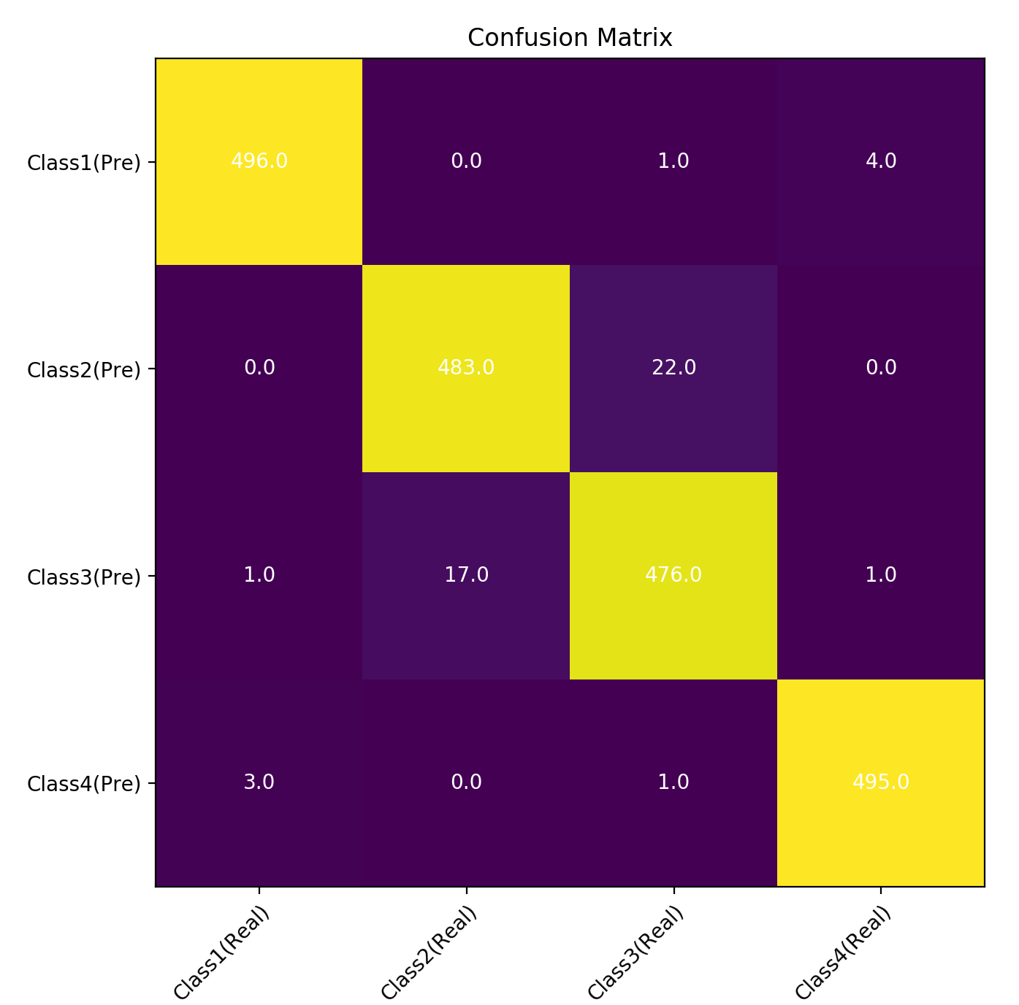
Noisy data | 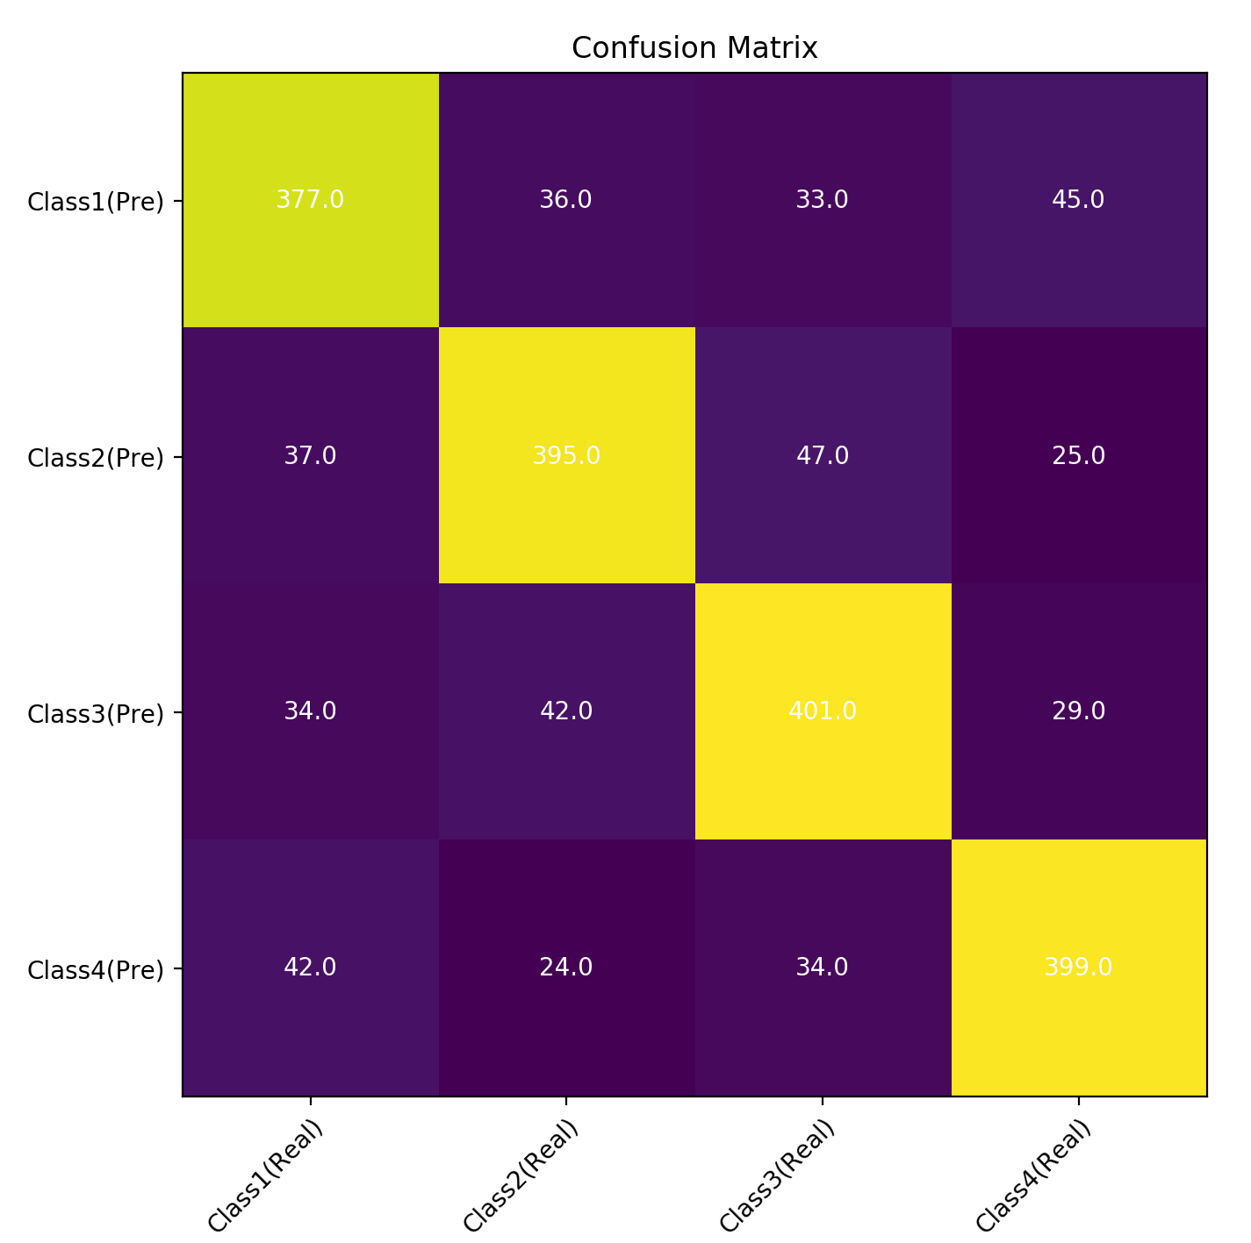 | 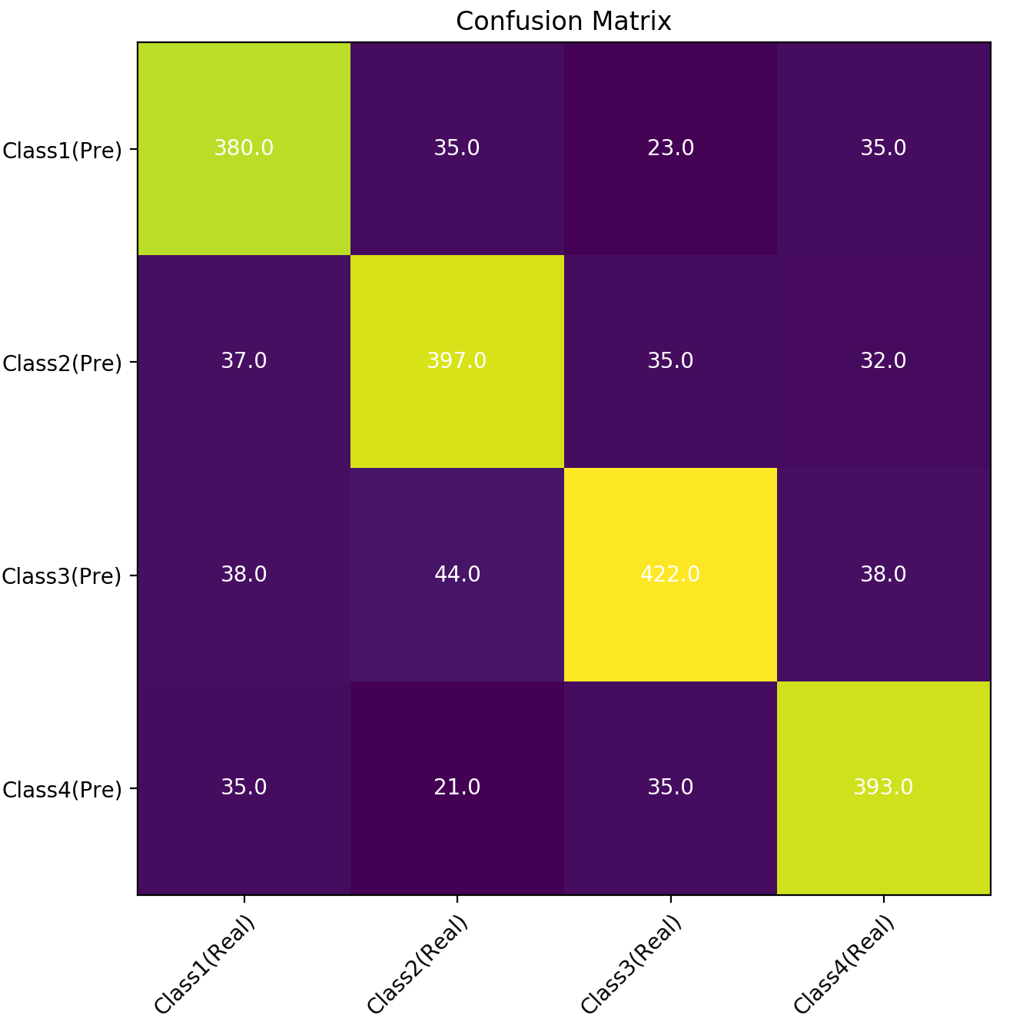

COMMENT:

In comparison between with and without pruning, when using a noisy dataset, the numbers of correctly-classified sample for class 1,2 and 3 are increased by 3, 2, and 21 respectively, suggesting a greater accuracy for classification, especially for class 3. These might due to the better ability to classify between class 1 and class 4, class 2 and class 4, as the number of miss-classified sample between these classes gets smaller.

For clean data, the confusion matrix demonstrates that class 2 and class 3 are hard to distinguish compared with other pairs of classes. Class 4 and class 1 have higher recall value which is 0.990 and 0.979 respectfully. Class 3 and Class 2 are less completed compared with other classes with the decision tree generated.

2.2 recall, precision & F1 score

 | Clean dataset |  |  |  |  |  | Noisy dataset
 | Without pruning |  |  | With pruning |  |  | Without pruning |  |  | With pruning
 | Recall | Precision | F1 score | Recall | Precision | F1 score | Recall | Precision | F1 score | Recall | Precision | F1 score
Class 1 | 0.990 | 0.992 | 0.991 | 0.990 | 0.992 | 0.991 | 0.769 | 0.769 | 0.767 | 0.805 | 0.775 | 0.788
Class 2 | 0.955 | 0.965 | 0.960 | 0.956 | 0.956 | 0.956 | 0.787 | 0.793 | 0.788 | 0.795 | 0.797 | 0.793
Class 3 | 0.962 | 0.952 | 0.957 | 0.949 | 0.953 | 0.950 | 0.793 | 0.780 | 0.785 | 0.779 | 0.820 | 0.798
Class 4 | 0.993 | 0.991 | 0.992 | 0.994 | 0.989 | 0.991 | 0.798 | 0.799 | 0.797 | 0.815 | 0.789 | 0.799

COMMENT:

When experimenting on noisy dataset, all three evaluation criteria show that decision tree with pruning has better performance than decision tree without pruning, except for class 3.
For clean dataset, all these criteria show a decrease in performance after adopting pruning.

2.3 classification rate

Classification rate | With pruning | Without pruning
Clean data | 0.969 | 0.973
Noisy data | 0.811 | 0.792

COMMENT:

Experiments carried on noisy dataset shows that decision tree with pruning will have better performance than decision tree without pruning. In average, pruning will bring 2% improvement in classification rate.

However, experiments carried on clean dataset shows an opposite result. The classification rate will decrease a little when using pruning.

WHY THE PERFORMANCE WITH AND WITHOUT PRUNING DOES NOT CHANGE ON CLEAN DATA SET

The average accuracy of the decision tree generated before pruning for clean data is 0.973 , whereas the tree generated after pruning has average accuracy of 0.969 which is decreased compared with tree without pruning. The reason behind this is that the decision trained by clean data does not have the problem of over-fitting. Tree with pruning is trained with less data since that a proportion of data is used for validation to prune the tree. The depth of the tree trained with whole training set is greater. Because that the pruning does not have influence on the tree for clean data. The tree that learn from less data performs worse than the tree without pruning but trained with more data.

3 tree visualization

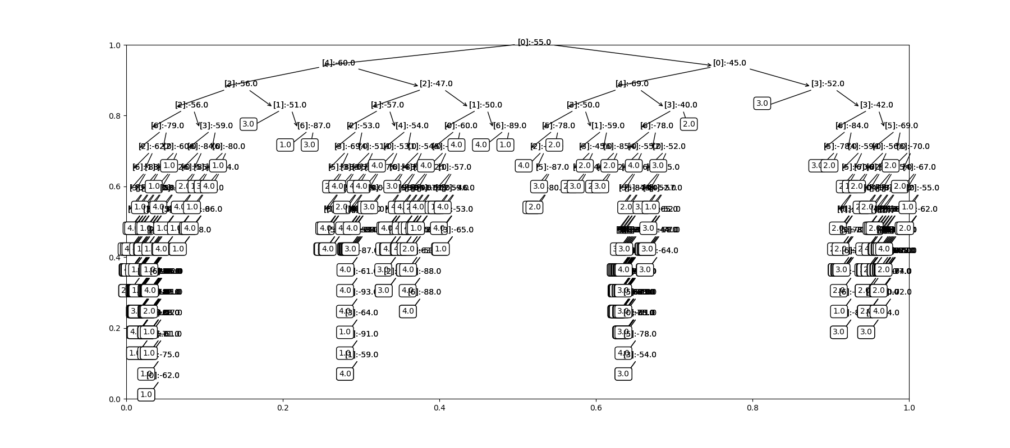Figure 1: decision tree without pruning
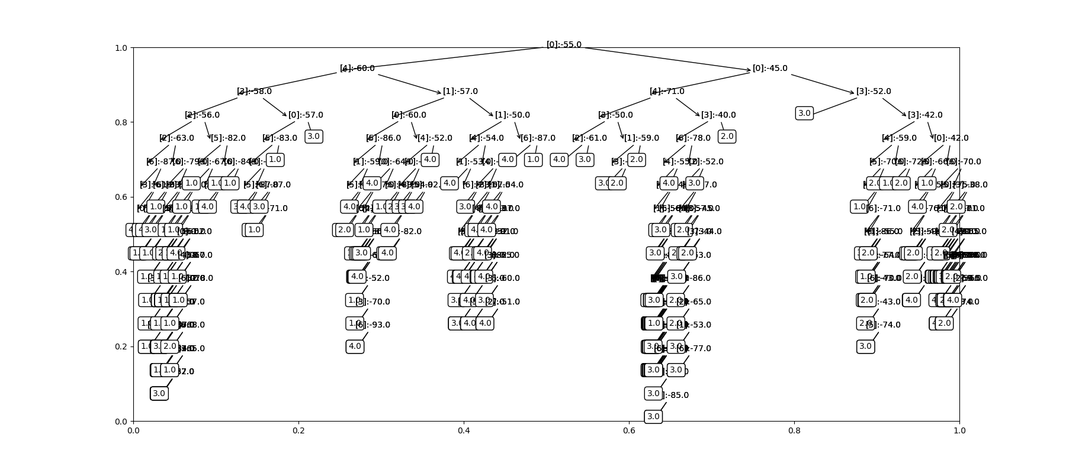Figure 2: decision tree with pruning

4 answers to questions

DIFFERENCE WHEN USING CLEAN DATA AND NOISY DATA

From the results in the table above, there is a significant difference in performance when using clean dataset and noisy dataset. The overall and per class performance on clean data is much higher than on noisy data. The reason of this performance difference is that the noisy data will cause the decision tree to make decision based on the noise rather than true data as the tree goes deeper.

Because the data is evenly distributed, the classification rate can be used to evaluate the performance of the model. Overall, the classification rate on clean data can be as high as 0.974 without pruning, whereas the classification rate on noisy data is only 0.800 before pruning.

The precision expresses the proportion of correctly predicted positive observations to the total predicted positive observations, while recall expresses the ratio of correctly predicted positive observations to all observations in the actual class. Precision is a measure of the exactness of the decision tree, a high precision means that a positive label is indeed positive (highly likely to be correct). Recall is a measure of the completeness of the classifier, a high recall means that there are only few incorrectly classified label and the class is correctly recognised.

Precision shows the same trend as recall. For noisy data, the precision and recall for all classes decreased. The recall value of Class 1 reduced the most, the precision value of Class 4 reduced the most. Class 2 is the most completed class in this tree. Class 1 still have the highest precision. The noisy data increased the difficulty of distinguish the classes, increased both false positive and false negative on each pair of data. Class 1 and Class 4 are affected the most. The reason behind might be that the features affect Class 1 and Class 4 have higher noise than others.

INFLUENCE OF PRUNING

How the pruning function is implemented:
1. store the accuracy of the current tree
2. search to find the pruning candidates, which are the nodes parent node of two leaf nodes
3. replace the parent node to leaf node and store the new tree
4. compare the accuracy of two trees, if new tree has higher accuracy, update new tree as the current tree and go back to step 1
On clean dataset, there’s only few change in the precision and recall which can be ignored. This shows that the cleaning data cannot be improved by pruning, the decision tree generated by clean data does not have overhitting problem, it learns the relevant features well.

On noisy data, the overall accuracy (classification rate) increased by 4%. The precision and recall increased after pruning for Class 1,2 and 3. However, the precision and recall for Class 4 decreased after pruning. Class 4 becomes more difficult to classify after pruning. Alternative method of preventing overhitting might be used to improve the performance further.

RELATION BETWEEN MAXIMAL DEPTH AND PREDICTION ACCURACY

The pruning function prevents overhitting by cutting the leaves of the decision tree. From the results shown in the experiments, the maximal depth of the tree generated for noisy data decreased and the prediction accuracy increased. Restrict the maximal depth of a decision tree during training can outcome overhitting problem, preventing the model from learning the noise of the features, thus increase the accuracy. Pruning does not have significant influence on the accuracy of tree generated for clean dataset but also shown that the accuracy increased slightly.

