# Installing Git on Windows

Go to <https://git-scm.com/downloads>, click on Windows, and follow the instructions given there.

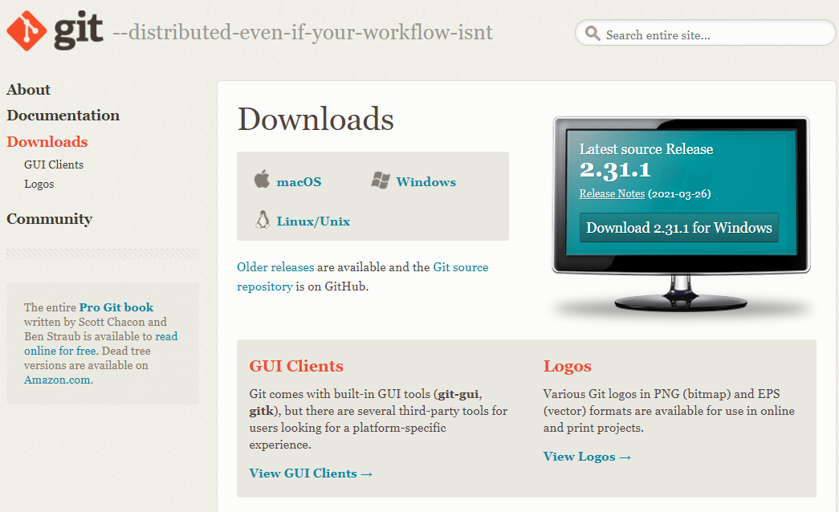

## Setup

Double-click on the Git-[version_number]-64-bit.exe executable that you just downloaded.

Assuming you’re using a university-owned computer, it may prompt you for an admin log-in - but your standard log-in for the computer should work as I don’t think Git needs any admin-only permissions.

Then the Git install window will appear.

Click “Next”.

## Components to install

It will offer you a list of components to install.

The options it suggests are sensible, and unless you have particular reason to want to change one you should leave them as they are.

For example Windows Explorer integration means you can navigate to directories in Windows Explorer, then open a Git Bash window there by right-clicking and selecting it from the menu, instead of having to navigate to the right directory within Git Bash. This saves time!

## Default text editor

Next it will ask what default text editor you would like Git to use.

In this tutorial we will use **Visual Studio Code**, so please select this. This is a nice text editor that you can also use as a graphical user interface for Git.

You can reconfigure this later, and we’ll show you how in the tutorial.

## Initial branch name

In June of 2020 Git released a [statement](https://sfconservancy.org/news/2020/jun/23/gitbranchname/).

While you are learning Git, we recommend you stick with “master” in order to reduce any possible confusion, since most online Git resources will not yet have updated to change this.

Within this tutorial we will refer to the default branch as “master”, but will provide instructions on how to change the branch name at a later point so you can use a name you’re comfortable with.

## PATH

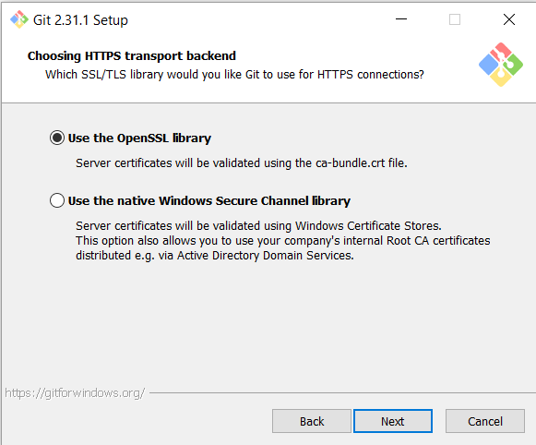Stick with the recommended option: “Git from the command line and also from 3rd-party software”.

## SSL

Stick with the default (“Use the OpenSSL library”) unless you have reason to do otherwise!

## Line endings

Again the default (“Checkout Windows-style, commit Unix-style line endings”) is good.

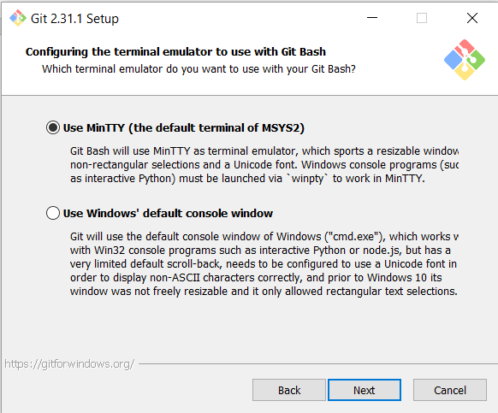

## Terminal emulator

## ‘Git pull’ behaviour

Stick with the default (“Default (fast-forward or merge)”)

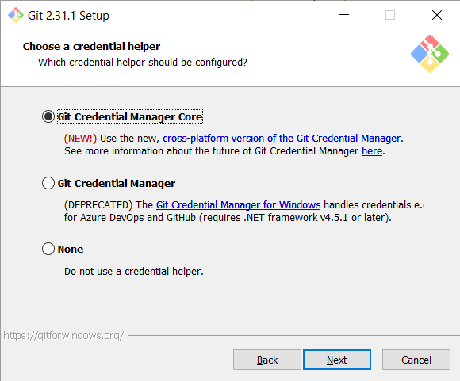

## Credential Manager

Stick with the default (“Git Credential Manager Core”)

## Extra options

Stick with the default - “enable file system caching”

## Experimental options

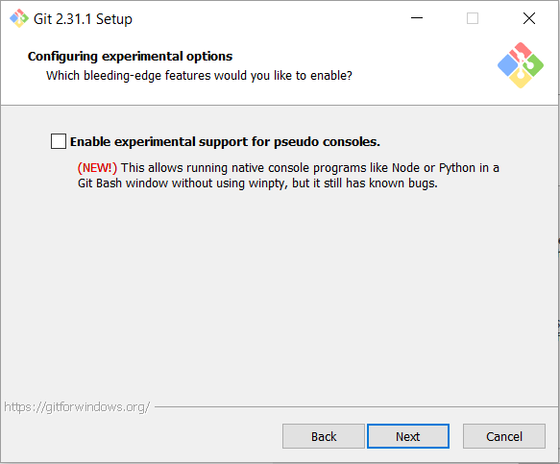Stick with the default (unselected).

When you click “Next” the actual installation will begin. This shouldn’t take long - a couple of minutes at most.

## Finish

We suggest that you untick “View Release Notes” as you probably don’t want to read these now!

Instead, select “Launch Git Bash” so you can see and familiarise yourself with the terminal window.

## The terminal

It should look like this, and will have opened in your home directory (indicated by the ~ in the line of coloured text).

The dollar sign indicates that you can begin typing commands here.

Go ahead and close it now, we’ll open a new one during the tutorial.

# Installing Visual Studio (VS) Code on Windows

Go to https://code.visualstudio.com/, click on ‘Download for Windows’, and follow the instructions given there.

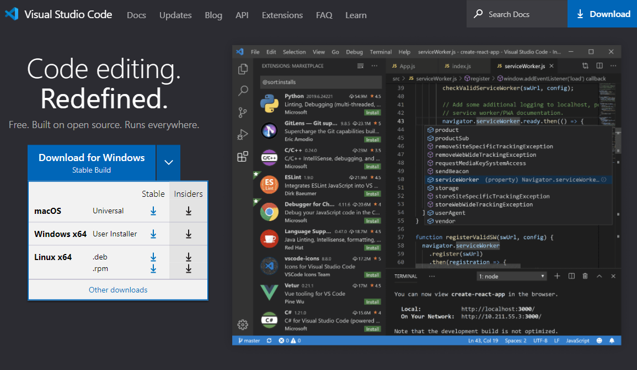

# Setup

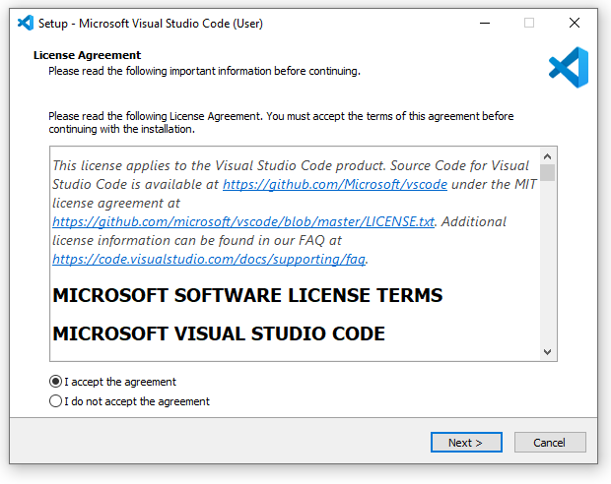Click “I accept the agreement” and ‘Next >’

# Extra Options

You should definitely add it to PATH. The others are up to you.

Click “Next >”

# Install

Click “Install” and then “Finish”!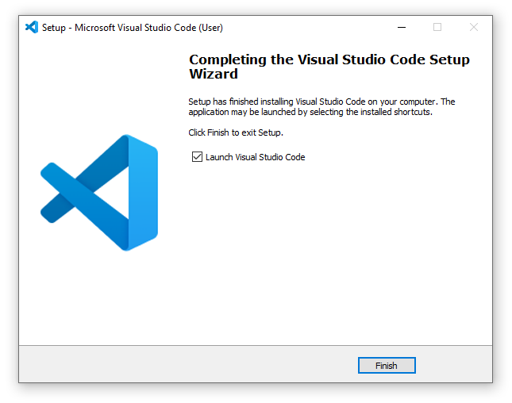

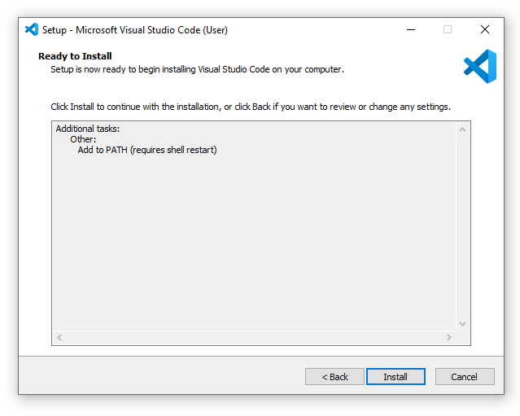

It will automatically open the visual studio code for you, which looks similar to below:

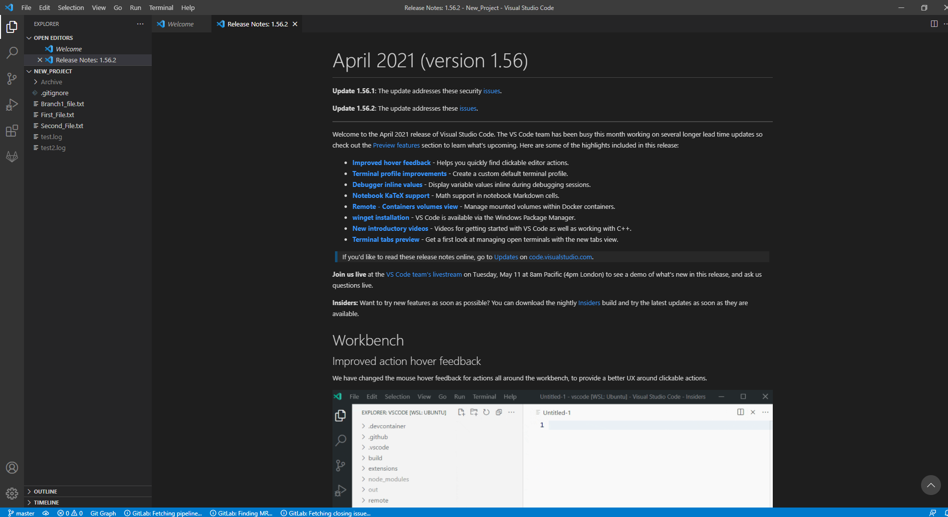

# Add Git graph extension

Down the left side of the window, there should be five icons. Select the bottom one, and it will open the marketplace toolbar. Search for “git graph” and install the extension underlined in red in the screenshot.

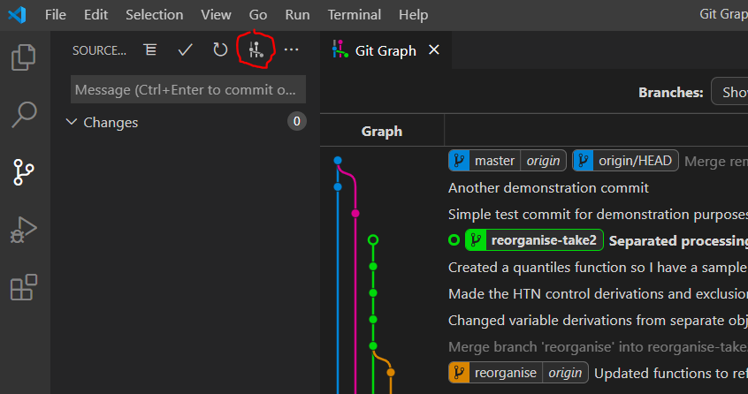Once it’s installed, when you go to the “Source control” pane in VS Code (third icon on left toolbar,), there should be an icon (circled in red in screenshot) which you can click to open up a tab, ‘Git Graph’.

Now you can close the window now, sit and relax, we’ll re-visit this during the tutorial ☺