Assignment1
Please submit your homework to both Canvas and the OJ system by October 11.
Please complete peer reviews for five classmates on Canvas between October 12 and October 18.
OJ System Tutorial：
Website: http://192.168.180.213:18080/d/cxsjfs2026fall/homework/
Access to the OJ system requires a connection to the campus network.
The username is cxsjfs2026 + your student ID, and the password is your student ID.
For example, if your student ID is 2500000, your username is cxsjfs20262500000, and your password is 2500000.
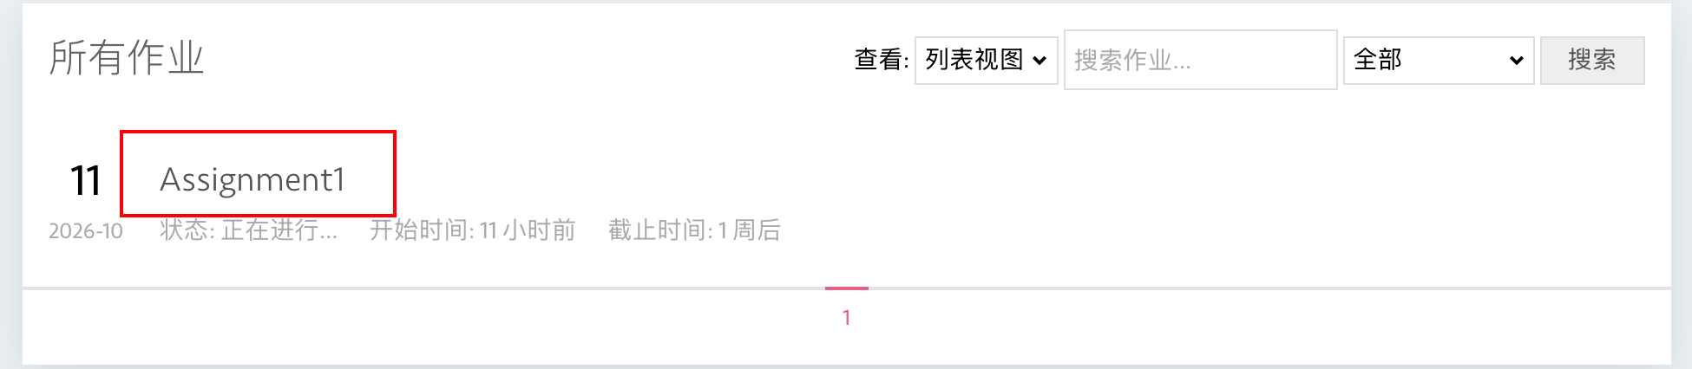
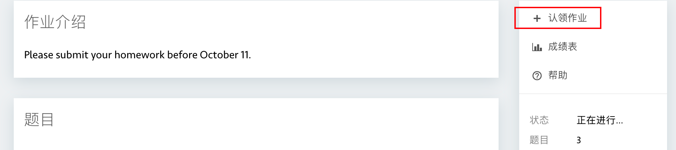

Problem 1: In-Place Prefix Sums

Description
Read n integers into a vector<long long>. First print the original vector. Then replace every element with the sum of all elements from the beginning of the vector through that position, and print the modified vector.
If the original vector is
2 -1 3 4 -2
then the modified vector is
2 1 4 8 6
because the values are 2, 2 + (-1), 2 + (-1) + 3, and so on.
The transformation must be performed in the same vector. Do not create a second vector to store the prefix sums.

Input Format
The input contains two lines:
- The first line contains an integer n, the number of elements.
- The second line contains n integers.

Output Format
Output two lines:
- The first line contains the original vector.
- The second line contains the vector after the in-place transformation.
Separate adjacent values with one space. Do not print an extra space at the end of a line.

Example
Input:
5
2 -1 3 4 -2
Output:
2 -1 3 4 -2
2 1 4 8 6

Constraints
1 <= n <= 100000
-1000000000 <= each input value <= 1000000000

Problem 2: Modifying a String Through a Pointer and a Reference

Description
Implement the following two functions:
void addPrefix(std::string* text);
void makeUppercase(std::string& text);
The function addPrefix must add CPP_ to the beginning of the original string object through a pointer.
The function makeUppercase must change every lowercase English letter in the original string object to its uppercase form through a reference. You may use std::toupper from <cctype>.
In main, read one non-empty string, print it, call addPrefix and print the result, then call makeUppercase and print the final result.
Do not return a new string from either function. Both functions must modify the original object.

Input Format
One non-empty string containing only lowercase English letters and digits, with no spaces.

Output Format
Output three lines:
- The original string.
- The string after calling addPrefix.
- The string after calling makeUppercase.

Example
Input:
homework1
Output:
homework1
CPP_homework1
CPP_HOMEWORK1

Constraints
1 <= text.length() <= 100

Problem 3: Maximum Profit from One Stock Transaction

Description
You are given an array prices, where prices[i] is the price of a stock on day i.
You may choose exactly one day to buy the stock and a different day in the future to sell it. Calculate the maximum profit that can be obtained from this transaction.
If no positive profit is possible, output 0.
The selling day must be later than the buying day. Your algorithm should run in O(n) time.

Input Format
The input contains two lines:
- The first line contains an integer n, the number of days.
- The second line contains n integers. The i-th integer is the stock price on day i.

Output Format
Output one integer: the maximum profit. If no profitable transaction is possible, output 0.

Example 1
Input:
6
7 1 5 3 6 4
Output:
5
Explanation: Buy on day 2 at price 1 and sell on day 5 at price 6. The profit is 6 - 1 = 5.

Example 2
Input:
5
7 6 4 3 1
Output:
0
Explanation: The price never rises after an earlier day, so no profitable transaction is possible.

Constraints
1 <= n <= 100000
0 <= prices[i] <= 10000

