**Question 1:**

Created local user ‘laujunxiang’ and granted privileges.

Show granted privileges given for the newly created local user.

Question 2:

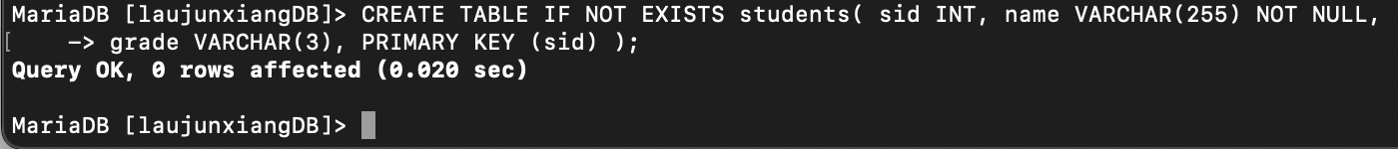

Question 3:

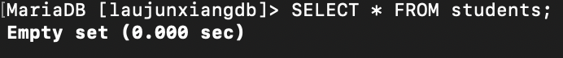

Question 4:

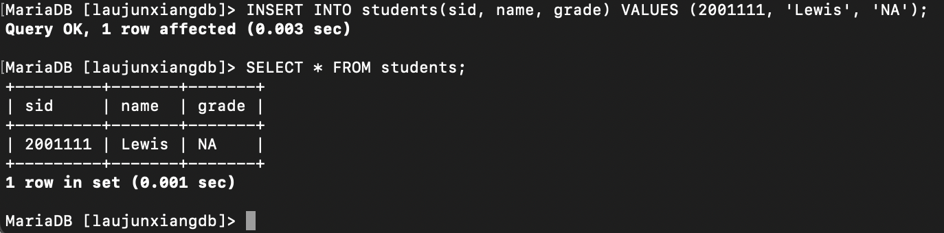

Inserted user into students table.

Inserted more users into the students table.

Question 5:

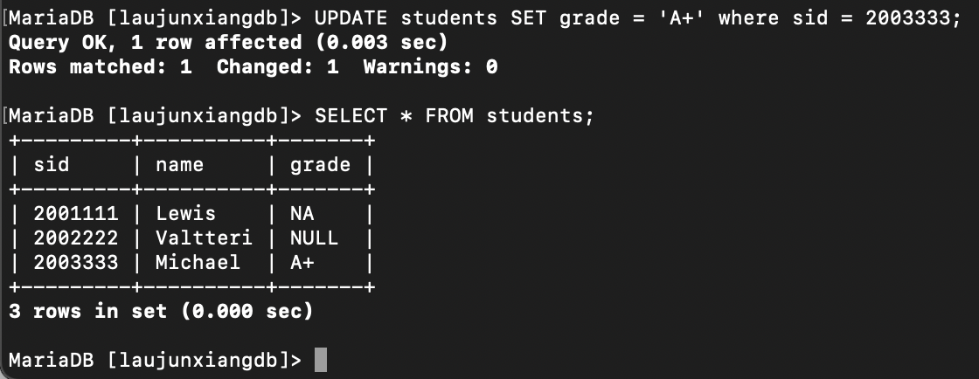

Updated Michael with grade A+

Updated Valtteri with grade A-

Question 6:

Deleted Valtteri from students table

Delete all users inside the table

Delete students table

Delete laujunxiangDB database