单目图像

去畸变问题
imshow("src img", image);
// Mat cameraMatrix = Mat::eye(3, 3, CV_64F);
// //内参矩阵, 就算复制代码，也不要用我的参数。摄像头都不一样...
// cameraMatrix.at<double>(0, 0) = 2.075319928848340e+03;
// cameraMatrix.at<double>(0, 1) = 0;
// cameraMatrix.at<double>(0, 2) = 1.273350420020438e+03;
// cameraMatrix.at<double>(1, 1) = 2.073416138777327e+03;
// cameraMatrix.at<double>(1, 2) = 6.898818022397845e+02;
// //畸变参数，不要用我的参数~
// Mat distCoeffs = Mat::zeros(5, 1, CV_64F);
// distCoeffs.at<double>(0, 0) = 0.005961692158170;
// distCoeffs.at<double>(1, 0) = 0.014892085926656;
// distCoeffs.at<double>(2, 0) = -0.007714274148788;
// distCoeffs.at<double>(3, 0) = -0.010548832296675;
// distCoeffs.at<double>(4, 0) = 0;
Mat view, rview, map1, map2;
Size imageSize;
imageSize = image.size();
initUndistortRectifyMap(cameraMatrix, distCoeffs, Mat(),
getOptimalNewCameraMatrix(cameraMatrix, distCoeffs, imageSize, 1, imageSize, 0),
imageSize, CV_16SC2, map1, map2);
remap(image, image, map1, map2, INTER_LINEAR);
imshow("dst img", image);

double camD[9] = {1500.8,0, 643.4475,
0, 1505.8, 375.6045,
0, 0, 1};
double distCoeffD[5] = {-0.3946,0.2691,-0.2266 ,0.0016,-0.0010 };//USB
Mat cameraMatrix = Mat(3,3,CV_64FC1,camD);//cameraMatrix, distCoeffs
Mat distCoeffs = Mat(5,1,CV_64FC1,distCoeffD);
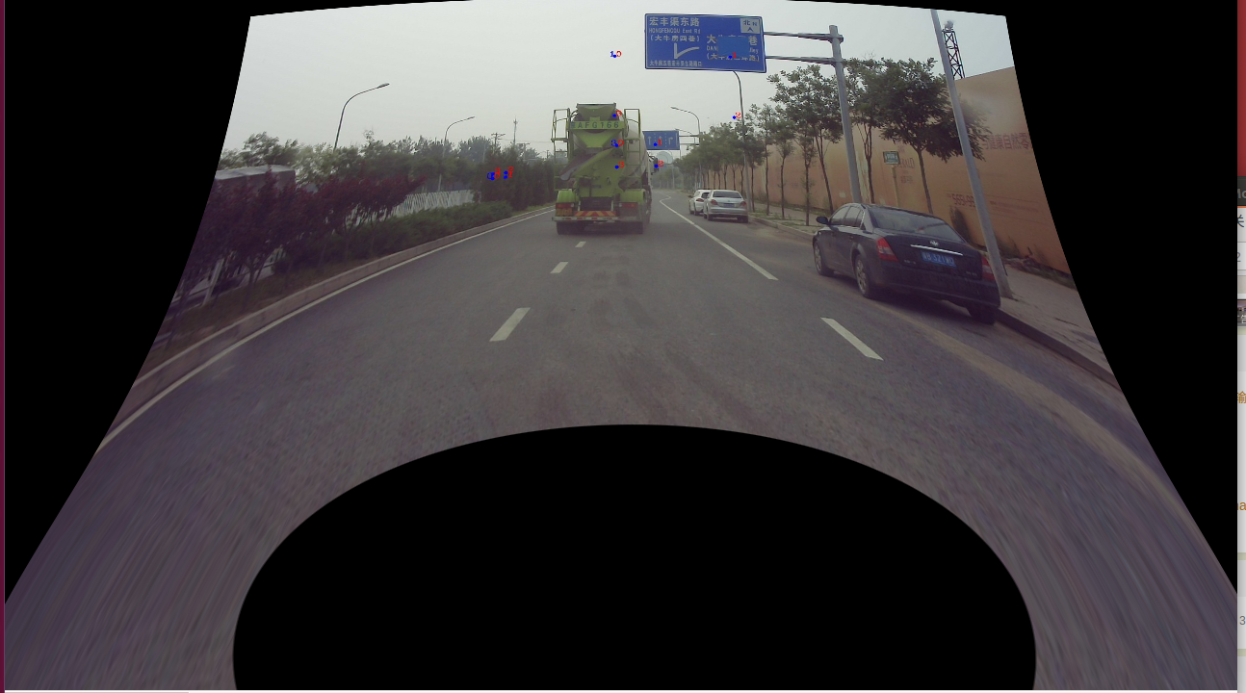

double camD[9] = {1501.09863931536,0, 644.3339,
0, 1506.20933393587, 377.2849,
0, 0, 1};
double distCoeffD[5] = {-0.3926,0.2494,-0.1475,0.000699584,-0.00133701813};
Mat cameraMatrix = Mat(3,3,CV_64FC1,camD);//cameraMatrix, distCoeffs
Mat distCoeffs = Mat(5,1,CV_64FC1,distCoeffD);

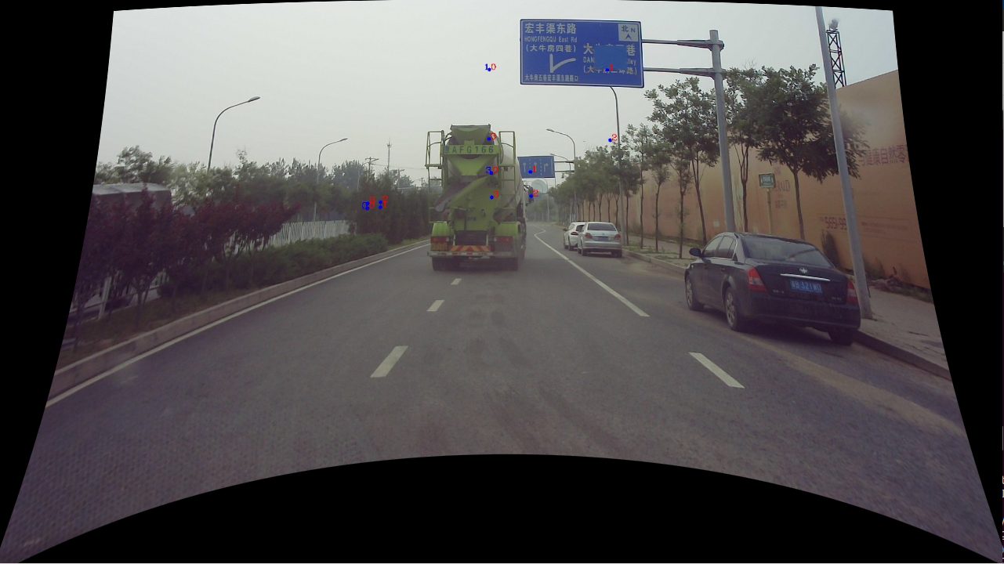

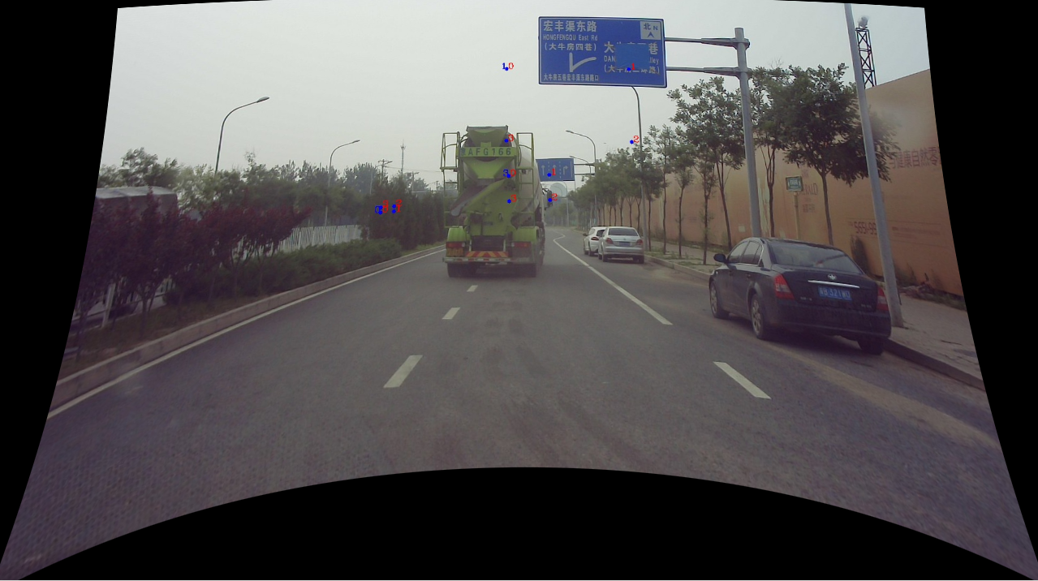

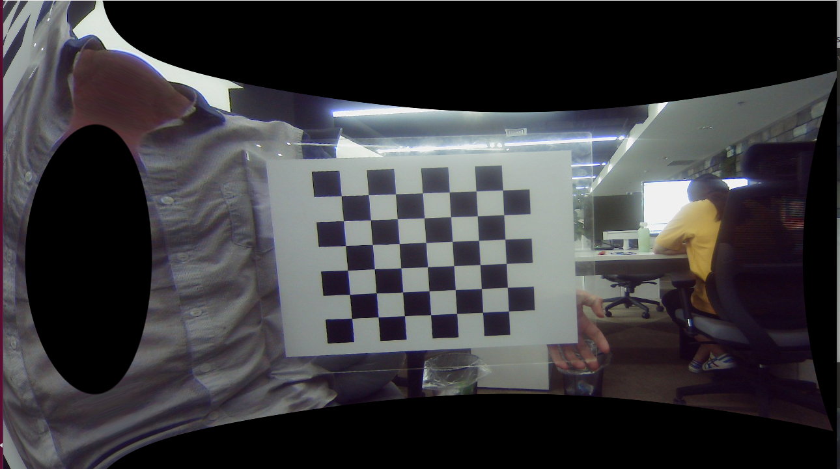

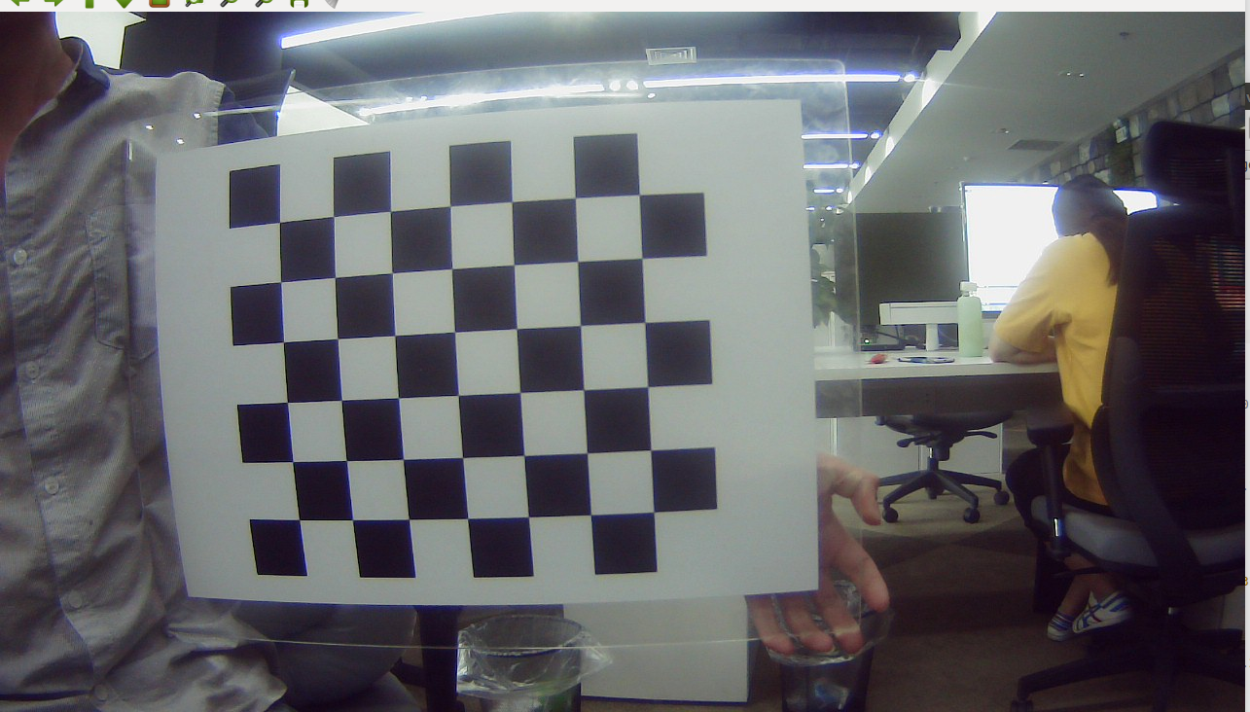

图片畸变矫正 -MATLAB矫正
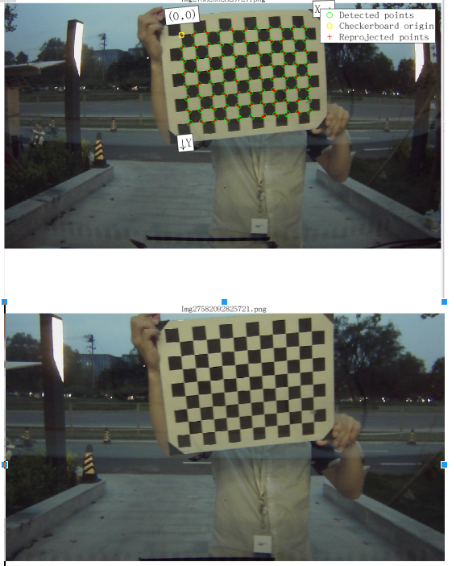

图片畸变矫正-opencv矫正

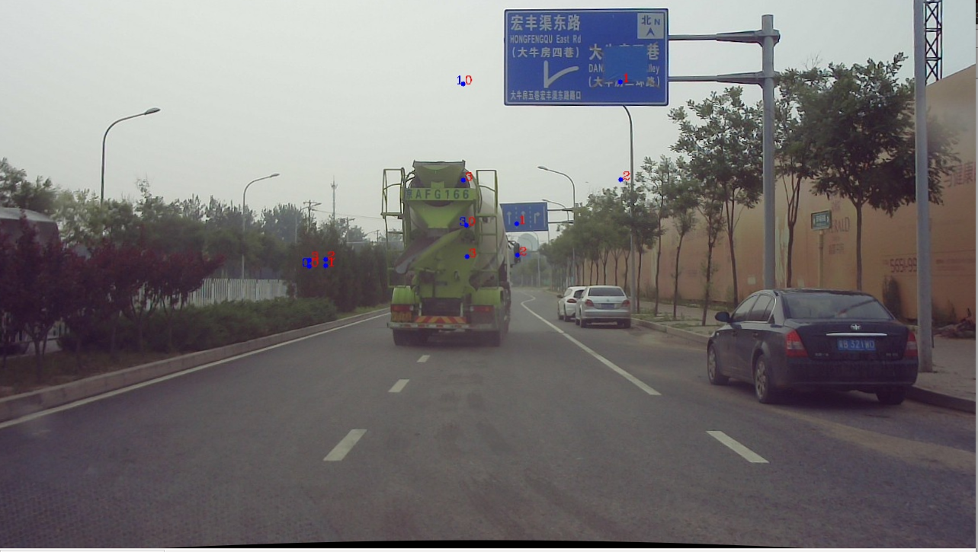
void Undistort_img(Mat map1, Mat map2, char *path)
{
Mat img1, img2;
img1 = imread(path);
if (img1.empty()) cout << "Cannot open the image" << endl;
remap(img1, img2, map1, map2, INTER_LINEAR);
// imwrite(path, img2);
imshow("src img", img1);
imshow("dst img", img2);
waitKey();
}

// 去畸变至全图
initUndistortRectifyMap(cameraMatrix, distCoeffs, Mat(), Mat(),
imageSize, CV_16SC2, map1, map2);

Undistort_img(map1, map2, "../src_image/1690.jpg");

// 去畸变并保留最大图
initUndistortRectifyMap(cameraMatrix, distCoeffs, Mat(),
getOptimalNewCameraMatrix(cameraMatrix, distCoeffs, imageSize, 1, imageSize, 0),
imageSize, CV_16SC2, map1, map2);

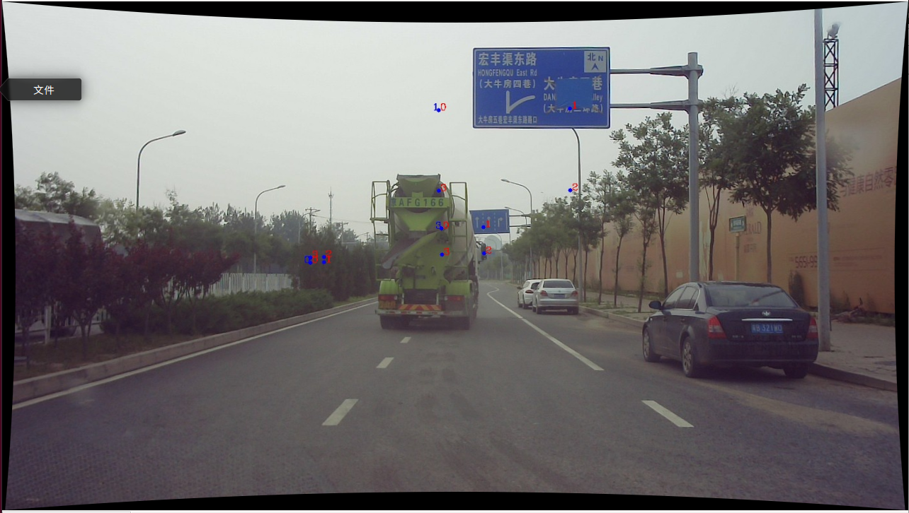

// // /* --------------------- 方法1--直接 undistort---------------------*/

Mat dstMat;
undistort(rawImg,dstMat,cameraMatrix, distCoeffs);//distCoeffs
imshow("undis_image",dstMat);
imwrite("../dst_image/1690_undistort.jpg", dstMat);


