Sofia_Tool Instructor

1. Design requirement
2. Modem Crash---count the number of key

U:\15-04-2016\buildname\rackname\PhoneDoctor_Logs\histroy_event

1. Resets---count the number of folders

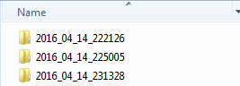

1. Ciritcal issues---count the number of crashlog which has the key

U:\15-04-2016\buldname\rackname\Application_Logs\Campaign

1. U:\15-04-2016\buildname\rackname\PhoneDoctor_Logs

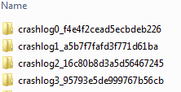

1. Code analysis

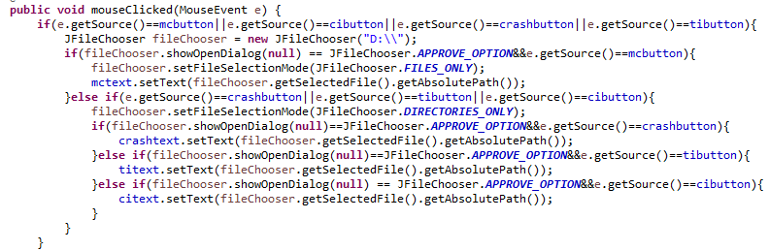

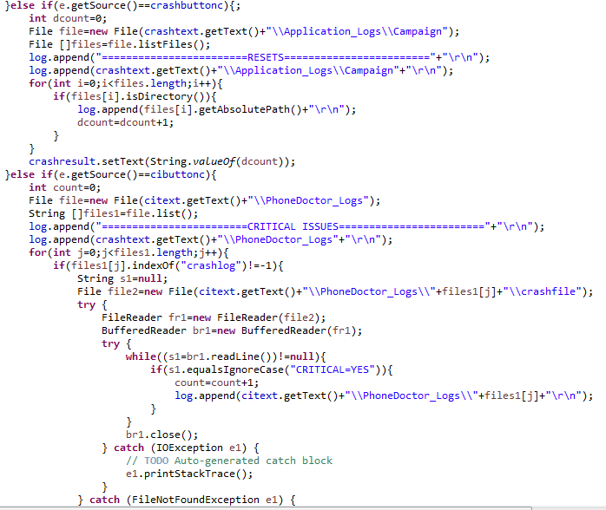

1. GUI

