深度学习背景介绍
https://blog.csdn.net/yingyujianmo/article/details/44945083
https://bbs.aliyun.com/detail/333316.html
https://www.csdn.net/gather_23/MtTaggysMTY4OS1ibG9n.html
http://www.aboutyun.com/thread-16597-1-1.html
http://www.360doc.com/content/14/0402/21/10724725_365831103.shtml
http://www.aboutyun.com/thread-16598-1-1.html
http://www.cnblogs.com/misszhu-home/p/5723268.html （这一篇在网上重复率，适合往论文里写）

算法介绍
https://blog.csdn.net/google19890102/article/details/49736619?utm_source=blogxgwz6
https://www.cnblogs.com/charlotte77/p/7759802.html
https://www.cnblogs.com/captain_ccc/articles/4305001.html
https://blog.csdn.net/qq_37471316/article/details/80644465
https://www.jianshu.com/p/3421bca14ddf

深度算法流程
https://blog.csdn.net/weixin_42398658/article/details/83929474

原理图
https://www.cnblogs.com/xyou/p/9353118.html

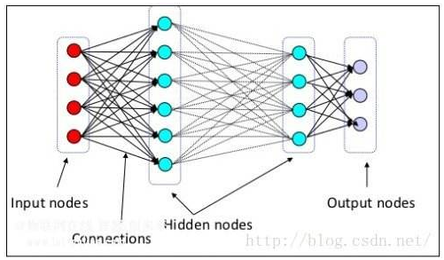

目前深度学习框架
http://baijiahao.baidu.com/s?id=1599943447101946075&wfr=spider&for=pc

