预算中出现的问题

1. 进入预算系统经常有人反映出现异常现象（2天）

用户审批流设置重复或者错误经常会出现该问题，重新检查审批流。

计划时间

20160713----20160714

1. ~~预算调整系统反应迟缓（太慢）~~

~~科目过多，网速，服务器配置，客户端配置等因素都会影响系统反应速度。~~

~~程序优化（2天）~~

1. *~~学员退费单据不能导出Excel表格（未按我方要求格式，小吕知道,格式见EXCEL附件）（3天）已更新~~

修改文件：

/webBill/bxgl/jkdFrame_Dz.aspx

计划时间

20160715----20160717



1. ~~*泰安大智打印预览报销单表头会出现乱码情况~~

~~（0.5天）~~

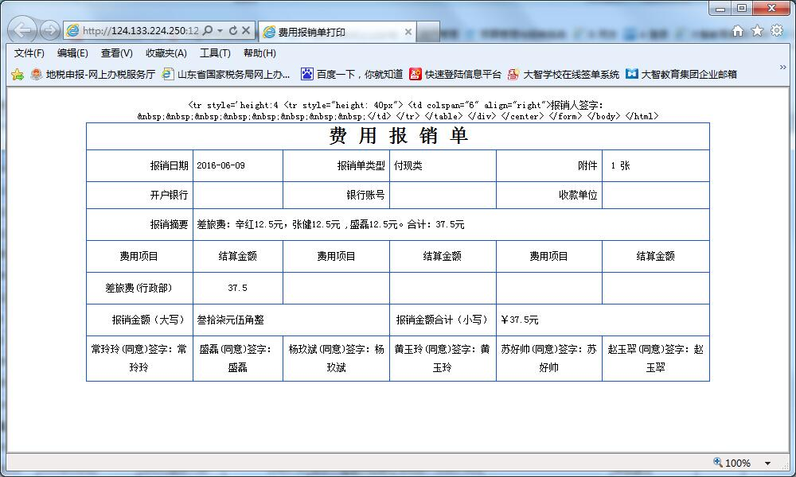

1. （0.5天）
2. 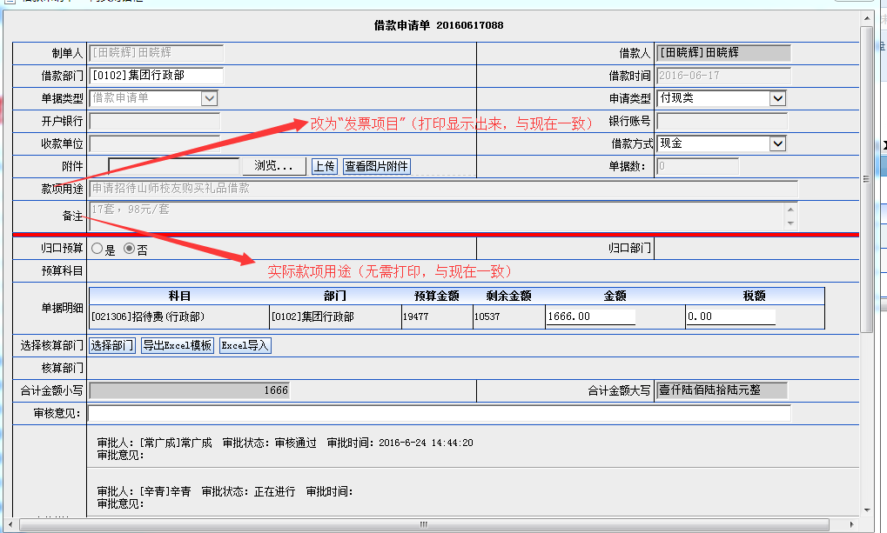

~~以上2个项目需要各改为“发票项目”和“实际款项用途”。~~

6.需变更如下：（0.5天）

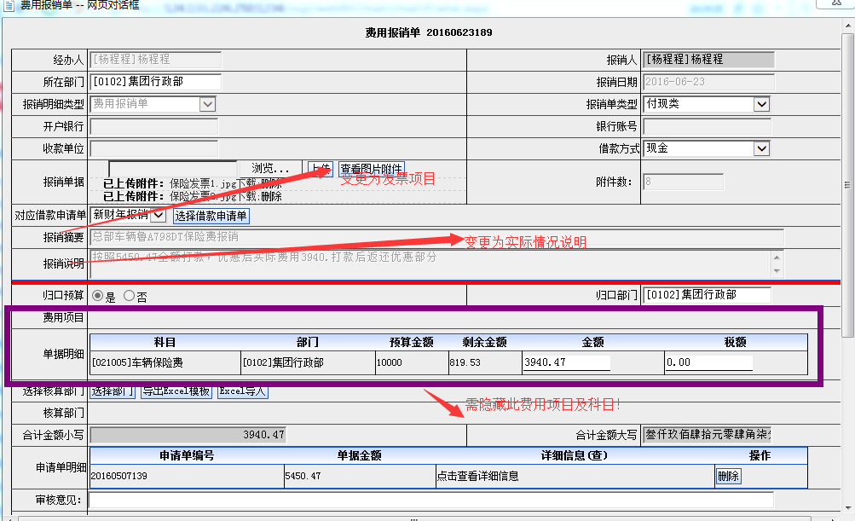

1. ~~借款单和报销单请将审批时间设置为可打印，目前无法打印。（1天）~~

=========新加功能

8．期间需由财年改为自然年，请估计工作量。（18天）---待测试

计划时间

20160718----20160806

添加三个月度进行追加预算

9. ~~退费调整：（4天）~~

~~退费之间的调整只不允许科目之间进行调整，不受预算管控，不占用总预算，只进行月份之间调整~~

~~计划时间~~

~~20160807---20160810~~

修改文件：

Bll/Newysgl/YsglMainBll

Dal/ SysDictionary/ YskmDal

webBill/ysgl/ystz_tf_dz.aspx?isdz=1

webBill/ysgl/tf_ystzDetail_dz.aspx

数据库修改：

0808 退费调整单 退费调整单 ../ysgl/ystz_tf_dz.aspx?isdz=1 807 NULL NULL

10.导出预算差异执行情况及预算统计的时候不能 按分校部门汇总（现在是按科目汇总），须按分校汇总的合计数、按部门汇总的合计数（4.5天）

计划时间

20160811---20160815

修改文件

webBill/tjbb_dz/fyqkListTable_new.aspx

数据修改

数据库修改：

新增bill_pro_fyqkb_new_dz

ALTER procedure [dbo].[bill_pro_fyqkb_new_dz](

@kssj datetime, --始时间

@jzsj datetime, --至日期

@deptcode varchar(150), --部门编号，空时指所有单位

@djzt varchar(4), --单据状态，-1未审核，end已审核，不限

@dydj varchar(50),--对应单据如果是null 默认

@ismj varchar(50)--是否预算到末级

)

as

begin

declare @nd varchar(4)

declare @index int

declare @sql varchar(4000)

declare @ysflowid varchar(50) ---预算flowid

declare @flowid varchar(50)--决算flowid

declare @deczyje decimal(18,4)--占用金额

declare @ndeczyje decimal(18,4)--年占用金额

--如果是费用类的直接对应费用报销单(yksq_dz)

if @dydj='02'

begin

set @flowid='yksq_dz'

end

else

begin

set @flowid=(select note2 from bill_dataDic where dictype='18' and diccode=@dydj)

end

set @nd=(select top 1 nian from bill_ysgc where kssj<=@kssj and jzsj>=@jzsj)--left(convert(varchar(8),@kssj,112),4)

create table #Yue(yue varchar(2))

insert into #Yue select yue from bill_ysgc where kssj>=@kssj and jzsj<=@jzsj and isnull(yue,'')!=''

--select * from #yue

--return

--set @index=@ksyf

--while @index<=@jzyf

-- begin

-- insert into #Yue values(cast(@index as varchar(2)))

-- set @index=@index+1

-- end

-- 编号 编码 名称 年初预算金额 本期报销金额 追加金额 调整出金额 调整入金额 结余金额 年度预算 年追加 年报销 年结余 本期占用金额 占用未报销金额 年占用金额 年占用未报销金额, 本期预算 预算执行率

create table #table(yskmCode varchar(50),yskmBm varchar(50),yskmMc varchar(200),je float ,bxje float ,zjje float, tzcje float, tzrje float,jyje float,nysje float,nzjje float,nbxje float,njyje float,zyje decimal(18,4),zysyje decimal(18,4), nzyje decimal(18,4),nzysyje decimal(18,4),bqys decimal(18,4),yszxl decimal(18,4))

insert into #table(yskmCode,yskmMc) values ('','合计')

create table #dept(code varchar(10) null )

if @deptcode=''

begin

if @ismj='Y'

begin

insert into #table(yskmCode,yskmMc,je,bxje,zjje,tzcje,tzrje,jyje,nysje,nzjje,nbxje,njyje,bqys)

select deptCode,deptName,0,0,0,0,0,0,0,0,0,0,0

from bill_departments

where deptCode in (select deptCode from bill_departments where sjDeptCode!=

(select deptCode from bill_departments where sjDeptCode='')) and sjDeptCode!=''

and deptcode in ( select deptcode from bill_yskm_dept dept,bill_yskm yskm where dept.yskmcode=yskm.yskmcode and yskm.dydj=@dydj )

end

if @djzt='0' --所有状态

begin

--年初预算数据+@ysflowid+

set @sql='update #table set je=( select sum(billje) from bill_main where flowid in (''ys'',''xmys'')

and billname in (select gcbh from bill_ysgc where nian='+@nd+' and ystype=''2''

and yue in (select yue from #Yue)) and billdept=#table.yskmCode)'

exec(@sql)

----本期预算(最终预算)

-- set @sql='update #table set bqys=(select sum(ysje) from bill_ysmxb

-- where gcbh in (select gcbh from bill_ysgc where nian='+@nd+' and ystype=''2''

-- and yue in (select yue from #Yue)) and yskm=#table.yskmCode)'

-- exec(@sql)

--追加预算

set @sql='update #table set zjje=(select sum(billje) from bill_main where flowid=''yszj'' and dydj='+@dydj+' and billname in (select gcbh from bill_ysgc where nian='+@nd+' and ystype=''2'' and yue in (select yue from #Yue)) and billdept=#table.yskmCode)'

exec(@sql)

--调整预算出

--（调整预算出/预算调整）

update #table set tzcje=isnull((select sum(isnull(ysje,0)) from bill_ysmxb

where billcode in (select billcode from bill_main where flowid='ystz' and dydj=@dydj)

and ysje<0 and gcbh in (select gcbh from bill_ysgc where nian=@nd and ystype='2' and yue in (select yue from #Yue))

-- )

and ysdept=#table.yskmCode),0)

--（调整预算出/科目预算调整）

update #table set tzcje=tzcje+isnull((select sum(isnull(ysje,0)) from bill_ysmxb

where billcode in (select billcode from bill_main where flowid='kmystz' and dydj=@dydj)

and ysje<0 and gcbh in (select gcbh from bill_ysgc where nian=@nd and ystype='2' and yue in (select yue from #Yue))

and ysdept=#table.yskmCode),0)

update #table set tzcje=-tzcje

--调整预算入

--(调整预算入/预算调整)

update #table set tzrje=isnull((select sum(isnull(ysje,0)) from bill_ysmxb

where billcode in (select billcode from bill_main where flowid='ystz' and dydj=@dydj)

and ysje>0 and gcbh in (select gcbh from bill_ysgc where nian=@nd and ystype='2' and yue in (select yue from #Yue))

and ysdept=#table.yskmCode),0)

--(调整预算入/科目预算调整)

update #table set tzrje=tzrje+isnull((select sum(isnull(ysje,0)) from bill_ysmxb

where billcode in (select billcode from bill_main where flowid='kmystz' and dydj=@dydj)

and ysje>0 and gcbh in (select gcbh from bill_ysgc where nian=@nd and ystype='2' and yue in (select yue from #Yue))

and ysdept=#table.yskmCode),0)

--报销数据

update #table set bxje=isnull((select sum(je) from bill_ybbxmxb_fykm

where billcode in (

select billcode from bill_main

where flowid in (@flowid,'qtbx','tfsq')

and billdate>=cast(@kssj as datetime)

and billdate<=(cast(@jzsj as datetime)+' 23:59:59')

and (

billcode in (select billcode from bill_ybbxmxb where bxmxlx in (select diccode from bill_datadic where dictype='02' and isnull(cjys,'1')='1'))

)

and isnull(note4,'否')='是'

and gkdept=#table.yskmCode

)),0)

----占用金额

update #table set zyje=isnull((select sum(je) from bill_ybbxmxb_fykm

where billcode in (

select billcode from bill_main

where flowid in ('ybbx','qtbx','tfsq')

and billdate>=cast(@kssj as datetime)

and billdate<=(cast(@jzsj as datetime)+' 23:59:59')

and (

billcode in (select billcode from bill_ybbxmxb where bxmxlx in (select diccode from bill_datadic where dictype='02' and isnull(cjys,'1')='1'))

)

and isnull(note4,'否')='是'

and billName not in( select yksq_code from dz_yksq_bxd )

and gkdept=#table.yskmCode

)),0)

--占用未报销金额

update #table set zysyje=ISNULL(zyje,0)

--结余金额

update #table set jyje=isnull(je,0)+isnull(zjje,0)+isnull(tzrje,0)-isnull(tzcje,0)-isnull(bxje,0)

--年预算

update #table set nysje=isnull((select isnull(sum(billje),0)

from bill_main where flowid in ('ys','xmys') and billname in (select gcbh from bill_ysgc where nian=@nd and ystype='2')

and billdept=#table.yskmCode),0)

--报销数据

update #table set nbxje=isnull((select sum(je) from bill_ybbxmxb_fykm

where billcode in (

select billcode from bill_main

where flowid in (@flowid,'qtbx','tfsq')

and billdate>=(select kssj from bill_ysgc where ysType='0' and nian=@nd)

and billdate<=( select jzsj from bill_ysgc where ysType='0' and nian=@nd)

and (

billcode in (select billcode from bill_ybbxmxb where bxmxlx in (select diccode from bill_datadic where dictype='02' and isnull(cjys,'1')='1'))

)

and isnull(note4,'否')='是'

and gkdept=#table.yskmCode

)),0)

----年度用款申请单占用金额

update #table set nzyje=isnull((select sum(je) from bill_ybbxmxb_fykm

where billcode in (

select billcode from bill_main

where flowid in ('ybbx','qtbx','tfsq')

and billdate>=(select kssj from bill_ysgc where ysType='0' and nian=@nd)

and billdate<=( select jzsj from bill_ysgc where ysType='0' and nian=@nd)

and (

billcode in (select billcode from bill_ybbxmxb where bxmxlx in (select diccode from bill_datadic where dictype='02' and isnull(cjys,'1')='1'))

)

and isnull(note4,'否')='是'

and billName not in( select yksq_code from dz_yksq_bxd )

and gkdept=#table.yskmCode

)),0)

---年占用未报销金额

update #table set nzysyje=ISNULL(nzyje,0)

--年追加

update #table set nzjje=isnull((select isnull(sum(billje),0)

from bill_main

where flowid='yszj' and dydj=@dydj

and billdate>=(select kssj from bill_ysgc where ysType='0' and nian=@nd)

and billdate<=( select jzsj from bill_ysgc where ysType='0' and nian=@nd)

--and left(convert(varchar(8),billdate,112),4)=@nd

and billdept=#table.yskmCode ),0)

--年结余

update #table set njyje=isnull(nysje,0)+isnull(nzjje,0)-isnull(nbxje,0)

end

else

begin

--年初预算数据

update #table set je=(select sum(billje) from bill_main where flowid in ('ys','xmys') and dydj=@dydj and stepid=@djzt

and billname in (select gcbh from bill_ysgc where nian=@nd and ystype='2' and yue in (select yue from #Yue))

and billdept=#table.yskmCode)

--本期预算数据除了预算的还得加上预算内追加的因为预算内追加的是直接去修改预算了而是flowid='ysnzj' 明细表状态为

update #table set je=je+(select isnull(sum(billje),0) from bill_main where flowid='ysnzj' and dydj=@dydj

and stepid='end' and billname in (select gcbh from bill_ysgc where nian=@nd and ystype='2'

and yue in(select yue from #Yue)) and billdept=#table.yskmCode)

--本期预算（最终）

--update #table set

-- bqys=(select sum(ysje) from bill_ysmxb

-- where gcbh in (select gcbh from bill_ysgc where nian=@nd

-- and ystype='2' and yue in (select yue from #Yue)

-- )

-- and yskm=#table.yskmCode

-- and billCode in (select billcode from dbo.bill_main where stepid=@djzt)

-- )

--set @sql='update #table set bqys=(select sum(ysje) from bill_ysmxb

-- where gcbh in (select gcbh from bill_ysgc where nian='+@nd+' and ystype=''2''

--and yue in (select yue from #Yue)) and yskm=#table.yskmCode)'

-- exec(@sql)

--追加预算

update #table set zjje=(select sum(billje) from bill_main where flowid='yszj' and dydj=@dydj

and stepid=@djzt and billname in (select gcbh from bill_ysgc where nian=@nd and ystype='2'

and yue in (select yue from #Yue)) and billdept=#table.yskmCode)

--调整预算出

--（调整预算出/预算调整）

update #table set tzcje=isnull((select sum(isnull(ysje,0)) from bill_ysmxb

where billcode in (select billcode from bill_main where flowid='ystz' and dydj=@dydj and stepid=@djzt )

and ysje<0 and gcbh in (select gcbh from bill_ysgc where nian=@nd and ystype='2' and yue in (select yue from #Yue))

and ysdept=#table.yskmCode),0)

--（调整预算出/科目预算调整）

update #table set tzcje=tzcje+isnull((select sum(isnull(ysje,0)) from bill_ysmxb

where billcode in (select billcode from bill_main where flowid='kmystz' and dydj=@dydj and stepid=@djzt )

and ysje<0 and gcbh in (select gcbh from bill_ysgc where nian=@nd and ystype='2' and yue in (select yue from #Yue))

and ysdept=#table.yskmCode),0)

update #table set tzcje=-tzcje

--调整预算入

--(调整预算入/预算调整)

update #table set tzrje=isnull((select sum(isnull(ysje,0)) from bill_ysmxb

where billcode in (select billcode from bill_main where flowid='ystz' and dydj=@dydj and stepid=@djzt )

and ysje>0 and gcbh in (select gcbh from bill_ysgc where nian=@nd and ystype='2' and yue in (select yue from #Yue))

and ysdept=#table.yskmCode),0)

--(调整预算入/科目预算调整)

update #table set tzrje=tzrje+isnull((select sum(isnull(ysje,0)) from bill_ysmxb

where billcode in (select billcode from bill_main where flowid='kmystz' and dydj=@dydj and stepid=@djzt )

and ysje>0 and gcbh in (select gcbh from bill_ysgc where nian=@nd and ystype='2' and yue in (select yue from #Yue))

and ysdept=#table.yskmCode),0)

--报销数据

update #table set bxje=isnull((select sum(je) from bill_ybbxmxb_fykm

where billcode in (

select billcode from bill_main

where flowid in (@flowid,'qtbx','tfsq')

and stepid=@djzt

and billdate>=cast(@kssj as datetime)

and billdate<=(cast(@jzsj as datetime)+' 23:59:59')

and (

billcode in (select billcode from bill_ybbxmxb where bxmxlx in (select diccode from bill_datadic where dictype='02' and isnull(cjys,'1')='1'))

)

and isnull(note4,'否')='是'

and gkdept=#table.yskmCode

)),0)

----本期用款申请单占用但是没报销的金额

update #table set zyje=isnull((select sum(je) from bill_ybbxmxb_fykm

where

billcode in (

select billcode from bill_main

where flowid in ('ybbx','qtbx','tfsq')

and stepid=@djzt

and billdate>=cast(@kssj as datetime)

and billdate<=(cast(@jzsj as datetime)+' 23:59:59')

and (

billcode in (select billcode from bill_ybbxmxb where bxmxlx in (select diccode from bill_datadic where dictype='02' and isnull(cjys,'1')='1'))

)

and isnull(note4,'否')='是'

and billName not in( select yksq_code from dz_yksq_bxd )

and gkdept=#table.yskmCode

)),0)

----

---占用未报销金额

update #table set zysyje=ISNULL(zyje,0)

--结余金额

update #table set jyje=isnull(je,0)+isnull(zjje,0)+isnull(tzrje,0)-isnull(tzcje,0)-isnull(bxje,0)

--年预算

update #table set nysje=(select sum(isnull(billje,0))

from bill_main where flowid in ('ys','xmys') and stepid=@djzt and billname in

(select gcbh from bill_ysgc where nian=@nd and ystype='2') and billdept=#table.yskmCode)

--本期预算数据除了预算的还得加上预算内追加的因为预算内追加的是直接去修改预算了而是flowid='ysnzj' 明细表状态为

update #table set nysje=nysje+isnull((select sum(isnull(billje,0))

from bill_main where flowid='ysnzj' and dydj=@dydj and stepid=@djzt

and billname in (select gcbh from bill_ysgc where nian=@nd and ystype='2')

and billdept=#table.yskmCode),0)

--年报销

update #table set nbxje=isnull((select sum(je) from bill_ybbxmxb_fykm

where billcode in (

select billcode from bill_main

where flowid in (@flowid,'qtbx','tfsq')

and stepid=@djzt

and billdate>=(select kssj from bill_ysgc where ysType='0' and nian=@nd)

and billdate<=( select jzsj from bill_ysgc where ysType='0' and nian=@nd)

--and left(convert(varchar(8),billdate,112),4)=@nd

and (

billcode in (select billcode from bill_ybbxmxb where bxmxlx in (select diccode from bill_datadic where dictype='02' and isnull(cjys,'1')='1'))

)

and isnull(note4,'否')='是'

and gkdept=#table.yskmCode

)),0)

----年度用款申请单占用但是没报销的金额

update #table set nzyje=isnull((select sum(je) from bill_ybbxmxb_fykm

where billcode in (

select billcode from bill_main

where flowid in ('ybbx','qtbx','tfsq')

and stepid=@djzt

and billdate>=(select kssj from bill_ysgc where ysType='0' and nian=@nd)

and billdate<=( select jzsj from bill_ysgc where ysType='0' and nian=@nd)

--and left(convert(varchar(8),billdate,112),4)=@nd

and (

billcode in (select billcode from bill_ybbxmxb where bxmxlx in (select diccode from bill_datadic where dictype='02' and isnull(cjys,'1')='1'))

)

and isnull(note4,'否')='是'

and billName not in( select yksq_code from dz_yksq_bxd )

and gkdept=#table.yskmCode

)),0)

---年占用未报销金额

update #table set nzysyje=ISNULL(nzyje,0)

--年追加

update #table set nzjje=isnull((select isnull(sum(billje),0) from bill_main where flowid='yszj' and dydj=@dydj

and stepid=@djzt

and billdate>=(select kssj from bill_ysgc where ysType='0' and nian=@nd)

and billdate<=( select jzsj from bill_ysgc where ysType='0' and nian=@nd)

--and left(convert(varchar(8),billdate,112),4)=@nd

and billdept=#table.yskmCode ),0)

end

--年结余

update #table set njyje=isnull(nysje,0)+isnull(nzjje,0)-isnull(nbxje,0)

---插入合计行

insert into #table (yskmCode,yskmBm,yskmMc,je,bxje,zjje,tzcje ,tzrje ,jyje ,nysje ,nzjje

,nbxje ,njyje ,zyje,zysyje , nzyje ,nzysyje ,bqys)

select SUBSTRING(yskmCode,0,3) ,''

,(select isnull(deptJianma+'合计','合计') from bill_departments where deptcode=SUBSTRING(yskmCode,0,3))

,sum(je),sum(bxje),sum(zjje),sum(tzcje),sum(tzrje),sum(jyje),sum(nysje),sum(nzjje)

,sum(nbxje),sum(njyje),sum(zyje),sum(zysyje),sum(nzyje),sum(nzysyje),SUM(bqys)

from #table where yskmCode!='' group by SUBSTRING(yskmCode,0,3)

end

else--统计指定单位的数据

begin

while len(@deptcode)>0

begin

if charindex(',',@deptcode)>0

begin

insert into #dept values(left(@deptcode,charindex(',',@deptcode) - 1))

set @deptcode=right(@deptcode,(len(@deptcode) - charindex(',',@deptcode)))

end

else

begin

insert into #dept values(@deptcode)

set @deptcode=''

end

end

insert into #table(yskmCode,yskmBm,yskmMc,je,bxje,zjje,tzcje,tzrje,jyje,nysje,nzjje,nbxje,njyje,bqys)

select distinct a.yskmCode,b.deptCode,replicate(' ',len(a.yskmCode)-2)+a.yskmmc as yskmmc,0,0,0,0,0,0,0,0,0,0 ,0

from bill_yskm a

left join bill_yskm_dept b on a.yskmCode=b.yskmCode and deptCode in (select code from #dept) and dydj='02'

where a.yskmCode in (select deptyskm.yskmcode from bill_yskm_dept deptyskm,bill_yskm yskm

where deptCode in (select code from #dept) and deptyskm.yskmcode=yskm.yskmcode and dydj='02' ) or tblx='02'

order by deptCode ,a.yskmCode

if @djzt='0' --状态为全部的时候

begin

--年初预算数据and deptcode=#table.bmbh

update #table set je=(select isnull(sum(ysje),0)

from bill_ysmxb where yskm=#table.yskmCode

and ysDept =#table.yskmBm and -- in (select code from #dept) and

billcode in (select billcode from dbo.bill_main where flowid in ('ys','xmys')

and billdept =#table.yskmBm -- in (select code from #dept)

and billname in (select gcbh from bill_ysgc where nian=@nd

and ystype='2' and yue in (select yue from #Yue) )

and yskm in(select yskmcode from bill_yskm where dydj=@dydj)

))

--本期预算

-- update #table set

-- bqys=(select isnull(sum(ysje),0)

-- from bill_ysmxb where yskm=#table.yskmCode

--and ysDept in (select code from #dept) and

-- billcode in (select billcode from dbo.bill_main where

-- billdept in (select code from #dept)

--and billname in (select gcbh from bill_ysgc where nian=@nd

-- and ystype='2' and yue in (select yue from #Yue) )

-- and yskm in(select yskmcode from bill_yskm where dydj=@dydj)

-- ))

--追加预算

update #table set zjje=(select isnull(sum(ysje),0) from bill_ysmxb where yskm=#table.yskmCode and ysDept in

(select code from #dept) and billcode in (select billcode from dbo.bill_main where flowid='yszj' and dydj=@dydj

and billdept =#table.yskmBm --in (select code from #dept)

and billname in (select gcbh from bill_ysgc where nian=@nd and ystype='2'

and yue in (select yue from #Yue))))

--调整预算出

--(调整预算出/预算调整)

update #table set tzcje=isnull((select sum(isnull(ysje,0)) from bill_ysmxb

where billcode in (select billcode from bill_main where flowid='ystz' and dydj=@dydj

and billdept =#table.yskmBm -- in (select code from #dept)

)

and ysje<0 and gcbh in (select gcbh from bill_ysgc where nian=@nd and ystype='2' and yue in (select yue from #Yue))

and yskm=#table.yskmCode),0)

--(调整预算出/预算科目调整)

update #table set tzcje=tzcje+isnull((select sum(isnull(ysje,0)) from bill_ysmxb

where billcode in (select billcode from bill_main where flowid='kmystz' and dydj=@dydj

and billdept =#table.yskmBm -- in (select code from #dept)

)

and ysje<0 and gcbh in (select gcbh from bill_ysgc where nian=@nd and ystype='2' and yue in (select yue from #Yue))

and yskm=#table.yskmCode),0)

update #table set tzcje=-tzcje

--调整预算入

--(调整预算入/预算调整)

update #table set tzrje=isnull((select sum(isnull(ysje,0)) from bill_ysmxb

where billcode in (select billcode from bill_main where flowid='ystz' and dydj=@dydj

and billdept= #table.yskmBm --in (select code from #dept)

)

and ysje>0 and gcbh in (select gcbh from bill_ysgc where nian=@nd and ystype='2' and yue in (select yue from #Yue))

and yskm=#table.yskmCode),0)

--(调整预算入/科目预算调整)

update #table set tzrje=tzrje+isnull((select sum(isnull(ysje,0)) from bill_ysmxb

where billcode in (select billcode from bill_main where flowid='kmystz' and dydj=@dydj)

and ysje>0 and gcbh in (select gcbh from bill_ysgc where nian=@nd and ystype='2' and yue in (select yue from #Yue))

and yskm=#table.yskmCode),0)

--报销数据

update #table set bxje=isnull((select sum(je) from bill_ybbxmxb_fykm

where fykm=#table.yskmCode

and billcode in (

select billcode from bill_main

where flowid in (@flowid,'qtbx','tfsq')

and gkdept = #table.yskmBm --in (select code from #dept)

and billdate>=cast(@kssj as datetime)

and billdate<=cast(@jzsj as datetime) +' 23:59:59'

and (

billcode in (select billcode from bill_ybbxmxb where bxmxlx in

(select diccode from bill_datadic where dictype='02' and isnull(cjys,'1')='1'))

and isnull(note4,'否')='是'

)

)),0)

--本期用款申请单占用但是没报销的金额

update #table set zyje=isnull((select sum(je) from bill_ybbxmxb_fykm

where fykm=#table.yskmCode

and billcode in (

select billcode from bill_main

where flowid in ('ybbx','qtbx','tfsq')

and gkdept = #table.yskmBm --in (select code from #dept)

and billdate>=cast(@kssj as datetime)

and billdate<=cast(@jzsj as datetime) +' 23:59:59'

and (

billcode in (select billcode from bill_ybbxmxb where bxmxlx in

(select diccode from bill_datadic where dictype='02' and isnull(cjys,'1')='1'))

and isnull(note4,'否')='是'

)

and billName not in( select yksq_code from dz_yksq_bxd )

)),0)

---占用未报销金额

update #table set zysyje=ISNULL(zyje,0)

--结余金额

update #table set jyje=isnull(je,0)+isnull(zjje,0)+isnull(tzrje,0)-isnull(tzcje,0)-isnull(bxje,0)

--年预算

update #table set nysje=isnull( (select sum(isnull(ysje,0)) from bill_ysmxb where billcode in

(select billcode from bill_main where flowid in ('ys','xmys')

and billdept = #table.yskmBm --

and

billname in (select gcbh from bill_ysgc where nian=@nd and ystype='2')) and yskm=#table.yskmCode) ,0)

--年报销

update #table set nbxje=isnull((select sum(je) from bill_ybbxmxb_fykm

where fykm=#table.yskmCode

and billcode in (

select billcode from bill_main

where flowid in (@flowid,'qtbx','tfsq')

and gkdept = #table.yskmBm --in (select code from #dept)

and billdate>=(select kssj from bill_ysgc where ysType='0' and nian=@nd)

and billdate<=( select jzsj from bill_ysgc where ysType='0' and nian=@nd)

and (

billcode in (select billcode from bill_ybbxmxb where bxmxlx in

(select diccode from bill_datadic where dictype='02' and isnull(cjys,'1')='1'))

)

and isnull(note4,'否')='是'

)),0)

--年度用款申请单占用但是没报销的金额

update #table set nzyje=isnull((select sum(je) from bill_ybbxmxb_fykm

where fykm=#table.yskmCode

and billcode in (

select billcode from bill_main

where flowid in ('ybbx','qtbx','tfsq')

and gkdept = #table.yskmBm --in (select code from #dept)

and billdate>=(select kssj from bill_ysgc where ysType='0' and nian=@nd)

and billdate<=( select jzsj from bill_ysgc where ysType='0' and nian=@nd)

and (

billcode in (select billcode from bill_ybbxmxb where bxmxlx in

(select diccode from bill_datadic where dictype='02' and isnull(cjys,'1')='1'))

)

and isnull(note4,'否')='是'

and billName not in( select yksq_code from dz_yksq_bxd )

)),0)

---年占用未报销金额

update #table set nzysyje=ISNULL(nzyje,0)

--年追加

update #table set nzjje=(select isnull(sum(ysje),0) from bill_ysmxb where yskm=#table.yskmCode

and ysDept = #table.yskmBm --in (select code from #dept)

and billcode in (select billcode from dbo.bill_main where flowid='yszj'

and dydj=@dydj

and billdate>=(select kssj from bill_ysgc where ysType='0' and nian=@nd)

and billdate<=( select jzsj from bill_ysgc where ysType='0' and nian=@nd)

and billdept = #table.yskmBm --in (select code from #dept)

))

end

else

begin

--年初预算数据

update #table set je=(select isnull(sum(ysje),0) from bill_ysmxb where yskm=#table.yskmCode

and ysDept = #table.yskmBm --in (select code from #dept)

and billcode in (select billcode from dbo.bill_main where flowid in ('ys','xmys') and stepid=@djzt

and billdept = #table.yskmBm --in (select code from #dept)

and billname in (select gcbh from bill_ysgc where nian=@nd and ystype='2'

and yue in (select yue from #Yue))))

--本期预算数据除了预算的还得加上预算内追加的因为预算内追加的是直接去修改预算了而是flowid='ysnzj' 明细表状态为

update #table set je=je+isnull((select isnull(sum(ysje),0) from bill_ysmxb where yskm=#table.yskmCode and

ysDept = #table.yskmBm --in (select code from #dept)

and billcode in (select billcode from bill_main where flowid='ysnzj' and dydj=@dydj

and stepid=@djzt and billdept = #table.yskmBm --in (select code from #dept)

and billname in (select gcbh from bill_ysgc

where nian=@nd and ystype='2' and yue in(select yue from #Yue)))),0)

-- 本期预算

--update #table set bqys=(select isnull(sum(ysje),0) from bill_ysmxb where yskm=#table.yskmCode and ysDept in

-- (select code from #dept) and billcode in (select billcode from dbo.bill_main where stepid=@djzt

-- and billdept in (select code from #dept) and billname in (select gcbh from bill_ysgc where nian=@nd and ystype='2'

-- and yue in (select yue from #Yue))))

--追加预算

update #table set zjje=(select isnull(sum(ysje),0) from bill_ysmxb where yskm=#table.yskmCode

and ysDept = #table.yskmBm --in(select code from #dept)

and billcode in (select billcode from dbo.bill_main where flowid='yszj' and dydj=@dydj

and stepid=@djzt

and billdept = #table.yskmBm --in (select code from #dept)

and billname in (select gcbh from bill_ysgc where nian=@nd and

ystype='2' and yue in (select yue from #Yue))))

--调整预算出

--调整预算出/预算调整

update #table set tzcje=isnull((select sum(isnull(ysje,0)) from bill_ysmxb

where billcode in (select billcode from bill_main where flowid='ystz' and dydj=@dydj

and stepid=@djzt and billdept = #table.yskmBm --in (select code from #dept)

)

and ysje<0 and gcbh in (select gcbh from bill_ysgc where nian=@nd and ystype='2' and yue in (select yue from #Yue))

and yskm=#table.yskmCode),0)

--调整预算出/科目预算调整

update #table set tzcje=tzcje+isnull((select sum(isnull(ysje,0)) from bill_ysmxb

where billcode in (select billcode from bill_main where flowid='kmystz' and dydj=@dydj and stepid=@djzt

and billdept = #table.yskmBm --in (select code from #dept)

)

and ysje<0 and gcbh in (select gcbh from bill_ysgc where nian=@nd and ystype='2' and yue in (select yue from #Yue))

and billcode not in( select billcode from bill_ysmxb

where billcode in (select billcode from bill_main where flowid='ystz' and dydj=@dydj and stepid='end'

and billdept = #table.yskmBm --in (select code from #dept)

)

and ysje>0 and gcbh in (select gcbh from bill_ysgc where nian=@nd and ystype='2' and yue in (select yue from #Yue))

)

and yskm=#table.yskmCode),0)

update #table set tzcje=-tzcje

-- 调整预算入

-- 调整预算入/预算调整

update #table set tzrje=isnull((select sum(isnull(ysje,0)) from bill_ysmxb

where billcode in (select billcode from bill_main where flowid='ystz' and dydj=@dydj and stepid=@djzt and

billdept = #table.yskmBm --in (select code from #dept)

)

and ysje>0 and gcbh in (select gcbh from bill_ysgc where nian=@nd and ystype='2' and yue in (select yue from #Yue))

and yskm=#table.yskmCode),0)

--调整预算入/科目预算调整

update #table set tzrje=tzrje+isnull((select sum(isnull(ysje,0)) from bill_ysmxb

where billcode in (select billcode from bill_main where flowid='kmystz' and dydj=@dydj

and stepid=@djzt and billdept = #table.yskmBm --in (select code from #dept)

)

and ysje>0 and gcbh in (select gcbh from bill_ysgc where nian=@nd and ystype='2' and yue in (select yue from #Yue))

and yskm=#table.yskmCode),0)

--报销数据

update #table set bxje=isnull((select sum(je) from bill_ybbxmxb_fykm

where fykm=#table.yskmCode

and billcode in (

select billcode from bill_main

where flowid in (@flowid,'qtbx','tfsq')

and stepid=@djzt

and billdate>=cast(@kssj as datetime)

and billdate<=cast(@jzsj as datetime) +' 23:59:59'

and gkdept = #table.yskmBm --in (select code from #dept)

--and left(convert(varchar(8),billdate,112),4)=@nd

and (

billcode in (select billcode from bill_ybbxmxb where bxmxlx in (select diccode from bill_datadic where dictype='02' and isnull(cjys,'1')='1'))

)

and isnull(note4,'否')='是'

)),0)

--本期用款申请单占用但是没报销的金额

update #table set zyje=isnull((select sum(je) from bill_ybbxmxb_fykm

where fykm=#table.yskmCode

and billcode in (

select billcode from bill_main

where flowid in ('ybbx','qtbx','tfsq')

and stepid=@djzt

and billdate>=cast(@kssj as datetime)

and billdate<=cast(@jzsj as datetime) +' 23:59:59'

and gkdept = #table.yskmBm --in (select code from #dept)

--and left(convert(varchar(8),billdate,112),4)=@nd

and (

billcode in (select billcode from bill_ybbxmxb where bxmxlx in (select diccode from bill_datadic where dictype='02' and isnull(cjys,'1')='1'))

)

and isnull(note4,'否')='是'

and billName not in( select yksq_code from dz_yksq_bxd )

)),0)

---占用未报销金额

update #table set zysyje=ISNULL(zyje,0)

--结余金额

update #table set jyje=isnull(je,0)+isnull(zjje,0)+isnull(tzrje,0)-isnull(tzcje,0)-isnull(bxje,0)

--年预算

update #table set nysje=(select sum(isnull(ysje,0)) from bill_ysmxb where billcode in (select billcode from bill_main

where flowid in ('ys','xmys') and stepid=@djzt and billdept = #table.yskmBm --in (select code from #dept)

and billname

in (select gcbh from bill_ysgc where nian=@nd and ystype='2')) and yskm=#table.yskmCode)

--本期预算数据除了预算的还得加上预算内追加的因为预算内追加的是直接去修改预算了而是flowid='ysnzj' 明细表状态为

update #table set nysje=nysje+isnull((select sum(isnull(ysje,0)) from bill_ysmxb where billcode in

(select billcode from bill_main where flowid='ysnzj' and dydj=@dydj and stepid=@djzt

and billdept= #table.yskmBm -- in (select code from #dept)

and billname in (select gcbh from bill_ysgc where nian=@nd and ystype='2'))

and yskm=#table.yskmCode),0)

--年报销

update #table set nbxje=isnull((select sum(je) from bill_ybbxmxb_fykm

where fykm=#table.yskmCode

and billcode in (

select billcode from bill_main

where flowid in (@flowid,'qtbx','tfsq')

and stepid=@djzt

and gkdept = #table.yskmBm --in (select code from #dept)

and billdate>=(select kssj from bill_ysgc where ysType='0' and nian=@nd)

and billdate<=( select jzsj from bill_ysgc where ysType='0' and nian=@nd)

--and left(convert(varchar(8),billdate,112),4)=@nd

and (

billcode in (select billcode from bill_ybbxmxb where bxmxlx in (select diccode from bill_datadic where dictype='02' and isnull(cjys,'1')='1'))

or billcode in (select billcode from bill_qtbxmxb where bxmxlx in (select diccode from bill_datadic where dictype='02' and isnull(cjys,'1')='1'))

)

and isnull(note4,'否')='是'

)),0)

--年度用款申请单占用但是没报销的金额

update #table set nzyje=isnull((select sum(je) from bill_ybbxmxb_fykm

where fykm=#table.yskmCode

and billcode in (

select billcode from bill_main

where flowid in ('ybbx','qtbx','tfsq')

and stepid=@djzt

and gkdept = #table.yskmBm --in (select code from #dept)

and billdate>=(select kssj from bill_ysgc where ysType='0' and nian=@nd)

and billdate<=( select jzsj from bill_ysgc where ysType='0' and nian=@nd)

--and left(convert(varchar(8),billdate,112),4)=@nd

and (

billcode in (select billcode from bill_ybbxmxb where bxmxlx in (select diccode from bill_datadic where dictype='02' and isnull(cjys,'1')='1'))

or billcode in (select billcode from bill_qtbxmxb where bxmxlx in (select diccode from bill_datadic where dictype='02' and isnull(cjys,'1')='1'))

)

and isnull(note4,'否')='是'

and billName not in( select yksq_code from dz_yksq_bxd )

)),0)

---年占用未报销金额

update #table set nzysyje=ISNULL(nzyje,0)

--年追加

update #table set nzjje=(select isnull(sum(ysje),0) from bill_ysmxb where yskm=#table.yskmCode and

ysDept = #table.yskmBm --in (select code from #dept)

and billcode in (select billcode from dbo.bill_main where flowid='yszj' and dydj=@dydj

and billdate>=(select kssj from bill_ysgc where ysType='0' and nian=@nd)

and billdate<=( select jzsj from bill_ysgc where ysType='0' and nian=@nd)

and stepid=@djzt and billdept = #table.yskmBm -- in (select code from #dept)

))

end

--年结余

update #table set njyje=isnull(nysje,0)+isnull(nzjje,0)-isnull(nbxje,0)

--本期预算= 年初预算+调整入+追加-调整出

update #table set bqys=ISNULL(je,0)+ISNULL(tzrje,0)+ISNULL(zjje,0)-ISNULL(tzcje,0)

---插入部门合计

insert into #table (yskmCode,yskmBm,yskmMc,je,bxje,zjje,tzcje ,tzrje ,jyje ,nysje ,nzjje

,nbxje ,njyje ,zyje,zysyje , nzyje ,nzysyje ,bqys)

select '',yskmBm

,(select isnull('合计'+deptName,'合计') from bill_departments where deptcode=yskmBm)

,sum(je),sum(bxje),sum(zjje),sum(tzcje),sum(tzrje),sum(jyje),sum(nysje),sum(nzjje)

,sum(nbxje),sum(njyje),sum(zyje),sum(zysyje),sum(nzyje),sum(nzysyje),SUM(bqys)

from #table where yskmCode!='' group by yskmBm

end

--年结余

update #table set njyje=isnull(nysje,0)+isnull(nzjje,0)-isnull(nbxje,0)

--本期预算= 年初预算+调整入+追加-调整出

update #table set bqys=ISNULL(je,0)+ISNULL(tzrje,0)+ISNULL(zjje,0)-ISNULL(tzcje,0)

--计算预算执行率

update #table set yszxl=bxje/bqys where bqys<>0

--select sum(yszxl)from #table where left(yskmCode,2)='合计'

update #table set

bxje= isnull((select sum(bxje) from #table where left(yskmMc,2)!='合计' and right(yskmMc,2)!='合计'),0)

,je= isnull((select sum(je) from #table where left(yskmMc,2)!='合计' and right(yskmMc,2)!='合计'),0)

,zjje= isnull((select sum(zjje) from #table where left(yskmMc,2)!='合计' and right(yskmMc,2)!='合计'),0)

,tzcje= isnull((select sum(tzcje) from #table where left(yskmMc,2)!='合计' and right(yskmMc,2)!='合计'),0)

,tzrje= isnull((select sum(tzrje) from #table where left(yskmMc,2)!='合计' and right(yskmMc,2)!='合计'),0)

,jyje= isnull((select sum(jyje) from #table where left(yskmMc,2)!='合计' and right(yskmMc,2)!='合计'),0)

,nysje= isnull((select sum(nysje) from #table where left(yskmMc,2)!='合计' and right(yskmMc,2)!='合计'),0)

,nzjje= isnull((select sum(nzjje) from #table where left(yskmMc,2)!='合计' and right(yskmMc,2)!='合计'),0)

,nbxje= isnull((select sum(nbxje) from #table where left(yskmMc,2)!='合计' and right(yskmMc,2)!='合计'),0)

,njyje= isnull((select sum(njyje) from #table where left(yskmMc,2)!='合计' and right(yskmMc,2)!='合计'),0)

,zyje= ISNULL((select sum(zyje) from #table where left(yskmMc,2)!='合计' and right(yskmMc,2)!='合计'),0)

,nzyje= ISNULL((select sum(nzyje) from #table where left(yskmMc,2)!='合计' and right(yskmMc,2)!='合计'),0)

,zysyje= ISNULL((select SUM(zysyje) from #table where left(yskmMc,2)!='合计' and right(yskmMc,2)!='合计'),0)

,nzysyje= ISNULL((select SUM(nzysyje) from #table where left(yskmMc,2)!='合计' and right(yskmMc,2)!='合计'),0)

,bqys= ISNULL((select SUM(bqys) from #table where left(yskmMc,2)!='合计' and right(yskmMc,2)!='合计'),0)

,yszxl=ISNULL((select sum(bxje)/sum(bqys) from #table where left(yskmMc,2)!='合计' and right(yskmMc,2)!='合计' and bqys!=0),0)

where yskmMc='合计'

delete from #table where bxje= 0 and je= 0 and zjje= 0 and tzcje= 0 and tzrje= 0 and jyje= 0 and nysje= 0

and nzjje= 0 and nbxje= 0 and njyje= 0 and zyje= 0 and nzyje= 0 and zysyje= 0 and nzysyje=0 and bqys= 0 and yszxl=0

declare @deptrows int

select @deptrows = COUNT(*) from #dept

if @deptrows>0

begin

select * from #table order by yskmBm,yskmCode desc, yskmMc

end

else

begin

select * from #table order by yskmCode

end

--

drop table #table

end

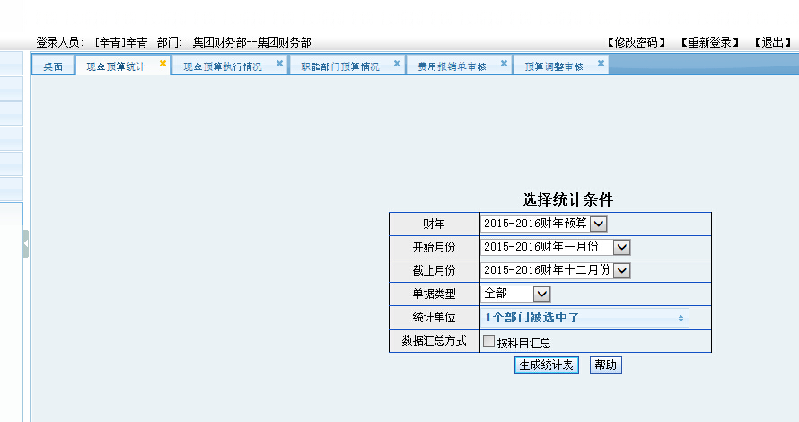

11．*借款单金额大于报销单时，剩余额不归集到预算项目中，而是一直占有额度，如预算借款200的费用，实际报销150，余额50只是占用了额度，未冲借款申请单（2.5天）

计划时间

20160816---20160819

回写预算数  
-- billcode=报销单的code  
update bill_main set billJe=(select billJe from bill_main where billCode='')  
 where billName=(select yksq_code from dz_yksq_bxd where bxd_code='5ab5220d-8e3e-4a81-bbc8-87b43550814a')

Update dz_yksq_bxd set not2=‘回冲人，冲金额 回冲时间’where

存储过程

ALTER PROCEDURE [dbo].[dz_cjyk]

AS

BEGIN

--1.创建临时表

create table #tb(

billcode_sqd nvarchar(50) null,--

billname_sqd nvarchar(50)null,--申请单据编号

billcode_bxd nvarchar(50)null,--

billname_bxd nvarchar(50) null,--报销单编号

sqdje decimal(18,4) null,--申请单金额

bxdje decimal(18,4)null,--报销单金额

kcjje decimal(18,4) null,--可冲减金额

)

--对应过的申请单

insert into #tb

select billCode, billName,'','', billje,0,0 from bill_main

where billName in (select yksq_code from dz_yksq_bxd ) and flowID='ybbx'

--更新报销单billcode

update #tb set billcode_bxd=a.bxd_code

from (

select * from dz_yksq_bxd

)a where a.yksq_code=#tb.billname_sqd

--更新报销单单据号和报销金额,bxdje=a.billJe

update #tb set billname_bxd =a.billName

from (

select * from bill_main where flowID='yksq_dz'

) a

where a.billCode=#tb.billcode_bxd

update #tb set bxdje=a.billJe

from (

select sum(je) as billJe,billname,fykm

from bill_main main inner join bill_ybbxmxb_fykm

fykm on main.billcode=fykm.billcode

where flowid='yksq_dz'

group by billname,fykm

)a where a.billName=#tb.billname_bxd

update #tb set kcjje=sqdje-bxdje

--select * from #tb where billname_bxd='20151203034'

--return

select * from #tb where kcjje>0 and ISNULL(billname_bxd,'')!=''

order by billname_bxd desc ,billname_sqd

END

说明：

~~字体为 红色带有删除线需求辛总要求比较急已更新~~

8—11为新增需求

~~对应的列表 将摘要改成 实际情况说明~~

~~webBill/bxgl/bxglFrame_Dz.aspx~~

赵老师：加批量追加预算

@选择部门，选择科目 跳转到月度列表 填写追加金额

0324 预算批量追加 预算批量追加 ../ysgl/yszjList_bykm.aspx 324 NULL NULL

webBill/ysgl/yszjList.aspx

webBill/ysgl/yszjList_bykm.aspx

webBill/ysgl/yszjAdd_bykm.aspx

~~市立医院：检查单据导入时部门不能为已经禁用的~~

~~做报销单 核算部门不能筛选已禁用的部门~~