A non-parametric method for joint association analysis of sequencing and imaging data
Xiaoran Tong

Abstract
The next generation genome sequencing and neroimaging technology give rise to large, mult-site cohort with growing wealth of next generation sequencing (NGS) data and magnetic resonance imaging (MRI) data, which mandates the corresponding analytical methodology capable of utilizing both type of information to identify predictive biomarkers associated with complex disorders. Such attemp, however, are met with "the curse of dimensionality", due to the large number of variants in the genome and images. In this work, we tackled the dimensionality issue of 3D cortical surface vertices by training a stacked audoencoder with deep learning algorithm, and generating a compact, abstracted representation of the original surface with the encoder per se. An U statistic with profile similarity based weight term were then adopted to evaluate the joint association of encoded surface and genome data with the phenotype. We showed by simulation that the method maintains the correct type 1 error rate, and achieved a statistical power higher then using either genome or image data alone, or using the original surface, or methods relying on large number of per-variant test. To illustrate our approach, we apply the proposed method to the genomic sequencing and neuroimage data from the Alzheimer’s disease Neuroimaging Initiative (ADNI).

1 Introduction
The decade long search of casual variant by genome wide associatio analysis (GWA) hasn’t been satisfying. So far GWA hardly find any single nucleotite variant (SNV) with an large enough effect to act as a stand along necessary cause of any complex diseases. Although a large number of statistically significant common variants were indeed identified by GWA, only a moderate fraction of heritability have been explained by the totality of these finding[Error: Reference source not found, Error: Reference source not found]. Despite the setback, human genome is still an intriging source of curiosity owning to its intrisic advantages. When viewed as an exposure, genetic polymophisim is consistant throughout an individual’s life course and most types of organism, saving the complication of statistical modeling. Also, as one of the fundermental causes of all biological processes, genomic polymophisim as an exposure, is not suseptable to reverse causality that troubles most non-experimantal designs. From a population perspective, the occurance of genetic variation is random, mimicing a random assignment of exposure in an quasi-experiment, which in turn can be exploited to infer non-genetic effect through an intrumental variable approach, embodied by a Mandilian Randomization design[Error: Reference source not found, Error: Reference source not found]. These features keeps genomic analysis a promising tool for weak effect inference in a complex casual netowrk.
The "common variant, common disease (CVCD)" notion led to the GWA era, as its alternative, the "rare variant, common disease (RVCD)" hypothesis states that the "missing heritability" inexplanable by GWA findings could be attributed to unobserved rare variants of moderate to large effect [Error: Reference source not found]. In other words, the so called "whole genome" in GWA was not yet up to its name. The Next Generation Sequencing (NGS) projects, growing in both number and scale over the last decade, facilitated the trial of rare variants. However, as the NGS data keep stockpiling, it also poses a number of new methodological challange. For one, the variants in a NGS profile is much more densely located in the genome, than a typical GWA profile typed by microarrays, which poses serious computational and multiple testing issue should the traditional per-variant screening procedures were applied. Also, as expected, most of the newly called rare variants come with minor allele frequencies (MAF) close to 0. As a direct consequence, such lack of heterogeneity in genotype poses a heavy toll on the statistical power for studies of moderate and smaller sample size. In the epidemiology sence, the number of exposed subjects (either cases or controls) is too small to draw any meaningful inference. So far the most widely accpeted solution is signal aggregation, that is, instead of screening the whole profile one variant after another, one first assign the variants to groups accroding to certain criteria, and subsequently all the variants in one group are test as one unit, by aggregating their signal in a certain way. Commanly, the aggregation can be achieved by collapsing the group into a single variable [Error: Reference source not found], or by jointly testing all the variants together [Error: Reference source not found, Error: Reference source not found]. Signal aggregation could be post-screening as well, done by first perform a traditional per-variant GWA screening, then the test statistics (e.g. odds ratio) or its derivation (e.g. the p-values) of a group are combined into a single statistics [Error: Reference source not found, Error: Reference source not found]. Through grouping and aggregation, the number of hypothesis testing reduces to the number of groups, and the heterogeniety of genotype is enchanced to the probability of any variation of the group member. A difficulty comes along with the approach however, is the choice of groupingcriteria. The most popular grouping schemes refer prior knowledge of biological function, resulting in gene or pathway based grouping. Some more debatable schemes rely on the physics of the genome, such as binning the genome by every few kb[? ] or by a threshold of linkage disequilibrium (LD) [Error: Reference source not found]. The function based grouping is less subjective and better suited for later interpretation, but for the same reason it is also somewhat a ad-hoc approach, since the ultimate goal of grouping these variants by function, is itself the inference of certain function. Another downside of functional grouping is that it can not exhaustively cover the whole genome, because some variants do not fall into any protein coding gene or known pathway. The physical grouping, on the other hand, could comprehensively cover the entire genome, but is somewhat arbitrary, because the the optimal bin size, LD threshold, and starting position of segmentation, are not pre-known by the investegators. The analytical outcome could also be drastcially different if a different setting was choosen. Aside from signal aggregation, another trend is to form huge, multi-site cohort for large sample such as GIANT and ARIC, or to perform meta-analysis for a large number of published result [Error: Reference source not found], so the sheer number of the observations could overcome the issue of multip testing and low MAF. Now it is not uncommon to apply a brutle per-variant scan for a cohort of more than a thousand subjects. However, the curse of weak effect and low heritability is still lingering, despite frequently reported rare variants reaching statistical significance. The general picture, is still a lack of methodology of moderate prediction power for complexe health outcomes.
The reasons of genetic effects being weak, is in many way like any other fundermantal cause in a casual network, such as social economy status, race/ethnicity and birth place. While being persistant and relatively free from feedback loops, this kind of causes have to reach the final outcomes through a huge "blackbox". As a result, solely altering one dimension of the exposure while leaving the other causes and modifiers untouched won’t change the outcome by large. Naturely one would seek amending forces in attempt to unfold the "blackbox", which can be approached from both ends of the casual network. From the downstream end, the bottom-up approach revoles around the central dogma, that is, DNA transcript to mRNA, and mRNA translate to Protein, and thus the profiles of interest are expanded into transcriptome and proteome, respectively. The most prominent practises are expression quantitative trait loci (eQTL)[Error: Reference source not found, Error: Reference source not found] and gene network analysis. Also from the upstream end, an investegator could collect a variety of strong indicators proximate to the health outcome. Typical examples are conventional biomarkers like inflammatory cytokines, c-reactive protein, serum cholesterol and anti-body titers [Error: Reference source not found, Error: Reference source not found], and non-conventional biomarkers, such as the neuroimage profiles [Error: Reference source not found, Error: Reference source not found, Error: Reference source not found, Error: Reference source not found] included by our study. To be noted however, unfolding the "blackbox" is no easy task since any intermidiate factor in the casual network loses the simplicity of a fundermental cause. Namely, an indicators is susceptable to feedback loops and confounders, thus a strong biomarker does not equate to a strong cause, hince the separation of a cause and an indicator. Also, unlike genomic variants, intermidicate indicators are no longer static throughout time and space, for example, the transcriptome of the same subject are quite distinct across different types of cell and life cycle. As an matter of fact, eQTL and gene network analysis are largely seen with, and mostly limited to cancer researches. The downstream strong biomarkers are usually considered as the golden standard of diagnose and confirmation, but are arely suitable for long term risk prediction. A difficulty this work trying to address is the joint analysis of both fundermental casuse and intermidiate factors, either from upstream or downstream. Traditional epidemiology relies on regression to tease apart the direct effect of the fundermental cause and the effect mediated throught the intermidiate factors. This is not suitable when the potential causes in question are groups of tens of hundrends genomic variants, and more ever, when the proximate indicators, in our case, the neuroimage profiles, have even higher dimensionality than an average genomic testing unit.
As mentaioned above, alongsided with the NGS data, the neuroimaging profiles have been incroperated into the statistical models for the added oppertunity to detect associations, and are applied with procedured similar to those designed for genomic analysis. The strength of association between neuroimaging profile and neurological disorder are much higher than from the genome to the same disease per se since, the deteriation of cortial surface and subcortical tissue is a proximite event to the final outcome in CNS. Similar to GWA, one could also define a image variant for as the target of statistical inference, which is usually an atomic image unit. For the structure MRI, a variant usually takes the form of a cubic voxel in the 3D volumn spanned by an array of slices [a picture? ], which is also an 3D analogy of a square pixel in a 2D plane. The value of voxel taken from the intensity of MRI image, that is, the darkest one has a value of 0, the brightest one is 1. For our study though, the neuroimg profile are not the original MRI and its voxels, but instead we use the 3D cortical surface reconstructed from the structure MRI, performed with the FreeSurferimage analysis suite, which is documented and freely available for download online (http://surfer.nmr.mgh.harvard.edu) [Error: Reference source not found]. Every subject has two cortical surfaces reconstructed, corresponding to the left and right hemispheres, each cortical surface is spanned by 163842 connected vertices, each of which is teated as a variant. The value of a variant(vertex) is no longer the MRI scan brightness, but the gray matter thickness [Error: Reference source not found, Error: Reference source not found], white matter area, gray matter volumn, located around the close proximity of that variant, which is calculated by FreeSurferduring the cortical surface reconstruction. The neuroimaging profile, either the brightness of the voxels or the genometry of the vertices, do not suffer the issue of poor signal like the rare genomic variant does, because the values of either type of image units are continuous. Therefore, much like GWA, a per-variant screening can be applied to neuroimage profiles to search for signifiant loci. For analysis using the brightness of voxels from the original MRI slices, this is called voxel-wise analysis (VWA) [Error: Reference source not found, Error: Reference source not found, Error: Reference source not found, Error: Reference source not found]. As for vertices in the reconstructed surface, FreeSurfercomes with its own surface analysis tool which is essentially applying generalized mixed linear regression for each vertex [Error: Reference source not found, Error: Reference source not found], the small area around each vertex is then color coated with the cooresponding −logP. A clinical association between neuroanatomical region of interest (ROI) and the health outcome is readly checked by comparing the color pattern of that ROI (Figure 1). In such sense, the FreeSurfersurface analysis tool can be called vertex-wise analysis, also abbrevated to VWA. However, the FreeSurfertool is not meat for cohort analysis involving hundreads to thousands participants, because the investigation of color coated surface has to be done by human labor.
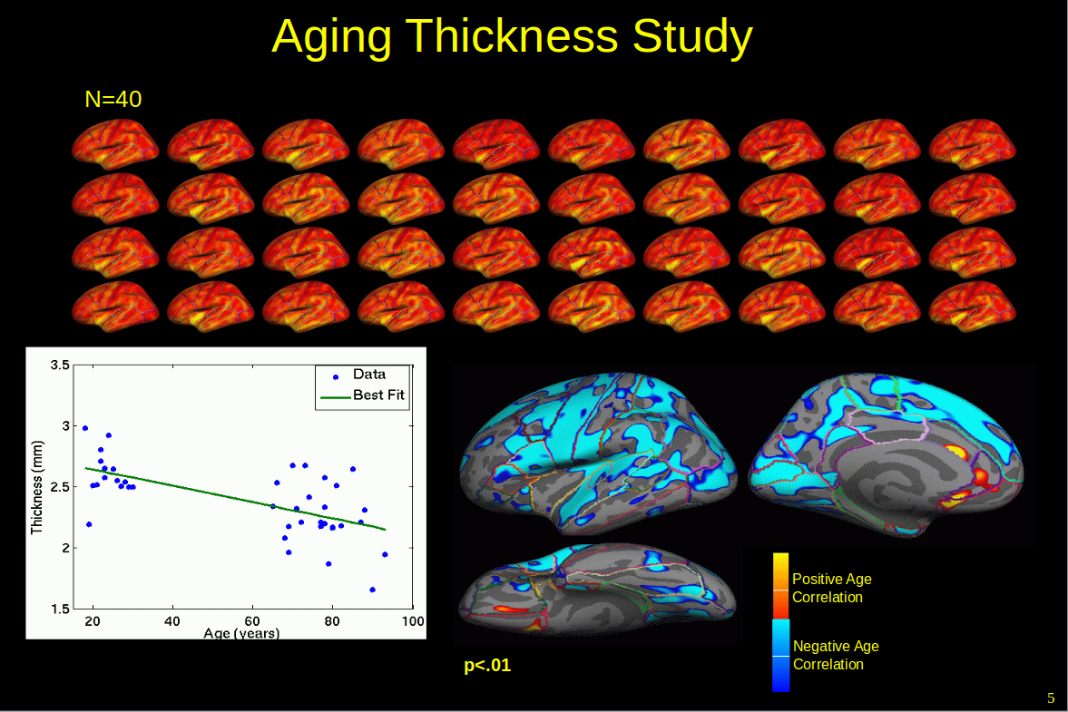
Figure 1: FreeSurfer’s Vertex-Wise AnalysisFreeSurfer
top: 40 sample cortical surfaces color coated by gray matter thickness; bottom left: fitted thickness−age slop at one of the 327684 vertices; bottom right: cortical surface color coated by −logP of the thickness−age slop at each vertex.
Recognizing that the closely located variants are clearly highly correlated, the grouping and aggregation accepted by genomic analysis can also be used on image profiles to enhance statistical power[Zhu et. al.]. Before the signal aggregation of a testing unit however, a number of procedures could be applied to the unit to enhance statistical power, which usually involves dimension reduction and noise supression. For genomic profiles, a growing trend is to treat it as a discrate sample drawn from a smooth function [Olga V.]. With a well-balanced emphasize on smoothness and goodness of fit, a small expense of profile accuray can reduce the mean differences among the cases as well as among the controls while enlarging the difference between the two group, achieving higher power. Similar priciple can be applied to any type of high dimensional testing unit, as long as we believe the within group difference are most likely contrubited by noises unexplainable with the case/control membership, thus grinding them away with a smoother helps distinguishing the profile of a case from that of a control. A technic commonly adopted by neuroimaging analysis is to burn away trivial details with a gaussian filter while retaining major features by restricting the size of the filter[Error: Reference source not found, Error: Reference source not found, Error: Reference source not found, Error: Reference source not found]. In this work however, we construct a stacked autoencoder (SA) for each cortical surface testing unit. Unlike the Gaussian filter who uniformly remove a certain level of detail from the image, an SA is actively looking for meaningful high order features and droping trivias.
We are now seeing an increasingly denser genomic profile with large number of rare variants, and the oppertunity to incroporate high dimensional profiles other than genomics. We propose a similarity based U statistics for the association analysis involving more than one high dimensional profiles; we would also try to tackle the dimensionality and low power issue with signal aggregation, and perticularly to the medical image profiles, we will construct an stacked autoencoder to extract major features of lower dimensionality, and lower noise/signal ratio.

2 Material
Whole genome sequencing (WGS) and magnetic resonance imaging (MRI) data were obtained from Alzheimer’s Disease Neuroimaging Initiative (ADNI). A totol of 808 subjects at the screening and baseline of ADNI1 and ADNI2 study have both types of profiles sampled, alongside with Alzheimer Disease diagnosis, demographics, and the genotype of APOE ε4.
The MRI data first went throught a series of preprocessing pipeline composed of special registration, skull stripping, cortical/subcortical segmentation, white/gray matter segregation, vexel intensity normalization, reconstruction of brain surface, surface registration and virtual anatomical paceration. The whole pipeline is supported by FreeSurfer - a software initiated by [Dale and Fischl et.al.] and currently maintained by the Laboratory for Computational Neuroimaging (LCN) at the Athinoula A. Martinos Center for Biomedical Imaging. The preprocessing produces a 3D brain surface, with each hamersphere expressed by vertices connected by triangles, and vitually segemented into 34 anatomical regions [pic ? ]. For each vertex, besides its location in the 3D space, statistics ascribing the tissure at its close vicility were also calculated, among which the most important properties are gray matter thickness and sulcity (positive means the vertex is in a gyrus, otherwise in a sulcus). For real data analysis, the 68 anatomical regions are treated as testing unit; for a single iteration in a simulation study, small ovals of vertices (mean diametter=28mm) were randomly picked from the whole surface.
Rigorous quality control had been done by ADNI during variant calling process, thus the WGS data from ADNI do not require intensive preprocessing. For genomic profile, the testing unit for both real data and simulation study are based on gene. The chromosome location of known genes were queried from the table of genomic features of human reference genome assemble version 38, maintained by Genome Reference Consortium (GRCh38). An extra 5k flanking basepairs were attached to both ends of a gene when searching for vairants in a testing unit. Despit the added flanking region, some unit contains no genomic variant, and they were excluded from further opertations.

3 Method
To simoteniously detect association among genomics, cortical surface and phenotype profiles, a generalized multivariate similarity U statistic was used, postulated by Changshuai et. al. [Error: Reference source not found]. Of all three types profile, the cortical surface has the most numerous variants, with 68 anatomical regions comprised of few hundreds to more than ten thousands of vertices. To deal with the dimensionality issue, a 4 layered Stacked Autoencoder(SA) was trained with a greed layer by layer manner, as suggested by the deep learning literatures. The SA is capable of abstracting high order features from the vertices in the cortical surface, and at the same time reducing its dimenstionality by 16 fold. The vertex similarity can then be calculated with the code instead of the orignial. Supposingly, any U statistic involving a vertex similarity weight should enjoy a power boost if the raw verties were to be replaced with the code, because high order features are less suscptable to random noise. to calculate will be cal by piping the encoded vertices can then by derived by summerizing the product of pairwise similarity between subjects, with respect to the aforementioned genetic and phenotipic profiles, and the encoded vertices.

3.1 Similarity U Test
To derive the proposed U statistic, one U-kernel and one or more U-weights must be constructed. A kernal/weight measures the similarity of each pair of samples, with respect to one of the profiles. The measurement funciton can be flexable depending on the distribution of the profile and the hypothesis in mind, as long as it is symmetric and has finite second moment. Thus, function f is a valid U kernal/weight if and are satisfied. For the three types of profile, three pairwise similarity measurement were chosen according to common practice.
For biallelic genetic variants whose value was taken from minor allele count 0,1,2, a common choice is the weighted complement of Manhattan Distance (wMD):

[Sorry. Ignored \begin{split} ... \end{split}]
(1),which is also called identical by state (IBS) kernel. Here () is the value of the mth. variant (e.g. a SNP, indel, or deletion) in a testing unit (e.g. a gene) for the ith.(jth.) sample; |G| is the dimensionality of the genomic testing unit (e.g. total number of SNPs, indels and deletions in a gene). is the weight assigned to the mth. variant depending on a prior hypothesis, one such example is the reversed square root of minor allele frequency which places more emphasize on rarer variants:

Without any a prior hypothesis of the relative importance of genomic variants, an unweighted complement of Manhatten Distance (uMD) can be used by forcing :

[Sorry. Ignored \begin{split} ... \end{split}]
For vertices in the reconstructed cortical surface, their values, for now, is taken from white matter thickness rescaled to [0,1], one could base the similarity measurement on weighted Euclidian Distance (wED):

[Sorry. Ignored \begin{split} ... \end{split}]
(2),which is also called a Gaussian kernel. Here () is the value of the m th. vertex of the cortical surface testing unit in the i(j) th. sample, while |V| is the number of vertices in it that testing unit, that is, the dimensionality. is the weight assigned to the m th. vertex in the testing unit. Without pre-knowledge regarding the relative importance of the vertices, the similarity measurement is simplifed by equal weighting ():

[Sorry. Ignored \begin{split} ... \end{split}]
Lastly, for a multivariate phenotype profile, first a rank normal quantile normalization were a pplied to all the components according to [Error: Reference source not found]:

where is the value of the mth. component of the phenotype for the ith. sample, and |Y| is the dimensionality of the phenotype (i.e. number of components). Doing so not only correct skewed components, but also remove the complication of admixed distribution type introduced by a multivariate phenotype. As a result, the phenotype based similarity can be measured in a manner similar to that of cortical surface:

[Sorry. Ignored \begin{split} ... \end{split}]
(3)where is the values of the mth. component of the normalized phenotype; the weight is the ralative importance of that dimension. For a case control study of one dimensional phenotype, that is, |Y|=1, the similarity measurement simplifys to:

All three types of the similarity are centralized by substracting the raw measurement from every pair (i,j) with two sample means of all measurements involving i and j, respectively, then adding the sample mean of all the pairs to it [Error: Reference source not found]. Takeing the weighted genetic similarity as an example, the centralized similarity measurement is:

[Sorry. Ignored \begin{split} ... \end{split}]
()where N is number of samples. The same centralization scheme is applied to the other two similarity measurements. The U statistics is the mean of the product of three centralized similarity measurement across all but mirrored pairs:

The actual implementation calculated three symmetric N×N similarity matrices to facilitate later manipulation. The U statistic follows a mixture of distrubtion, a p value can then be calculated using Davis method [Error: Reference source not found].
For now, the genomic and vertex similarity are treated U-weight terms, while the phenotype similarity acts as the U-kernel term. In general, the assignment of U-kernal and U-weight terms does not alter the limiting distribution of the final U statistics. More specific association test can be perform by dropping one of the U-weight terms. To see if only the phenotype and genomic profiles are associated, construct the U statistics without vertex similarity term:

Likewise, dropping the genomic similarity to test if only the phenotype and genomic profiles are uncorrelated:

3.2 Stacked Autoencoder
The purpose of an encoder is to abstract high order features from the raw input which is meaningful for decision making. A real life example is vewing a painting: what intrests the viewer is the concept of object or event the painting captures, not the exact colouring at every inch of the canvas. As for the cortical surface profile, being able to see the overall shrinkage and laceration sites in a aged brain, even without the exact volumn, location, and boundery of these sites, is far more important than knowning the exact thickness, curvature and coordinates at every vertex. An extreamly accurate and objective measurement at every unit of the cortical surface is, though highly informative, remotely helpful for diagnostic purpose without abstraction of high order feature from it. The Stacked Autoencoder (SA) to be implemented here is the result of recent development of deep artificial neuro-network, originally inspired by the sentinental processing of visual information. By definition, an abstraction must reduce the complexity of the raw image considerablly so the host could possibly process and make a sound accessment. The SA will take the high dimensional cortical surface and output abstracted features of much lower dimensionality.
An SA is formed by layers of autoencoders stacked from bottom to top, hence "Stacked". An autoencoder represents a linear recombination of the input elements, followed by an element-wise non-linear transformatio. Usually, the output has a lower dimensionality then the input to ensure abstraction and dimension reduction. In symbolic form, an autoencoder at the i th. layer of an SA can be written as:

[Sorry. Ignored \begin{split} ... \end{split}]
(5),where is the output and is the input, which is also the output from the layer down below – the i−1 th. autoencoder in the stack. Linear recombination of the input is achieved by the corss product between the input and the weight matrix , followed by adding an offset of . The superscript and denote the dimensionality of both data and parameters. As mentioned before, to ensure that feature abstraction and dimension reduction actually happens, in most cases, is chosen to be smaller than . As for the elementwise non-linear transformation, s, the most popular choice is inverse logit function:

[Sorry. Ignored \begin{split} ... \end{split}]
(6)Here is the result of linear recombination of input , with the super script denoting its dimensionality and indexing its elements. The "S" shaped inverse logit curve resembles the biological activation of the k th. neuron in the i th. layer when the sum of input from all neurons in the previous layer, , weighted by the k th. row of WEIii−1i, , exceeds threshold which is the negation of k th. elements in the offest vector . The actual biological activation of a neuron is a step function of the total input, which is steeper than the inverse logit, but the later, being smooth and differentiabe throughout the real line, will facilitate gradient gudided learning procedure in the future.
An SA of M layers, P dimensional raw input x and Q dimensional output, can be assembled by recursively pluging the output of an autoencoder into the one above, and ensuring the output of the top layer is Q dimensinal:

[Sorry. Ignored \begin{split} ... \end{split}]
(7)where and denote the P dimensional raw input, and the Q dimensional output, repectively. The vector is the intermidiate output of the i th. autoencoder. Here we use superscripts to display dimensionalities. The P dimensional input is viewed as output of the non-existing 0 th. autoencoder, denoted by , where . From the bottom to up, the SA will gradually abstract higher order features from the P dimensional input , until the dimensionality of the output is as low as .
The SA just constructed is useless without calibration. One must find a set of parameters that truely represents body of knowlege regarding the observed data x, only then it would be capable of abstracting meaningful features instead of haphazardly reducing a high dimensional input into a small but irrelevent output (e.g. a vector of Q random numbers). The "capability" of the SA can be gauged by two different criteria. For one, it is reasonable to say an abstraction should help to better predict the outcome of interest. Turning strategies based on this criteria belong to the so called supervised machine learning. Another criteria, saying if an abstraction is indeed done better, we should be able to be reconstructed the original input from it more accurately, will resulting in the so called unsupervised machine learning. Here “supervised” means the “goodness of abstraction” is judged by asking how accurate the predictions were made using features extracted by the SA from the raw input, in comparison with the known external fact from a specific domain of problems. The SA thus learned will try to extract features better suited for problems from that domain (e.g. tell the future risk of neuralogical disorder by examing the cortical surface). The “unsupervised” learning, on the other hand, judges the “goodness of abstraction” by having the raw input comparing with its reconstructed self from the extracted features. An SA tuned in this manner will try to extract more general features not necessarily specific to a certain problem domain. In this work, the later, unsupervised learning is to be used to explore generic knowledge regarding the human cortical surface, not just for the purpose of diagnosing a certain type of neuralogical disorder (e.g. Alzheimer’s Disease). As a matter of fact, all available T1 MRI samples contrubute to the “machines’s understanding of human brain”, even if more than half of them cannot enter the association analysis because of non-definite diagnosis.
Prior to unsupervised learning however, one has to come up with a reconstruction scheme – a decoder counterpart of the SA. The most nature way is to mirror the structure of the SA, that is, the number of layers in the decoder is the same with the SA, each layer is also a linear recombination of its input followed by a element-wise non-linear transformation, but the dimensionality changes are exactly in reverse order of the SA. In symbolic form, the decoder can be structured in a similar manner:

[Sorry. Ignored \begin{split} ... \end{split}]
(8)From bottom to up, the decoder gradually restores details from the abstracted features , and eventually reaches a reconstruction of the raw input . The encoder 7 is linked from below by plugin its output into the bottom of the decoder through ŷ. The entire encoding – decoding structure can be written as:

[Sorry. Ignored \begin{split} ... \end{split}]
(9)pppp The discrepancy between ̃x and x is a measure of how badly the reconstructed input resemble the original, which also tells us how poorly the encoder had performed, because a truely meaningful abstraction should not obstruct the recovery of details. Therefore, the learning of the SA is the process of minimizing the disagreement between ̃x and x by fine tuning the structuring parameters in the entire autoencoder and decoder stack, which is:

[Sorry. Ignored \begin{split} ... \end{split}]
(10)The measurement of the disagreement between and is also called the loss function or reconstruction loss, the current most popular loss is cross entrophy, which has the following form:

[Sorry. Ignored \begin{split} ... \end{split}]
(11). L(̃X,X) measures the total reconstruction loss of the entire study of N profiles, with two N×P matrices ̃X and X representing the reconstructed and the original version, respectively. measures the loss contributed by the j th. sample, with and being the j th. row vectors from ̃X and X, respectively. For each profile, k indexes one of the P demensions. The total reconstruction loss L is monotonic with the poorness of the performance of SA, thus the search for the best set of parameter is expressed as a numerical optimization problem:

. The optimization is done by gradient decent. Starting with a randomly initialized assignment of at t=0, and compute the next assignment by substracting from the current assignment a small fraction of the gradient of reconstruction loss L with respect to the current assignment (). The small fraction is called a learning step, if the step is reasonablly small, the reconstruction loss L will keep dropping. The learning will repeat until L cease to drop. The final assignment is considered the optimal τ.
The gradient is calculated by a process called backward propagation [? ], which relies heavily on the chain rule of derivatives. First, realize the total loss L(̃X,X) is a summation of of individual loss for j=1,…,N, and in turn is a function of (the observed is a constant vector), at last, is a function of all structure parameters τ, using the additive rule and chain rule we get:

[Sorry. Ignored \begin{split} ... \end{split}]
Here we use ⊘ to denote element-wise division. From now on we would focus on the j th. sample and ommit j from the subscript, since the top output is constructed in exactly the same manner across all N individuals. Recall the symbolic form of SA and the cooresponding decoders on its top (see 7, 8 and 9), the output of any layer, either from an encoder or a decoder, is a function of its own structure parameters and the direct input supplied by the lower layer. The gradient of the output with respect to the paremeters and input can be calculated directly,

[Sorry. Ignored \begin{split} ... \end{split}]
(12)Here diag(v) means creating a 0 matrix and asign the vector v to its diagonal. Since the input of a layer is essencially the output of the layer down below, who also has its own structure paremeters and input from the layer even lower, the gradient of the top output, , with respect to any lower layers’ parameters, can be calculated by recursively invoking the chain rule, that is,
(13)
In reverse to the "bottom to top" encoding and decoding procedure, the gradient is propagated from top to bottom, hince the name "backward propagation". Taking the M layered SA and its decoder counterpart together, the total number of parameters to be calibrated is . The optimization can be computationally intense because this number is usually huge. One commonly applied strategy for learning an SA is to constrain the weight matrix in the decoder layers to be the transpose of their counterpart in the SA, that is, forcing for i=1…M, and on top of the assignment of gradient layed out in 12 and 13, the gradient of the top output with respect to the weight matrix of any decoder will be absorded by the one in its encoder counterpart, that is,

[Sorry. Ignored \begin{split} ... \end{split}]
Doing so introduces slightly more computation for each learning step, but at the same time almost halve the number of tuning parameters to , greatly speed up the convergence of L(̃X,X). Beside, the whole structure fits the common sense that, encoding and decoding are essentially symmetric operations. More importantly, the constraint encourages learning of an optimal SA instead of a sub-optimal SA coupled with a powerful decoder on its top, afterall, our best interest is the high order feature abstracted from the raw input, not its reconstruction.
Despite the benifit of constraint on decoder weight matrices, it is still powerless when the depth of the SA grows large. A deeper network is consideribaly harder to learn because the complexity of the function represented by the network grows exponentially alongside with the number of layers while holding the total number of parameters constant. In fact, a network with with more intermediate layers leaves more local minimum in the parameter space for the reconstruction loss L to fall into. Yet, for the same reason, deeper network is enormously intrigging, because a exponentially richer funtion space means a much better chance to find a network that further reduce L, which in tune implies better abstraction of knowledge. Deep artificial neuro networks have gained popularity in recent years, thanks to the break through in machining leaning, or, the introduction of “deep learning”. In this study we implement the layer-wise greedy pre-training procedure postulation made by Hilton et.al.[Error: Reference source not found]. The idea is to first learn each encoder layer separately, then fine tune of the entire structure afterwards. During the pre-training, the output of i th. autoencoder is not sent to the i+1 th., but instead redirected to its decoder counterpart for an immediate reconstruction, creating a encoder–decoder tuple whose small number of parameters can be easily learned by minimizing the local reconstruction loss . A total of M such tuples is constructed and learned, they can be written as:
(14)
What the greedy layer-wise pre-training has achieved is a non-randomly initialization of the entire structure to a state already close to optimum. After pre-training, all the encoders and the decoders are wired together and all paremeters is fine tuned together. The optimization procedure will reach convergence much faster and less likely to fall into a poor local minimum then a direct learning scheme without the pre-training. The pre-training cannot be parallelized because the higher tuples relies on the encoding output of lower ones, yet the extra computation is easily compensated by the much improved performace of the fining tuning stage which optimize all parameters together.
All 808 cortical surface profiles will be used to construct the stacked autoencoder (SA), even if diagnosis status being definite or unsure (e.g. intermediate status between MCI and AD). The SA thus create would encampus general knowledge of human cortical surface not limited to diagnostic purpose. We then pipe the profile of 327 subject with definite diagnossis (healthy control or Alzeimer’s disease) throught the SA to obtain abstrated image code. This code, can then replace the original vertex data for the evaluation of pairwise similarity, which is one of the weight components of the aforementioned U statistics.

4 Result

4.1 Simulation
The simulations are based on 806 participants of ADNI study with both WGS and MRI data avaliable. Each iteration run choose a pair of testing units for genomc and image profiles. The genomic testing unit is a gene randomly picked from the genomic features list supplied by GRC38. For neuroimage profile, the testing unit is a region of 512 vertices randomly located in the cortical surface reconstructed by FreeSurfer. The genomic effect and vertex effect are then generated by randomly selecting 5% of the variants in both types of testing unit (e.g. SNPs in a gene, and vertices in a cortical region), and assigning a value drawn from standard normal N(0,1). Given the row major genomic profile and image profile of all subjects, two column vectors of continuous response and were calculated by adding up the element-wise products of variants and their corresponding effect across the choosen testing unit; two additional continuous responses and are then created by adding up the two basic ones element-wise, with or without one additional element-wise product of the two. Here, the subscripts G, V, A, and I denote the constituents of the simulated effect originating from genomic variant only, from cortical vertices only, addition of the two, and interaction of the two, respectively; the superscript C says the response is continuous. Four dichotomous responds: , , and were also generated by putting the four continuous ones through inverse logit and draw cases from the resulting probabilities. The generation of all 8 responses can be written as:

[Sorry. Ignored \begin{split} ... \end{split}]
where is a size n sample drawn from Normal distribution of mean μ and standard variance ; is a size n sample drawn from Bernoulli distribution of mean p; |G| and |V| denote the number of genomic variants and cortical vertices in a chosen pair of gene and cortical region, respectively. For now |V| is fixed to 512.
Three factors are to be considered in the comparative study. For one, the formulation of U statistics has 3 options memtioned in the method section. The second factor is the construct of responses listed above. The first two factors are meant to test the performance of the U statistics when its weight kernel constituents are correctly, partially correctly, and wrongfully reflecting the effect constitution of response. Lastly, unless a purely genomic U statistic is used (, that is), 3 constructs for the vertex bases similarity () are at one’s disposal: using the original vertices, the encoded vertices, or the original vertices but also the vertex-wise analysis (VWA) instead of the proposed regional aggregation. In brief, the VWA is done by first smoothing the vertex values (e.g. gray matter thickness) via a gaussian blur process, followd by the calculation of and statistics for each vertex in the testing unit. The testing unit will be declared significant if the lowest FDR (false discover rate) adjected p-value falls below the usual 0.05 threshold. All scensiable combinations of the three factors were tried out across a spectrium sample size from 100 to 800. The comparison among continuous responses is shown in Figure 2.

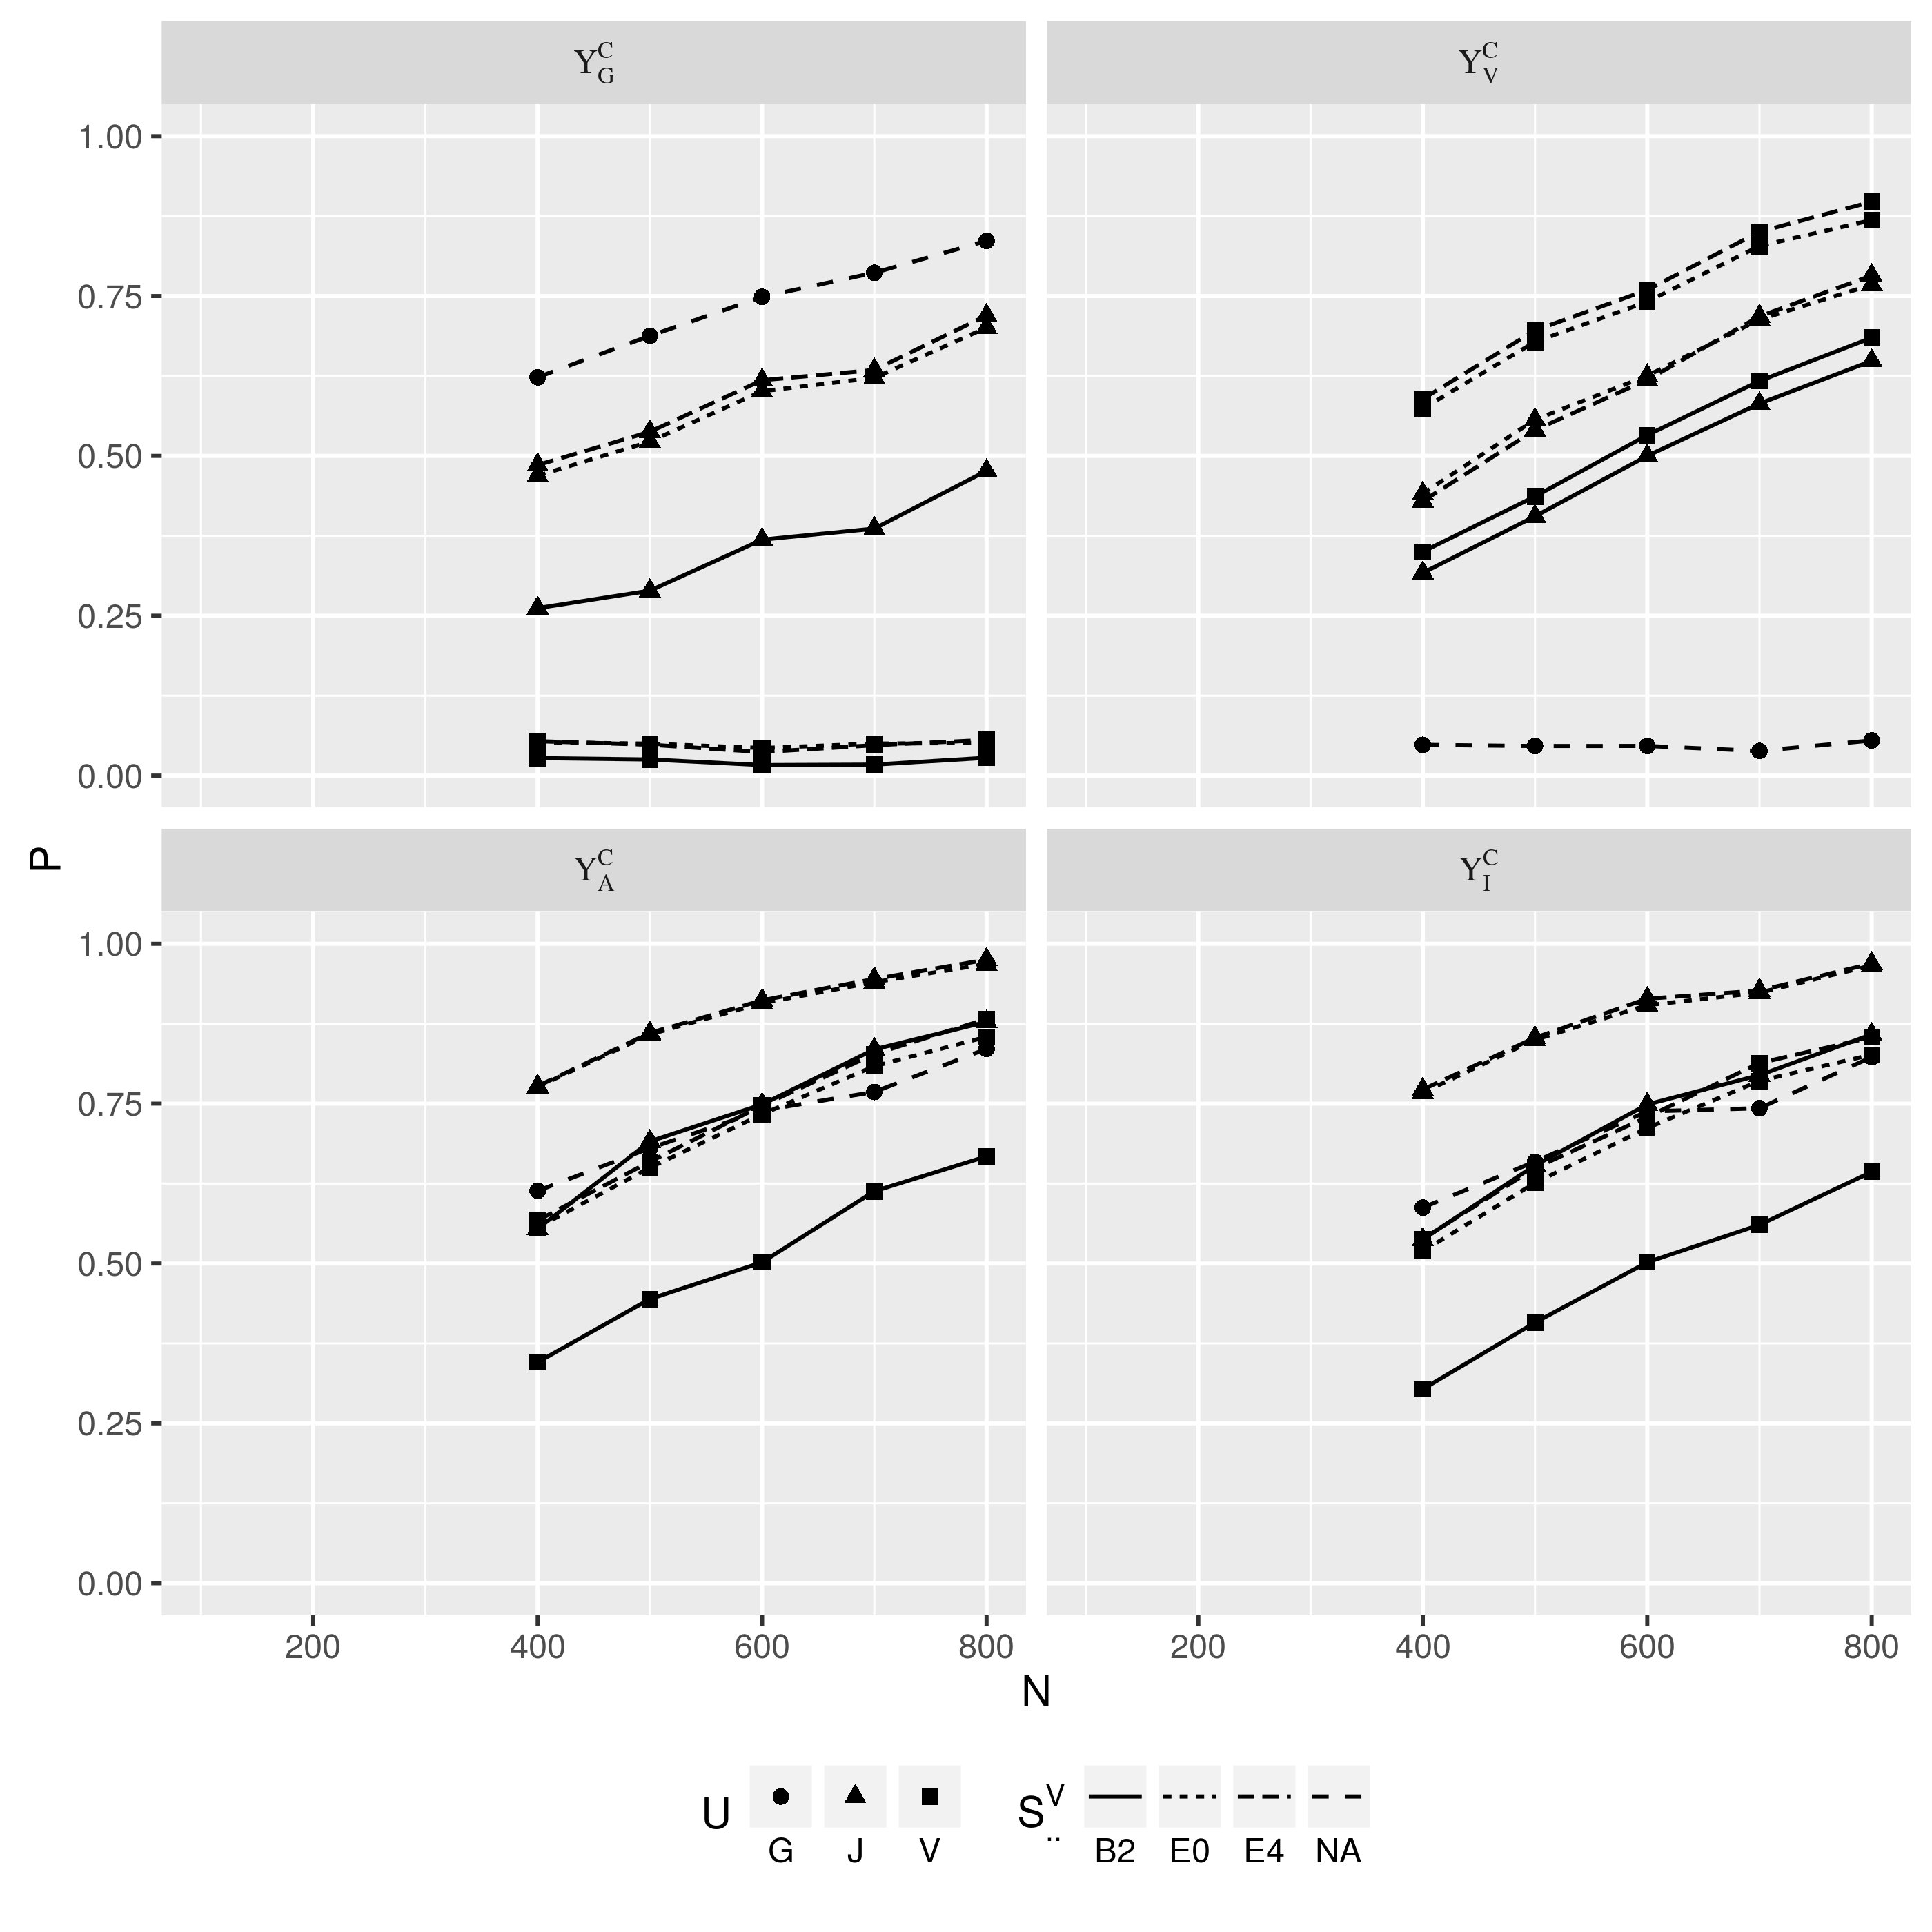
Figure 2: power performace for continuous responses
For continuous outcomes, the purely genomic profile based U statistic had the best performace out of the 3 when the response is chosen to be which is also of purely genomic origin, but no power can be seen when the response is purely cortical vertex based . Conversely, the purely cortical vertex based U stistic displayed heighest power when the response , is also so constructed, and no power at all when the chosen response was exclusively constructed from genomic variant. The joint statistics outperformed the two basic statistics and when the response was the additive or the higher ordered . Between the two last responses, all 3 statistics displayed slightly higher power with the addtive then with the ineractive . As expected, the consitution of an U statistics that better matches the underlying effect of the response should asertaine heigher power across all sample sizes, while under a scenario of complete mis-specification no statistical power should be seen. Partially mis-specified U statistics maintained a performance close to that of the perfect match, thus making the joint statistic an overall better choice [figure ? ]. By limiting the comparesion among tests involving raw vertices, one could see that regional U statistics outperformed VWA under all circumstances except the total mis-specification where both showed no power. By only looking at regional U tests involving vertices, those employing encoded vertices would be equal or slightly underpowered at smallest sample sizes (N=100) but enjoy larger power boost alongside an constant increament in sample size. When the U statistic is correctly specified, the power is always higher if encoded vertices were used to construct or . When a partial mis-specification was inccured by testing the vertex effect with a joint U statistics , where the encoded vertices outperformed the raw vertices at a higher sample size (>500), suggesting that the benefit brought by image feature abstraction could "back fire" when the statistical model is partially or fully wrong and a small sample is given.
For dichotomous responses, the power performace shares similar patten under every circumstances, albeit universally poorer then its continuous counterpart, which is shown in Figure 3. Another noteworthy fact is that the U statistics are indifferent to the preprocessing of the binary response thanks to the rank normal quantile standardization. The same U score are obtained regardless the U kernel being based on the deviance residual, the least squre resisual, or the binary response itself. Nonetheless, the simulation demonstrated that the joint U statistics is an omnibus test which is more robust under most circumstances, especially when the prior knowledge of effect composition is unknown to the investigator. The feature abstration and dimension reduction is generally benificial, in that the resulting vertex code offered an accelerated power boost when sample sizes is linearly increased.

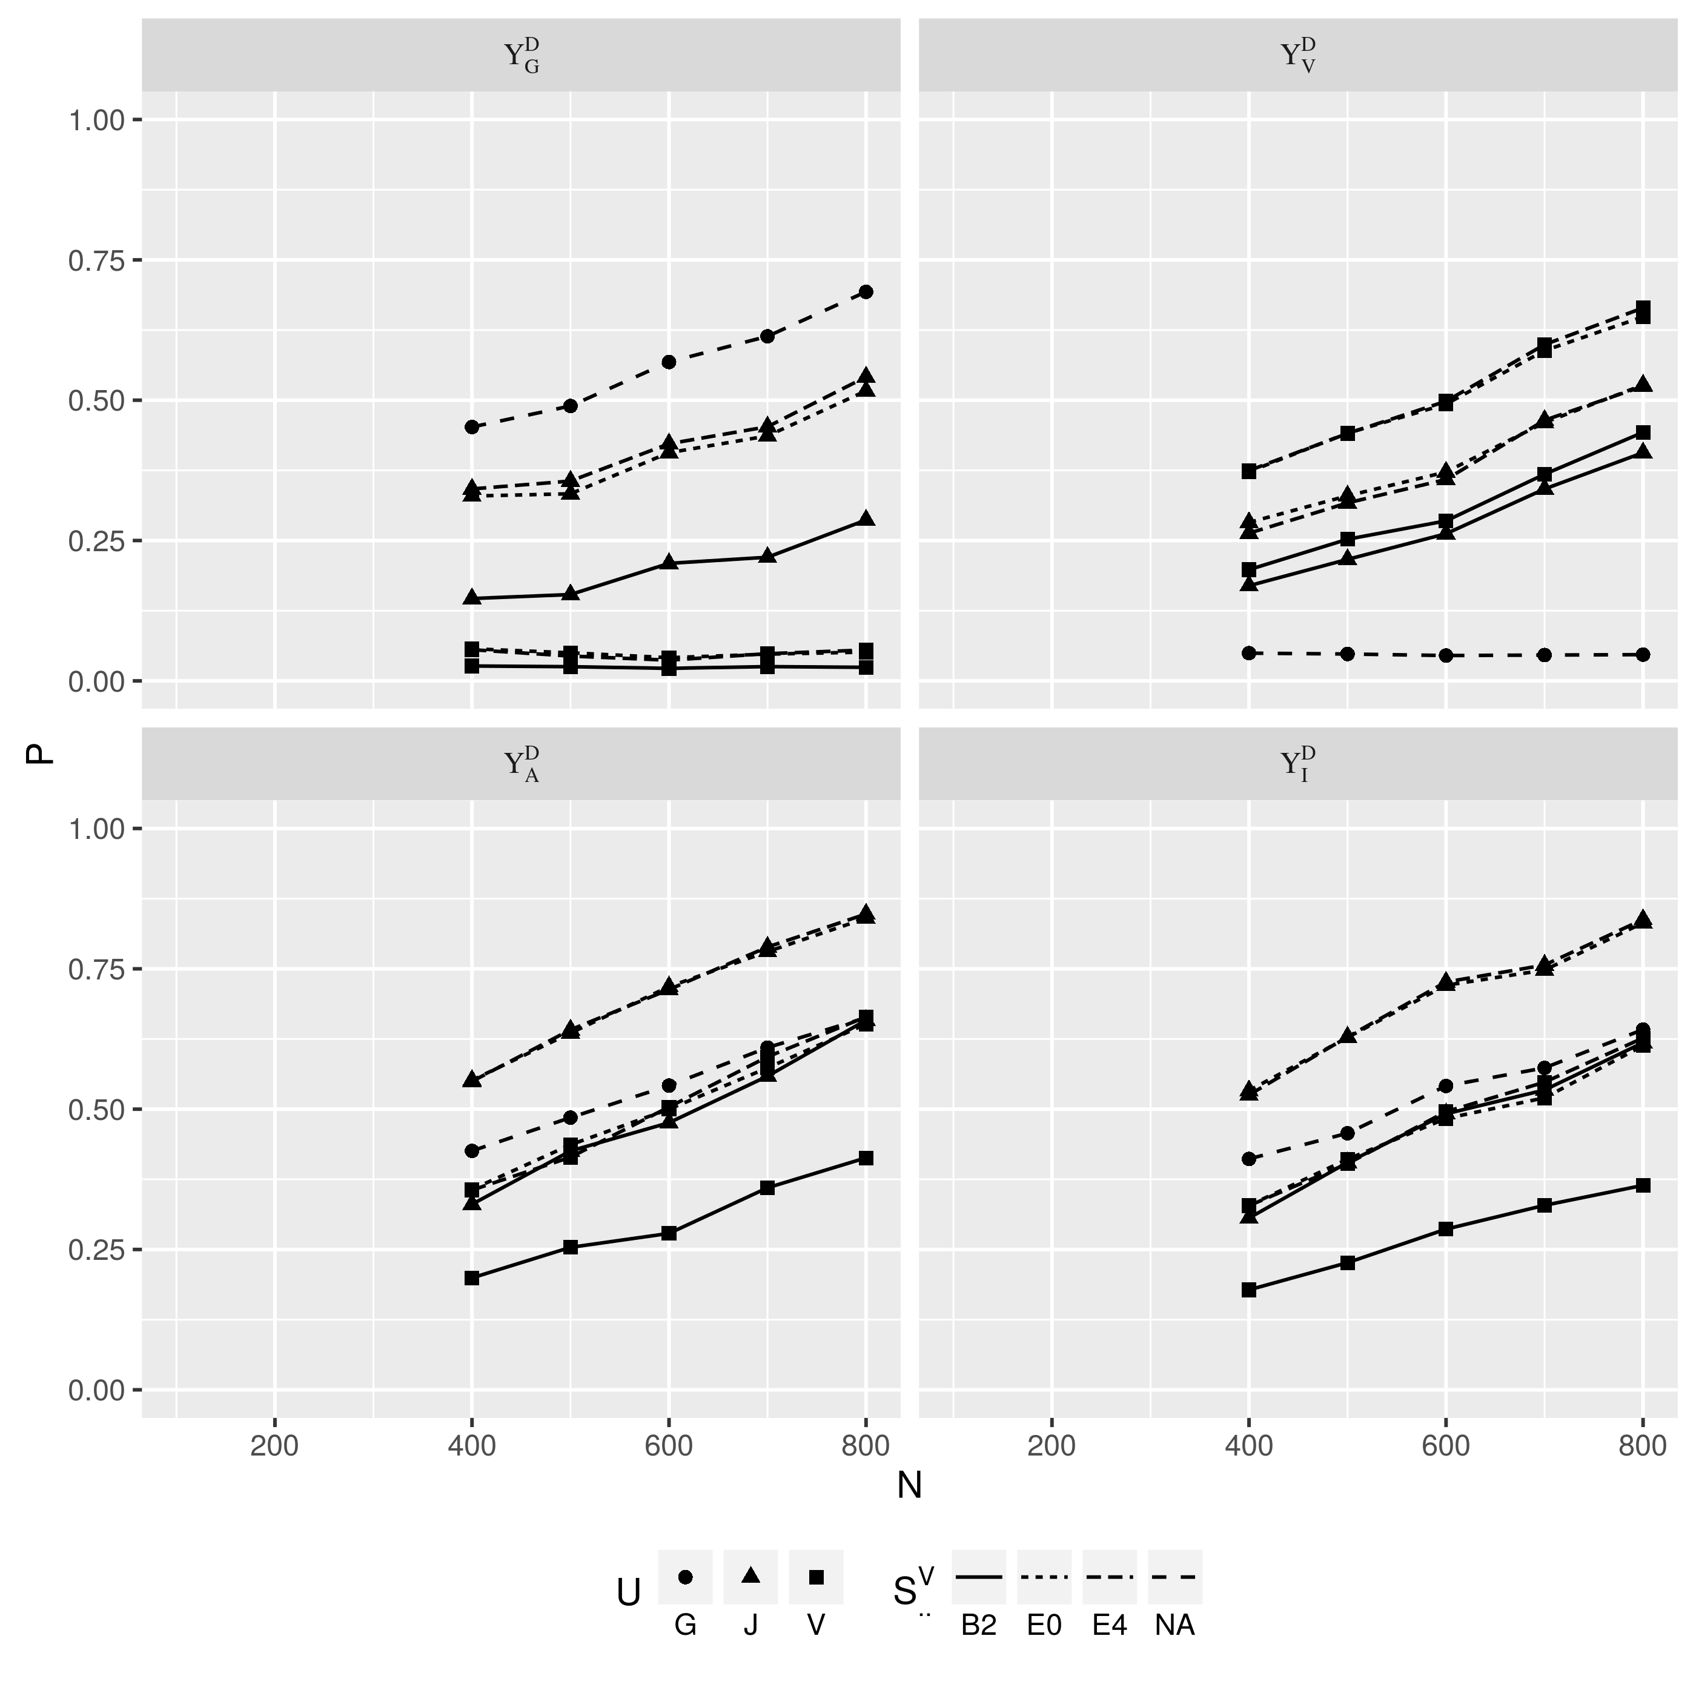
Figure 3: power performance for dichotomous responses

4.2 real data analysis
The baseline data of the same 806 ANDI study participants were used for the real data analysis. The genomic testing units are still genes, and thus the calculation of the corresponding similarity component of the U statistics is the same with the simulation study. The image testing units are 68 standard anatomy regions in the cortical surface, and only the encoded vertices are used. To train the 68 encoders for these region, all 806 subjects are utilized since they all have MRI image profile. The subsequenct U statistic test only included 327 subjects comprised of 47 definite Alzheimer’s disease (AD) cases and 280 healthy controls (CN). The rest 479 participants diagnosed with pre-AD or stage such as minor congitive impairment (MCI) or probable AD (PAD) were excluded from the analysis. The dichotomous outcome was first regressed on 7 known risk factors of AD, namely age, gender, race, ethnicity, years of education, marriage status, ever smoking, and APOE ε4 allele count. The regression residuals were then taken as an continuous phenotype to construct the U kernel and weight terms. The comprehensive resuls of all 3 types of U statistics are show in Figure [? ], the top 10 most significant tests are listed in table [? ]. The results showed that the vertex based test are statistically more significance then the genome based ones, which is coherent with the fact that the neuron loss and thinning of gray matter is an proxmate indicator of the progression of Alzheimer’s , while genomic profile is a remote predictor of a greater uncertainty. A noteworthy phenominium is how the joint U statistic () could "borrow" power from the two simpler genomic () and vertex () statistics, such that for most combinations of gene and @M regions the p-value of the joint test aligns closer to the more significant one of the two simpler U statistics, moreover, when both and are moderately significant, will be more so then either of them. In fact, the top 10 tests in table[? ] were all from the joint U statistics , which is the combination of the most significant WM region - left superiortemporal and the 10 most significant genes from tests and , respectively. Decection of left superiortemporal by either vertex U or joint U test is consistant with known fact that thinning of this region is a strong indicator for AD diagnosis, which is backed by ample evidences from imaging and atopsy studies [? ]. The top genes so far detected couldn’t remain statistically significant after multiple-testing correction and didn’t contain or close to the top 20 SNPs [ref: AD SNP database] reported so far by GWAS and meta-analysis, they are likely to be due to chance.

cortex | gene
SFG | IGLV1-44 | 1.68e-11 | 3.51e-04 | 2.77e-13
SFG | NBEAP2 | 1.68e-11 | 1.19e-04 | 4.74e-13
SFG | RPL21P89 | 1.68e-11 | 6.36e-04 | 5.14e-13
SFG | LOC102724504 | 1.68e-11 | 1.41e-03 | 5.56e-13
SFG | CNTNAP3P8 | 1.68e-11 | 1.08e-03 | 6.17e-13
SFG | CDH4 | 1.68e-11 | 4.64e-03 | 6.96e-13
SFG | HNRNPA1P19 | 1.68e-11 | 8.88e-04 | 7.80e-13
SFG | FAM72C | 1.68e-11 | 9.28e-06 | 7.82e-13
SFG | RP11-638L3.1 | 1.68e-11 | 1.41e-01 | 9.49e-13
SFG | CPXM1 | 1.68e-11 | 8.78e-04 | 1.08e-12
SFG | LOC101929612 | 1.68e-11 | 1.44e-02 | 1.15e-12
SFG | LOC100996517 | 1.68e-11 | 6.77e-04 | 1.20e-12
SFG | IGLV5-45 | 1.68e-11 | 3.44e-04 | 1.23e-12
SFG | MIS18BP1 | 1.68e-11 | 4.95e-03 | 1.35e-12
SFG | CDR2 | 1.68e-11 | 1.82e-04 | 1.39e-12
SFG | RPL41P2 | 1.68e-11 | 6.04e-03 | 1.59e-12
SFG | LOC101927737 | 1.68e-11 | 7.20e-03 | 1.60e-12
SFG | IGLV1-47 | 1.68e-11 | 1.44e-02 | 1.60e-12
SFG | IGLV7-46 | 1.68e-11 | 9.15e-04 | 1.69e-12
SFG | ZDHHC15 | 1.68e-11 | 1.56e-03 | 1.73e-12

Table 1: Top 20 combinations

5 discussion
The joint U statistics can effectively combine information from multiple sources and types to achieve better statistical power, which, in our case, is the joint U with both genomic and vertex components. The major strength of joint U test is robustness, demenstrated by its capability of retaining the power performance close to an optimal model specification, when the true constitution of effect was unknown a prior. Being a non-parametric method, the joint U is versertile enough to tolerate a diverse type of profiles. In our case, the the original vertex data may be generated from a multivariant normal distribution, while the encoded vertex could come from a unknown distribution type, yet either of them can be seemlessly included in the final statistics as a component term. As for the computation, the joint U test finished all combinations of 68 cortical regions and more than 20,000 genes within 24 hour on HPCC of MSU, with a peak load of 400 cpu.
The study also showed the higher order feature abstracted by the SA not only has much a lower dimension than the original profile, but also help the later U test involving the vertex component. The usefulness of the SA offered some intriguing prospects. First, it should grow deeper, by increasing the number of layers. A deeper SA is capable of creating more compact and more meaningful abstraction of the original vertex data, and therefore boost the statistical power even further. Second, the way we learned the SA, that is, in an unsupervised manner, implies greater use of data not allocated for any specific study, as long as the image aquisition follows compatible protocols. For example, the 489 subjects who didn’t enter the real data analysis due to uncertainly in diagnosis, can still contribute thire cortical surface profiles to the knowledge encrypted in the SA. If we go even further in the future, besides the 806 subjects with both high dimensional profiles available, the rest, over one thousand ADNI1 and ADNI2 participants not included in this study due to the lack of WGS profiles, could also help building the SA since with their MRI scan at baseline. Aside from cortical surface profile, the learning and encoding can be applied to the genomic profile as well, which is also high dimensional. The advantages of unsupervised learning could be even more pronounced with genomic data, given the abundance of publicly available databanks of human genome such as the 1000 genome project.
The study is not without issues however. Although the information from the cortical surface profile did help the joint U statistics to achieve whole genome, whole surface significance, but the genomic component was still under powered, which could be the limitation of our small sample (N=327). As we just mentioned, without additional sample, the power could still be hopefully boosted by constructing SA for genomic regions that encrypt general knowledge of human genome from large amount of public data.
We also believe the feature abstraction better demonstrated its potent in the real data analysis than in the simulation studies, because a real life diseases in the CNS usually morphe the cortical surface, making visible changes of features, but the simulation only assigned effective vertices randomly across the testing unit, instead of having the them clusterd at visible surface featuers such as the few dozen named sulci and gyri. As a consequence, our simulation treated the deep encoder more like an uniform noise reduction tool resembling the Gaussian filter employed by many traditional vertex-wise analysis (VWA), or at best, a generalized principal component analysis aimming to reduce the dimensionality. A simulation driven by visible feature is required to provide evidence of the full capacity of an SA.
The machine learning is still a intense operation even with the aid of greedy layer-wise pre-training. Creating 68 SA for all cortical surface regions took another 6 hours in the same HPCC cluster. A GPU cluster maybe a temporary solution, yet, when much deeper and wider SA is desired, the computation will eventually overrun the expedience brough by the pre-training. Also, as we want to the features to be abstracted from the genomic profile as well, the sheer number of genomic testing unit (more than 20000 genes) is already a serious concern. We are now closely following the machine learning literature, any learning scheme of better performace will be potentially helpful for both the deepening of an SA and its application on the numerous genomic features.

6 Appendix

6.1 Backward Propagation
First, realize the reconstruction loss is a function of ̃x while ̃x is a function of τ, using the chain rule, one gets:

[Sorry. Ignored \begin{split} ... \end{split}]
Here we use ⊘ to denote element-wise division.
In the main text, derivation of requires explict form of the gradient of a layer’s output with respect to its own paremeters and direct input. Here, we take the i th. decoder layer as an example, whose ouput, domestic parameters, and direct input are , and , respectively (see 8). The calculation for an encoder layer is similar, since the structure of an encoder layer is identical to its decoder counterpart except the dimensionality change (see 7 and 9). The derivatives will be calculated separately for each output element , because the inverse logit transformation is applied element-wise. To ease the thought process, the i th. decoder layer is rewritten in a per-element manner, which is

where is the k th. row vector of weight matrix , and is the k th. element of threshold vector , with . The gradients of the k th. element in the output, , with respect to its contributing parameters and the input are

[Sorry. Ignored \begin{split} ... \end{split}]
respectively. Notice that, the derivative of has a more compact expression using the dependent variable y instead of x, since

thus, during the invocation of chain rule, we have

Packing up the gradient for each element in the i th. decoder’s output into a vector, we have

[Sorry. Ignored \begin{split} ... \end{split}]
Besides the gradient of the i th. decoder ouput with respect to its own paremeters, notice the input of the i th. decoder layer, , is in fact a function of every structure parameter in the layers below, decoder and encoder regardless. Let’s deal with the decoders first. Using the chain rule, the gradient of with respect to the parameters in any of the lower decoder layer i is:

[Sorry. Ignored \begin{split} ... \end{split}]
where are parameters in the lower, j th. decoder layer (i<j). Puting together the above calculations, we see for the out of i th. decoder layer, , its gradient with respect to any structure parameters within itself or the other decoders down below can be calculated by recursively invoking the chain rule:

[Sorry. Ignored \begin{split} ... \end{split}]

[Sorry. Ignored \begin{split} ... \end{split}]

[Sorry. Ignored \begin{split} ... \end{split}]
(15)where i=(1…M). Thus, instead of pipping the output of the ith encoder layer () to the one above, it is pipped to the cooresponding M−ith. layer in the docoder counterpart for an immediate reconstruction of the input . The unit encoder–decoder tuple can then be trained by minimizeing the reconstruction loss . A total of M units can be formed and trained seperatetly. Although the pre-training cannot be done in parallel since the higher unit have to wait the lower for input, the process is very fast because the number of parameters is rather small in each unit compared with the whole network. The pre-training serves as a non-random parameter initilization, after which the whole network is already near convergence. Therefore, the subsequent fine-tuning of entire network would required much less steps to reach convergence.
The SA thus trained may suffer the overfitting problem, that is, the network abstracted well on the facts so far presented to it, showing low reconstruction loss, but may deals poorly for the future, unknown data. To better balance the internal and external validy, one way is to add a regulator term to the loss funciton L, usually the or norm of the parameter elements. Doing so discourages large parameters which causes instability of the prediction/reconstruction. For encoder training, another way to ensure generalizability is to randomly corrupt the input by setting some elements to zero [2008 Vincent]. The rationel is, the more rigours a feature is, the more like it will survive the random corruption. More training epoch is needed to ensure the randomness of corruption, but doing so encourages the network to seek major features of the input while neglecting the minor changes between facts. And since major feature are more likely to show up in the future, the external validty of the encoder is thus preserved.
For the current study howver, the purpose of deep-learning is not to construct an encoder encrypted with universal knowledge regarding white matter surface, but to produced the abstration the surface vertices at hand for the up-coming analysis. In other words, the code ŷ is the only concern here, and the external validty will be implictly handled by the subsequent U-statistical analysis using such code. For now, an ad-hoc encoder trained without regulator term or ramdom corruption would surfice. The current implementation is a five layered encoder, each halves the dimensionality of its input. Thus the final encoding will be 32 times smaller then the raw input.

