An Joint Association Analysis Method for Genomic Sequencing and Neuroimaging Data

Xiaoran Tong, Qin Lu

The next generation genome sequencing and neuroimaging technology give rise to large, multiple-site cohort with growing wealth of next generation sequencing (NGS) data and magnetic resonance imaging (MRI) data. These growing databases, while offering new opportunities to detect genetic association with complex diseases, also highlights the “curse of dimensionality” and the issue of low statistical power, due to the large number of variants in both types of data, and particularly the low MAF of the NGS data. In this work, we tackle the dimensionality issue of the neuroimaging profile by first training a stacked autoencoder, then use it to generating compact, abstracted representation of the raw image data. To solve the power issue, we adopt the grouping and aggregation technique, coupled with an U statistic composed of similarity based kernel functions to detect the joint association among the genomic, neuroimaging and phenotype profiles. The simulation study showed the method can withstand misspecified model and a wide variety of profile distributions. It also achieved a higher power by replacing raw image data with abstracted features, and by the grouping and aggregation of variants. Lastly, the method is applied to the real clinical diagnosis together with the genomic and neuroimaging data from the Alzheimer’s disease Neuroimaging Initiative (ADNI), which demonstrated its capability to detect strong interaction effect between the two high dimensional profiles while the genomic profile itself only weakly associated with the phenotype.

# Introduction

The decade long search of casual variant by genome wide association analysis (GWA) hasn’t been satisfying. So far GWA hardly find any single nucleotide variant (SNV) with a large enough effect to act as a stand along necessary cause of any complex diseases. Although a large number of statistically significant common variants were indeed identified by GWA, only a moderate fraction of heritability have been explained by the totality of these findings Manolio (2010; Pandey 2010). Despite the setback, human genome is still an intriguing source of curiosity owning to its intrinsic advantages. When viewed as an exposure, genetic polymorphism is constant throughout an individual’s life course and all types of organism, saving the complication of study design. Also, as one of the fundamental causes of all biological processes, genomic polymorphism is not susceptible to reverse causality. From a population perspective, the occurrence of genetic variation mimic a random assignment of treatment in a quasi-experiment, which in turn can be exploited to infer non-genetic effect through an instrumental variable approach, such as Mendelian Randomization Lawlor et al. (2008; G. D. Smith and Ebrahim 2003). These features keeps genomic analysis a promising tool for casual inference.

## Analysis of Rare Genomic Variants

The “rare variant, common disease (RVCD)” hypothesis aims to to explain of the “missing heritability” which GWA failed to capture. RVCD states the gap could be attributed to rare variants of moderate to large effect not covered by GWA Cirulli and Goldstein (2010). The Next Generation Sequencing (NGS) projects, growing in both number and scale over the last decade, offered numerous data sources for the analysis of rare variants. However, the stockpiling data also raise a number of methodological challenges. For one, the variants in a NGS profile is much denser than a GWA profile, which poses intense computation and multiple testing should the traditional per-variant based screening procedures is applied. Also, as the name suggested, the newly detected rare variants came with their minor allele frequencies (MAF) close to 0. As a consequence, the lack of heterogeneity in genotype threatens the statistical power for studies of moderate and small sample size. So far the most popular remedy is signal aggregation, that is, instead of screening the whole profile one variant after another, we first group the variants according to certain criteria, and subsequently all the variants in one group are tested together as an unit, during which the signal of the members are aggregated. The aggregation can be achieved by either collapsing the grouped variants into a single variant Madsen (2009) before the statistical test, or by testing all the variants together with a multivariate approach Wei et al. (2014; Wei, Elston, and Lu 2015; Wu et al. 2011). The aggregation can also be done after a per-variant screening, by summarizing the test statistics (e.g. p-values) of group members into one statistics Dai, Leeder, and Cui (2014; Purcell et al. 2007). Grouping and aggregation drastically reduce the number of hypothesis testing, and improve the heterogeneity or the testing unit. A dilemma comes along though, is the choice of grouping criteria. The most common criteria refer prior knowledge of biological function, resulting in gene or pathway based grouping. One could also group the variants by every few or by a threshold of linkage disequilibrium (LD) Purcell et al. (2007). Since the focus of this study is hypothesis testing, for now, we adopt a gene based grouping scheme for both simulation and real data analysis.

## Incorporating Imaging Data

A hard truth contributing to the unsatisfactory performance of GWA is the genetic effect being intrinsically weak over a complex disease, owning to the large “black box” between the upstream genomic variants and the health outcome at the downstream far end. It is always desirable to probe the “black box” by incorporating other intermediate biological profiles. The added information should increase the chance of detecting strong association, especially when the new profiles is in the casual pathway from the genomic profile to the disease. Our method borrows additional information from neroimaging data, knowing that the cerebral structure is a powerful indicator of neurological disorder. Much like the GWA, similar, per-variant screening procedures can be applied to image profiles if proper definition of variants and their values are given. Taking the structured MRI as an example, it is natural to view voxels in the MRI slices as variants, and the normalized brightness of those voxels as their values. Following such definition, a per-voxel screening can be immediately done to the entire profile to search for significant loci in the brain, which is typically called voxel-wise analysis (VWA) Ashburner and Friston (2000; S. M. Smith et al. 2006; J. Baron et al. 2001; Chételat et al. 2005). In our study, the neuroimaging profiles are processed by [**FreeSurfer**](http://surfer.nmr.mgh.harvard.edu/), a freely distributed neuroimaging processing software. Instead of the original structure MRI slices, the cortex reconstructed from these slices is taken as image profile. Instead of the voxels, the variants are redefined as the vertices spanning the 3D cortex, while the values are defined as the gray matter thickness at these vertices. [**FreeSurfer**](http://surfer.nmr.mgh.harvard.edu/)already comes with its own vertex-wise analysis (the abbreviation happens to be “VWA” as well), which in essential is applying generalized mixed linear model to very vertex Bernal-Rusiel et al. (2013; Salat et al. 2004). The per-variant screening approach may work better for the cortex than for the genomic profile, because the value of an vertex is continuous, which mean it does not suffer low variability like a rare genomic variant does. However, the multiple testing issue might be worsen because the neighboring image variants cover tightly connected cerebral tissue, their value (thickness of gray matter) are highly correlated. Thus, the grouping and aggregation strategy could also benefit analysis involving cortex profiles. As an analogy of gene based grouping and aggregation of genomic variants, the cortical vertices can be conveniently grouped into 68 recognized functional anatomy regions (34 in each hemisphere) and have each of them analyzed as an unit. In the simulation study, we will take out small regions from the cortex and compare the power performance of an aggregated unit against the per-variant based VWA.

## Dimension reduction using Deep Artificial Neural Network

The typical testing unit of the image profile is also high dimensional, oftentimes even higher then most of the genomic testing units. For our study data, after segregating cortex into 68 anatomy regions with [**FreeSurfer**](http://surfer.nmr.mgh.harvard.edu/), the chance of a randomly picked cortex region holding more variants than a randomly picked gene is 96.8%. Although the multivariate algorithms that works with genomic testing unit can be applied to the cortex with little to no rework, it would be desirable to first reduce the dimensionality of a image based test unit before the analysis. One popular trend is using deep artificial neural network to extract high order features from the raw profile, which not only lowers the dimensionality but also raises the signal - noise ratio Hinton and Salakhutdinov (2006). The potent of deep network lies in its capability to cumulatively encrypt incoming knowledge with unsupervised training technique. In other words, as long as the future collection of image data follows protocols compatible to the current, the existing deep network can be incrementally refined to achieve more precise and concise feature abstraction. For now, included in the method is a series of stacked autoencoders for each the cortical regions, which are light weighted deep network whose capability is comparable to the more powerful but much slower deep belief networks Vincent et al. (2010; Glorot and Bengio 2010). The formulation and calibration of the stacked autoencoder is detailed in the method section and appendix, simulation studies are conducted to compare the performance of original cortical vertices versus the high order features abstracted from these vertices.

## Association Analysis of multiple high-dim Component

The introduction of additional high dimensional profile also complicated the constitution of an association. In most cases, an investigator does not know the effect composition in advance, that is, the variation of phenotypes can be attributed to either genomic polymorphism or cortical vertex alone, or both, either with or without unknown type of interaction, mediation or even feedback loops among these profiles. Thus, the method in mind must be sensitive to the association but at the same time robust enough to maintain statistical power when the putative mode is unavoidably, partially misrepresenting-representing the reality. Also, the value of genomic and cortical variants could be drawn from distinct non-normal distributions, while the phenotype profile could also be multivariate, with each element following unknown distribution. Considering these uncertainties, the test statistic in mind should also be versatile enough to counter an admixture of possibly skewed, non-normally distributed data component. More ever, even with the grouping and aggregation that reduces the number of tests, the method has to be reasonably fast and powerful, because the combination of two or more profile can still be a huge number (in our case, there are approximately 41,000 genes and 68 cortex regions), which is already a computational and multiple testing challenge, and not to forget is the dimensionality of each testing unit. The core of the proposed method is the generalized multivariate similarity U (GMSU) postulated by Wei et al. (2014; Wei, Elston, and Lu 2015), a fast, distribution insensitive non-parametric statistics. GMSU is capable of capturing associations among multiple high dimensional profiles without assuming the effect composition.

In summary, seeing the increasingly denser genomic profile with a growing number of rare variants, and the availability of other high dimensional biological profiles motivated this study to design and test a befitting method capable of exploring these new data to search for the heritability. We propose the similarity U statistic to involve both genomic and cortex profile. Specifically to the cortex profile, we adopt variant grouping and aggregation from genomic analysis to boost statistical power, and the used stacked autoencoders to reduce dimensionality and noise of the testing units.

# Material and Method

## Study Data Source

The next generation sequencing (NGS) and magnetic resonance imaging (MRI) data were obtained from Alzheimer’s Disease Neuroimaging Initiative (ADNI). A total of 808 subjects at the screening and baseline of ADNI1 and ADNI2 study have both profiles available, alongside with disease diagnosis, demographics, and the genotype of APOE 4.

The structure MRI data first went through a series of processing including special registration, skull stripping, cortical/sub-cortical segmentation, white/gray matter segregation, voxel intensity normalization, reconstruction of cortex, cortex registration, and cortex paceration. The entire pipeline is implemented by [**FreeSurfer**](http://surfer.nmr.mgh.harvard.edu/)- a neuroimaging analysis package developed by Fisher and Dale et.al. Fischl (2012), and currently maintained by *the Laboratory for Computational Neuroimaging (LCN)* at *the Athinoula A. Martinos Center for Biomedical Imaging*. [**FreeSurfer**](http://surfer.nmr.mgh.harvard.edu/)is freely distributed online ([http://surfer.nmr.mgh.harvard.edu](http://surfer.nmr.mgh.harvard.edu/)). The reconstructed cortex is spanned by vertices in 3D space. Each vertex is treated as a image variant, with a number of geometrical attribute attached to it, such as the coordinate of the vertex, the gray matter thickness, average curvature, local area and volume around its vicinity. Currently we took the gray matter thickness as the value of each vertex. The last processing step of [**FreeSurfer**](http://surfer.nmr.mgh.harvard.edu/)– cortex paceration, divides the cortical surface into 68 anatomical regions. For real data analysis, these regions are taken as testing units, for simulation study, small ovals of vertices (mean diameter=28mm) were randomly picked from the cortex as testing units. There are 2 samples failed the image processing, the total sample left for the study is 806.

The NGS data has gone through rigorous quality control during variant calling process, thus the NGS data from ADNI do not require intensive processing. The testing units for both real data and simulation study are gene based. The chromosome location of known genes were queried from the table of genomic features of human reference genome assemble version 38, maintained by Genome Reference Consortium (GRCh38). An extra 5k flanking region were attached to both ends of a gene when group variants in a testing unit. Despite the added flanking region, some unit contains no genomic variant, and they were excluded from further operations. At the end, there are primary and alternative gene assembles eligible for the subsequent study.

## Generalized Multivariate Similarity U Statistic

The goal of our method is to jointly test possible association existing among the genomic, cortex and the phenotype profiles using the generalized similarity U statistic (GMSU) Wei et al. (2014; Wei, Elston, and Lu 2015). To derive the GMSU, three kernel functions are chosen for each profile accordingly. A kernel function measure the similarity between a pair of samples with respect to one of the profiles. Depending on the characteristics of that profile, the exact form of the kernel functions are flexible, as long as they are symmetric and have finite second moment. That is, the similarity measurement is a valid U kernel function, if and are satisfied.

For genomic variants taking values from discrete minor allele count , a fairly common choice of similarity measurement is the identical by state (IBS) kernel function [eq:wSG]

where and is the value of th. variant in the testing unit (e.g. a gene) taken from the th. and th. samples, respectively, and is the dimensionality of that testing unit (e.g. number of polymorphism in that gene). is the weight assigned to the variant according to *a prior* hypothesis, an example is the minor allele frequency (MAF) based which emphasize more on rare variants. Without prior knowledge though, the IBS kernel is simplified to by setting .

For cortex profiles whose variants (the vertices) taking continuous values in , the euclidean distance based kernel function [eq:wSV]

is used to measure the similarity between sample and , which is also called a Gaussian kernel function. Here and are values of the th. vertex in the cortical testing unit of the th. and th. sample, respectively, and denotes the number of vertices in the testing unit. The vertices can also be weighted by the vector , but for now we have no prior knowledge of the relative importance of the vertices, the Gaussian kernel function is thus simplified to .

Lastly, for a multivariate phenotype profile whose elements may be drawn from a variety of unknown distributions, we first normalize its elements with the rank normal quantile function

where is the th. element of the phenotype profile, is the dimensionality of the phenotype (i.e. number of elements), and is the number of samples. Doing so not only corrects skewed elements, but also bypass the complication of admixed distribution types introduced by such a multivariate phenotype. As a result, the pairwise similarity with regard to phenotype can also be measured by a Gaussian kernel function

where is the values of the th. element of the normalized phenotype profile of the th. sample, with weight denoting the relative importance of the th. phenotype element. For a phenotype with only one dimension, that is, , the measurement simplifies to .

All three kernel functions must be centralized, which is done by subtracting the function value at each pair with the two marginal mean of all pairs involving and , respectively, then adding the mean of all pairs to it Wei et al. (2014). Taking the kernel function of genomic profile as an example, the centralized similarity measurement is

where is number of samples.

Finally, the generalized multivariate similarity U statistics is the mean product of three similarity measurement of all pairs except the self-pairs, which is

Under the null hypothesis that no correlation exists among all three profiles, the mean product of all pairs of similarity measurement should be since all three kernel functions are centralized. If the value of significantly deviates from , it means the similarity regarding one profile is related to the similarity regarding one or more other profiles, which implies the presence of association. Under the null, follows a mixture of distribution, the value can be calculated using Davis method Wei et al. (2014; Wei, Elston, and Lu 2015).

The joint U statistic is the core of proposed method, to test its robustness under model misspecification, two parsimonious statistics are also calculated. By dropping the kernel function of cortex vertices , the simplified similarity U statistic

tests the more specific null hypothesis that no association exists between the phenotype and genomic profiles. Likewise, by dropping the kernel function ,

test the null hypothesis that no association exists between the phenotype and the cortex profiles.

The method also applies grouping and signal aggregation on cortex profile. For comparison purpose, we also implement the vertex-wise analysis (VWA). Briefly speaking, it first smooth the testing unit with a Gaussian filter of standard deviation 2, which reduces the noise by grinding away trivial details in the cortical surface. Next, it treats vertices in the original testing unit as single dimensional testing unit, based on which (or ) statistics are calculated, and FDR (false discovery rate) adjusted p-values are derived. Should any of the adjusted p-values below 0.05 threshold, the entire testing unit is significantly associated with some other profiles (phenotype, genomic, or both).

## Stacked Autoencoder

The stacked autoencoder is an artificial neural network mimicking sentimental visual processing which abstracts high order features from the raw image input. The high order feature not only has lower dimensionality, but is also more relevant to decision making. Taking our data as an example, being able to see the approximate location and size of the laceration sites in the cortex, is far more important than knowing the exact thickness, curvature and coordinates of every vertex in the raw profile. Thus, besides dimension reduction, we also anticipate a power boost for any similarity U statistics involving cortex profile if the raw vertex data is replaced with abstracted feature.

An SA is formed by layers of autoencoders stacking on top of each other, hence the name “Stacked”. What an autoencoder layer does is first linearly recombining the input elements, then applying a non-linear transformation to every element of the recombination. Under most circumstances, the recombination is made lower in dimensionality than the input to ensure feature abstraction and dimension reduction actually happen. The autoencoder at the th. layer of the stack is has the form

where is the layer output and is the layer input. They layer input is also the output of the autoencoder from down below, that is, the th. layer in the stack. The linear recombination of input elements is achieved by the cross product between the input vector and the weight matrix plus the offset . The superscript and denote the dimensionality of data and structure parameters of the autoencoder layer. As mentioned, to ensure feature abstraction and dimension reduction actually happens, is made smaller than . For our method, a autoencoder layer always halve the dimension of its input, that is, = . Lastly, inverse logit function is chosen to non-linearly transform every element in the recombination, that is,

where is the linear recombination of the input ; the super script denotes its dimensionality and indexes its elements. Upon close look, each element in the output is calculated as

The th. elements is an “S” shaped function of all elements of the input, which resembles the biological activation of the th. neuron in the th. layer of visual cortex when the weighted sum of stimuli from the neurons in the previous layer, , exceeds a threshold . The weight is the th. row vector of the weight matrix , and the threshold is the negation of th. elements of the offset .

An SA of layers, dimensional input and dimensional output , is assembled by recursively taking the output of the lower autoencoder layer and, as the input, piping it to one layer above, and ensuring the dimension of the topmost output is .

where is the dimensional input of one sample, which is seen as the output of the non-existing th. autoencoder with . Reading from bottom to top, the SA gradually abstracts higher order features from the dimensional raw input , until the dimensionality of the output is as low as .

The SA thus constructed is useless without calibration, a process that finds a set of structure parameters that best represents the body of knowledge regarding the data, which, in our case, is the knowledge of human cortex. Only then the SA is truly capable of abstracting meaningful features out of the input instead of haphazardly reducing it into a small but irrelevant output (e.g. a vector of random numbers). The calibration must be guided by a “badness of abstraction” gauge. We first reconstruct the input from the abstracted high order feature , and compare it with true input . The disagreement between the reconstructed and the true input tells us how poorly the encoder had performed. The rationale is, a superior abstraction should be easier to recover the input from. Therefore, a set of parameter that lower the difference between and is considered a better configuration of the SA. The calibration guided by such criteria is called unsupervised training, or unsupervised machine learning. The term “unsupervised” states the fact that no external knowledge other than the raw input is needed. The unsupervised training encourage the SA to manifest into an encrypted knowledge of the concerned data. Not requiring labeled data is the greatest strength of unsupervised learning, which allows a much larger pool of samples to contribute to its calibration, and, as new samples keep popping up, the SA can be continuously refined, mimicking a sentient being’s ability of accepting new knowledge. In particular to our method, unsupervised learning ensure all 806 samples could contribute their cortex profiles to construct the SA, even if 427 of them cannot enter the read data analysis due to uncertainties in disease diagnosis.

The new issue on the table is how to reconstruct the input, that is, a decoder counterpart of the stacked autoencoder is needed. The most nature way to build a decoder is to mirror the encoder structure, thus the decoder will also be a stack of layers, each layer also performs linear recombination of its input through a weight matrix and a offset vector, followed by a element-wise inverse logit transformation, but, the dimensionality change is in exactly reverse order of the encoder stack. By mirroring the th. encoder in the SA, the th. layer in the decoder stack is

With the above layer definition, the decoder stack can be assembled in the same way the encoder stack was done. Continue with the layered example SA in [eq:ES], its decoder counterpart is

Reading from bottom to top, the decoder gradually adds details back to the abstracted feature , and eventually produce a restored state of the input on its top, denoted by . The restoration process is driven by the dimensionality change from to , which is in exact reversed order of the SA. Now with both encoder and decoder stacks ready, the complete cycle of encoding and reconstruction is done by redirecting the top output of the SA ([eq:ES]), that is, the abstracted code , as the input, to the lowest layer of the decoder stack. The combined the structure is

In addition to structure mirroring, a common strategy to train an SA is to constrain the weight matrix in a decoder layer to be the transpose of its encoder counterpart, that is, by forcing , the th. decoder layer become

We adopt this strategy, which not only halve the number of parameter to be calibrated but also follow the common sense that encoding and decoding are essentially symmetric concept. More importantly, this constraint encourages calibration of an optimal SA, not an inferior SA coupled with a superior decoder stack on its top. After all, our best interest is the high order features , not the reconstructed input .

The next thing to do is to measure the total disagreement between original profiles and reconstructed profiles for all the samples, which is called the reconstruction loss . For now, the most popular form is cross entropy

The two matrices and store the original and the reconstructed profiles of all samples, respectively, with each individual sample indexed by , and the elements in each sample profile indexed by . One could view the restoration of from as an array of binary classification problems, with the true probabilities being , the predicted probability being . The reconstruction loss closely resembles the deviance of a logistic regression analysis which measures of how badly the fitted model reflects the observed reality. With the reconstruction loss defined, the calibration of SA become a numerical optimization problem

With the constraint ([eq:CW]) on the weight matrices in the decoder stack, the set of parameters to be tuned is

whose size is , which is parameters less then the non-constrained decoder. The optimization procedure is is done by gradient guided iterative algorithm, which is covered in the appendix section.

The optimization is computational intense, because the number of parameters is usually large. When the number of layers in the stack is also large, the computation used to be inhibiting, because with a fixed number of parameters, the complexity of the function represented by the network grows exponentially with the number of layers. A a deeper SA has more local minimum in the parameter space for the reconstruction loss to fall into. Yet, deep networks are enormously intriguing, since a exponentially richer function space means a much better chance to further reduce while at the same time produce even more compact abstraction (i.e. smaller ). Deep artificial neural networks have revived its popularity in recent years, thanks to the break through in its training procedure, which is now popularly dubbed “deep learning”. For our method, we implement the layer-wise greedy pre-training procedure Bengio et al. (2007; Vincent et al. 2010). The idea is to first train each encoder layer separately, then fine tune the entire structure afterwards. To perform the layer-wise pre-training, the output of th. autoencoder is not sent to the th. autoencoder above it, but instead is redirected to its decoder counterpart immediately to produce an intermediate reconstruction ,

The th. encoder–decoder tuple can then be pre-trained by minimizing the local reconstruction loss , which is fairly easy thanks to the small number of parameters in . A total of tuples is assembled and pre-trained separately. What the greedy layer-wise pre-training has achieved is non-randomly initialize the entire structure to a state closer to optimum. After pre-training, all the encoders and the decoders are wired back together like [eq:ED] and fine tuned together. The comprehensive fine tuning will reach convergence much faster and less likely to “climb the wrong mountain” then a direct training scheme without the pre-training.

## Implementation

The proposed method is based on the joint GMSU statistic , formulated with three kernel functions corresponding to the three profiles. To test its robustness and versatility, we simulated continuous and binary phenotypes from the effect of purely genomic base, purely vertex base and mixed. Under these scenarios, the statistical power of is compared with two parsimonious statistics and whose null hypothesis is more specific but less flexible. The method also intents to replace the original testing unit of the cortex profile with high order features abstracted from it, by training a 4 layered stacked autoencoder with all 806 sample profiles. The newly derived U statistics are compared with the one relying on the original vertices.

Lastly, we pick out 327 individual whose real diagnosis status is certain (either healthy control or Alzheimer’s disease/Dementia case) and apply the proposed method to screen for associations among diagnosis, genes and cortex regions.

# Result

## Simulation Studies

The simulations are based on the real NGS and MRI data of 806 ADNI participants with both profiles. Each iteration run choose a pair of genomic and cortical testing units. The genomic testing unit is a gene with 5kb upstream and downstream flanking window. As for the cortex, a testing unit is a region of 512 vertices randomly picked from the entire cortical surface, which is is roughly an oval of 2.8mm in diameter. The genomic effect and vertex effect are simulated by assigning values drawn from standard normal distribution to a certain percentage of the variants randomly selected from a testing unit (e.g. polymorphism in a gene or vertices in an oval cortical region). The purely genomic and vertex based response are then generated as the product of the testing unit with the simulated effect. An additive and an interactive response are also created by adding up the two basic responses, with and without an additional element-wise product of the two. Lastly, we assign some noise to the generated responses. For now we will focus on continuous response, the simulation study for dichotomous responses will be covered later.

### Robustness of the Joint U

The first set of study aims to test the robustness of the joint U statistics under very likely circumstances of model misspecification. The power performance of the joint U is compared with the two simpler statistics without either genomic or vertex kernel function. The performance under 8 sample size setting and the 4 scenarios of effect composition is shown in Figure [fig:PWR_CNT_KNL].

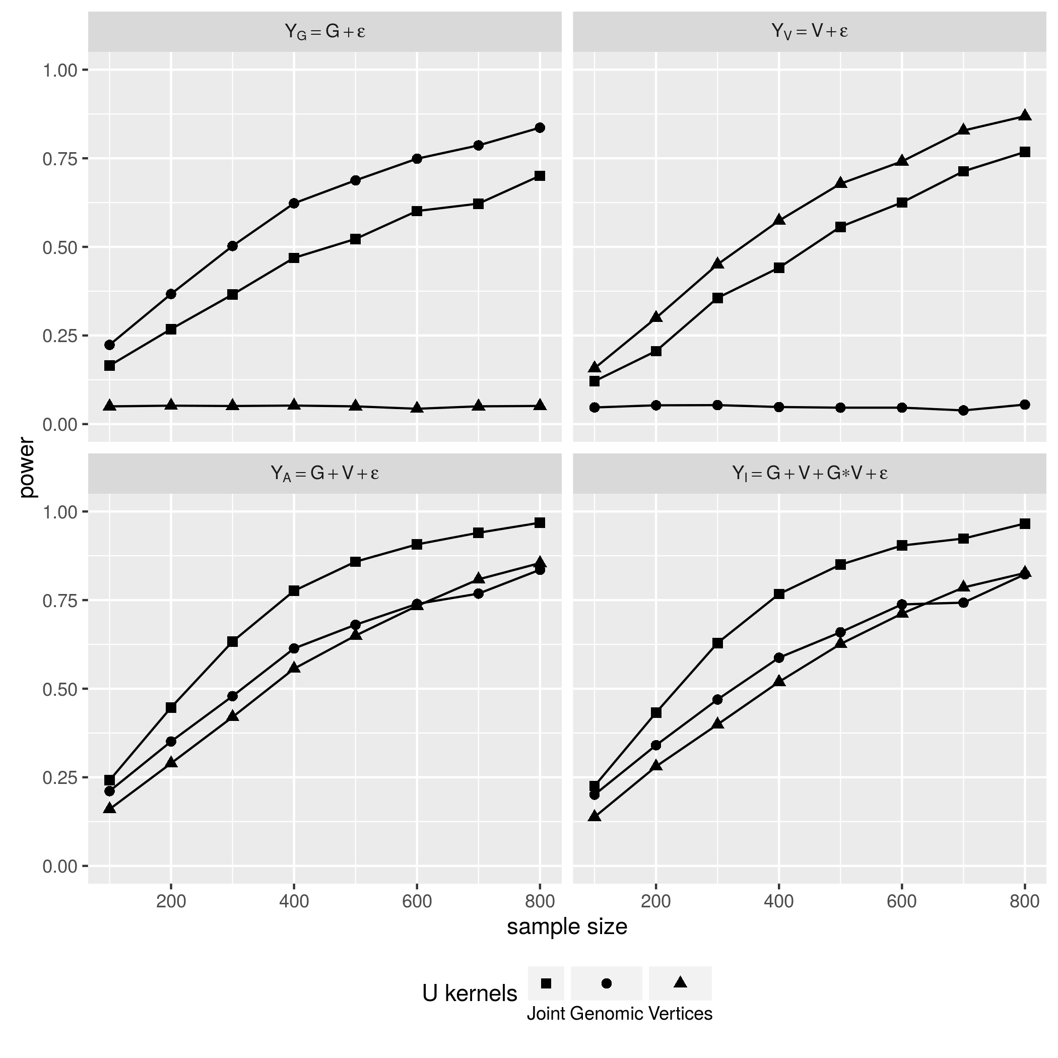

Joint U v.s. Parsimonious U statistics

The top row of Figure [fig:PWR_CNT_KNL] shows that, the two parsimonious statistics and performed the best when the underlying effects were indeed purely genomic and vertex backed, respectively, but they are completely powerless when the actual effect composition does not concur with their choice of U-kernel functions. In contrast, the joint statistic performed fairly well under both circumstances, close to the optimal power displayed by correctly specified parsimonious models. The bottom row of Figure [fig:PWR_CNT_KNL] shows joint U statistic outperformed both and when the effect is additive, either with (Figure [fig:PWR_CNT_KNL] down left) or without (Figure [fig:PWR_CNT_KNL] down right) an additional interaction term.

### Grouping and Aggregation on Vertices

We known vertices in a cortex profile do not have “low MAF” issue that rare genomic variants have, but the grouping and aggregation strategy used by analysis of NGS data may still benefit analysis involving cortical surfaces. The second study aims to see weather an aggregated cortical testing unit achieve higher power than the per-vertex based VWA followed by FDR (false discovery rate) correction. Comparison of the two strategy is done under the same 8 sample size and 4 effect compositions, but without the statistics since it does not involves cortex profile. The result is shown in Figure [fig:PWR_CNT_VWA].

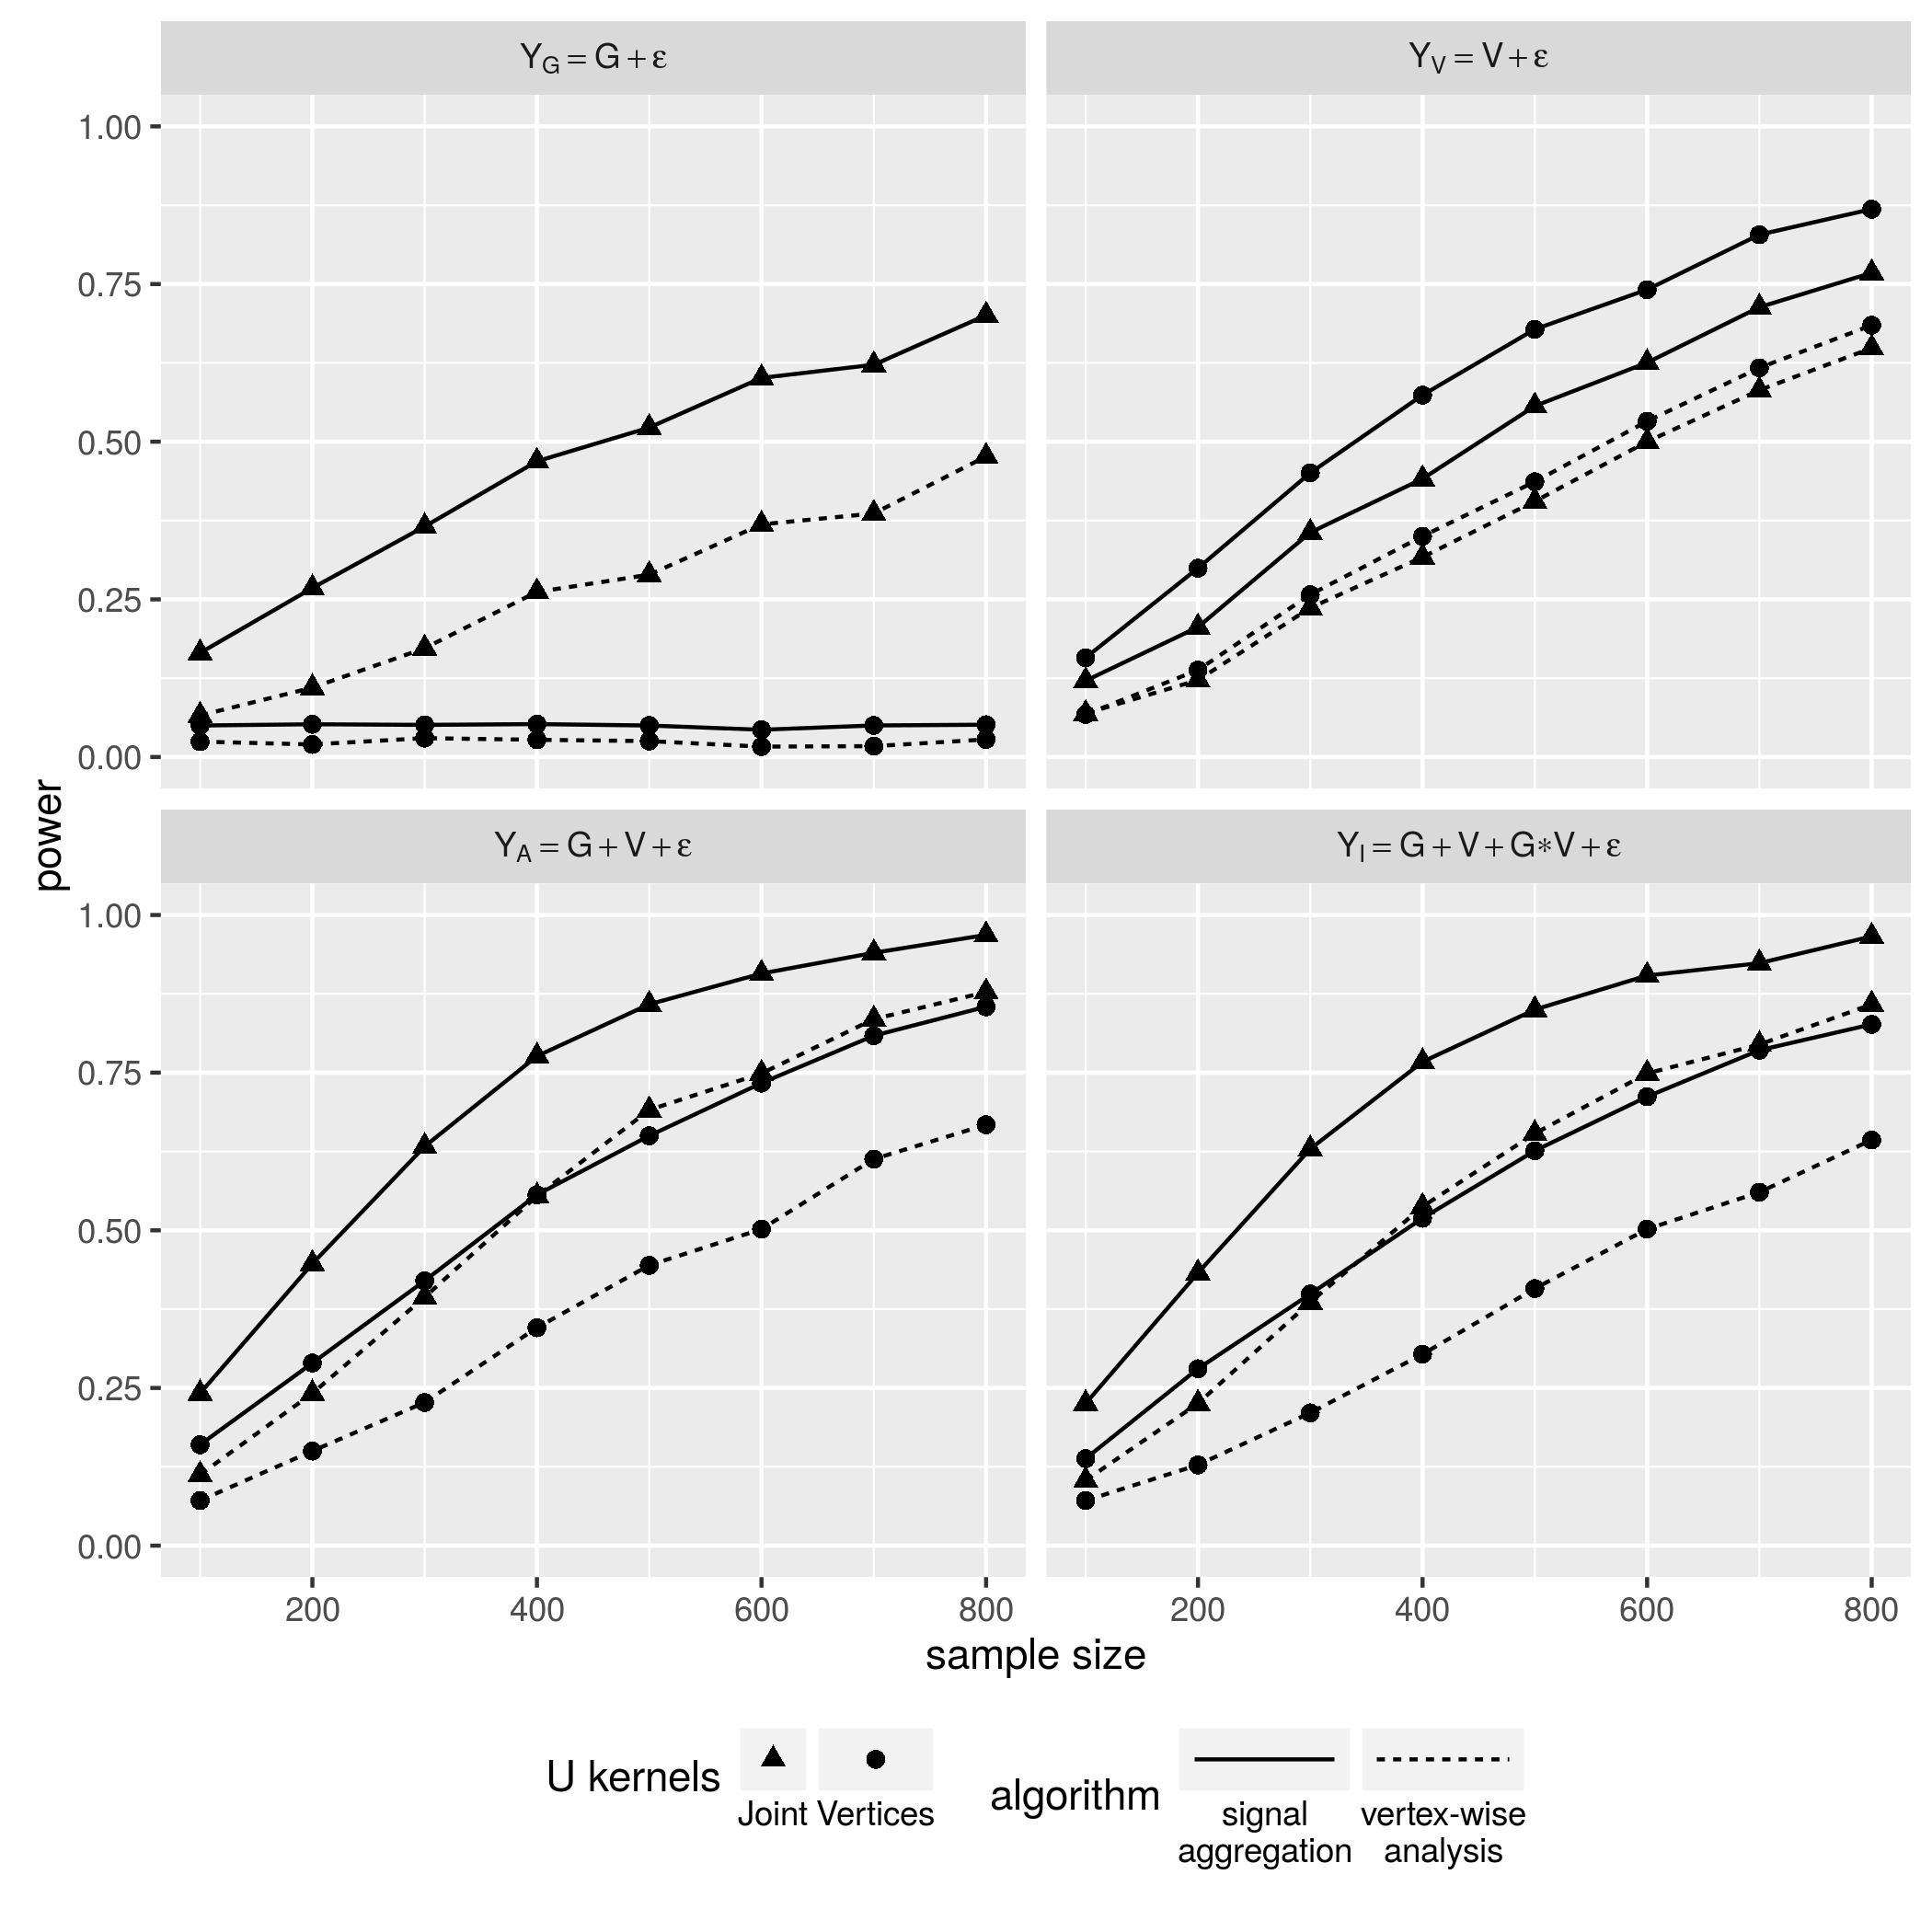

Vertex Grouping & Aggregation v.s. Vertex-wise Analysis

Under all simulation settings, the aggregated testing unit (solid lines) overpowers the per-vertex based VWA (dashed lines). This gap is only slightly closed when the sample size grows large. Another interesting speculation is when the U kernel functions is totally misspecified, the type I error rate of VWA is lower then the 0.05 threshold while the aggregated test isn’t (Figure [fig:PWR_CNT_VWA], top left panel). The multiple testing correction is done by false discover rate (FDR) adjustment, which says that the adjusted p-value will be conservative if the tests were not independent. Therefore, a conservative type I error rate reflects the fact that closely located vertices are correlated as they were sampled from tightly connected brain tissue. As a result, grouping and signal aggregation is also recommended for cortex profile.

Another issue worth mentioning is the computation time. VWA takes drastically more time than grouping and aggregation, because it has to perform tests in order to derive one final or statistic instead of just once. For now, the simulation study fixes to 512, under the largest sample size, 800, a single run of the proposed method using 1 CPU core takes only a few seconds, but the VWA approach paralleled on 4 CPU cores requires nearly 4 hours.

### Taking High Order Features from Cortical Vertices

The third set of studies test whether the high order features abstracted from the raw cortex profile provides higher statistical power than the raw profile itself. Again the comparisons is done under all settings except those involving. The result is shown in Figure [fig:PWR_CNT_SAE].

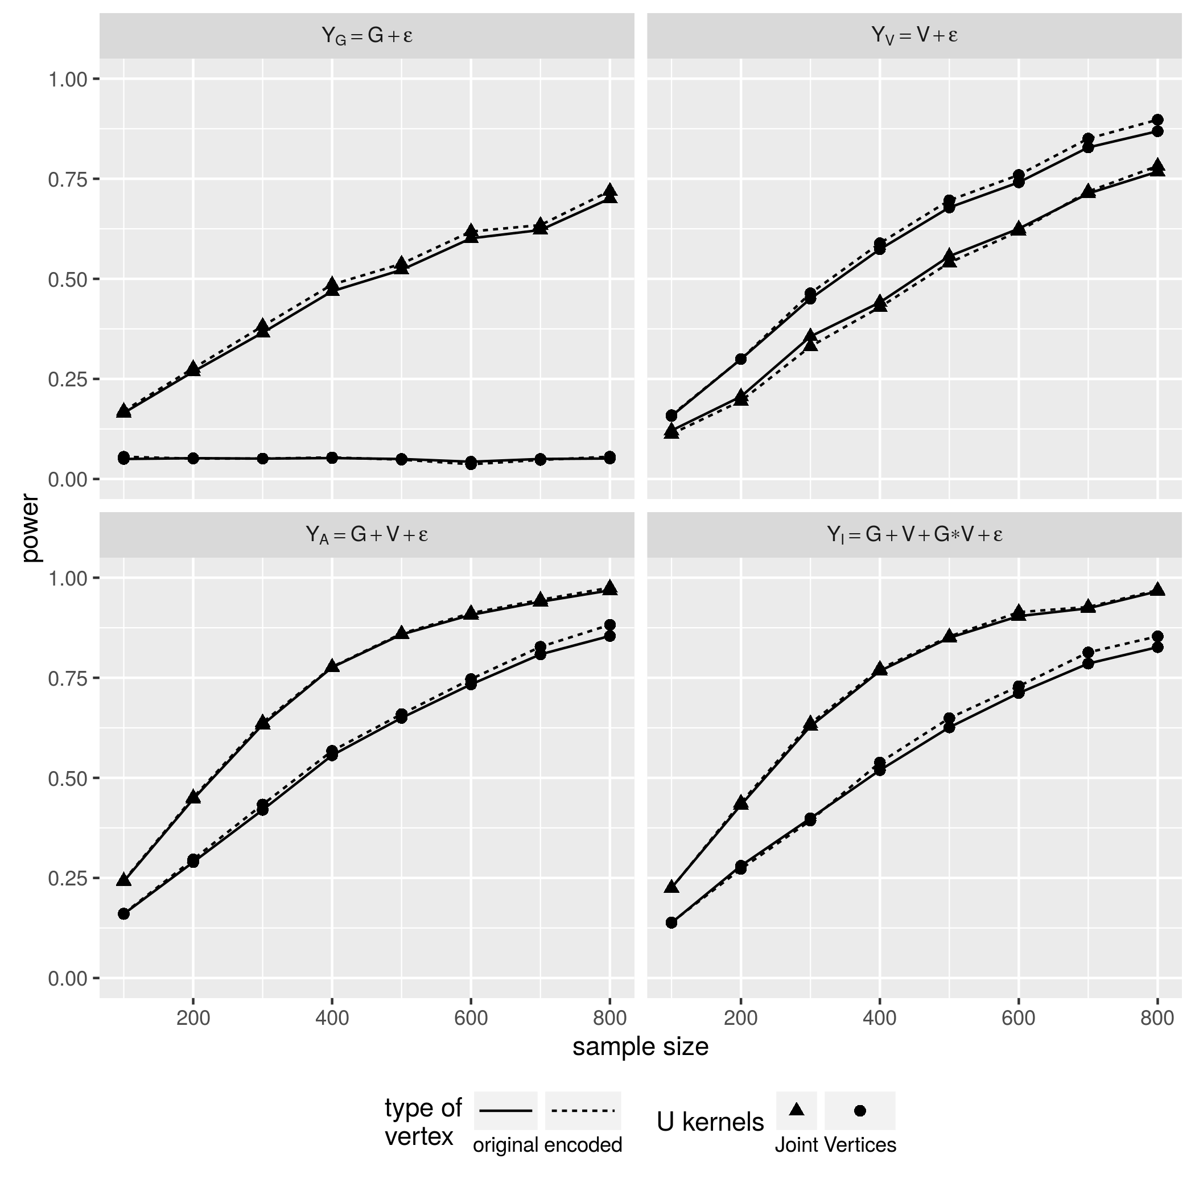

High Order Features v.s. Original Vertices

In most scenarios, the abstracted features (Figure [fig:PWR_CNT_SAE], dashed lines) offers more power then the original vertices (Figure [fig:PWR_CNT_SAE], solid lines), and the margin is growing with the sample size. The only exception happened when the sample size is lower then 600, the effect is purely vertex based, and the partially misspecified joint U statistic is used for the test (Figure [fig:PWR_CNT_SAE], top right). Since the rejection of null hypothesis counts as type I error when the kernel functions are complete misspecified, the top left panel in [fig:PWR_CNT_SAE] shows that, the use of abstracted features doesn’t deviate the type I error rate from the 0.05 threshold.

### Simulation study of Binary phenotypes

The dichotomous responses is simulated by plugging the continuous responses into inverse logit function to get an array of probabilities, then draw the binary case/control status from these probabilities. The power performance shares very similar patterns under every scenario, albeit poorer than their continuous counterpart. The results is shown in Figure [fig:PWR_BIN_KNL], [fig:PWR_BIN_VWA] and [fig:PWR_BIN_SAE], which still suggests the use of joint statistic UJ, the grouping and aggregation of high order neuroimaging features.

In general, the simulation studies have so far demonstrated the robustness and versatility of the proposed method when faced with uncertain effect composition and a variety of phenotype distributions. Also shown is the helpfulness of grouping and aggregation strategy used by many rare genomic variant studies over other types of high dimensional whose variants are not “rare” but potentially correlated. The power boost offered by the stacked autoencoders is not dramatic, but is increasingly more positive when the sample size grows.

## Real Data Analysis

The baseline data of 327 out of 806 participants who has definite diagnosis status entered the analysis. The genomic testing units are still defined by gene. The image testing units are now 68 cortical anatomy regions. These 68 sets of vertices are sent to 68 corresponding stacked autoencoders trained with all 806 profiles, the resulting 68 sets of high order features are then combined with all the genes to form a total of joint U statistics, that is, the number of genes times the number of cortical regions. Among the 327 chosen subjects, 47 of them are diagnosed with either Alzheimer’s disease (AD) or dementia, while the rest 280 subjects are healthy controls (CN). The case/control outcomes were first regressed on 7 known risk factors of AD, namely age, gender, race, ethnicity, years of education, marriage status, ever smoking, and APOE 4 haplotype. The regression residuals were then taken as the actual phenotype. For each tuple of gene and cortical region, we also derive and to test the two simplified null hypothesis. Thus, the results came in triplets of p-values , and , corresponding to the three U statistics , , and . The triplets are show in Figure [fig:RDA_PVL] horizontally, ordered by , and for each triplets, the three p-values are lining up vertically by the negative log transformed value.

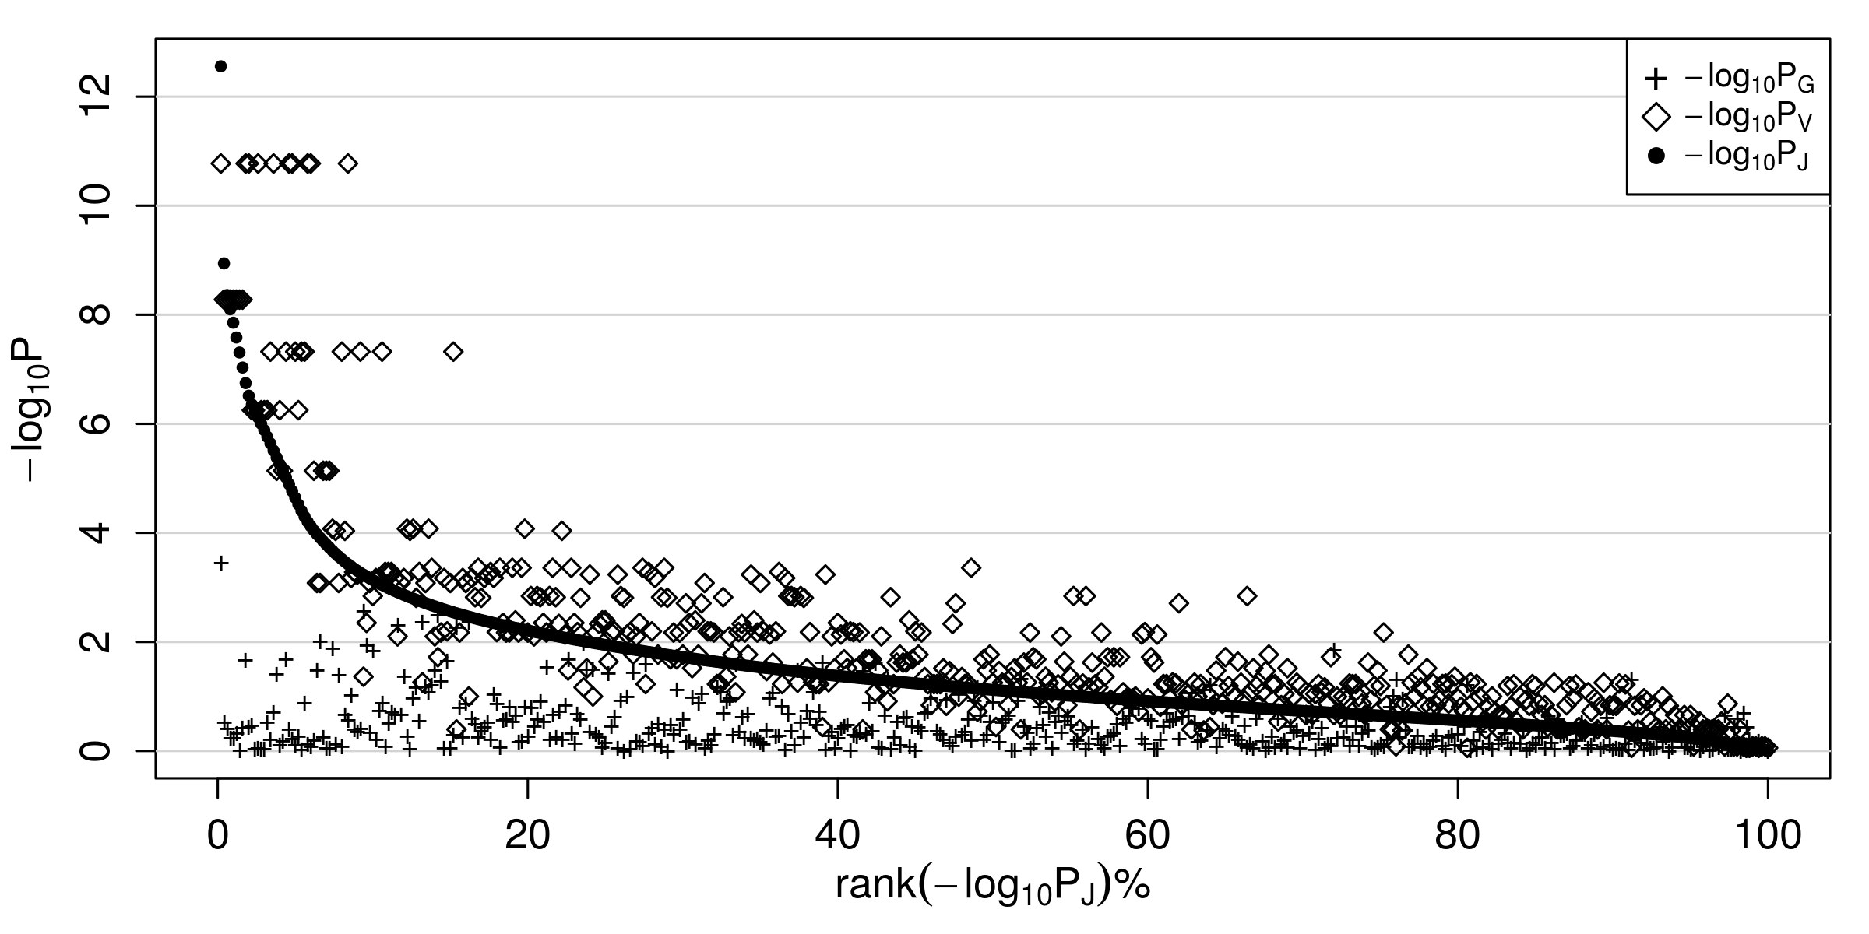

p-values of real data analysis

In general, the significance of the purely vertex based (Figure [fig:RDA_PVL] diamonds) is above the purely genomic based (Figure [fig:RDA_PVL] crosses), reflecting the fact that genomic effect is weak while the cortex profile is a very indicator of the diseases in brain, and the joint similarity U statistic (Figure [fig:RDA_PVL] dots) lies between the two, leaning closer to the cortical vertex based . To be noted is how “borrow” information from the cortex profile to enhance the statistical significance of the purely genomic based , which by itself never reaches significance at the threshold of after the FDR adjustment of tests. When is also moderately significant, the corresponding joint statistic could be more significant than both and , reaching the 0.05 threshold even after FDR adjustment over tests, which is shown by the dots in the most top left corner of Figure [fig:RDA_PVL], and reflected by the 20 top significant triplets listed in Table [tab:RDA_T20].

Top 20 most significant joint test - overall

|  |  |  |  |  |  |  |
| --- | --- | --- | --- | --- | --- | --- |
| GENE | CORTEX |  |  |  |  |  |
| IGLV1-44 | l.superiortemporal | 7271 | 174 |  |  |  |
| NBEAP2 | l.superiortemporal | 7271 | 238 |  |  |  |
| RPL21P89 | l.superiortemporal | 7271 | 90 |  |  |  |
| LOC102724504 | l.superiortemporal | 7271 | 59 |  |  |  |
| CNTNAP3P8 | l.superiortemporal | 7271 | 40 |  |  |  |
| CDH4 | l.superiortemporal | 7271 | 9464 |  |  |  |
| HNRNPA1P19 | l.superiortemporal | 7271 | 17 |  |  |  |
| FAM72C | l.superiortemporal | 7271 | 174 |  |  |  |
| RP11-638L3.1 | l.superiortemporal | 7271 | 4067 |  |  |  |
| CPXM1 | l.superiortemporal | 7271 | 208 |  |  |  |
| LOC101929612 | l.superiortemporal | 7271 | 256 |  |  |  |
| LOC100996517 | l.superiortemporal | 7271 | 34 |  |  |  |
| IGLV5-45 | l.superiortemporal | 7271 | 179 |  |  |  |
| MIS18BP1 | l.superiortemporal | 7271 | 553 |  |  |  |
| CDR2 | l.superiortemporal | 7271 | 260 |  |  |  |
| RPL41P2 | l.superiortemporal | 7271 | 87 |  |  |  |
| LOC101927737 | l.superiortemporal | 7271 | 157 |  |  |  |
| IGLV1-47 | l.superiortemporal | 7271 | 138 |  |  |  |
| IGLV7-46 | l.superiortemporal | 7271 | 130 |  |  |  |
| ZDHHC15 | l.superiortemporal | 7271 | 80 |  |  |  |

*: below 0.05 after Bonferroni correction  
+: below 0.05 after FDR correction

From Table [tab:RDA_T20] we see the top 20 most significant test all involves the left superior temporal cortex, whose neuron loss and shrinkage in volume is highly associated with the onset of Alzheimer’s Disease and its progression to dementia Gómez-Isla et al. (1997).

To see some more diverse cases of cortex profile “lending” information to the genomic test to enhance the significance of joint statistic , we compiled the most significant involving each of the 68 regions, and listed the top 20 in Table [tab:RDA_JNT].

top 20 most significant joint test - per cortical region

|  |  |  |  |  |  |  |
| --- | --- | --- | --- | --- | --- | --- |
| CORTEX | GENE |  |  |  |  |  |
| IGLV1-44 | l.superiortemporal | 7271 | 174 |  |  |  |
| ZNF749 | l.entorhinal | 1102 | 321 |  |  |  |
| FAM72C | r.superiortemporal | 6868 | 174 |  |  |  |
| ZNF749 | r.entorhinal | 902 | 321 |  |  |  |
| FAM72C | l.cuneus | 1630 | 174 |  |  |  |
| ZNF749 | l.fusiform | 4714 | 321 |  |  |  |
| FAM72C | l.middletemporal | 4452 | 174 |  |  |  |
| FAM72C | r.cuneus | 1638 | 174 |  |  |  |
| ZNF749 | l.temporalpole | 839 | 321 |  |  |  |
| FAM72C | r.precuneus | 7975 | 174 |  |  |  |
| HSPD1P13 | l.pericalcarine | 1912 | 86 |  |  |  |
| FAM72C | r.fusiform | 4661 | 174 |  |  |  |
| HSPD1P13 | r.pericalcarine | 1823 | 86 |  |  |  |
| FAM72C | r.precentral | 10705 | 174 |  |  |  |
| HSPD1P13 | r.paracentral | 3831 | 86 |  |  |  |
| ZNF749 | r.temporalpole | 817 | 321 |  |  |  |
| FAM72C | l.precentral | 10740 | 174 |  |  |  |
| FAM72C | l.superiorfrontal | 12179 | 174 |  |  |  |
| FAM72C | l.postcentral | 9519 | 174 |  |  |  |
| ZNF749 | l.insula | 5229 | 321 |  |  |  |

*: below 0.05 after Bonferroni correction  
+: below 0.05 after FDR correction

We see in some cases both the genome and cortex based and do not reach statistical significance after multiple testing adjustment yet the joint statistic does, even if the number of tests () is way larger than the number of genes () or cortical regions (). These result suggest the existence of strong interaction of unknown type between the corresponding gene and cortex. Because the test is backed by grouping and signal aggregation, also the abstracted features which is 16 times smaller than the original cortex are used, the entire analysis of triplets can be quickly done in 12 hours in the MSU HPCC clusters.

# discussion

The proposed method can effectively combine information from multiple high dimensional data sources of distinct type to achieve higher statistical power, which in our case are the joint signal of genomic and cortex profiles. The major strength of the method is its robustness and versatility. The robustness is demonstrated by its ability of retaining power that is close to the optimal model specification, when the true effect constitution was not known . The versatility is shown by its acceptance of a wide variety of profiles regardless of their distribution. The proposed method also applies variant grouping and signal aggregation strategy to the cortex profiles, which not only considerably boosted the statistical power over the per-variant screening procedure, but also save the computation time. With properly assigned kernel functions, the method can also incorporate additional profiles into the analysis, such as other “omics” data closer to the upstream genomics, or inflammatory bio-markers closer to the down-stream health outcome, without worrying about many possible high order interactions among more than two or three types of profile.

The method also build one of its components with the high order features abstracted from the cortex profile of eligible samples () using the stacked autoencoders (SA) trained with the whole dataset (). The abstracted features not only has lower dimensionality, but also help the methods to achieve slightly higher statistical power. We feel the potent of the deep artificial neural network is only explored at its surface, and the usefulness of the SA opened up intriguing prospects. First, the encoders can go deeper, by increasing the number of layers. Though a deeper SA is harder to train, it is capable of creating more compact yet more meaningful abstraction from the original input, subsequently boost the statistical power even further yet lower the computation load. Second, as mentioned before, the SA was trained in an unsupervised manner, which means a bank of data collected not for any particular study can be used to incrementally refine the existing SA, as long as the data collection follows compatible protocols. In our case, the 489 subjects who couldn’t enter the real data analysis due to uncertainly in diagnosis, still contributed their cortex profile to train the SAs. Further, in the near future, the rest of the ADNI participants who were not included in this study due to the lack of next generation sequencing genomic profile, can still help to refine the SAs we already have, because every ADNI participants has structure MRI data. Lastly, it is very tempting to use the same training and abstraction approach on the genomic profile, which is also high dimensional and growing in size, and again, with unsupervised training technique, we can utilize a huge wealth of NGS data from collaborators and public database, such as the freely available 1000 genome project data.

These prospects, are not coming without challenges. First regarding the construction of the joint U statistic, it is easy to bring in more high dimensional components, but when an overall association is detected, it is very hard to tease out exactly how each component contributed to that association, and it is also hard to tell the (other than a simple product form in the simulation) and effect size of that interaction between the components when more than two kernel functions are involved. In the real data analysis, when the joint U statistic turned out to be statistically significant while the two simplified and didn’t, the interaction between the genomic and cortex profile is guaranteed, but one can not be sure this interaction is associated with the phenotype profile. When all three statistics are significant, we known from the simulation study the interaction between genomic and cortex profiles may, or may not exists. The proposed method is better suited for fast screening of a large number of combinations of multiple high dimensional profiles, but in the end an explicit modeling is still required for the categorization and quantifying of the associations.

Another challenge involves the way variants are grouped, and the way stacked autoencoders are trained and utilized. An autoencoder require constant input dimension. The cortex profile is stable in the number of vertices (), so are the 68 anatomy regions, if the current and future samples are registered to the same atlas. We trained 68 stacked autoencoders for each region, but in reality, they are far too coarse to accurately pinpoint the loci in the cortex. For the genomic data, grouping variants by gene is an accepted compromise between accuracy and statistical power, however, the input dimension is not fixed since the number and location of variants can differ from study to study, also the dimension of a gene can differ from sample to sample due to the indels and copy number variation. Besides, given the number of gene assembles, training over thousands stacked autoencoders is hardly affordable given the intensity of computation even if the greedy layer-wise pre-training technique is used. So a grouping and training scheme not colluded with any existing functional information is required. Instead of training an SA for any specific gene or cortical region, an SA will be only be trained for an reasonable input dimensionality, which is small enough to both satisfy the desired accuracy and ease the computation, but not too small so enough meaningful high order feature is contained. Taking the cortex profile as an example, if the manipulation of vertices in the 3D space is not too complicated, one could first realign the vertices to a sphere with uniform spacing without altering the topology of the cortex, after which only one SA will be trained to encrypt the general knowledge of any cortical region mapped to a sphere surface of, for example, 5 degree in both latitude and longitude. For the genomic profile, only one SA will be trained to encrypt the general knowledge of, for example, a 100kb segment any where in the genome except the proximity of centromeres and telomeres. Yet, another complication will surface due to the inclusion of redundant sequences between the nucleotide polymorphism, making the abstracted feature likely to have even higher dimension than the polymorphism in any 100kb region, unless a very deep stacked autoencoder is successfully trained. What can be guaranteed however, is the abundance of training materials.

There is also rooms to improve the simulation studies. We known the disease in CNS does not alter the genome, but it does so to the cortex, often making visible changes of features. The current simulation only assigned effects to vertices randomly chosen across a testing unit, instead of changing the thickness for a group of connected vertices to create a visible shrinkage. As an result, the benefit of feature abstraction may be more pronounced in the real data analysis, without the evidence from the simulation study. The desired simulation however, may required intense human input because the change of features must mimic the real life clinical experiences, plus the difficulty to manipulate the vertices in 3D space. A more approachable simulation can be done by assigning the effect to vertices clustered in existing visible features such as the few dozen named sulci and gyri which is already marked by [**FreeSurfer**](http://surfer.nmr.mgh.harvard.edu/).

Should these challenges be addressed and improvements be realized, we see a greater used of the rich and ever accumulating data, for more powerful inference of the relationship between complex disease and genome.

# Appendix

## Gradient Descent

The optimization is done by gradient decent. Starting with a randomly initialized assignment of at , and compute the next assignment by substracting from the current assignment a small fraction of the gradient of reconstruction loss with respect to the current assignment (). The small fraction is called a learning step, if the step is reasonablly small, the reconstruction loss will keep dropping. The learning will repeat until cease to drop. The final assignment is considered the optimal .

The gradient is calculated by a process called backward propagation [?], which relies heavily on the chain rule of derivatives. First, realize the total loss is a summation of of individual loss for , and in turn is a function of (the observed is a constant vector), at last, is a function of all structure parameters , using the additive rule and chain rule we get:

Here we use to denote element-wise division. From now on we will focus on the th. sample and ommit from the subscript, since the output on top is constructed in exactly the same manner across all individuals. Recall the symbolic form of SA and the decoders on its top (see [eq:ES], [eq:DS] and [eq:ED]), the output of any layer, either from an encoder or a decoder, is a function of its own structure parameters and the direct input come from the lower layer. The gradient of the layer output with respect to its own paremeters and input can be calculated directly. Let us take the th. decoder layer as an representative, whose own ouput, parameters, and input are , and , respectively (see [eq:DS]). The calculation for an encoder layer will be similar, since the structure of an encoder layer is identical to its decoder counterpart except the dimensionality change (see [eq:ES] and [eq:ED]). The derivatives will be calculated separately for each output element , because the inverse logit transformation is applied element-wise. To ease the thought process, the th. decoder layer is rewritten in the per-element manner,

where is the th. row vector of weight matrix , and is the th. element of threshold vector , with . The gradients of the th. element in the output, , with respect to its contributing parameters and the input are

respectively. Notice that, the derivative of has a more compact expression using the dependent variable instead of , since

thus, during the invocation of chain rule, we have

Packing up the gradient for each element in the th. decoder’s output into a vector, we have

$$\begin{split} \arraycolsep=1.4pt\def\arraystretch{1.5} {\frac{\partial {{{{\boldsymbol{\tilde{z}}}}_{i-1}^{d_{i-1}}}}}{\partial {\boldsymbol{\tilde{\theta}}}_{i}}} &= \left[\begin{array}{c} {\frac{\partial \tilde{z}_{i-1,1}}{\partial [{{{{\boldsymbol{\tilde{w}}}}_{i1}^{1 \times d_{i}}}}, \tilde{b}_{i1}]}} \\ {\frac{\partial \tilde{z}_{i-1,2}}{\partial [{{{{\boldsymbol{\tilde{w}}}}_{i2}^{1 \times d_{i}}}}, \tilde{b}_{i2}]}} \\ \vdots \\ {\frac{\partial \tilde{z}_{i-1,k}}{\partial [{{{{\boldsymbol{\tilde{w}}}}_{ik}^{1 \times d_{i}}}}, \tilde{b}_{ik}]}} \\ \vdots \\ {\frac{\partial \tilde{z}_{i-1,d_{i-1}}}{\partial [{{{{\boldsymbol{\tilde{w}}}}_{id_{i-1}}^{1 \times d_{i}}}}, \tilde{b}_{id_{i-1}}]}} \\ \end{array} \right] = \left[\begin{array}{c} \tilde{z}_{i-1,1}(1-\tilde{z}_{i-1,1}) [{{{{\boldsymbol{\tilde{z}}}}_{i}^{d_{i}\prime}}}, 1] \\ \tilde{z}_{i-1,2}(1-\tilde{z}_{i-1,2}) [{{{{\boldsymbol{\tilde{z}}}}_{i}^{d_{i}\prime}}}, 1] \\ \vdots \\ \tilde{z}_{i-1,k}(1-\tilde{z}_{i-1,k}) [{{{{\boldsymbol{\tilde{z}}}}_{i}^{d_{i}\prime}}}, 1] \\ \vdots \\ \tilde{z}_{i-1,d_{i-1}}(1-\tilde{z}_{i-1,d_{i-1}}) [{{{{\boldsymbol{\tilde{z}}}}_{i}^{d_{i}\prime}}}, 1] \\ \end{array} \right] \\ &= {\text{diag}({{{{\boldsymbol{\tilde{z}}}}_{i-1}^{d_{i-1}}}})} {\text{diag}({\boldsymbol{1}}- {{{{\boldsymbol{\tilde{z}}}}_{i-1}^{d_{i-1}}}})} [{{{{\boldsymbol{\tilde{z}}}}_{i}^{d_{i}\prime}}},1], \\ \text{in a similarly way,} \\ {\frac{\partial {{{{\boldsymbol{\tilde{z}}}}_{i-1}^{d_{i-1}}}}}{\partial {{{{\boldsymbol{\tilde{z}}}}_{i}^{d_{i}}}}}} &= \left[\begin{array}{c} {\frac{\partial \tilde{z}_{i-1,1}}{\partial {{{{\boldsymbol{\tilde{z}}}}_{i}^{d_{i}}}}}} \\ {\frac{\partial \tilde{z}_{i-1,2}}{\partial {{{{\boldsymbol{\tilde{z}}}}_{i}^{d_{i}}}}}} \\ \vdots \\ {\frac{\partial \tilde{z}_{i-1,k}}{\partial {{{{\boldsymbol{\tilde{z}}}}_{i}^{d_{i}}}}}} \\ \vdots \\ {\frac{\partial \tilde{z}_{i-1,d_{i-1}}}{\partial {{{{\boldsymbol{\tilde{z}}}}_{i}^{d_{i}}}}}} \\ \end{array} \right] = \left[\begin{array}{c} \tilde{z}_{i-1,1}(1-\tilde{z}_{i-1,1}){{{{\boldsymbol{\tilde{w}}}}_{i1}^{1 \times d_{i}}}} \\ \tilde{z}_{i-1,2}(1-\tilde{z}_{i-1,2}){{{{\boldsymbol{\tilde{w}}}}_{i2}^{1 \times d_{i}}}} \\ \vdots \\ \tilde{z}_{i-1,k}(1-\tilde{z}_{i-1,k}){{{{\boldsymbol{\tilde{w}}}}_{ik}^{1 \times d_{i}}}} \\ \vdots \\ \tilde{z}_{i-1,d_{i-1}}(1-\tilde{z}_{i-1,d_{i-1}}){{{{\boldsymbol{\tilde{w}}}}_{id_{i-1}}^{1 \times d_{i}}}} \\ \end{array} \right] \\ &= {\text{diag}({{{{\boldsymbol{\tilde{z}}}}_{i-1}^{d_{i-1}}}})} {\text{diag}({\boldsymbol{1}}- {{{{\boldsymbol{\tilde{z}}}}_{i-1}^{d_{i-1}}}})} {{{\boldsymbol{\tilde{W}}}}_{i}^{d_{i-1} \times d_{i}}} \end{split}$$

$$\label{eq:GD} \begin{split}\ \begin{array}{rl} \textrm{the i th. decoder:} & \begin{array}{rcl} {\frac{\partial {{{{\boldsymbol{\tilde{z}}}}_{i-1}^{d_{i-1}}}}}{\partial {\boldsymbol{\tilde{\theta}}}_i}} & = & {\text{diag}({{{{\boldsymbol{\tilde{z}}}}_{i-1}^{d_{i-1}}}})} {\text{diag}({\boldsymbol{1}}{} - {{{{\boldsymbol{\tilde{z}}}}_{i-1}^{d_{i-1}}}})} [{{{{\boldsymbol{\tilde{z}}}}_{i}^{d_{i}\prime}}}, 1] \\ {\frac{\partial {{{{\boldsymbol{\tilde{z}}}}_{i-1}^{d_{i-1}}}}}{\partial {{{{\boldsymbol{\tilde{z}}}}_{i}^{d_{i}}}}}} & = & {\text{diag}({{{{\boldsymbol{\tilde{z}}}}_{i-1}^{d_{i-1}}}})} {\text{diag}({\boldsymbol{1}}{} - {{{{\boldsymbol{\tilde{z}}}}_{i-1}^{d_{i-1}}}})} {{{\boldsymbol{\tilde{W}}}}_{i}^{d_{i-1} \times d_{i}}} \\ \end{array} \\ \\ \textrm{the i th. encoder:} & \begin{array}{rcl} {\frac{\partial {{{{\boldsymbol{z}}}_{i}^{d_{i}}}}}{\partial {\boldsymbol{\theta}}_i}} & = & {\text{diag}({{{{\boldsymbol{z}}}_{i}^{d_{i}}}})}{\text{diag}({\boldsymbol{1}}- {{{{\boldsymbol{z}}}_{i}^{d_{i}}}})} [{{{{\boldsymbol{z}}}_{i-1}^{d_{i-1}\prime}}}, 1] \\ {\frac{\partial {{{{\boldsymbol{z}}}_{i}^{d_{i}}}}}{\partial {{{{\boldsymbol{z}}}_{i-1}^{d_{i-1}}}}}} & = & {\text{diag}({{{{\boldsymbol{z}}}_{i}^{d_{i}}}})} {\text{diag}({\boldsymbol{1}}- {{{{\boldsymbol{z}}}_{i}^{d_{i}}}})} {{{\boldsymbol{W}}}_{i}^{d_{i} \times d_{i-1}}}\\ \end{array} \end{array} \end{split}$$

Here means creating a matrix and asign the vector to its diagonal. Since the input of a layer is essencially the output of the layer down below, who also has its own structure paremeters and input from the layer even lower, the gradient of the top output, , with respect to any lower layers’ parameters, can be calculated by recursively invoking the chain rule, that is,

$$\begin{aligned} {\frac{\partial {{\boldsymbol{\tilde{z}}}}_0}{\partial {\boldsymbol{\tilde{\theta}}}_{2 }}} &= {{\frac{\partial {{\boldsymbol{\tilde{z}}}}_0}{\partial {{\boldsymbol{\tilde{z}}}}_{1 }}}{\frac{\partial {{\boldsymbol{\tilde{z}}}}_{1 }}{\partial {\boldsymbol{\tilde{\theta}}}_{2 }}}} & {\quad \quad}{\frac{\partial {{\boldsymbol{\tilde{z}}}}_0}{\partial {{\boldsymbol{\tilde{z}}}}_{2 }}} &= {{\frac{\partial {{\boldsymbol{\tilde{z}}}}_0}{\partial {{\boldsymbol{\tilde{z}}}}_{1 }}}{\frac{\partial {{\boldsymbol{\tilde{z}}}}_{1 }}{\partial {{\boldsymbol{\tilde{z}}}}_{2 }}}} \\ {\frac{\partial {{\boldsymbol{\tilde{z}}}}_0}{\partial {\boldsymbol{\tilde{\theta}}}_{3 }}} &= {{\frac{\partial {{\boldsymbol{\tilde{z}}}}_0}{\partial {{\boldsymbol{\tilde{z}}}}_{2 }}}{\frac{\partial {{\boldsymbol{\tilde{z}}}}_{2 }}{\partial {\boldsymbol{\tilde{\theta}}}_{3 }}}} & {\quad \quad}{\frac{\partial {{\boldsymbol{\tilde{z}}}}_0}{\partial {{\boldsymbol{\tilde{z}}}}_{3 }}} &= {{\frac{\partial {{\boldsymbol{\tilde{z}}}}_0}{\partial {{\boldsymbol{\tilde{z}}}}_{2 }}}{\frac{\partial {{\boldsymbol{\tilde{z}}}}_{2 }}{\partial {{\boldsymbol{\tilde{z}}}}_{3 }}}} \\ {\quad \quad}&\vdots & {\quad \quad}&\vdots \\ {\frac{\partial {{\boldsymbol{\tilde{z}}}}_0}{\partial {\boldsymbol{\tilde{\theta}}}_{M-1}}} &= {{\frac{\partial {{\boldsymbol{\tilde{z}}}}_0}{\partial {{\boldsymbol{\tilde{z}}}}_{M-2}}}{\frac{\partial {{\boldsymbol{\tilde{z}}}}_{M-2}}{\partial {\boldsymbol{\tilde{\theta}}}_{M-1}}}} & {\quad \quad}{\frac{\partial {{\boldsymbol{\tilde{z}}}}_0}{\partial {{\boldsymbol{\tilde{z}}}}_{M-1}}} &= {{\frac{\partial {{\boldsymbol{\tilde{z}}}}_0}{\partial {{\boldsymbol{\tilde{z}}}}_{M-2}}}{\frac{\partial {{\boldsymbol{\tilde{z}}}}_{M-2}}{\partial {{\boldsymbol{\tilde{z}}}}_{M-1}}}} \\ {\frac{\partial {{\boldsymbol{\tilde{z}}}}_0}{\partial {\boldsymbol{\tilde{\theta}}}_{M }}} &= {{\frac{\partial {{\boldsymbol{\tilde{z}}}}_0}{\partial {{\boldsymbol{\tilde{z}}}}_{M-1}}}{\frac{\partial {{\boldsymbol{\tilde{z}}}}_{M-1}}{\partial {\boldsymbol{\tilde{\theta}}}_{M }}}} & {\quad \quad}{\frac{\partial {{\boldsymbol{\tilde{z}}}}_0}{\partial {{\boldsymbol{\tilde{z}}}}_{M }}} &= {{\frac{\partial {{\boldsymbol{\tilde{z}}}}_0}{\partial {{\boldsymbol{\tilde{z}}}}_{M-1}}}{\frac{\partial {{\boldsymbol{\tilde{z}}}}_{M-1}}{\partial {{\boldsymbol{\tilde{z}}}}_{M }}}} \\ {\quad \quad}& {\quad \quad}& {\quad \quad}{\frac{\partial {{\boldsymbol{\tilde{z}}}}_0}{\partial {{\boldsymbol{z}}}_{M }}} &= {\frac{\partial {{\boldsymbol{\tilde{z}}}}_0}{\partial {\boldsymbol{\hat{y}}}}} = {\frac{\partial {{\boldsymbol{\tilde{z}}}}_0}{\partial {{\boldsymbol{\tilde{z}}}}_M}} {\addtocounter{equation}{1}\tag{\theequation}}\label{eq:BP} \\ {\frac{\partial {{\boldsymbol{\tilde{z}}}}_0}{\partial {\boldsymbol{\theta}}_{M }}} &= {{\frac{\partial {{\boldsymbol{\tilde{z}}}}_0}{\partial {{\boldsymbol{z}}}_{M }}}{\frac{\partial {{\boldsymbol{z}}}_{M }}{\partial {\boldsymbol{\theta}}_{M }}}} & {\quad \quad}{\frac{\partial {{\boldsymbol{\tilde{z}}}}_0}{\partial {{\boldsymbol{z}}}_{M-1}}} &= {{\frac{\partial {{\boldsymbol{\tilde{z}}}}_0}{\partial {{\boldsymbol{z}}}_{M }}}{\frac{\partial {{\boldsymbol{z}}}_{M }}{\partial {{\boldsymbol{z}}}_{M-1}}}} \\ {\frac{\partial {{\boldsymbol{\tilde{z}}}}_0}{\partial {\boldsymbol{\theta}}_{M-1}}} &= {{\frac{\partial {{\boldsymbol{\tilde{z}}}}_0}{\partial {{\boldsymbol{z}}}_{M-1}}}{\frac{\partial {{\boldsymbol{z}}}_{M-1}}{\partial {\boldsymbol{\theta}}_{M-1}}}} & {\quad \quad}{\frac{\partial {{\boldsymbol{\tilde{z}}}}_0}{\partial {{\boldsymbol{z}}}_{M-2}}} &= {{\frac{\partial {{\boldsymbol{\tilde{z}}}}_0}{\partial {{\boldsymbol{z}}}_{M-1}}}{\frac{\partial {{\boldsymbol{z}}}_{M-1}}{\partial {{\boldsymbol{z}}}_{M-2}}}} \\ {\quad \quad}&\vdots & {\quad \quad}&\vdots \\ {\frac{\partial {{\boldsymbol{\tilde{z}}}}_0}{\partial {\boldsymbol{\theta}}_{2 }}} &= {{\frac{\partial {{\boldsymbol{\tilde{z}}}}_0}{\partial {{\boldsymbol{z}}}_{2 }}}{\frac{\partial {{\boldsymbol{z}}}_{2 }}{\partial {\boldsymbol{\theta}}_{2 }}}} & {\quad \quad}{\frac{\partial {{\boldsymbol{\tilde{z}}}}_0}{\partial {{\boldsymbol{z}}}_{1 }}} &= {{\frac{\partial {{\boldsymbol{\tilde{z}}}}_0}{\partial {{\boldsymbol{z}}}_{2 }}}{\frac{\partial {{\boldsymbol{z}}}_{2 }}{\partial {{\boldsymbol{z}}}_{1 }}}} \\ {\frac{\partial {{\boldsymbol{\tilde{z}}}}_0}{\partial {\boldsymbol{\theta}}_{1 }}} &= {{\frac{\partial {{\boldsymbol{\tilde{z}}}}_0}{\partial {{\boldsymbol{z}}}_{1 }}}{\frac{\partial {{\boldsymbol{z}}}_{1 }}{\partial {\boldsymbol{\theta}}_{1 }}}} & {\quad \quad}& & & \end{aligned}$$

In reverse to the “bottom to top” encoding and decoding procedure, the gradient is propagated from top to bottom, hince the name “backward propagation”. Taking the layered SA and its decoder counterpart together, the total number of parameters to be calibrated is . The optimization can be computationally intense because this number is usually huge. One commonly applied strategy for learning an SA is to constrain the weight matrix in the decoder layers to be the transpose of their counterpart in the SA, that is, forcing for , and on top of the assignment of gradient layed out in [eq:GD] and [eq:BP], the gradient of the top output with respect to the weight matrix of any decoder will be absorded by the one in its encoder counterpart, that is,

$$\begin{split}\ {\frac{\partial {{\boldsymbol{\tilde{z}}}}_0}{\partial {{\boldsymbol{W}}}_i}}^* &= {\frac{\partial {{\boldsymbol{\tilde{z}}}}_0}{\partial {{\boldsymbol{W}}}_i}} + ({\frac{\partial {{\boldsymbol{\tilde{z}}}}_0}{\partial {{\boldsymbol{W}}}_i}})^\prime. \end{split}$$

Doing so introduces slightly more computation for each learning step, but at the same time almost halve the number of tuning parameters to , greatly speed up the convergence of . Beside, the whole structure fits the common sense that, encoding and decoding are essentially symmetric operations. More importantly, the constraint encourages learning of an optimal SA instead of a sub-optimal SA coupled with a powerful decoder on its top, afterall, our best interest is the high order feature abstracted from the raw input, not its reconstruction.

## Simulation study of Binary Phenotype

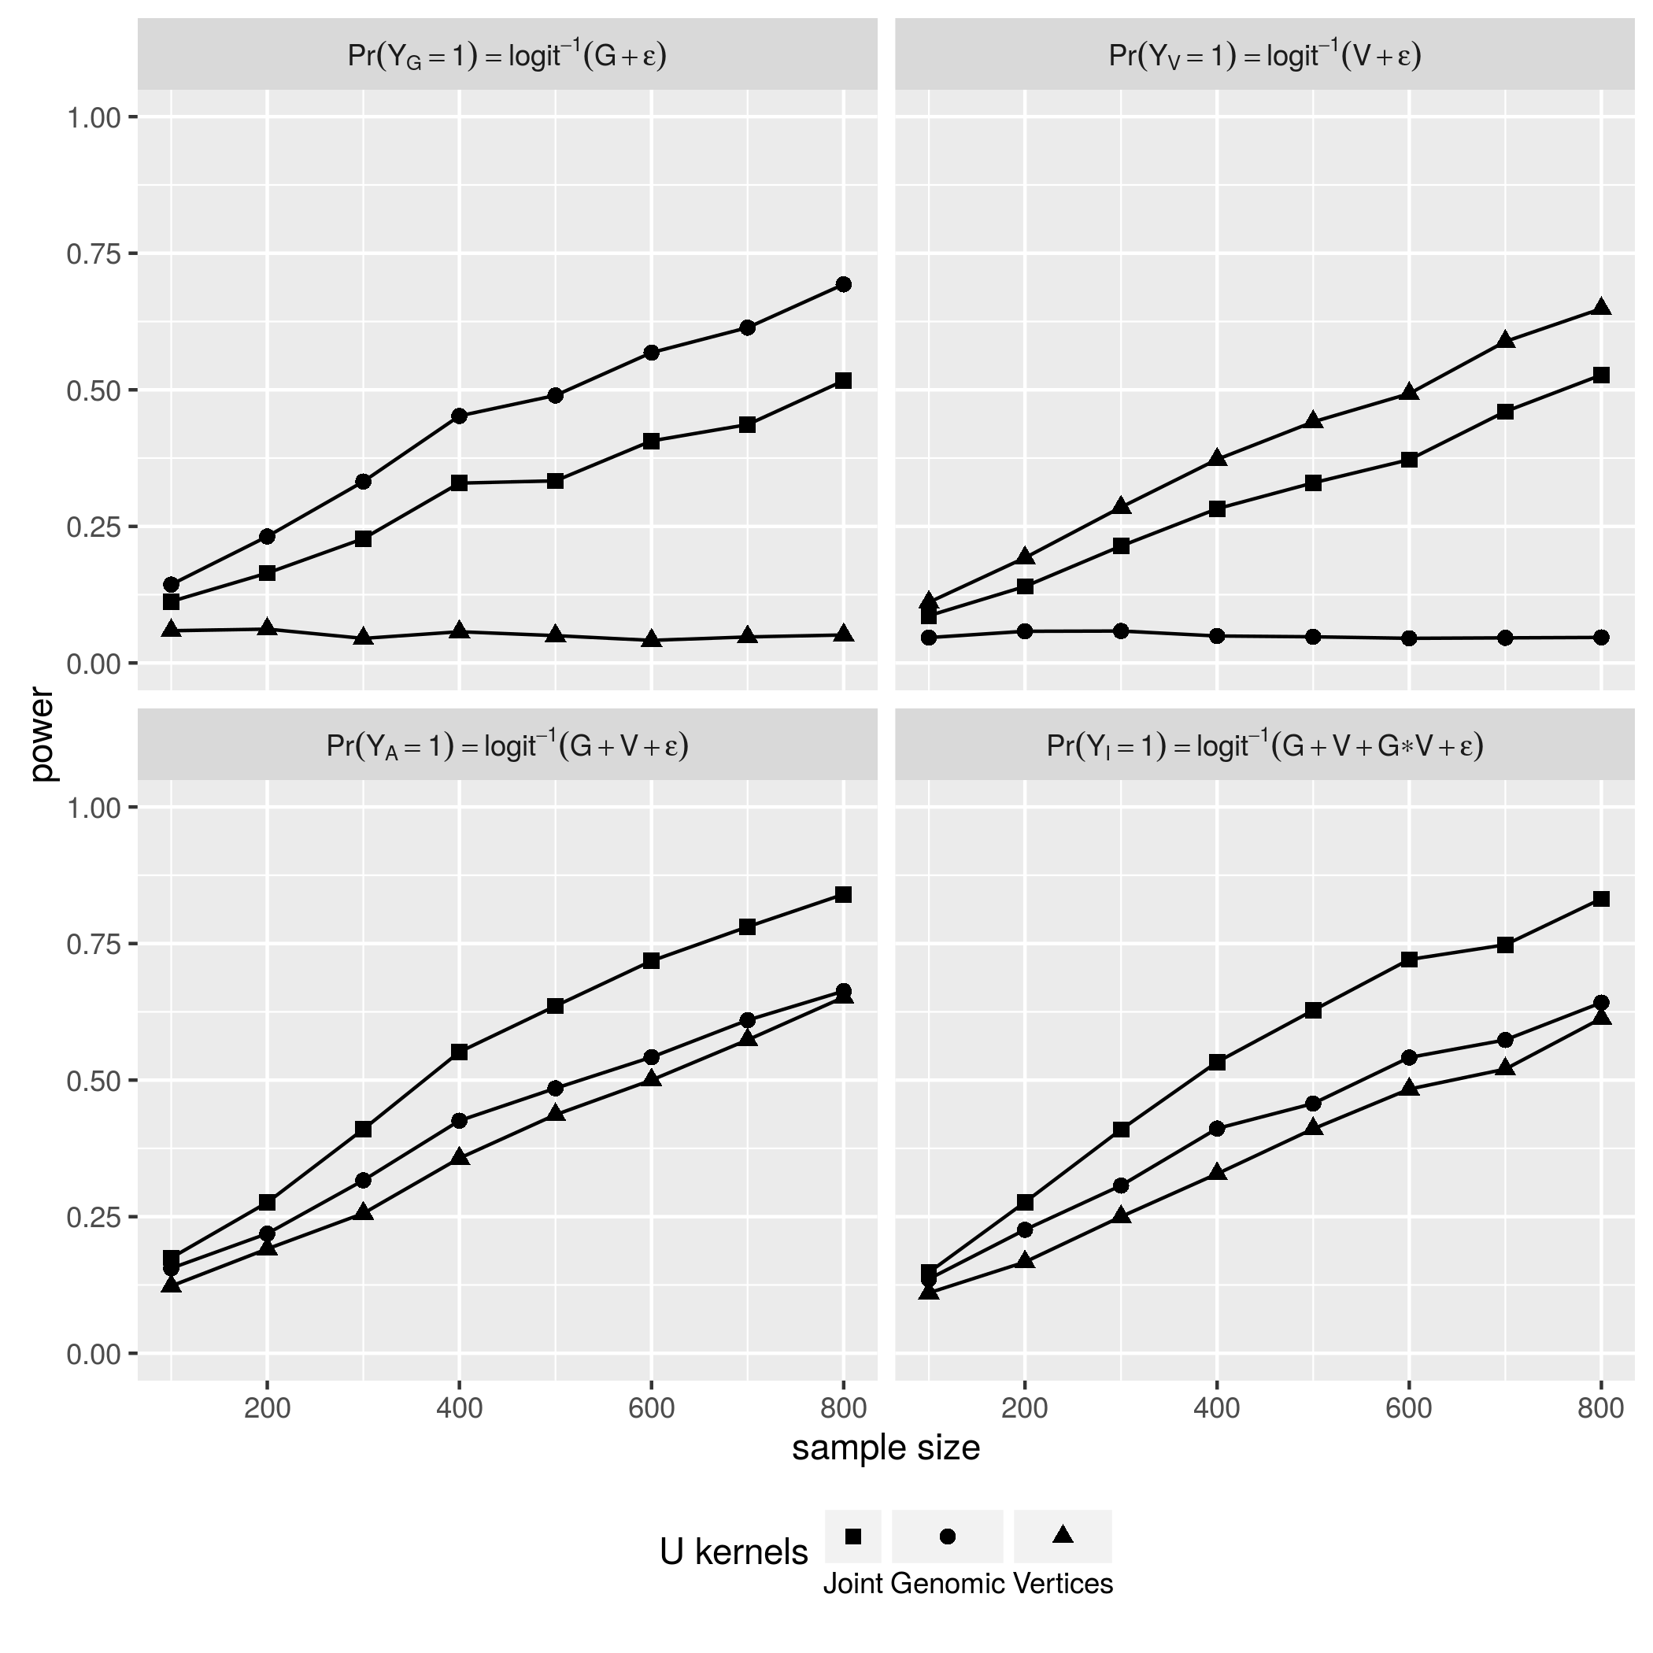

Joint U v.s. Parsimonious U statistics (Binary)

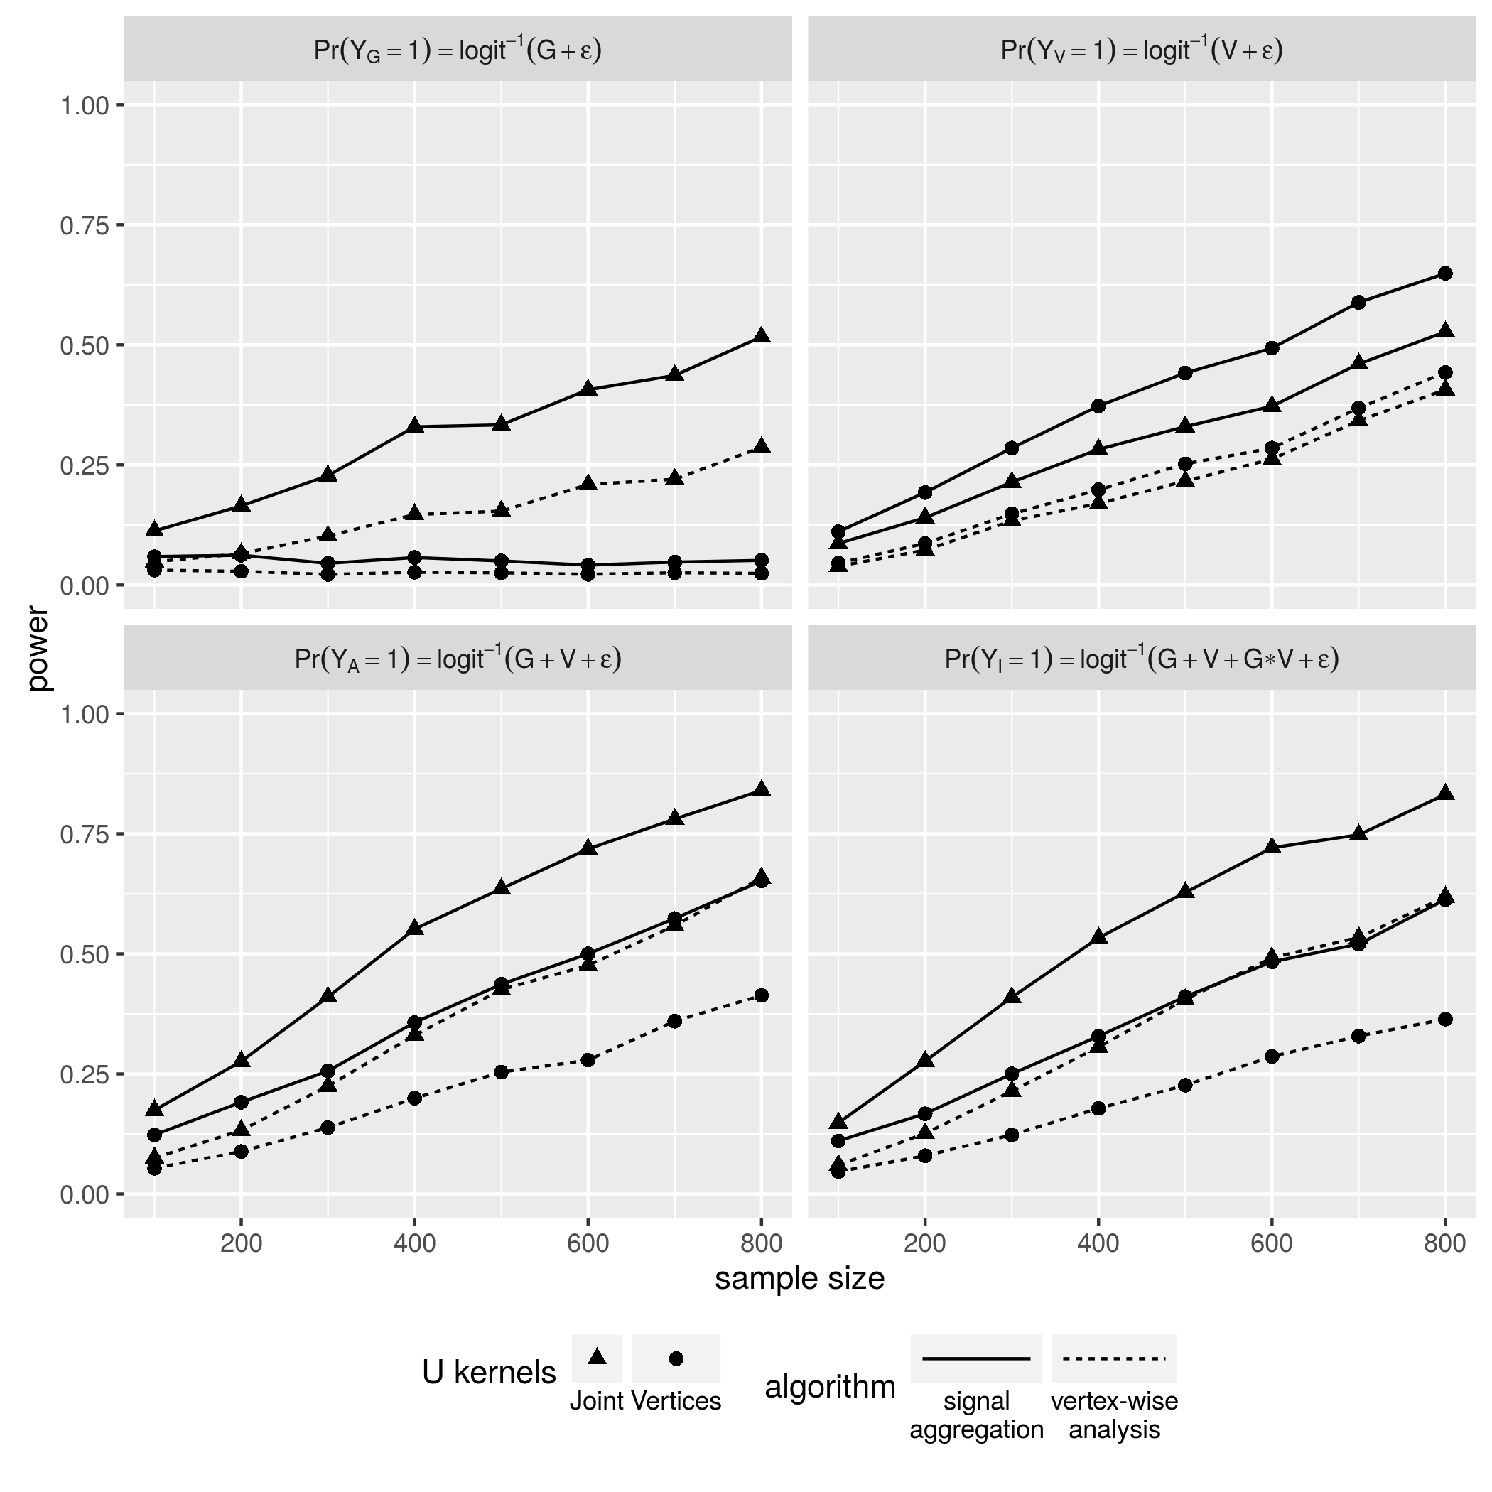

Vertex Grouping & Aggregation v.s. Vertex-wise Analysis (Binary)

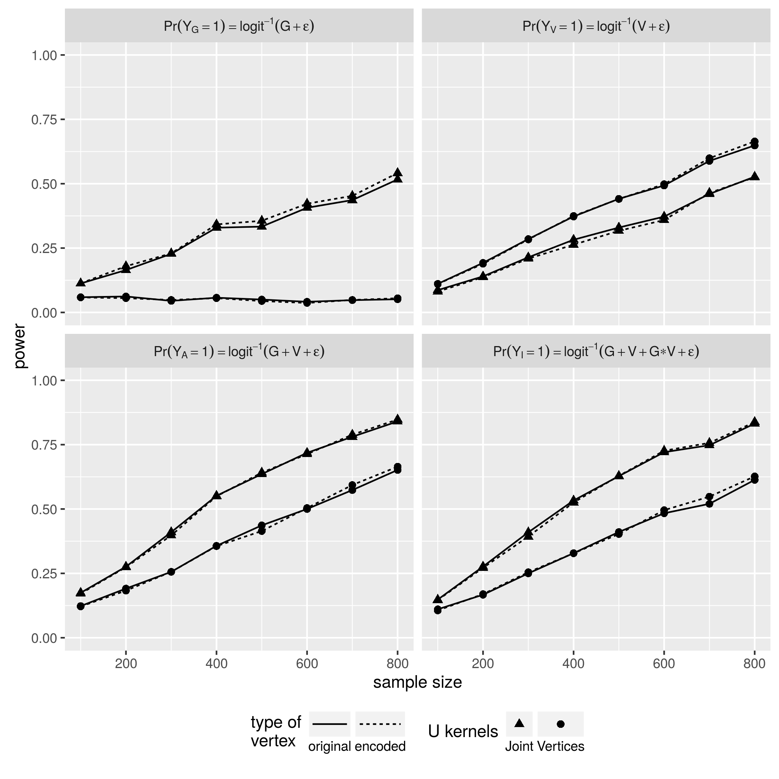

High order features v.s. original vertices

Ashburner, John, and Karl J. Friston. 2000. “Voxel-Based Morphometry—The Methods.” *NeuroImage* 11 (6): 805–21. doi:[http://dx.doi.org/10.1006/nimg.2000.0582](https://doi.org/http://dx.doi.org/10.1006/nimg.2000.0582).

Baron, J.C., G. Chételat, B. Desgranges, G. Perchey, B. Landeau, V. de la Sayette, and F. Eustache. 2001. “In Vivo Mapping of Gray Matter Loss with Voxel-Based Morphometry in Mild Alzheimer’s Disease.” *NeuroImage* 14 (2): 298–309. doi:[http://dx.doi.org/10.1006/nimg.2001.0848](https://doi.org/http://dx.doi.org/10.1006/nimg.2001.0848).

Bengio, Yoshua, Pascal Lamblin, Dan Popovici, Hugo Larochelle, and others. 2007. “Greedy Layer-Wise Training of Deep Networks.” *Advances in Neural Information Processing Systems* 19. MIT; 1998: 153.

Bernal-Rusiel, Jorge L., Douglas N. Greve, Martin Reuter, Bruce Fischl, and Mert R. Sabuncu. 2013. “Statistical Analysis of Longitudinal Neuroimage Data with Linear Mixed Effects Models.” *NeuroImage* 66: 249–60. doi:[http://dx.doi.org/10.1016/j.neuroimage.2012.10.065](https://doi.org/http://dx.doi.org/10.1016/j.neuroimage.2012.10.065).

Chételat, G., B. Landeau, F. Eustache, F. Mézenge, F. Viader, V. de la Sayette, B. Desgranges, and J.-C. Baron. 2005. “Using Voxel-Based Morphometry to Map the Structural Changes Associated with Rapid Conversion in Mci: A Longitudinal {Mri} Study.” *NeuroImage* 27 (4): 934–46. doi:[http://dx.doi.org/10.1016/j.neuroimage.2005.05.015](https://doi.org/http://dx.doi.org/10.1016/j.neuroimage.2005.05.015).

Cirulli, Elizabeth T, and David B Goldstein. 2010. “Uncovering the Roles of Rare Variants in Common Disease Through Whole-Genome Sequencing.” *Nature Reviews Genetics* 11 (6). Nature Publishing Group: 415–25.

Dai, Hongying (Daisy), J Steven Leeder, and Yuehua Cui. 2014. “A Modified Generalized Fisher Method for Combining Probabilities from Dependent Tests.” *Frontiers in Genetics* 5 (32). doi:[10.3389/fgene.2014.00032](https://doi.org/10.3389/fgene.2014.00032).

Fischl, Bruce. 2012. “FreeSurfer.” *NeuroImage* 62 (2): 774–81. doi:[http://dx.doi.org/10.1016/j.neuroimage.2012.01.021](https://doi.org/http://dx.doi.org/10.1016/j.neuroimage.2012.01.021).

Glorot, Xavier, and Yoshua Bengio. 2010. “Understanding the Difficulty of Training Deep Feedforward Neural Networks.” In *International Conference on Artificial Intelligence and Statistics*, 249–56.

Gómez-Isla, Teresa, Richard Hollister, Howard West, Stina Mui, John H. Growdon, Ronald C. Petersen, Joseph E. Parisi, and Bradley T. Hyman. 1997. “Neuronal Loss Correlates with but Exceeds Neurofibrillary Tangles in Alzheimer’s Disease.” *Annals of Neurology* 41 (1). Wiley Subscription Services, Inc., A Wiley Company: 17–24. doi:[10.1002/ana.410410106](https://doi.org/10.1002/ana.410410106).

Hinton, G. E., and R. R. Salakhutdinov. 2006. “Reducing the Dimensionality of Data with Neural Networks.” *Science* 313 (5786). American Association for the Advancement of Science: 504–7. doi:[10.1126/science.1127647](https://doi.org/10.1126/science.1127647).

Lawlor, Debbie A., Roger M. Harbord, Jonathan A. C. Sterne, Nic Timpson, and George Davey Smith. 2008. “Mendelian Randomization: Using Genes as Instruments for Making Causal Inferences in Epidemiology.” *Statistics in Medicine* 27 (8). John Wiley & Sons, Ltd.: 1133–63. doi:[10.1002/sim.3034](https://doi.org/10.1002/sim.3034).

Madsen, Sharon R., Bo Eskerod AND Browning. 2009. “A Groupwise Association Test for Rare Mutations Using a Weighted Sum Statistic.” *PLoS Genet* 5 (2). Public Library of Science: e1000384. doi:[10.1371/journal.pgen.1000384](https://doi.org/10.1371/journal.pgen.1000384).

Manolio, Teri A. 2010. “Genomewide Association Studies and Assessment of the Risk of Disease.” *New England Journal of Medicine* 363 (2): 166–76. doi:[10.1056/NEJMra0905980](https://doi.org/10.1056/NEJMra0905980).

Pandey, Janardan P. 2010. “Comment on Genomewide Association Studies and Assessment of Risk of Disease.” *New England Journal of Medicine* 363 (21): 2076–7. doi:[10.1056/NEJMc1010310](https://doi.org/10.1056/NEJMc1010310).

Purcell, Shaun, Benjamin Neale, Kathe Todd-Brown, Lori Thomas, Manuel AR Ferreira, David Bender, Julian Maller, et al. 2007. “PLINK: A Tool Set for Whole-Genome Association and Population-Based Linkage Analyses.” *The American Journal of Human Genetics* 81 (3). Elsevier: 559–75.

Salat, David H., Randy L. Buckner, Abraham Z. Snyder, Douglas N. Greve, Rahul S.R. Desikan, Evelina Busa, John C. Morris, Anders M. Dale, and Bruce Fischl. 2004. “Thinning of the Cerebral Cortex in Aging.” *Cerebral Cortex* 14 (7): 721–30. doi:[10.1093/cercor/bhh032](https://doi.org/10.1093/cercor/bhh032).

Smith, George Davey, and Shah Ebrahim. 2003. “‘Mendelian Randomization’: Can Genetic Epidemiology Contribute to Understanding Environmental Determinants of Disease?” *International Journal of Epidemiology* 32 (1). IEA: 1–22.

Smith, Stephen M, Mark Jenkinson, Heidi Johansen-Berg, Daniel Rueckert, Thomas E Nichols, Clare E Mackay, Kate E Watkins, et al. 2006. “Tract-Based Spatial Statistics: Voxelwise Analysis of Multi-Subject Diffusion Data.” *Neuroimage* 31 (4). Elsevier: 1487–1505.

Vincent, Pascal, Hugo Larochelle, Isabelle Lajoie, Yoshua Bengio, and Pierre-Antoine Manzagol. 2010. “Stacked Denoising Autoencoders: Learning Useful Representations in a Deep Network with a Local Denoising Criterion.” *J. Mach. Learn. Res.* 11 (December). JMLR.org: 3371–3408. <http://dl.acm.org/citation.cfm?id=1756006.1953039>.

Wei, C., R. C. Elston, and Q. Lu. 2015. “A weighted U statistic for association analysis considering genetic heterogeneity.” *ArXiv E-Prints*, April.

Wei, Changshuai, Ming Li, Zihuai He, Olga Vsevolozhskaya, Daniel J. Schaid, and Qing Lu. 2014. “A Weighted U-Statistic for Genetic Association Analyses of Sequencing Data.” *Genetic Epidemiology* 38 (8): 699–708. doi:[10.1002/gepi.21864](https://doi.org/10.1002/gepi.21864).

Wu, Michael C., Seunggeun Lee, Tianxi Cai, Yun Li, Michael Boehnke, and Xihong Lin. 2011. “Rare-Variant Association Testing for Sequencing Data with the Sequence Kernel Association Test.” *The American Journal of Human Genetics* 89 (1): 82–93. doi:[http://dx.doi.org/10.1016/j.ajhg.2011.05.029](https://doi.org/http://dx.doi.org/10.1016/j.ajhg.2011.05.029).