1, I read the first paper carefully.

They have developed a global (volume averaged) model of the O2/Ar discharge to determine which reactions determine the discharge properties.

1, They investigate which reactions are important for the creation and destruction of oxygen atoms and negative oxygen ions. Most of the reactions included in this model have a negligible influence on the discharge.

2, They observe an increase in the fractional dissociation of the oxygen molecule with an increased argon content in the discharge. It is related to an increase in the reaction rate for electron impact dissociation of the oxygen molecule. The increase in the reaction rate is due to an increased electron temperature with an increased argon content in the discharge. The electron temperature increases due to a higher ionization potential of argon than those for molecular and atomic oxygen. The increased reaction rate due to a higher electron temperature thus leads to increased electron density and O(1D) density as observed experimentally.

3, Also they proved that penning dissociation leads to a significant increase in oxygen dissociation with increased argon content. Dissociative attachment from the metastable oxygen molecule O2(a 1g) is the single most important reaction for the creation of the negative O− ions.

Their model:

1, A steady flow q of neutral species is introduced through the inlet. 2, 18 species in the discharge.

2.1In addition to electrons the oxygen discharge consists of molecular oxygen in ground state O2(X 3− g ), metastable molecular oxygen O2(a 1g), O2(b 1+ g ) and O2(A 3+ u , A3u, c 1− u ), atomic oxygen in ground state O(3P), metastable atomic oxygen O(1D), ozone O3, the positive ions O+ and O+ 2 and the negative ions O−, O− 2 and O− 3 .

2.2 The argon discharge consists of argon atom in the ground state Ar(3s23p6), metastable argon Arm (the metastable levels 1s5 and 1s3), radiatively coupled levels Arr (the levels 1s4 and 1s2), Ar(4p) and positive argon ions Ar+.

2.3 Electrons are assumed to have a Maxwellian-like energy distribution in the range 1–7 eV.

3, Main reactions

3.1 the rate coefficients for the re-excitations from the 1s5 to 1s4 are much higher than those for 1s3 to 1s2 The reaction e + Arm −→ e + Arr is entirely due to the transition from 1s5 to 1s4

3.2 The dominant reaction of e+O2 −→ O +O +e is e+O2 −→ O(3P) +O(1D) +e

4, Balance

4.1 quasi-neutrality condition (the sum of density of negative ion + density of e = the sum of density of positive ion)

4.2 power balance (Which is not introduced in this homework)

5 losses to walls

They calculated the rate coefficient of flux to the wall of : ions, atomic oxygen O(3P), the metastable oxygen atoms O(1D), metastable oxygen molecules O2(a 1g) and excited argon atoms (Arm, Arr and Ar(4p)) as neural species.( We also included most of these reactions in our homework)

6 wall recombination

The densities of the atomic oxygen and the metastable oxygen molecule are largely determined by their interactions with the wall. The ionic composition in oxygen discharges depends strongly on the wall recombination coefficient. (They also proved this in the results part)

7 Temperature increased as the power increase

Their results:

1, The variation with recombination coefficient decreases with increased argon content and is negligible for 98% argon content.

2, The influence of the wall recombination coefficient on the electron density is much smaller.

3, If the neutral gas temperature is doubled, from 600 to 1200 K, the density of atomic oxygen falls 37% for pure oxygen discharge and about 60% at 80% argon content.

4, If the flow rate is increased from 50 to 500 sccm the density of atomic oxygen decreases 41% for a 1 : 1 [Ar] : [O2] mixture.

5, The density of the ground state oxygen molecule O2(X 3− g) falls with increased argon content. Similarly the O(3P) density falls as the argon fraction is increased in the discharge. The density of the metastable oxygen atoms O(1D) increases up to roughly 42.8% argon fraction, where it starts to fall with further argon increase.

6, For low fractional argon flow rate the dominant ion in the discharge is O+2 and as the argon fraction is increased the Ar+ ion dominates. The creation of Ar+ is mainly through electron impact ionization of the ground state atom. The electron density increases with increased argon content. This may be due to additional energy loss channels in the oxygen discharge. Negative ions are trapped within the discharge by the positive potential of the plasma with respect to all wall surfaces and are assumed to be lost only by recombination with positive ions and detachment in the volume.

7, Oxygen discharges are weakly electronegative. The negative ion O− is the dominant negative ion in the discharge and the density of the O− 2 and O− 3 ions is significantly smaller.

8, The fractional dissociation([O]/([O] + [O2])) is about 40% at 1 mTorr and falls with increased pressure. The fractional dissociation increases with increased argon content in the discharge and increased applied power.

9, For high applied power the electron temperature increases monotonically with increased argon content in the discharge. For lower applied power the electron temperature first falls with increased argon content to a minimum and then increases sharply with further argon increase. This is to be expected due to higher ionization potential for the argon atom (15.76 eV) compared with molecular (12.06 eV) and atomic (13.61 eV) oxygen.

10, the O(3P) creation:

e+O( 1 D) −→ O( 3 P) + e( 20%-60%)

O2(X 3 − g ) + O( 1 D) −→ O( 3 P) + O2(X3 − g )30%

e+O2(X 3 − g , a 1 g, b 1 + g , A 3 + u , A 3 u, c 1 − u ) −→ O(3P) + O(3P) + e, O(3P) + O(1D) + e 19–25%

e+O2(X 3 − g , a 1 g, b 1 + g , A 3 + u , A 3 u, c 1 − u ) −→ O( 3 P) + O− 8%

The destruction of O(3P) is mainly through wall recombination and electron impact excitation

11, the O(1D) creation:

Electron impact excitation of the oxygen atom 55–75%

The electron impact dissociation from the ground state oxygen molecule O2(X 3− g ) 15–10%

Electron impact dissociation from the metastable molecule O2(a 1g) 5% O2(A 3+ u , A3u, c 1− u ) 12% and metastable O2(b 1+ g ) 2%.

12, Thus, the metastable 410 Oxygen discharges diluted with argon oxygen molecules play a major role in the creation of negative ions in an oxygen discharge. Dissociative attachment of the oxygen molecule is almost the sole source of O− in the discharge.

13, loss of O- can be due to a lot of reactions: The contribution of O− + Ar+ −→ O + Ar becomes increasingly more important as the fractional argon flow rate is increased and reaches 50% contribution for 98% argon in the discharge(dominant one). For high fractional argon content electron impact detachment e+O− −→ O( 3 P) + 2e is the dominating loss process, varying from 20% contribution for pure oxygen discharge to about 50% contribution at 98% argon content.

Comparing the different mechanism:

1, less species of O is considered in the second paragraph(7): atomic and molecular oxygen, the metastable molecule O2(a 1g), the positive ions O+ 2 and O+, the negative ion O− and electrons. Less metastable molecule O2 were studied in this paper.

2, No argon is introduced in this system.

3, The experimental study(2nd) is complemented by a global model that includes capacitive and inductive coupling.

2

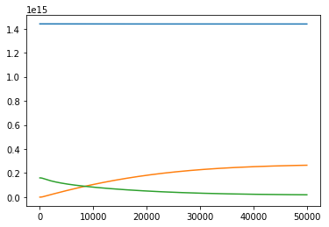blue: Ar orange: O green: O2

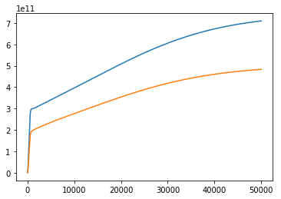blue: electron orange: Ar\*

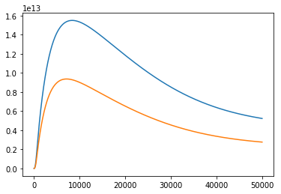blue: O2(v) orange: O2\*

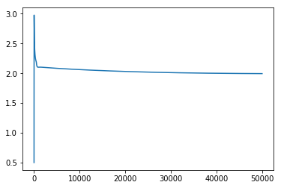Te

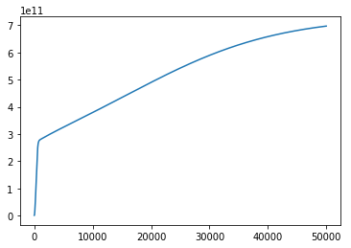Ar+

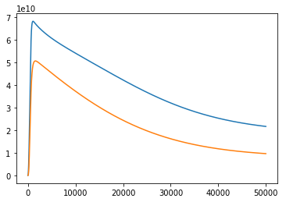Blue: o2+ orange: o-

3,a, At first, there is no O-, and excited O2. In this stage, the dominant reaction is e+O2(ground state) to create O-, and excited O2. At that time, the density of O2 is much larger than O-, and excited O2, there will be more O-, and excited O2 being created (rate coefficient is high due to the high density of O2) rather than the reaction of consuming O-, and excited O2( rate coefficient is low due to the low density of O-, and excited O2) And then with the increase of the density of O-, and excited O2 and the consuming of O2, the dominant reaction will be O-, and excited O2 + electron to create other things. Thus due to the high density of O-, and excited O2(which means high rate coefficient of consuming these particles), the density of O-, and excited O2 decreased and reached stable.

B, 2 reasons I think: the Ar original density is much higher than the O2 density; due to the different k of different reaction and different numbers of reactions related to O2 or Ar, the consuming of Ar is much smaller than O2. This leads to Ar/O2 much higher. The Ar density is much larger than Ar+, so Ar+ is keeping to be created until stable states with high rate coefficient. However the O2 density keep going down and with the answer is a, the O2+ is going down and much smaller than Ar+

C, o2 density: 19448382900829.613 O density 265093651192829.12

This is a good assumption to ignore other states of O. Firstly I do not know the reason of this problem.

I remembered in the lecture in last week, it is explained that there will be some terminal species of O with some reaction of O, These species are intermediate stages of O and will finally turn to O2 which does affect too much to the total system.

4, 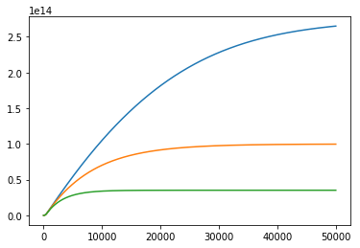O blue0.01 orange:0.3 green 1

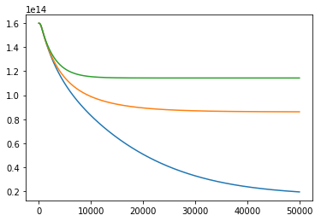 O2 blue0.01 orange:0.3 green 1

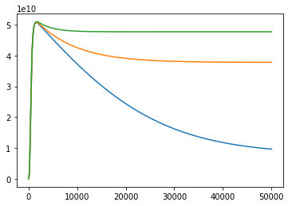O- blue0.01 orange:0.3 green 1

Surface reaction is really important reaction to decide the density of the O and O2.

This reaction is the only way to consume O. So with B increases, O density will become small. In the opposite, the O2 density becomes larger due to more O2 was created from O with surface reaction. Also with more O2, more O- will be created especially when B=1, the O2 density changed a little and is much larger than O-, so the density of O- decrease just a little bit after reach the peak.(The rate of creating O- related to the density of O2 is pretty high)

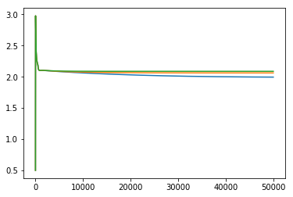Te blue0.01 orange:0.3 green 1(slightly higher with B increased)

5, 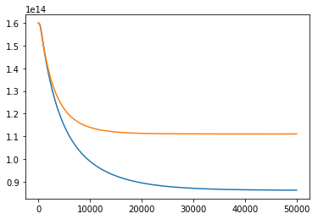o2 blue(300sccm) orange(3000sccm)

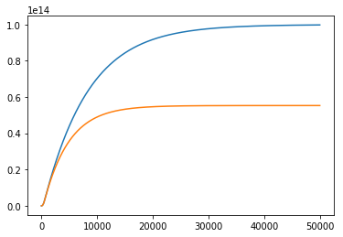 o blue(300sccm) orange(3000sccm)

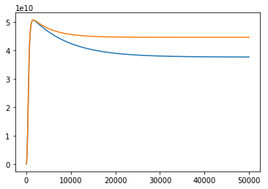o- blue(300sccm) orange(3000sccm)

a,b, I think the higher the flow rate is, the time a molecule or atom will spend less time in the chamber and less likely to react with other species. Thus the O2 density is pretty high. And there is no flow in for O and no flow in and out for O- thus the density change of these 2 species should follow the change of O2. Thus O- increase with higher O2 density and O decrease with higher O2.

From the lecture last week,

there is significant dissociation of O2 creating O atoms. This decreases the mole fraction of O2 flowing out of the reactor compared to O2 flowing into the reactor. The end result is that flow appears to be a net source of O2. As a result, as the flow rate increases, the O2is replenished faster than it is deple

ted and the O2 density increases.