Paper 1:

Pulsed inductively coupled plasmas (ICPs) have recently attracted considerable interest in the field of integrated circuit fabrication. Pulsing provides more flexibility for tuning an etch process by introducing new reactor control parameters: the pulsing frequency, the duty cycle of the pulses, and the phase between the ICP pulses and the bias pulses.

Some results in this paper:  
1, When the ICP excitation is off, the ion flux decays with two different time constants. The fast initial decay of the ion flux in the early afterglow is attributed to electron, while the subsequent slow decay is due to ambipolar losses of the charge species on the chamber walls. The ion flux ramps up from its value at the end of the previous afterglow period. Since the rise time of ion flux is significantly shorter than the plasma pulsing period, it follows that the ion flux rapidly converges toward its steady state value. Thus in rare gas plasmas, the value of the ion flux in the active glow is almost independent of the duty cycle. It is only for the smallest duty cycle (10%) that the duration of the active glow is too short to reach a steady state. (He, Ar)

2, In the molecular and highly electronegative plasma formed in Cl2/SiCl4( etching high k material): the rise-time of the ion flux at the beginning of the active glow period is significantly slower and it depends strongly on the duty cycle, after the fast initial ion flux drop, the ion flux tends to increase and then it decreases very slowly thereafter.

3, Steady sate value reached by the ion flux depends strongly on the duty cycle. When the duty cycle is increased, the value of the ion flux at the end of the ON period increases dramatically.

4, Assuming that all the RF bias power bias delivered to the chuck is used to accelerate the ions toward the wafer then this power should be approximately equal to the product of the DC self-bias voltage bias that develops across the blocking capacitor of the chuck multiplied by the total ion current to the wafer .

5, self-bias voltage (thus the ion energy) which develops on the chuck during the active period should be independent of the duty cycle, as it is indeed observed. (Ar)

6, When the plasma is pulsed, the intensity of the high-energy peak of the IVDF decreases dramatically when the duty cycle is reduced. This is because the ion flux in the active glow period decreases rapidly when the duty cycle is reduced as observed. (Cl2)

7, Finally, it is expected from the above results that by heavily diluting a reactive molecular gas with Ar or He and using a pulsed plasma at low duty cycle, one could benefit from a high ion flux together with a very small flux of reactive radicals.

Paper2:

Finding on this paper:

The influence of simultaneous source and bias pulsing on plasma characteristics and IEADs has been discussed based on results from a computational investigation using a reactor scale model coupled to a feature profile model.

The bulk plasma quantities are sensitive functions of the source ICP power deposition while the bias pulse shape and the overlap of source and bias powers strongly impact the IEADs of ions incident to the wafer.

A higher peak electron temperature at the leading edge of the power-on pulse is obtained following each pulse cycle at lower duty cycles due to lower plasma densities. The IEADs have a high energy tail component owing to higher bias voltages to deposit the same power during the initial pulse period but are, in general, dominantly populated by ions with energies near the bias voltage.

Etching rates were found to be higher at higher duty cycles but less than those of an equivalent continuous operation owing to lower time averaged power deposition. Pulsing the source and bias power pulses with some phase lag can provide for tuning of etch rates. For the plasma conditions investigated, etch rates decreased with increasing phase lag. Etch rates vary with phase lag owing to a combination of source-off/bias-on period during the pulse which increases the ion flux and ion energies incident to the wafer. Pulsing the source and bias out of phase may therefore allow for somewhat independent control of the ion fluxes and the IEADs. ACKNOWLEDGMENTS The authors would like to thank Valentin Tod

2, For this part, I still have some bugs can not be fix which lead my result going to infinite.

For hw4, there are 4 parts contribute to gas temperature. I eliminate the second part (Sum over reactions that have a H of reaction (or exothermicity) that contributes to gas heat-ing.) so that my code can run and the stable temperature is a little bit lower than expect. However the trend is almost the same. Another problems is that I set the power increased from 0 to Pmax in 10 μs.

(6ms)

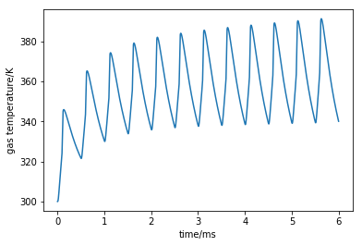

Fig 1: Gas temperature versus time

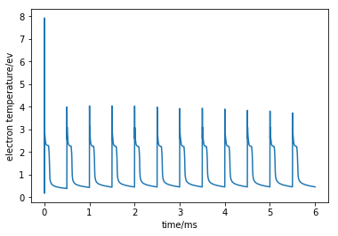

Fig2: electron temperature versus time

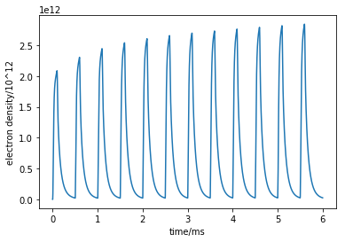

Fig3: electron density versus time

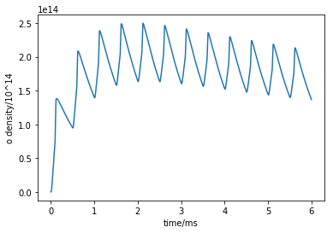

Fig4: O density versus time

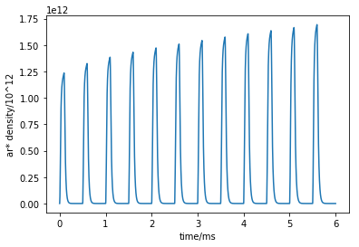

Fig5: ar* density versus time

Explain: from the formular of each parameter in this system. Power only infect Te directly. And Te affect other part. For small duty circle that the duration of the active glow is too short to reach a steady state, the value of whatever any parameter will go down when the power is almost 0. However after 1 pulse some parameter like T gas, won’t goes to its original value, it will be a little higher after every circle until it reach stable state. For other parameter, if T and Te goes periodically stable, since the rise time of flux is significantly shorter than the plasma pulsing period, it follows that the flux rapidly converges toward its steady state value periodically.

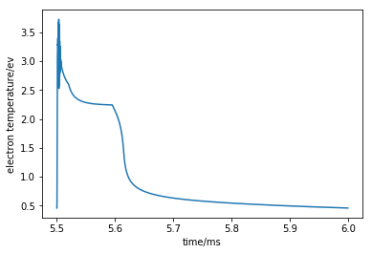

Fig6: electron temperature variance in last pulse

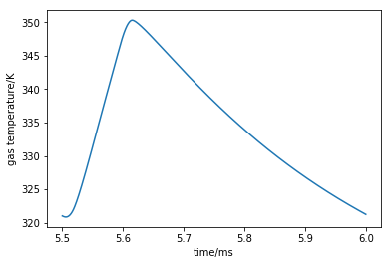

Fig7: gas temperature variance in last pulse

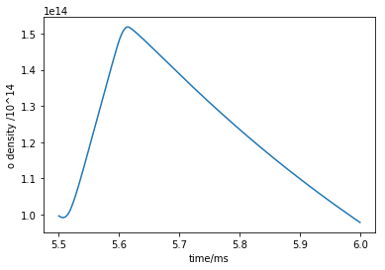

Fig8: o density variance in last pulse

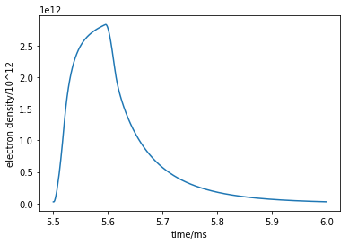

Fig 9: electron density in last pulse

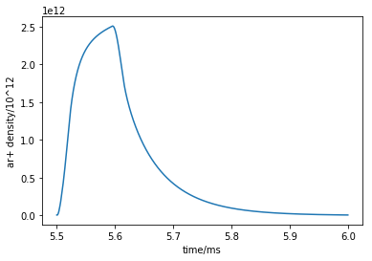

Fig 10: ar+ density in last pulse

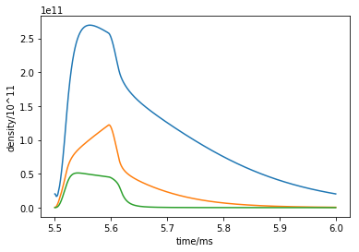

O2+

O1+

O1-

Fig 11: o ion density in last pulse

At first the electron density is pretty low. In order to deliver a high power(1333.3kw), power loss per electron should be large thus Te is large. ( about 8ev) In order to dissipate the power, the dne/dt>0(which provides more electrons). When it reaches stable, dne/dt=0. Thus at first Te is large than it get stable.

Why do the ions change their relative densities in the afterglow after the power-on pulse? This seems to be explained in the first paper: When the ICP excitation is off, the ion flux decays with two different time constants. This is especially visible in He: the fast initial decay of the ion flux in the early afterglow is attributed to electron cooling [which takes place on a timescale of about 10 ls (Ref. 14)], while the subsequent slow decay is due to ambipolar losses of the charge species on the chamber walls.

3, keep Pave and tp same, Pmax and ton change.

|  |  |  |  |  |
| --- | --- | --- | --- | --- |
| (max,ave) | 15% | 30% | 60% | 100 |
| Te(ev) | 3.72,0.98 | 3.10,1.27 | 2.61,1.49 | 2.28,2.28 |
| Ne(10^12) | 2.84,0.77 | 1.36,0.57 | 0.64,0.50 | 0.36,0.36 |
| Ar*(10^12) | 1.69,0.34 | 0.93,0.31 | 0.48,0.30 | 0.29,0.29 |
| O(10^12) | 151.82,123.40 | 133.88,113.1 | 114.89,104.48 | 100.55,99.82 |
|  |  |  |  |  |

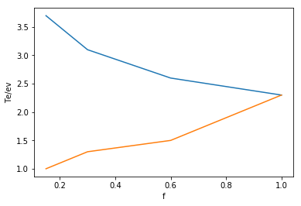

Max

Ave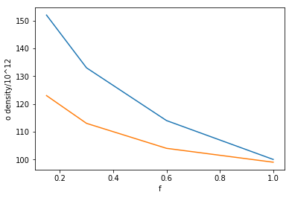

Fig 12: electron temperature change versus f

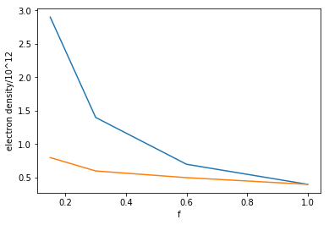

Max

Ave

Fig 13: electron density versus f

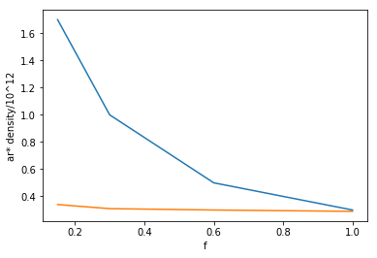

Max

Ave

Fig14: ar* density versus f



Max

Ave

Fig 15: o density versus f

Except ave Te goes up, all the others goes down, and max goes down much more than ave and finally reach the same.

As f goes up, Pmax goes down which leads to lower peak Te.( as explained in 2 about the reason of the peak of Te). However the ton increase , the time for heating increase and this has more significant impact on Te ave and thus Te ave increase.

For ne, it decrease as f increase whatever ave or max.

In spite of the average Te decreasing with decreasing f, the average value of ne increases. This results from the more efficient ionization that occurs during the transient at the start of the power pulse when Te overshoots to its maximum value.

For ar* and o, ar*ave is almost stable and o ave , o max, ar* max all go dowm.

Why does the peak-to-average density for Ar* vary much more than for O atoms?

For this problem, in the class, it is explained that Ar* are more sensitive to Te compared to o.

For my respective, there are more reactions related to ar* related to Te(such as (Te^x)*exp(y/te) however less o reaction are related to Te in this system. However from my plot and results , the peak-to-average density of o atoms seem to be larger than ar*

4, when I change the rate coefficient of these 2 reaction, my results go to infinite. Thus, I can not figure out how to do this problem now…………….