Face Recognition for Attendance Recording System

Lim Wei Xiang 1171101805 (1), Ng Jin Bin 1171303325 (1), and Lim Sin Li 1171101711 (1)

- Faculty of Computing & Informatics, Multimedia University

Abstract

This project aims to provide a solution to the current attendance system in Malaysia. Most of the education sector in Malaysia is still implementing QR Code and manual attendance as their attendance recording method which is time consuming and students tend to cheat on their attendance. In this project, we applied the MTCNN technique for face detection and the LBPH algorithm for face recognition. We used the React JS as the front-end development, the Flask as the back-end development, and the Heroku to host our system. Through the help of the face recognition system, users can take their attendance without interrupting the class.

Index Terms— LBPH, CNN, attendance system, face recognition

Introduction

For the past decades, human beings have utilized intelligence systems such as smart fingerprint lock, robot vacuum cleaners, and autonomous driving systems which can bring benefit in terms of security and reduced time. In this project, we found the importance of applying intelligent systems onto our problem of manual attendance tracking. The existing manual method imposes problems such as fake attendance, inefficiency, and resource wastage.
To curb all the aforementioned problems from taking manual attendance, we decided to build a web application for automatic attendance taking. The web app can register new faces and identify existing faces by matching the face with the name and ID. We used the state-of-the-art face detection method named MTCNN, which is using deep learning. A good face detection method will ensure we get the best possible result for face recognition. On the other hand, we used the traditional LBPH technique for face recognition.

Research Objectives

The benefits of the proposed attendance recording system by using face recognition include:
- This system can keep track of the presence of a student automatically without the student being absent but marked as present.
- This system can save time the time for manual recording the attendance
- This system can tackle the problem of dishonest students that are absent but are marked as present using the QR Code or other means.

literature review
A face recognition system normally will consist of two stages, which is to first detect where the face is and then proceed to categorize the face, which we call face recognition. In this section, we will have a look at the existing face detection and recognition techniques to get some intuitions in developing our face recognition attendance system.

Face detection techniques

The face detection techniques that we are going to explore include Haar cascade classifier and MTCNN.

Haar cascade classifier

Face detection has been initiated in a seminal work of Viola and Jones (2001). They apply a Haar feature to the input image pyramid of various scales that allows objects to be detected at different sizes. Multi-scale pyramids of images also help to narrow down the number of proposed regions which can boost the classification. However, this method has a tradeoff for its fast speed with non-frontal faces and low light conditions.
The paper in Liao et al. (2015) has improved the proposed architecture. From the Viola and Jones algorithm, it cannot detect large pose variations, illumination variations, occlusions, expression variations, out-of-focus blur, and low image resolution. So, Liao et al. (2015) have improved the proposed architecture by proposing the Normalized Pixel Difference (NPD) to address the following problems from the Viola-Jones face detection algorithm and is 6 times faster than the Viola-Jones face detection algorithm.

MTCNN

In Ku and Dong (2020)’s paper, the authors used MTCNN to detect and align faces. In their paper, they explained MTCNN is a good face detection algorithm because it is more robust to light, angle and facial expression changes in the natural environment.
Furthermore, it has a small memory consumption. They achieved an accuracy of 98.53% when they used MTCNN as face detection combined with VGGNet deep convolutional neural network as face recognition.
In their experiments, they used various deep learning algorithms to compare the face recognition rate. One of the methods is the DeepFace model, which is based on the MTCNN network structure to align the image. Under the LFW dataset test, the model achieved an accuracy of 97.35%.
In Ma and Wang (2018)’s work, they performed multi-view face detection and landmark localization using MTCNN. They experimented on frontal faces and achieved good results on FDDB and AFLW facial datasets. The MTCNN face detector can detect frontal face accurately and locate their landmarks. It performed well for smaller scale faces. It can also detect smaller scale faces, unclear and slightly occluded faces with high probability. However, several large-angle nono-frontal faces are still missed from the current algorithm.
So, they constructed a non-frontal face dataset and trained the dataset on a non-frontal face detector. They first collect non-frontal face images from different scenes and different angles from the FERET database and the Internet, then they annotate the collected images.
After that, to be able to detect both frontal and non-frontal faces, they combined the two MTCNN detectors so the combined detector can detect multi-view faces. The experiment has overall improved the accuracy for detecting non-frontal faces. From Figure 3-1, we can see that the non-frontal faces and frontal faces are detected.
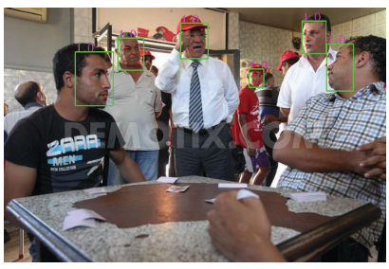
Figure 3-1: Detection result of the frontal and non-frontal face detectors

Face recognition techniques

Since the early works of face recognition, we found some existing methods that can be examined for our work such as the Principal Component Analysis (PCA), Local Binary Pattern Histogram (LBPH), and deep learning.

PCA (Principal Component Analysis)

In this paper by Kar et al. (2012), the face recognition technique is done using PCA (Principal Component Analysis) without any deep learning method. PCA is a statistical approach that is commonly used to perform patterns finding in data and PCA can express the data as an eigenvector to highlight the similarities or differences in data.

LBPH (Local Binary Pattern Histogram)

Tiwari et al. (2018) used the Local Binary Pattern Histogram (LBPH) face recognizer algorithm, which focuses on local and small features of an image. This method puts the face images with a simple data vector and can achieve impressive results in a controlled environment. The authors claimed this model can be applied in payments, security, criminal identification, and advertising purposes.
Working on the class attendance checking system domain, Phankokkruad and Jaturawat (2017) tested on three face recognition algorithms. One of the algorithms is the LBPH algorithm. In their paper, they have stated that the LBPH algorithm has the advantage of being invariant to the light intensity, but it requires more processing time. In their work, they compared LBPH with PCA Eigenface and Fisherface algorithms. The factors that may affect the accuracy of the system is the facial expressions as shown in Figure 3-2 and face viewpoints as shown in Figure 3-3.
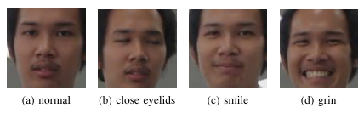
Figure 3-2: The example of images with face expressions variations (a) normal (b) close eyelids (c) smile, and (d) grin respectively
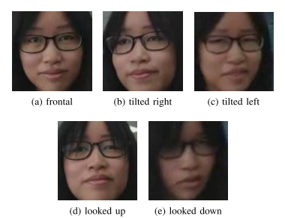
Figure 3-3: The example of images with face viewpoints variations (a) frontal (b) tilted right (c) tilted left, (d) looked up, and (d) looked down respectively
The results of their experiment showed that the LBPH algorithm outperforms every other algorithm by achieving 81.67% accuracy. Eigenface and fisherface archived 46.67% and 69.33% respectively. They concluded that LBPH is the most suitable algorithm to apply in a class attendance checking system.
Working on the automated attendance system and gender classification, Shrivastava and Manda (2018) created a system using the Raspberry Pi3 and Pi camera. In their project, they used the LBPH and Linear Discrimination Analyser (LDA). They claimed that LBPH algorithm is convenient because it is provided by the OpenCV Library. LBPH is responsible for finding and identifying the characteristic feature of the image. LBPH improves the detection performance on the datasets at a very fast rate. LBPH supports real-time face recognition by comparing pre-processed data (provided by the line database) with the training dataset (student information database).

Deep Learning

The authors Wang and Li (2018) and Arsenovic et al. (2017) are applying CNN as a feature extraction technique. Arsenovic et al. (2017) is proposing a face recognition method that will first use a pre-trained network FaceNet to obtain the face embeddings and then use a support vector classifier to classify the input face. The architecture of the face recognition model used in the work by Wang and Li (2018) is similar to the work by Arsenovic et al. (2017). Arsenovic et al. (2017) will first use the LeNet 5 CNN model to extract the features from the face image, then it will pass the feature vector into the final layer, which is a classification layer to categorize the input face image. In their project, they took many face images and cropped irrelevant parts of the face. Then, they stitched the images in their face dataset and then got the small face database grey degree treatment for the training of face data.
Arsenovic et al. (2017) mentioned that by using CNN, the performance is improved because it has reduced memory requirements and takes in less number of parameters to be trained. The authors claimed that the method can save up the effort for preprocessing or feature extraction, which is a necessary step for other machine learning algorithms. Although CNN can achieve good results, they mentioned the problem of requiring a large training dataset to construct a depth model.

Summary

In this project, we choose the MTCNN as our face detection model because it is considered as the state-of-the-artwork technique in face detection domain. With its high accuracy as proven in the previous works, we are confident the MTCNN is useful for our project because it can detect faces accurately without losing information. Furthermore, MTCNN is a built-in Python library and it is efficient and quick enough for it to process an image.
On the other hand, we have concluded that the LBPH method best suits to perform face recognition tasks which can be useful in the development of our school attendance recording system considering the nature of our dataset. This method can achieve great results even though it is one of the oldest but it is one of the most popular face recognition methods.
Even though using CNN in face recognition has proven to achieve great results in the face recognition field, we do not consider that method due to the complexity of our application which does not require multiple faces recognition or other complex background analysis. Furthermore, high processing power is required to build a deep learning model due to its multiple layers. At the same time, when the system wishes to register a new face for a new student, then the deep learning model has to be retrained, which is computational expensive and inefficient. Thus, our final decision would be choosing the LBPH method to perform face recognition.

Background study of the existing attendance recording system

We made a comparison of our application system with the current attendance recording systems to compare the features as shown in Table 3-1.

Table 3-1: Comparison of the existing system with our system
 | MMU Mobile Application | Our Application
Method to identify the presence of a student | Using scanning QR Code | Using a webcam to detect the face of student
Attendance time | Active during the period of class | Active during the period of class
Requirement | Smartphone with an internet connection | Smartphone and computer
Security | Login student ID and password at anywhere | Scan face on that class only

Approach

Assumption

To enable our system to work optimally, users must ensure that:
- The lighting is constant for the input face.
- The input face is clear and not noisy.
- The resolution for the input image should not be too low.

Hardware requirement

- An electronic device that has a camera and has internet connection.
- Any devices such as laptop, mobile phone or tablet.

Software requirement

React JS (Front-End)

React is a JavaScript library for building reusable and composable user interfaces components over time. Lots of people use React as the V in MVC. React offers a simpler programming model and better performance. React can also render on the server using Node, and it can power native apps using React Native.
The reason we choose react JS as our front end is because it guarantees quicker rendering. Not only that, react framework call react native is suitable for mobile application also since it is a responsive framework. In our case, the user can choose to take their attendance by using any hardware. It is responsive to phone, tablet and laptop, etc.

Flask (Back-End)

Flask is part of the categories of the micro-framework. Micro-framework is normally frameworks with little to no dependencies to external libraries. Flask has its pros and cons. The pros would be that the framework is light, there is a little dependency to update and watch for security bugs. Meanwhile, the cons are you might have to do more work by adding external plugins. However, in our case, since flask is written in python and thus it will support all the libraries that we need such as opencv, tensorflow and opencv-contrib. Therefore, there is no need for us to install any other external plugins.
The reason we choose flask as our backend is because flask is a lightweight framework for python. Our application is not that heavy, hence flask is a better option for us. Not only that, Flask does not consume much time to learn from zero compared to other frameworks like django. Last but not least, flask is simple and can be built in a shorter time if compared to other frameworks such as spring boot, laravel and django.

Multi-Tasked Convolutional Neural Network (Face Detection)

Deep Learning advancement in recent years has enabled the widespread use of face detection and face recognition technology. MTCNN is one of the deep learning methods. MTCNN has three convolutional networks (P-Net, R-Net and O-net) and it can outperform many other face-detection benchmarks while retaining real-time performance. Below is the explanation of the flow of MTCNN.
First, an input image is passed into the program. Then, this model will create an image pyramid which means it creates different copies of the same image in different sizes to search for different sized faces within the image. For each image pyramid, a 12x12 kernel will state scanning every part of the image. This portion of the image will then pass into the P-Net. Since the weight and biases of P-Net have been trained so that it outputs a relatively accurate bounding box for every 12x12 kernel. Then, the model needs to parse the P-Net output to get a list of confidence levels for each bounding box and delete the box with low confidence. Then apply Non-Maximum Suppression (NMS) to clear the remaining bounding box.
In the second stage, there might be some case that the bounding box is out of bound. Therefore, the model copies the portion of the image in the bounding box to the array and fills in everything else with 0 (Zero Padding). After padding, resize the bounding box to 24x24 pixels and normalize them to value -1 and 1. Then feed the output to R-Net. R-Net output will be similar to P-Net, but with more accurate bounding box. Then, apply the same steps as Stage 1, get rid of the bounding box with lower confidence and apply NMS again.
In the third stage, the model resizes the boxes to 48x48 pixels and passes in the bounding box to O-Net. O-Net provides 3 outputs: the coordinates of the bounding box (out[0]), coordinate of facial landmarks (out[1]) and the confidence level of each box (out[2]). Once again, do the same step to get rid of the bounding box with lower confidence and apply NMS, there should be one bounding box for every face in the image only.
To further illustrate, we will display how the MTCNN works in Error: Reference source not found.
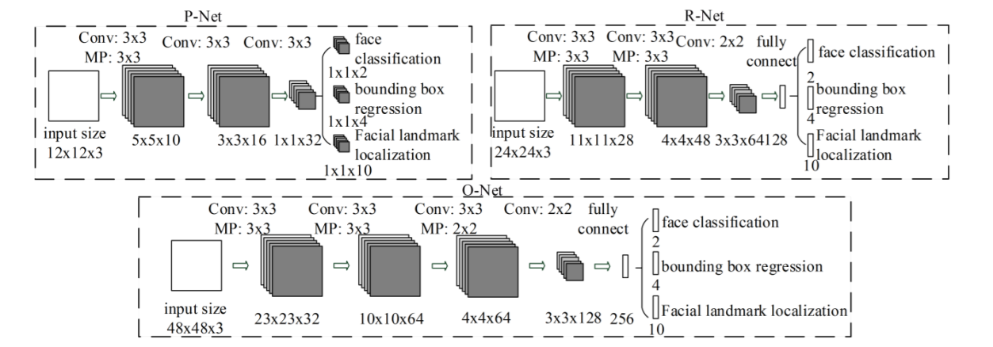
Figure 4-4: MTCNN architecture

In short, we choose this model because high accuracy is achieved with this model. This is due to it having multiple networks with multiple layers. As each network can fine-tune the results of the previous one, the high precision of the model will be formed.

Local Binary Patterns Histogram (Face Recognition)

The LBP is a texture feature extraction method. LBP is the particular case of Texture Spectrum model and this method is very popular for face detection and pattern recognition approaches. We will elaborate on the concept of LBP feature vectors in the following section.

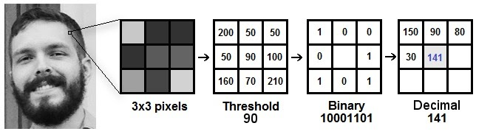
Figure 4-5: how LBP works
As we can see from Figure 4-5, the LBP will first divide the examined window into cells, then for each 3x3 pixels in a cell, compare the pixel to each of its 8 neighbours. Follow the pixels along a circle, clockwise or counterclockwise. Then, we need to take the central value of the matrix to use it as a threshold. For example, if the centre pixel’s value is greater than the neighbour’s value, write “0”, then if the opposite way then we write “1”. This will generate an 8-digit binary number.
After that, using the 8-digit binary number, we convert this binary value to a decimal value and set it to the central value of the matrix, which is a pixel from the original image.
Next, compute the histogram over the cells of the frequency of each “number” occurring. This histogram can be seen as a 256-dimensional feature vector. Lastly, normalize the histogram and concatenate the normalized histogram of all cells.
In short, the LBP uses neighbourhoods of different sizes. Using circular neighbourhoods and bilinearly interpolated the pixel values allows any radius and number of pixels in the neighbourhood. We choose to implement the LBPH model because it is simple. It does not require much time for us to learn from scratch but yet the model accuracy is quite high for face recognition.

Flowchart
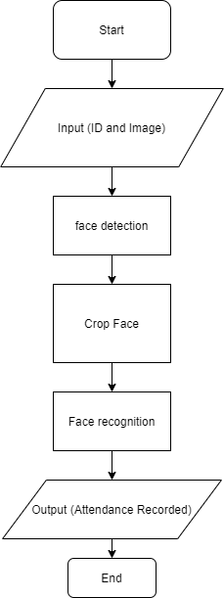
Figure 4-6: Flowchart for our system

Figure 4-6 shows the flow chart for the attendance system to work. Firstly, the user is required to input their student ID into the application. Once the user clicks on the submit button, the photo of the person will be automatically captured. A total of three pictures of the face will be captured during the three seconds countdown.
After that, the system will perform face detection steps. In each photo that has been captured by the camera from the electronic device used, the MTCNN model will perform face detection by finding the region of interest of the face. Then, there will be a bounding box drawn on top of the face and the bounding box will be cropped. Once the face is cropped, the system can now recognize the face by comparing the face in the database with the cropped face from the input. The face recognition technique is implemented using the LBPH model. Then, we designed the system such that it can validate the student ID with the recognized facial accuracy of the person. If the student ID is correct, and the confidence of the face recognition model is lower than a threshold of 40%, then the attendance is successfully recorded.

Use Case Diagram

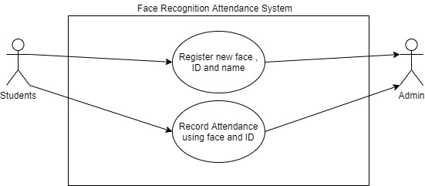
Figure 4-7: Use case diagram for our system

There are a total of two use cases that the user can perform in our face recognition attendance system. First and foremost, users will have to undergo the registration process because there is no record of the student’s information in the database by default. The user will be registered as a new student. A user needs to key in his or her name, student ID and snap 6 photos of his or her face to register as a new student.
Secondly, users can record their attendance using our system. Assuming that the user is already registered in the database, the user can enter his student ID and take three still pictures of his face. After that, the system will show whether the face matches with the student ID of the user and notify the user whether the attendance record is a success or failure.

implementation

Storyboard

In this section, we will show how our face recognition attendance system looks like when it is deployed into Herokuapp.com. This is the link to access to our system. https://blooming-refuge-98979.herokuapp.com/ By clicking on the link, the user will be redirected to the homepage as shown in Figure 5-8.

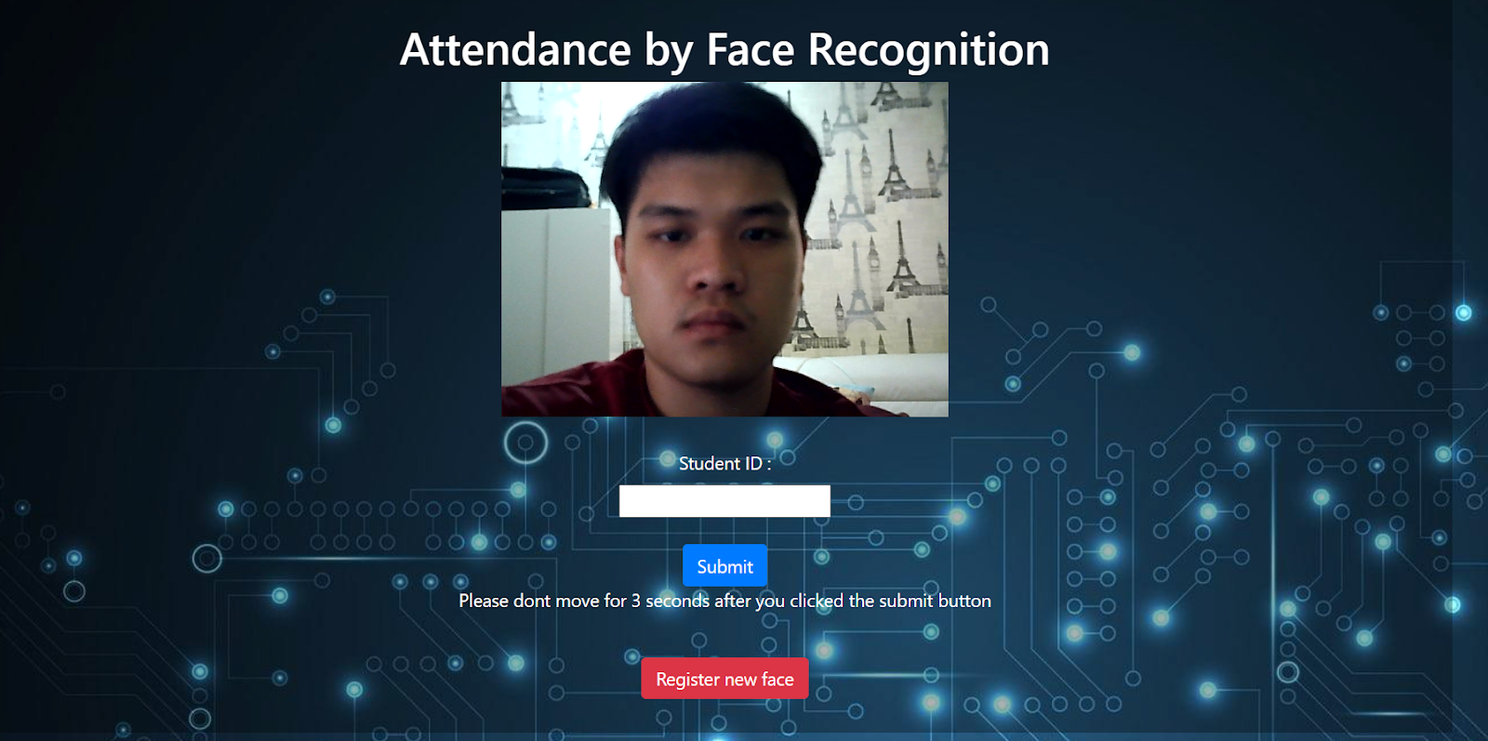
Figure 5-8: Homepage of our system

Assuming that a new student uses this system, the student needs to register his face into the system first. After clicking the “Register new face” button, he will be redirected to the page as shown in Figure 5-9.

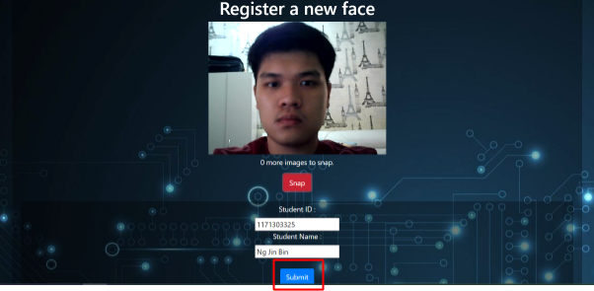
Figure 5-9: Register a new face page

In the page from Figure 5-9, the user is prompted to key in his student ID and student name. The user is also required to take six snapshots of his face by pressing the “Snap” button. Then, the user can click on the “submit” button to proceed. A notification will be shown to notify the users that the submission is successful as shown in Figure 5-10.

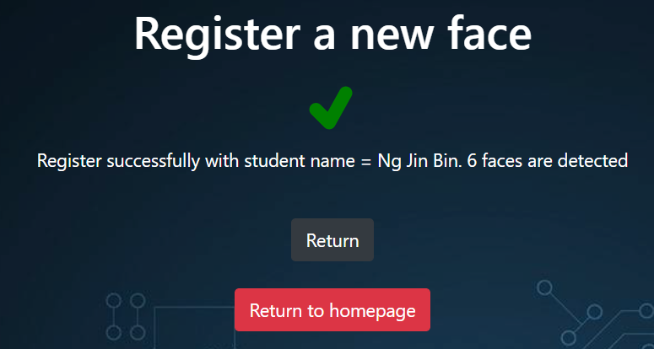
Figure 5-10: Successfully registered new face
After the user successfully registered his details on the system, he can start to take his attendance. In the homepage, the user can see his face because the system has real-time access to the camera. Assuming the user has already registered his information in the database, he can enter his student ID and click on the “submit” button. At this point, the student needs to wait for three seconds in which each second will take one photo. The three photos will be the inputs to be compared with the face that has been registered in the database. If the confidence level for the face recognition is lower than 40% and the student ID matches with the input ID, the attendance will be successfully recorded which can be seen in Figure 5-11.

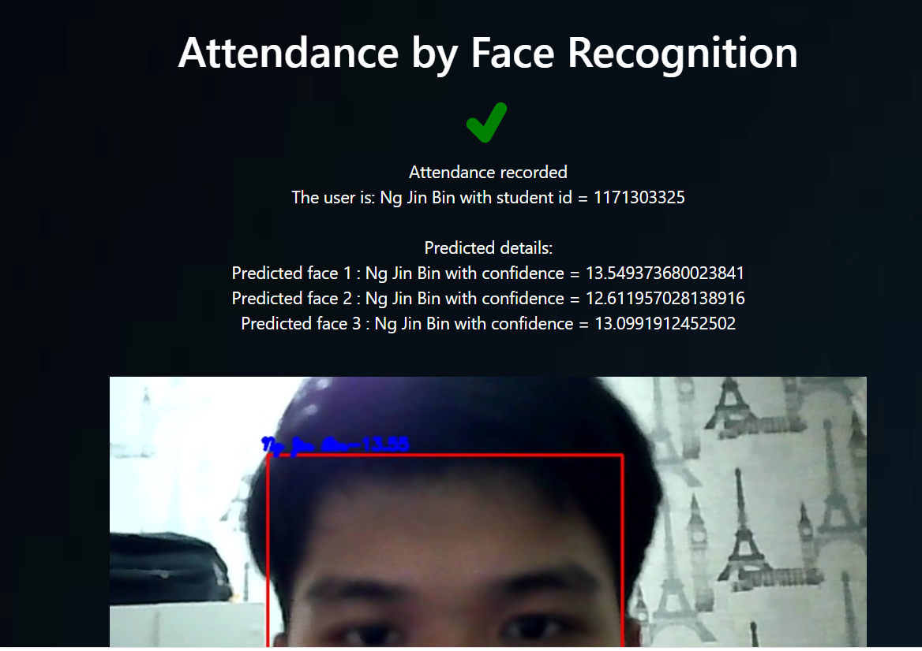
Figure 5-11: Face recognized and matched student ID

However, the result will show the name of the user as unknown when the confidence level is more than 40%. The user will fail to take his attendance if his student ID and face is not matched as seen in Figure 5-12.

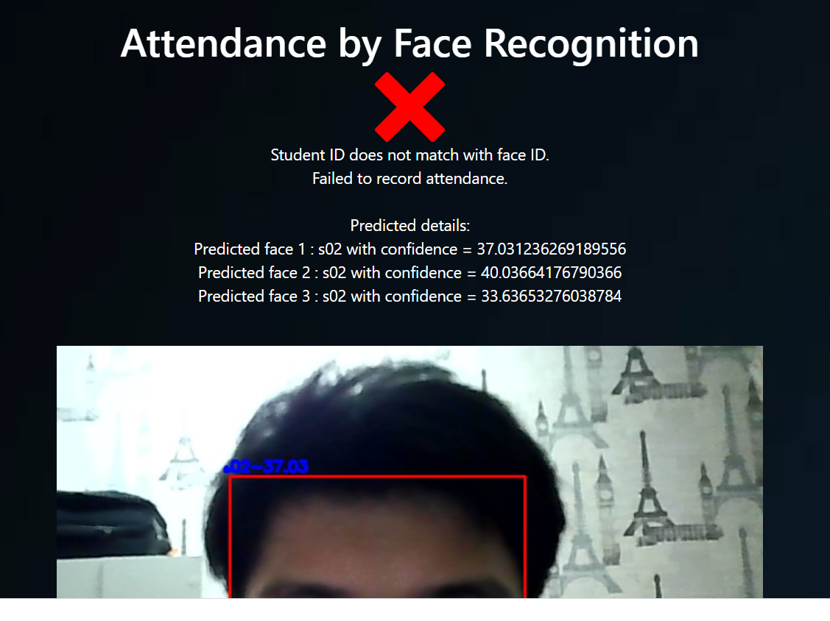
Figure 5-12: Failed to record attendance

Use Case 1: Register New Face

Assuming John is a student of MMU and visits the system.
- John visits the website https://blooming-refuge-98979.herokuapp.com/
- John clicks on the “Register new face” button at the homepage.
- John is redirected to the face registration page.
- John keys in his student ID and name.
- John takes six pictures of his face.
- John clicks on the “submit” button.
- John is successfully registered in the system database.

Use Case 2: Record Attendance

Assuming John is a student of MMU and is already registered in the system database.
- John visits the website https://blooming-refuge-98979.herokuapp.com/
- John fills in his student ID.
- John positions his face to his device camera.
- John clicks on the “submit” button.
- John waits three seconds after clicking the “submit” button.
- The system shows the attendance information for John in the attendance page.

experiment

In this project, we will use two online datasets to implement our quantitative evaluation. At the same time, the face images of our team members and the people surrounding us will be taken as the simulation data for qualitative evaluation.

Dataset

The first dataset that we will be using is the open-source image dataset offered from the University of Essex [2]. The images from this dataset are cropped to the face of the subjects, and the picture is taken at the same location with the same lighting. The images are relevant because they cover various male and female subjects which are university students and also some older individuals. The images in the dataset fulfil our requirement because it has lower noise at the background. Furthermore, we can see the face of the individual clearly, and images of the same person are organized in a folder that is labelled by the individual’s name. The dataset contains 152 people and each person has 20 images. Therefore, the dataset contains 3040 images in total. Figure 6-13 is showing some sample images from this dataset and as we can see, the background and lighting are the same for every image.
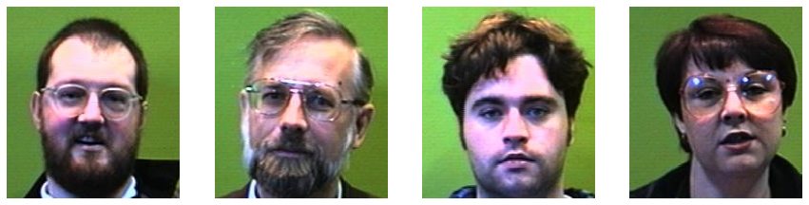
Figure 6-13: Same background and lighting for faces

On the other hand, we will be using another dataset that is the Georgia Tech face database [10]. In this dataset, there are 50 people with different facial expressions, lightings and scales, which are different from the dataset from the University of Essex. For each person, there are 15 images and thus there are 750 images in total. The purpose of using this dataset is to compare the outcome of face recognition algorithm using face dataset with a controlled environment with the outcome of using face dataset with different lighting conditions and facial expression. Figure 6-14 is showing a subset of this dataset, we can see that the person is having three different backgrounds, lighting, facial expressions and poses.
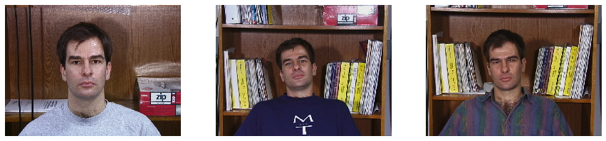
Figure 6-14: same person in different condition pictures

Evaluation

Quantitative Evaluation

In our quantitative evaluation, we will first split our dataset into 75% train and 25% test dataset. Then, we will use MTCNN as our face detector to detect the face in each image and store the face into an array. At the same time, the names of people are stored as labels for ground truth data. After that, we will update the LBPH face recognizer to recognize the train images followed by evaluating the accuracy of the testing dataset. Throughout the experiment, the test data for each set of data will remain unchanged to ensure the quality of results. At the same time, we will observe the average value of confidence when the LBPH algorithm is predicting an image. The confidence value is the distance between the histogram of the predicted image and the histogram of the input image. Therefore, the lower the confidence, the better the prediction.
Table 6-2: evaluation result for different face database
Training Dataset | Accuracy (number of correctly identified/total amount of test images) | Average confidence of correctly identified cases | Average confidence of wrongly identified cases
Georgia Tech face database without data augmentation | 84.57% | 17.7685 | 24.19
Georgia Tech face database with data augmentation | 87.23% | 17.2401 | 24.06
Face dataset from University of Essex without data augmentation | 99.87% | 11.56 | 31.99
Face dataset from University of Essex with data augmentation | 99.87% | 11.56 | 31.99

Apart from evaluating the accuracy of the algorithm, we will check with the effectiveness of data augmentation in improving the accuracy of the algorithm. Data augmentation is a technique to increase the diversity of training sets. To apply data augmentation, it will increase the size of training images. For the LBPH algorithm, this indicates that it has to learn with more histogram and more space is required to store the histogram. At the same time, more time is consumed to update the LBPH algorithm. Therefore, the decision of applying data augmentation should be made rationally. To apply data augmentation, for each training image, we will do a horizontal flip and random rotation within 25 degrees. This will increase the size of the training dataset by three times.
Just as what we had stated, for quantitative evaluation, we will be using two open-source online datasets which are a face dataset from the University of Essex and the Georgia Tech face database.
The objective of the quantitative evaluation is to calculate the accuracy of the face recognition (LBPH) algorithm. The accuracy is calculated by dividing the number of faces that are correctly categorized by the total amount of test images. Table 6-2 is showing the evaluation result. From Table 6-2, we can say that the algorithm can perform better in the images with the same lighting conditions, same background and similar facial expression than in the images with different facial expression and lighting. Other than that, we can see the average confidence of wrongly predicted cases is much higher than the confidence of correctly predicted cases. Therefore, we can use confidence as a threshold to determine whether the recognizer is performing a wrong or correct prediction. At the same time, data augmentation improves the performance of LBPH algorithm by 2.66% when it deals with the Georgia Tech face database with different lighting and people with various facial expressions and poses. However, data augmentation does not change the result of the LBPH algorithm using face dataset under a controlled environment.
As a conclusion, data augmentation will be used since our application has to deal with an uncontrollable environment and the confidence (distance) calculated by the LBPH algorithm can be used as a threshold in our application. The overall accuracy is over 80% and is considered acceptable in our case.

Qualitative Evaluation

In qualitative evaluation, we had asked 6 students from MMU to test with our application that is deployed on Heroku. Each student will have to register their face first. For a new individual to be recognized by the system, we will require him or her to snap 6 images and upload to our system. At the same time, the person will be required to provide his or her information such as student id and name. Then, we will update the LBPH face recognizer to recognize that particular face.
After that, the students will proceed to scan their faces under (1) different backgrounds and (2) different lighting. Each student will try to submit attendance five times for us to gather more data.
The purpose of this qualitative evaluation is to simulate the real situation when our application is being used by MMU students and gather the data from the real situation. At the same time, we also receive feedback from end-users about the flow of the application and the user experience. In short, this is a simulation of MMU attendance system by face recognition to gather statistical data for our purpose.
Table 6-3: evaluation with actual MMU student face
Student Name | Accuracy (correct cases/5 * 100%) | Average confidence of correctly identified cases | Average confidence of wrongly identified cases
Lim Wei Xiang | 80% | 26.55 | 48.21
Lim Sin Li | 80% | 28.11 | 64.61
Justin Ngu Kai Ming | 60% | 30.17 | 46.86
Lucas Wong Zi Jiang | 80% | 21.88 | 43.69
Kelvin Pang Chun Kai | 80% | 13.39 | 44.41
Ng Jin Bin | 60% | 22.42 | 44.57
Average | 73% | 23.75 | 48.73

Table 6-3 shows the result of the experiment that we had run for qualitative evaluation. As we can see, the overall accuracy is around 73% which is still considered acceptable in our case as we are using the traditional LBPH algorithm. Other than that, the overall confidence value of wrong cases is 48.73 and therefore, we decided to set our threshold of LBPH algorithm to 40. The confidence over 40 is considered wrongly predicted and the confidence below or equal to 40 will be considered as correctly predicted. In case the threshold set is allowing some occurrences of the wrong prediction, the application will take in one more input to verify the student validity, which is a student ID.
With the setting of our application, we believe the attendance system is more secure than the current system and it can generate new insight for MMU to improve their attendance system. However, the main limitation for LBPH face recognizer algorithm is that the angle of taking photos will greatly affect the accuracy of the model and therefore, LBPH algorithm is having the best performance under a controlled environment. On the other hand, the device that is used to snap the face will also affect the result as different devices will obtain different resolutions of images. Different resolutions will result in different details of the face image and the histogram generated by the LBPH algorithm will be different.
In short, our proposed solution for a face recognition attendance system is still facing difficulties in dealing with different situations. However, it is sufficient to be implemented in an attendance system with a minor error rate and consume less computer memory at the same time.

conclusion

From this project, we learnt the face detection and recognition technique from scratch and explored face-related visual information processing experiments for the first time.
Firstly, the preparation of the proposal has allowed us to learn the background of face recognition as well as its development history. This is important for us to choose which technique for us to start with. In the end, we had chosen MTCNN as our face detector and LBPH algorithm as our face recognizer. The reason behind this is because MTCNN is using a deep learning approach and thus it will manifest a very high accuracy in detecting faces in an image. Although LBPH is an old and traditional way of performing face recognition, we choose it because the accuracy is very high if it is under controlled environment and we can actually learn a lot of image processing techniques from it rather than just training a deep learning model.
At the same time, to deliver the application and prove its practicability, we had created a working prototype application that can show the efficiency and performance of our method. In the progress of developing this application, we had learnt how to build a user-friendly GUI and how to smoothen the flow of the application. We had to consider the network cost and the way to present it to the end-users. In the end, we have to deploy the application. The whole process can be considered as a “mini” software development flow.
In our application, there is still a large room for improvement. For instance, we can make it a real-time face recognizer and the users no longer need to click any button to submit their faces. However, this would require us to optimize the algorithm for both face detector and recognizer. At the same time, the network cost should be a concern.
On the other hand, we can apply deep learning in our face recognizer so that it can achieve better performance while dealing with different environments such as low light environments, noisy backgrounds, different angles of faces and various facial expressions of a person. By applying a deep neural network in face recognizer, higher accuracy can be achieved and the users no longer need to input their student ID. This can smoothen the whole process flow and improve user experience. The Facenet deep learning model could be a starting point for us to start with in order to improve the face recognition part.

References

Arsenovic, M., Sladojevic, S., Anderla, A., & Stefanovic, D. (2017). FaceTime – Deep Learning Based Face Recognition Attendance System. 53–58.
Kar, N., Debbarma, M. K., Saha, A., & Pal, D. R. (2012). Study of Implementing Automated Attendance System Using Face Recognition Technique. January. https://doi.org/10.7763/IJCCE.2012.V1.28
Ku, H., & Dong, W. (2020). Face Recognition Based on MTCNN and Convolutional Neural Network. 4(1), 37–42.
Liao, S., Jain, A. K., & Li, S. Z. (2015). A Fast and Accurate Unconstrained Face Detector. 1–16.
Ma, M., & Wang, J. (2018). Multi-view Face Detection and Landmark Localization Based on MTCNN. 4200–4205.
Phankokkruad, M., & Jaturawat, P. (2017). Influence of Facial Expression and Viewpoint Variations on Face Recognition Accuracy by Different Face Recognition Algorithms. 231–237.
Shrivastava, K., & Manda, S. (2018). Conceptual Model for Proficient Automated Attendance System based on Face Recognition and Gender Classification using Haar-Cascade , LBPH Algorithm along with LDA Model. 13(10), 8075–8080.
Tiwari, H., Goyal, S., Agrawal, R., & Pawar, M. (2018). Live Attendance System via Face Recognition. April.
Viola, P., & Jones, M. (2001). Rapid Object Detection using a Boosted Cascade of Simple Features.
Wang, J., & Li, Z. (2018). Research on Face Recognition Based on CNN.

