类似这样的抬头；

公司logo 如下； 或者只显示PLOVER



目录保留：

About us
Products
Sectors
Quality and Certificates
Posts
Downloads
Contact
搜索框
外加链接图标；
https://www.instagram.com/ploverindustrial79/
https://www.facebook.com/profile.php?id=61573017871719

About us

- Company
- Management policy
- Services

Products

Valve Pipe Fitting

Gate Valve Dismantling joint
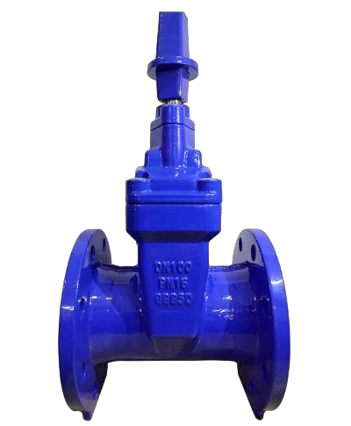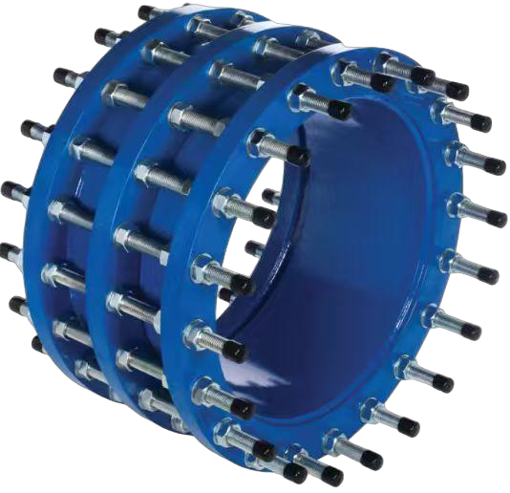

Butterfly Valve Coupling

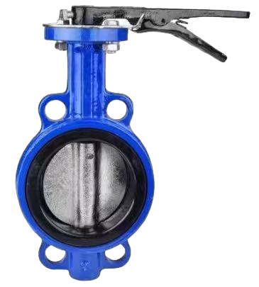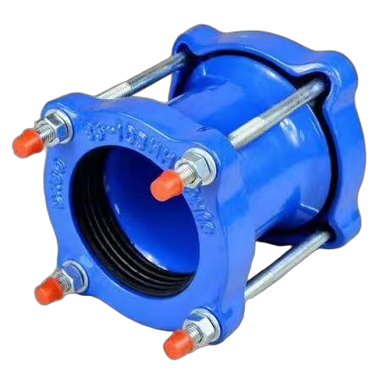
Check Valve Flange adaptor

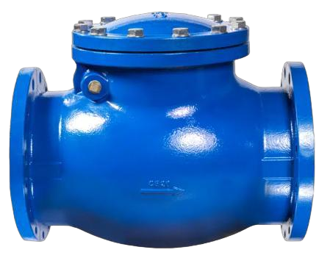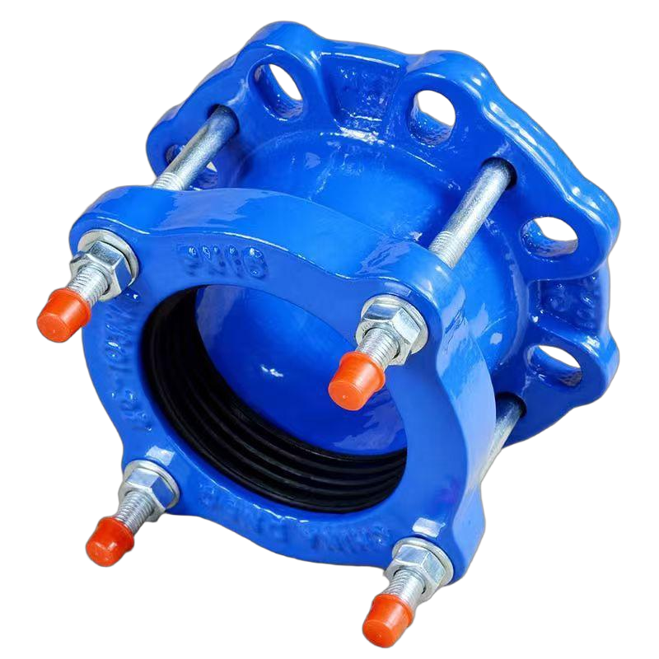
Y strainer Rubber joint
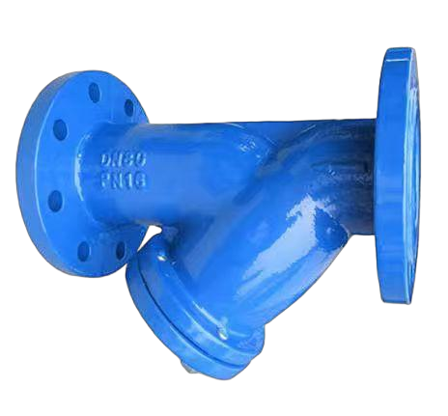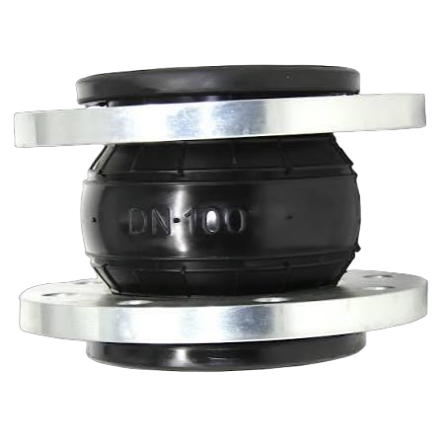
Air Valve
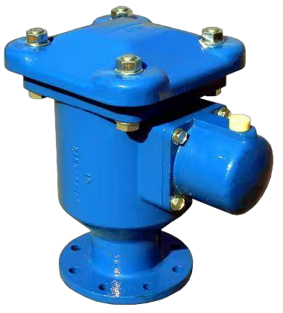
Ball Valve
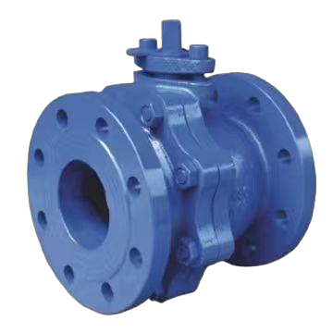
Globe Valve
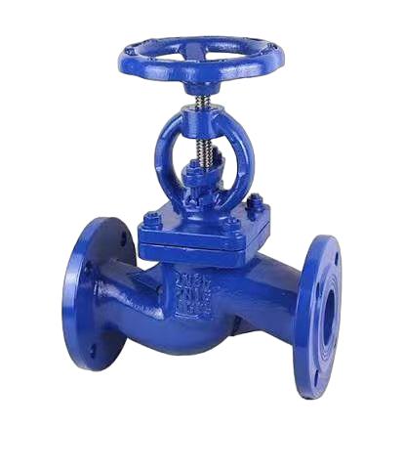
产品页面详情；

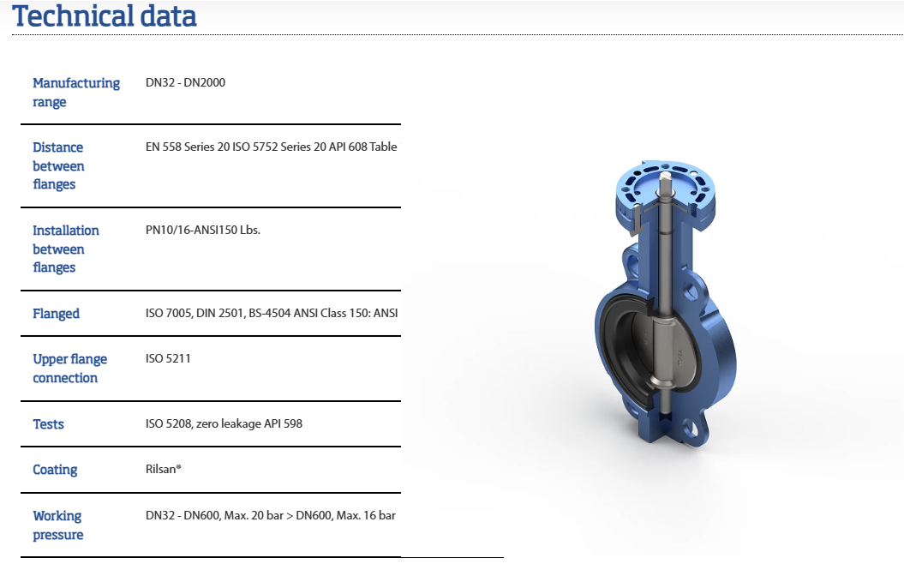

做成这样的。 产品图片右下角添加两个按钮：两个文件下载按钮

Manual
Product Catalog
类似以下图片：


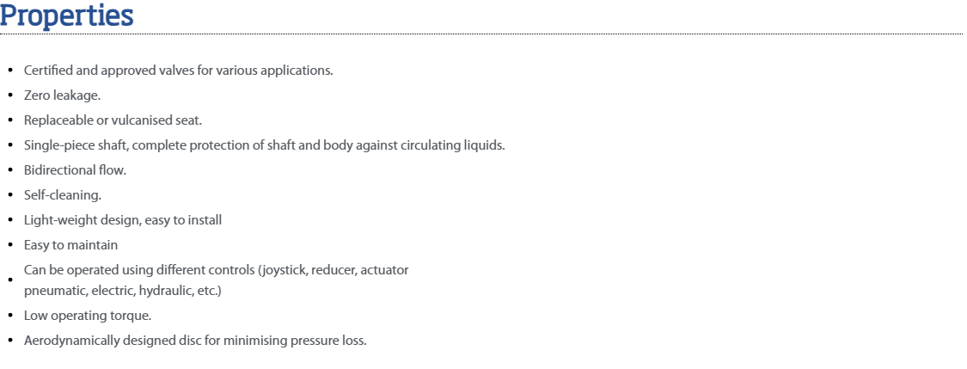
以下为产品特性。 内容做成可编辑的。 我可以后期自己修改。

Properties
Certified and approved valves for various applications.
Zero leakage.
Replaceable or vulcanised seat.
Single-piece shaft, complete protection of shaft and body against circulating liquids.
Bidirectional flow.
Self-cleaning.
Light-weight design, easy to install
Easy to maintain
Can be operated using different controls (joystick, reducer, actuator
pneumatic, electric, hydraulic, etc.)
Low operating torque.
Aerodynamically designed disc for minimising pressure loss.

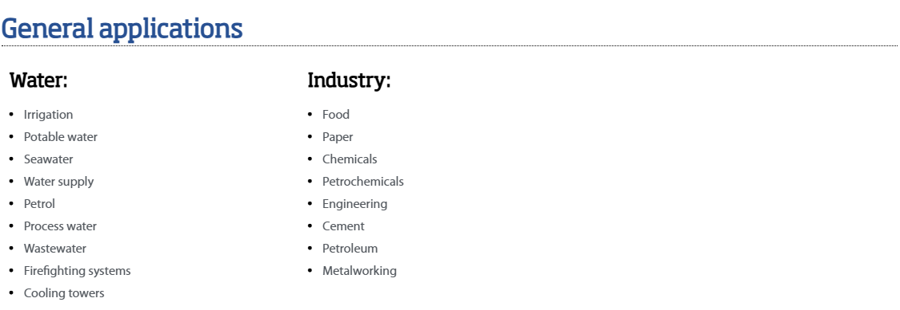

要求同上： 做成可编辑的。
General applications
Water:
Irrigation
Potable water
Seawater
Water supply
Petrol
Process water
Wastewater
Firefighting systems
Cooling towers
Industry:
Food
Paper
Chemicals
Petrochemicals
Engineering
Cement
Petroleum
Metalworking

Contact 页面做成下面这种的：

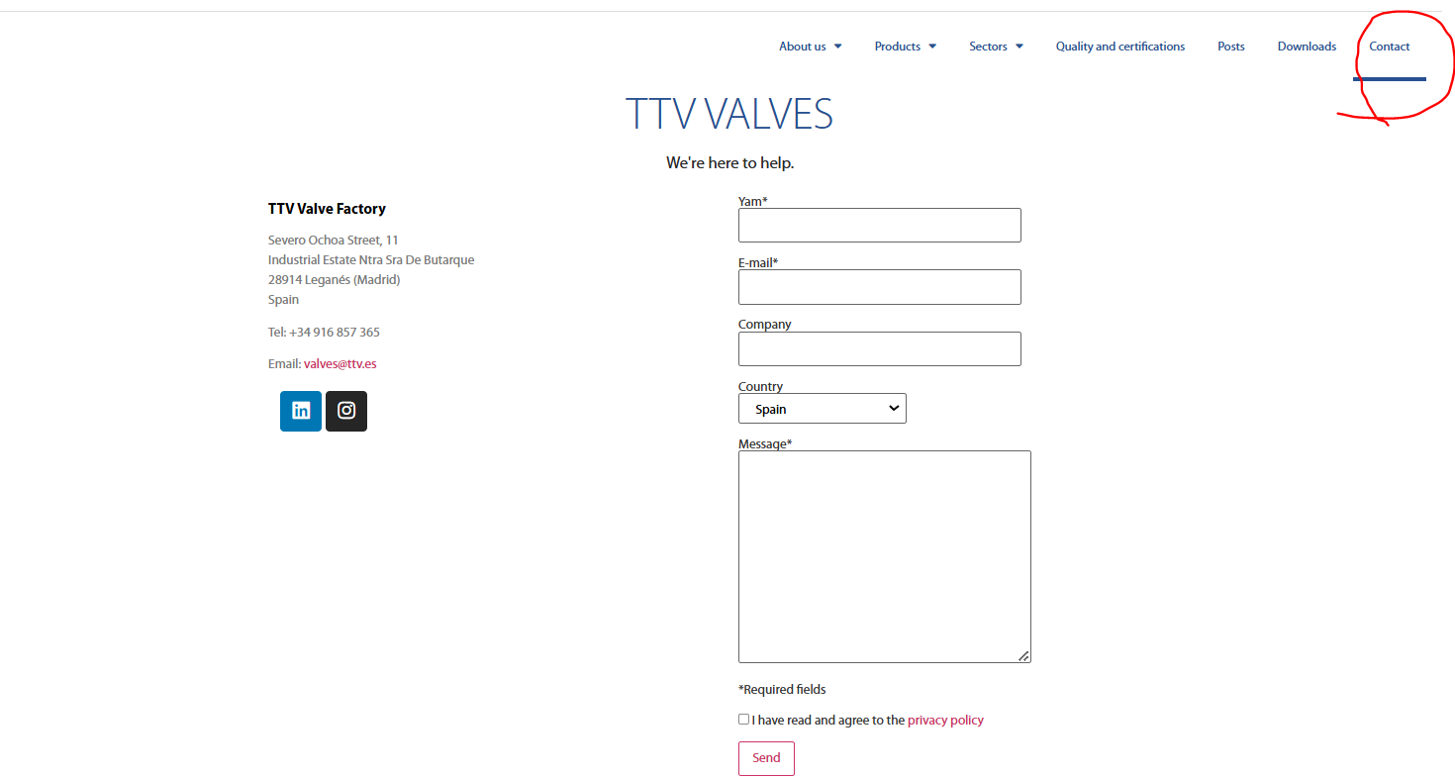

PLOVER INDUSTRIAL CO.,LTD
We’re here to help.

PLOVER INDUSTRIAL CO.,LTD
Address: xxxx
Tel;+86 19816553848
Email: charles@ploverindustrial.com

右边按照图片设计。

Download 页面：

可以上传PDF 文档等， 客户可以下载。

Posts:

我这边后台上传文章、公司动态等内容。

Quality and Certificate

这里显示质量文章，以及可以下载证书文件。

