高斯投影坐标正反算

一、基本思想：
高斯投影正算公式就是由大地坐标（L，B）求解高斯平面坐标（x，y），而高斯投影反算公式则是由高斯平面坐标（x，y）求解大地坐标（L，B）。

二、计算模型：
基本椭球参数：
椭球长半轴
椭球扁率
椭球短半轴：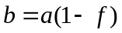
椭球第一偏心率 ：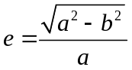
椭球第二偏心率 ：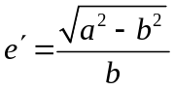
高斯投影正算公式：此公式换算的精度为0.001m
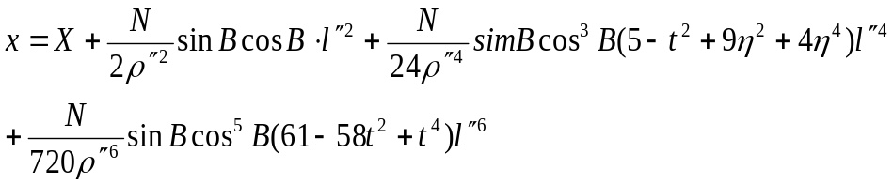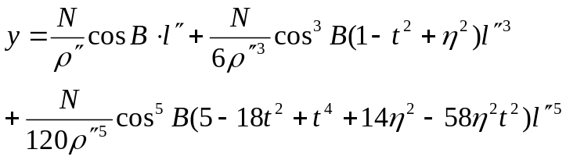
其中：角度都为弧度
为点的纬度，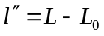，为点的经度，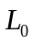为中央子午线经度；
为子午圈曲率半径，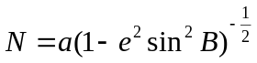；
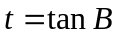；
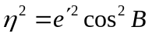
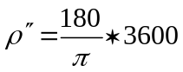
其中为子午线弧长：
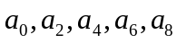为基本常量，按如下公式计算：
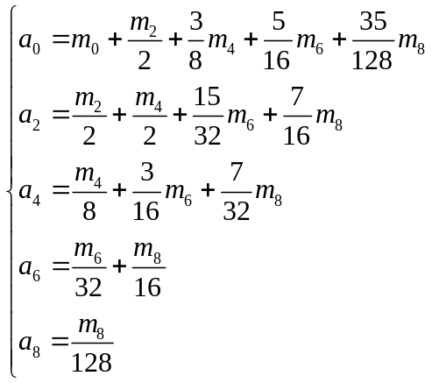
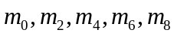为基本常量，按如下公式计算：
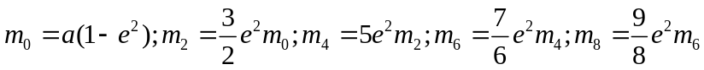；

高斯投影反算公式：此公式换算的精度为0.0001’’.
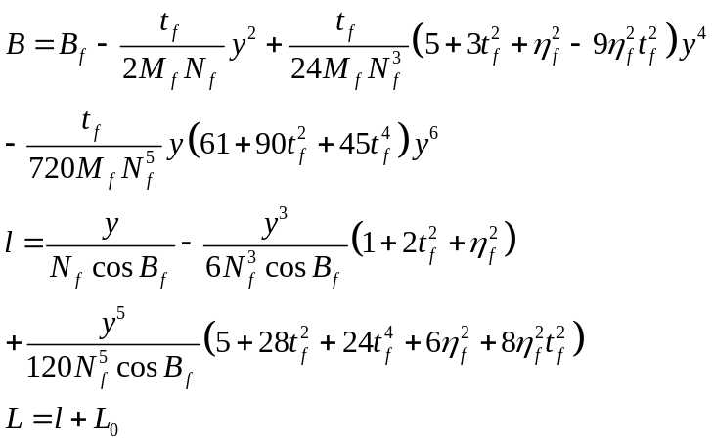

其中：
为中央子午线经度。
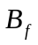为底点纬度，也就是当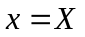时的子午线弧长所对应的纬度。按照子午线弧长公式：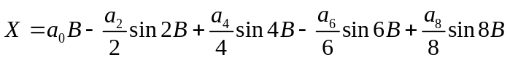，迭代进行计算；
初始开始时设：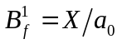
以后每次迭代按下式计算：
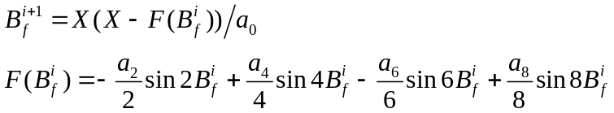
重复迭代至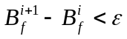为止。
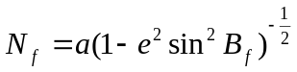；
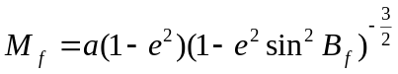
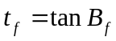；
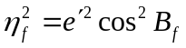

海福特椭球(1910) 我国52年以前基准椭球
a=6378388m b=6356911.9461279m α=0.33670033670
克拉索夫斯基椭球(1940 Krassovsky) 北京54坐标系基准椭球
a=6378245m b=6356863.018773m α=0.33523298692
1975年I.U.G.G推荐椭球(国际大地测量协会1975) 西安80坐标系基准椭球
a=6378140m b=6356755.2881575m α=0.0033528131778
WGS-84椭球(GPS全球定位系统椭球、17届国际大地测量协会) WGS-84 GPS 基准椭球
a=6378137m b=6356752.3142451m α=0.00335281006247

三、程序代码函数：
/************高斯投影正算函数***************
输入 : double a ,f 椭球参数，B,L为大地坐标,L0为中央子午线的经度，单位为弧度，x,y为高斯平面坐标,y加上了500000常量
返回：none
******************************************/
void gaosiforward(double a,double f,double B,double L,double L0,double &x,double &y)
{
double b, c,e1, e2; //短半轴，极点处的子午线曲率半径，第一偏心率，第二偏心率
double l, W,N, M, daihao;//W为常用辅助函数，N为子午圈曲率半径，M为卯酉圈曲率半径
double X;//子午线弧长，高斯投影的坐标
double ruo, ita, sb, cb,t;
double m[5],n[5];
//计算一些基本常量
{
b=a*(1-f);
e1=sqrt(a*a-b*b)/a;
e2=sqrt(a*a-b*b)/b;
c=a*a/b;
m[0]=a*(1-e1*e1);
m[1]=3*(e1*e1*m[0])/2.0;
m[2]=5*(e1*e1*m[1])/4.0;
m[3]=7*(e1*e1*m[2])/6.0;
m[4]=9*(e1*e1*m[3])/8.0;
n[0]=m[0]+m[1]/2+3*m[2]/8+5*m[3]/16+35*m[4]/128;
n[1]=m[1]/2+m[2]/2+15*m[3]/32+7*m[4]/16;
n[2]=m[2]/8+3*m[3]/16+7*m[4]/32;
n[3]=m[3]/32+m[4]/16;
n[4]=m[4]/128; /////by kjh 2014.5.22 把改成了
}
//由纬度计算子午线弧长
{
X=n[0]*B-sin(B)*cos(B)*((n[1]-n[2]+n[3])+(2*n[2]-(16*n[3]/3.0))*sin(B)*sin(B)+16*n[3]*pow(sin(B),4)/3.0);
}
l=L-L0;//弧度
ita=e2*cos(B);
sb=sin(B);
cb=cos(B);
W=sqrt(1-e1*e1*sb*sb);
N=a/W;
t=tan(B);
ruo=(180/Pi)*3600;
x=(X+N*sb*cb*l*l/2+N*sb*cb*cb*cb*(5-t*t+9*ita*ita+4*ita*ita*ita*ita)*l*l*l*l/24+N*sb*cb*cb*cb*cb*cb*(61-58*t*t+t*t*t*t)*l*l*l*l*l*l/720);
y=(N*cb*l+N*cb*cb*cb*(1-t*t+ita*ita)*l*l*l/6+N*cb*cb*cb*cb*cb*(5-18*t*t+t*t*t*t+14*ita*ita-58*ita*ita*t*t)*l*l*l*l*l/120);
y=y+500000;
}

/**************高斯反算函数***************
输入 : double a ,f 椭球参数， x,y为高斯平面坐标，L0为中央子午线的经度； B,L为大地坐标，单位为弧度

*返回：none
*****************************/
void gaosibackward(double a,double f,double x,double y,double L0,double &B,double &L)
{
double b, c,e1, e2; //短半轴，极点处的子午线曲率半径，第一偏心率，第二偏心率
double Bf,itaf,tf,Nf,Mf,Wf;
double l;
double m[5],n[5];
y=y-500000;

//计算一些基本常量
{
b=a*(1-f);
e1=sqrt(a*a-b*b)/a;
e2=sqrt(a*a-b*b)/b;
c=a*a/b;
m[0]=a*(1-e1*e1);
m[1]=3*(e1*e1*m[0])/2.0;
m[2]=5*(e1*e1*m[1])/4.0;
m[3]=7*(e1*e1*m[2])/6.0;
m[4]=9*(e1*e1*m[3])/8.0;
n[0]=m[0]+m[1]/2+3*m[2]/8+5*m[3]/16+35*m[4]/128;
n[1]=m[1]/2+m[2]/2+15*m[3]/32+7*m[4]/16;
n[2]=m[2]/8+3*m[3]/16+7*m[4]/32;
n[3]=m[3]/32+m[4]/16;
n[4]=m[4]/128;
}
//计算Bf
{
double Bf1,Bfi0,Bfi1,FBfi;
Bf1=x/n[0];
Bfi0=Bf1;
Bfi1=0;
FBfi=0;
int num=0;
do
{
num=0;
FBfi=0.0-n[1]*sin(2*Bfi0)/2.0+n[2]*sin(4*Bfi0)/4.0-n[3]*sin(6*Bfi0)/6.0;
Bfi1=(x-FBfi)/n[0];
if (fabs(Bfi1-Bfi0)>(Pi*pow(10.0,-8)/(36*18)))
{
num=1;
Bfi0=Bfi1;
}
} while (num==1);
Bf=Bfi1;
}
tf=tan(Bf);
Wf=sqrt(1-e1*e1*sin(Bf)*sin(Bf));
Nf=a/Wf;
Mf=a*(1-e1*e1)/(Wf*Wf*Wf);
itaf=e2*cos(Bf);
B=Bf-tf*y*y/(2*Mf*Nf)+tf*(5+3*tf*tf+itaf*itaf-9*itaf*itaf*tf*tf)*pow(y,4)/(24*Mf*pow(Nf,3))-tf*(61+90*tf*tf+45*pow(tf,4))*pow(y,6)/(720*Mf*pow(Nf,5));
l=y/(Nf*cos(Bf))-(1+2*tf*tf+itaf*itaf)*pow(y,3)/(6*pow(Nf,3)*cos(Bf))+(5+28*tf*tf+24*pow(tf,4)+6*itaf*itaf+8*itaf*itaf*tf*tf)*pow(y,5)/(120*pow(Nf,5)*cos(Bf));
L=l+L0;
}
2014-5-22

' 输入: double a ,f 椭球参数，B,L为大地坐标,L0为中央子午线的经度，单位为弧度，x,y为高斯平面坐标,y加上了常量
Private Function gaosiforward(ByVal a As Double, ByVal f As Double, ByVal B As Double, ByVal L As Double, ByVal L0 As Double) As Double()
Dim x, y, xy(2) As Double
Dim bb, c, e1, e2 As Double '短半轴，极点处的子午线曲率半径，第一偏心率，第二偏心率
Dim ll, W, N, M, daihao As Double 'W为常用辅助函数，N为子午圈曲率半径，M为卯酉圈曲率半径
Dim xx As Double '子午线弧长，高斯投影的坐标
Dim ruo, ita, sb, cb, t As Double
Dim mm(5), nn(5) As Double
bb = a * (1 - f)
e1 = Math.Sqrt(a * a - bb * bb) / a
e2 = Math.Sqrt(a * a - bb * bb) / bb
c = a * a / bb
mm(0) = a * (1 - e1 * e1)
mm(1) = 3 * (e1 * e1 * mm(0)) / 2.0
mm(2) = 5 * (e1 * e1 * mm(1)) / 4.0
mm(3) = 7 * (e1 * e1 * mm(2)) / 6.0
mm(4) = 9 * (e1 * e1 * mm(3)) / 8.0
nn(0) = mm(0) + mm(1) / 2 + 3 * mm(2) / 8 + 5 * mm(3) / 16 + 35 * mm(4) / 128
nn(1) = mm(1) / 2 + mm(2) / 2 + 15 * mm(3) / 32 + 7 * mm(4) / 16
nn(2) = mm(2) / 8 + 3 * mm(3) / 16 + 7 * mm(4) / 32
nn(3) = mm(3) / 32 + mm(4) / 16
nn(4) = mm(4) / 128
xx = nn(0) * B - Sin(B) * Cos(B) * ((nn(1) - nn(2) + nn(3)) + (2 * nn(2) - (16 * nn(3) / 3.0)) * Sin(B) * Sin(B) + 16 * nn(3) * Pow(Sin(B), 4) / 3.0)
ll = L - L0 '弧度
ita = e2 * Cos(B)
sb = Sin(B)
cb = Cos(B)
W = Sqrt(1 - e1 * e1 * sb * sb)
N = a / W
t = Tan(B)
ruo = (180 / PI) * 3600
x = (xx + N * sb * cb * ll * ll / 2 + N * sb * cb * cb * cb * (5 - t * t + 9 * ita * ita + 4 * ita * ita * ita * ita) * ll * ll * ll * ll / 24 + N * sb * cb * cb * cb * cb * cb * (61 - 58 * t * t + t * t * t * t) * ll * ll * ll * ll * ll * ll / 720)
y = (N * cb * ll + N * cb * cb * cb * (1 - t * t + ita * ita) * ll * ll * ll / 6 + N * cb * cb * cb * cb * cb * (5 - 18 * t * t + t * t * t * t + 14 * ita * ita - 58 * ita * ita * t * t) * ll * ll * ll * ll * ll / 120)
y = y + 500000
xy(0) = x
xy(1) = y
Return xy
End Function
Private Function gaosibackward(ByVal a As Double, ByVal f As Double, ByVal x As Double, ByVal y As Double, ByVal L0 As Double) As Double()
Dim b, l, bl(2) As Double
Dim bb, c, e1, e2 As Double '短半轴，极点处的子午线曲率半径，第一偏心率，第二偏心率
Dim Bf, itaf, tf, Nf, Mf, Wf As Double
Dim ll As Double
Dim m(5), n(5) As Double
y = y - 500000

bb = a * (1 - f)
e1 = Sqrt(a * a - bb * bb) / a
e2 = Sqrt(a * a - bb * bb) / bb
c = a * a / bb
m(0) = a * (1 - e1 * e1)
m(1) = 3 * (e1 * e1 * m(0)) / 2.0
m(2) = 5 * (e1 * e1 * m(1)) / 4.0
m(3) = 7 * (e1 * e1 * m(2)) / 6.0
m(4) = 9 * (e1 * e1 * m(3)) / 8.0
n(0) = m(0) + m(1) / 2 + 3 * m(2) / 8 + 5 * m(3) / 16 + 35 * m(4) / 128
n(1) = m(1) / 2 + m(2) / 2 + 15 * m(3) / 32 + 7 * m(4) / 16
n(2) = m(2) / 8 + 3 * m(3) / 16 + 7 * m(4) / 32
n(3) = m(3) / 32 + m(4) / 16
n(4) = m(4) / 128
'计算BF
Dim Bf1, Bfi0, Bfi1, FBfi As Double
Bf1 = x / n(0)
Bfi0 = Bf1
Bfi1 = 0
FBfi = 0
Dim num As Integer = 0
Do
num = 0
FBfi = 0.0 - n(1) * Sin(2 * Bfi0) / 2.0 + n(2) * Sin(4 * Bfi0) / 4.0 - n(3) * Sin(6 * Bfi0) / 6.0
Bfi1 = (x - FBfi) / n(0)
If (Abs(Bfi1 - Bfi0) > (PI * Pow(10.0, -8) / (36 * 18))) Then
num = 1
Bfi0 = Bfi1
End If
Loop While num = 1
Bf = Bfi1
tf = Tan(Bf)
Wf = Sqrt(1 - e1 * e1 * Sin(Bf) * Sin(Bf))
Nf = a / Wf
Mf = a * (1 - e1 * e1) / (Wf * Wf * Wf)
itaf = e2 * Cos(Bf)
b = Bf - tf * y * y / (2 * Mf * Nf) + tf * (5 + 3 * tf * tf + itaf * itaf - 9 * itaf * itaf * tf * tf) * Pow(y, 4) / (24 * Mf * Pow(Nf, 3)) - tf * (61 + 90 * tf * tf + 45 * Pow(tf, 4)) * Pow(y, 6) / (720 * Mf * Pow(Nf, 5))
ll = y / (Nf * Cos(Bf)) - (1 + 2 * tf * tf + itaf * itaf) * Pow(y, 3) / (6 * Pow(Nf, 3) * Cos(Bf)) + (5 + 28 * tf * tf + 24 * Pow(tf, 4) + 6 * itaf * itaf + 8 * itaf * itaf * tf * tf) * Pow(y, 5) / (120 * Pow(Nf, 5) * Cos(Bf))
l = ll + L0
bl(0) = hdtod(b)
bl(1) = hdtod(l)
Return bl
End Function
'度转换为弧度
Private Function dtohd(ByVal d As Double) As Double
Dim hd As Double
hd = d * PI / 180
Return hd
End Function
'弧度转换为度
Private Function hdtod(ByVal hd As Double) As Double
Dim d As Double
d = hd * 180 / PI
Return d
End Function
Private Function dfmtod(ByVal dfm As Double) As Double
Dim dfm2, dfm3(), du, fen, miao, miao1, miao2 As String
Dim duf As Double
dfm2 = dfm.ToString
dfm3 = dfm2.Split(".")
du = dfm3(0)
fen = dfm3(1).Substring(0, 2)
miao1 = dfm3(1).Substring(2, 2)
miao2 = dfm3(1).Substring(4)
miao = miao1 & "." & miao2
duf = Convert.ToInt32(du) + Convert.ToInt32(fen) / 60.0 + Convert.ToDouble(miao) / 3600
Return duf
End Function

'国家坐标系椭球参数2000,84,54,80
a2 = 6378137
f2 = 1 / 298.257222101
a84 = a2
f84 = 1 / 298.257223563
a54 = 6378245
f54 = 0.33523298692
a80 = 6378140
f80 = 0.0033528131778

