开发小型的宾馆管理系统

问题
本案例实现一个小型的宾馆管理系统，满足一般小型旅馆的日程管理需要。完成的功能：
客房管理、客户管理、客户入住和客户结算、系统功能。
1.客房（房间）管理：对宾馆拥有的房间进行登记，描述房间的详细信息，提供查询、新建、修改和删除等功能。
2.客户管理：对宾馆登记的客户进行管理，描述客户的详细信息，提供查询、新建、修改和删除等功能。
3.客户入住：当顾客要求入住宾馆时，客户指定要入住的房间类型和其他要求，就可以对客房的入住情况进行查询，并展示房间的信息。选择符合自己要求的客房，便可办理入住手续。
4.客户结算：当入住的客户要求退房时，提供指定的房间号或用户名，用户可进行结算退房手续。
5.对入住的个人或者历史所有入住信息的查询。
6.登录系统，以及帐号密码修改功能。
分析
根据系统的功能划分和实现的方便，我们将整个程序分为三层：数据层、业务层和界面层。数据层负责对数据库进行操作，包括向表中插入数据、更新数据、查询数据和删除数据。业务层负责把界面上的各种操作传达给数据层。界面层主要负责界面的设计，包括控件的位置和外观等设置、实时反映系统的变化情况。
数据库表的设计
根据程序的功能得出数据实体，进行数据库设计分析，确定以下数据表，如图所示：
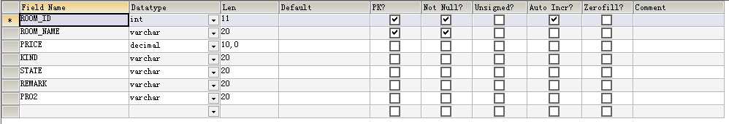
图1 客房表结构
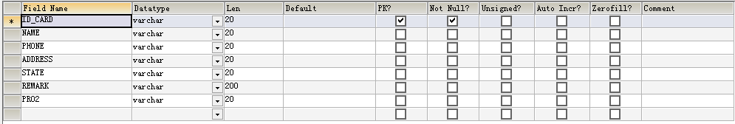
图2 住客表结构
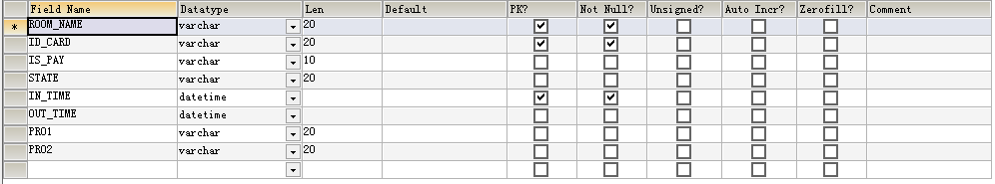
图3 入住表结构
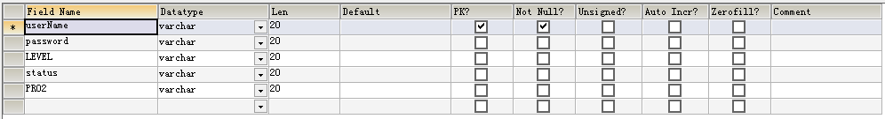
图4 用户表结构

方案实现：
在解决方案中添加3个项目，分别代表数据层、业务层和界面层。因为房间和住户对象的实现方式类似，以下以客房类为示例，讲解实现过程：
HotelManagementBLL. Room类的实现
该类主要实现客房的业务逻辑，如：添加、删除、修改和查找客房。具体代码如下所示：
using System;
using System.Collections.Generic;
using System.Linq;
using System.Text;
using System.Data;
using System.Windows.Forms;

namespace HotelManagementBLL
{
public class Room
{
private DataGridView _dgv;

public Room(DataGridView dgr)
{
_dgv = dgr;
}

public Room()
{

}

public void UpdateDataGrid()
{
DataSet objDataSet = HotelManagementDAL.Room.FillByAllRoom();
this._dgv.DataSource = objDataSet.Tables[0];
}

//添加房间
public void Add(string name, decimal price, string kind, string remark)
{
HotelManagementDAL.Room obj = new HotelManagementDAL.Room();
if (obj.GetDataReaderByName(name))
{
MessageBox.Show("该房间名已经存在" + name + "，请重新输入！", "课程已存在", MessageBoxButtons.OK, MessageBoxIcon.Error);
}
else
{
if (HotelManagementDAL.Room.Add(name, price, kind, remark) > 0)
{
UpdateDataGrid();
MessageBox.Show("成功添加房间信息！", "操作成功", MessageBoxButtons.OK, MessageBoxIcon.Information);
}
else
{
MessageBox.Show("添加房间信息失败！", "操作失败", MessageBoxButtons.OK, MessageBoxIcon.Information);
}
}
}

//修改房间信息
public void Update(int id, string name, decimal price, string kind, string state, string remark)
{
HotelManagementDAL.Room objRoom = new HotelManagementDAL.Room(name);
objRoom.RoomID = id;
objRoom.RoomName = name;
objRoom.RoomPrice = price;
objRoom.RoomKind = kind;
objRoom.RoomState = state;
objRoom.Remark = remark;
if (objRoom.Update() > 0)
{
UpdateDataGrid();
MessageBox.Show("修改房间信息成功！", "操作成功", MessageBoxButtons.OK, MessageBoxIcon.Information);
}
else
{
MessageBox.Show("更新操作失败！", "操作失败", MessageBoxButtons.OK, MessageBoxIcon.Information);
}
}

//删除房间
public void Delete()
{
string roomName = this._dgv.CurrentRow.Cells["roomName"].Value.ToString();
if (DialogResult.Yes == MessageBox.Show("确认删除房间：' " + roomName + " '吗?\n删除房间，将同时删除与该房间有相关的所有房间信息，要继续吗？", "删除确认", MessageBoxButtons.YesNo, MessageBoxIcon.Question))
{
HotelManagementDAL.Room objRoom = new HotelManagementDAL.Room(roomName);
if (objRoom.Delete() > 0)
{
UpdateDataGrid();
MessageBox.Show("成功删除房间" + roomName + " '!", "操作成功", MessageBoxButtons.OK, MessageBoxIcon.Information);
}
else
{
MessageBox.Show("删除操作失败 " + roomName + " '!", "操作失败", MessageBoxButtons.OK, MessageBoxIcon.Information);
}
}
}

//房间查询
public void Search(string roomName,decimal roomPrice,decimal roomPrice2, string roomKind,string state, bool useMatch)
{
DataSet objDataSet = HotelManagementDAL.Room.FillByAllRoom();
if (useMatch)
objDataSet = HotelManagementDAL.Room.SearchByFuzzy(roomName, roomPrice,roomPrice2, roomKind, state);
else
objDataSet = HotelManagementDAL.Room.SearchByPrecision(roomName, roomPrice,roomPrice2, roomKind, state);
_dgv.DataSource = objDataSet.Tables[0];
if(objDataSet.Tables[0].Rows.Count == 0)
MessageBox.Show("没有符合的记录！", "结果", MessageBoxButtons.OK, MessageBoxIcon.Information);
else
MessageBox.Show("搜索完毕", "结果", MessageBoxButtons.OK, MessageBoxIcon.Information);
}
}
}
HotelManagementDAL. Room类的实现
该类主要实现客房的对象的创建和数据库操作，如根据客房名查询是否有该客房存在、获得所有客房信息记录、以及对客房的添加、删除、修改和查、以及办理住退房的状态修改过操作。具体代码如下所示：
using System;
using System.Collections.Generic;
using System.Linq;
using System.Text;
using MySql.Data.MySqlClient;
using System.Data;

namespace HotelManagementDAL
{
public class Room
{
private int _roomID;
private string _roomName;
private string _roomKind;
private decimal _roomPrice;
private string _remark;
private string _roomState;

#region attribute
public int RoomID
{
get
{
return _roomID;
}
set
{
_roomID = value;
}
}

public string RoomName
{
get
{
return _roomName;
}
set
{
_roomName = value;
}
}

public string RoomState
{
get
{
return _roomState;
}
set
{
_roomState = value;
}
}

public string RoomKind
{
get
{
return _roomKind;
}
set
{
_roomKind = value;
}
}

public decimal RoomPrice
{
get
{
return _roomPrice;
}
set
{
_roomPrice = value;
}
}

public string Remark
{
get
{
return _remark;
}
set
{
_remark = value;
}
}
#endregion

public Room()
{

}

public Room(string roomName)
{
_roomName = roomName;
}

//有无该房间
public bool GetDataReaderByName(string _roomName)
{
string strSql = "select * from room_management where ROOM_NAME = @roomName";
return MySqlHelper.ExecuteReader(strSql, new MySqlParameter("@roomName", _roomName)).HasRows;
}

//添加房间信息
public static int Add(string _name, decimal _price, string _kind, string _remark)
{
string strSql = "insert into room_management(ROOM_NAME,PRICE,KIND,REMARK,STATE) values(@roomName,@roomPrice,@roomKind,@roomRemark,'未入住')";
MySqlParameter[] paras = new MySqlParameter[4];
paras[0] = new MySqlParameter("@roomName", _name);
paras[1] = new MySqlParameter("@roomPrice", _price);
paras[2] = new MySqlParameter("@roomKind", _kind);
paras[3] = new MySqlParameter("@roomRemark", _remark);
return MySqlHelper.ExecuteNonQuery(strSql, paras);
}

//修改房间信息
public int Update()
{
string strSql = "update room_management set ROOM_NAME = @roomName, PRICE = @roomPrice, KIND = @roomKind ,STATE = @roomState ,REMARK = @roomRemark where ROOM_ID = @roomID";
MySqlParameter[] paras = new MySqlParameter[6];
paras[0] = new MySqlParameter("@roomName", _roomName);
paras[1] = new MySqlParameter("@roomPrice", _roomPrice);
paras[2] = new MySqlParameter("@roomKind", _roomKind);
paras[3] = new MySqlParameter("@roomRemark", _remark);
paras[4] = new MySqlParameter("@roomID", _roomID);
paras[5] = new MySqlParameter("@roomState", _roomState);
return MySqlHelper.ExecuteNonQuery(strSql, paras);
}

//办理入住
public int CheckIn()
{
string strSql = "update room_management set STATE = '入住' where ROOM_NAME = @roomName";
MySqlParameter[] paras = new MySqlParameter[1];
paras[0] = new MySqlParameter("@roomName", _roomName);
return MySqlHelper.ExecuteNonQuery(strSql, paras);
}

//办理退房
public int CheckOut()
{
string strSql = "update room_management set STATE = '未入住' where ROOM_NAME = @roomName";
MySqlParameter[] paras = new MySqlParameter[1];
paras[0] = new MySqlParameter("@roomName", _roomName);
return MySqlHelper.ExecuteNonQuery(strSql, paras);
}

//按信息模糊查找
public static DataSet SearchByFuzzy(string roomName, decimal roomPrice,decimal roomPrice2, string roomKind, string roomState)
{
string strSql = "SELECT * FROM room_management where ROOM_NAME LIKE @roomName and PRICE BETWEEN @roomPrice AND @roomPrice2 and KIND LIKE @roomKind and STATE LIKE @roomState";
MySqlParameter[] paras = new MySqlParameter[5];
paras[0] = new MySqlParameter("@roomName", '%' + roomName + '%' );
paras[1] = new MySqlParameter("@roomPrice", roomPrice);
paras[2] = new MySqlParameter("@roomKind", '%' + roomKind + '%');
if (roomState == "")
roomState = "%";
paras[3] = new MySqlParameter("@roomState", roomState );
paras[4] = new MySqlParameter("@roomPrice2", roomPrice2);
DataSet ds = MySqlHelper.GetDataSet(strSql,paras);
return ds;
}

//按信息精确查找
public static DataSet SearchByPrecision(string roomName, decimal roomPrice, decimal roomPrice2, string roomKind, string roomState)
{
StringBuilder strSql = new StringBuilder("SELECT * FROM room_management where PRICE BETWEEN @roomPrice AND @roomPrice2 and");
MySqlParameter[] paras = new MySqlParameter[5];
if (roomName == "")
strSql.Append(" ROOM_NAME LIKE '%' ");
else
strSql.Append(" ROOM_NAME = @roomName ");
if (roomKind == "")
strSql.Append(" AND KIND LIKE '%' ");
else
strSql.Append(" AND KIND = @roomKind ");
if (roomState == "")
strSql.Append(" AND STATE LIKE '%' ");
else
strSql.Append(" AND STATE = @roomState ");
paras[0] = new MySqlParameter("@roomName", roomName);
paras[1] = new MySqlParameter("@roomPrice", roomPrice);
paras[2] = new MySqlParameter("@roomKind", roomKind);
if (roomState == "")
roomState = "%";
paras[3] = new MySqlParameter("@roomState", roomState);
paras[4] = new MySqlParameter("@roomPrice2", roomPrice2);
DataSet ds = MySqlHelper.GetDataSet(strSql.ToString(), paras);
return ds;
}

//删除房间
public int Delete()
{
//删除房间信息
StringBuilder strSql = new StringBuilder();
strSql.Append("delete from room_management where ROOM_NAME = @roomNAME ;");
//删除 入住信息
strSql.Append("delete from check_in where ROOM_NAME = @roomNAME;");
return MySqlHelper.ExecuteNonQuery(strSql.ToString(), new MySqlParameter("@roomNAME", _roomName));
}

//得到所有房间信息
public static DataSet FillByAllRoom()
{
string strSql = "select * from room_management";
DataSet ds = MySqlHelper.GetDataSet(strSql);
return ds;
}

}
}
界面设计：
系统的界面除去主运行界面外，还有客房、住客等对象相应的管理、添加、查找和修改等界面，以及入住和退房的界面，具体的界面如下图所示：
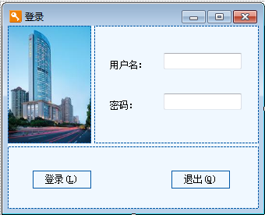
图5 登录界面
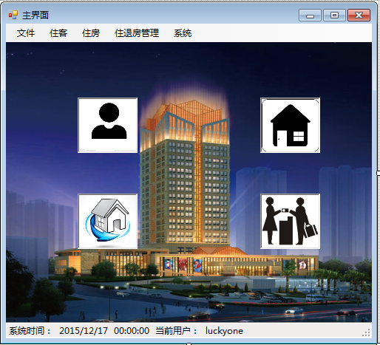
图6 主界面
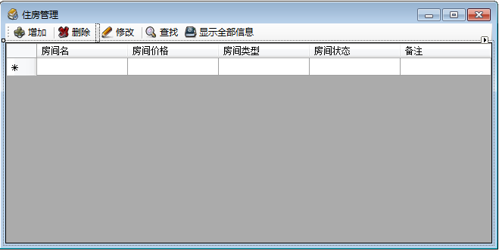
图7 住房管理界面

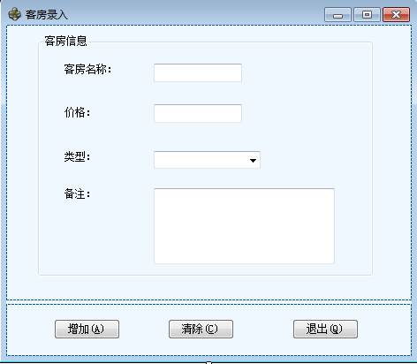
图7 客房录入界面

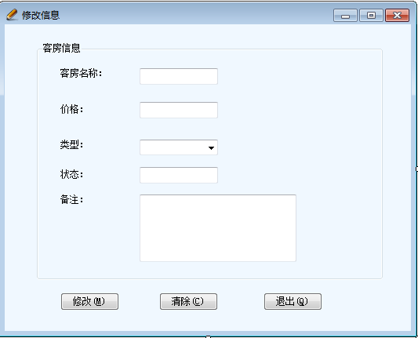
图8 客房信息修改界面

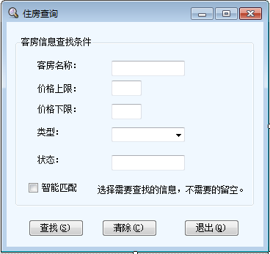
图9 客房信息查询界面

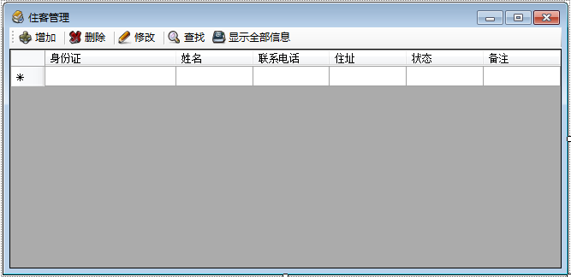
图9 住客管理界面
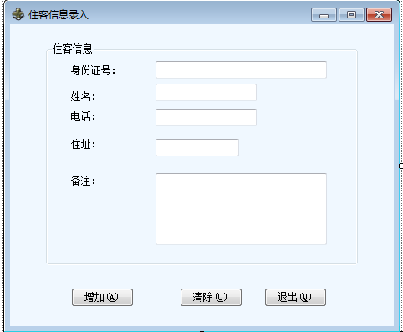
图10 住客信息录入界面

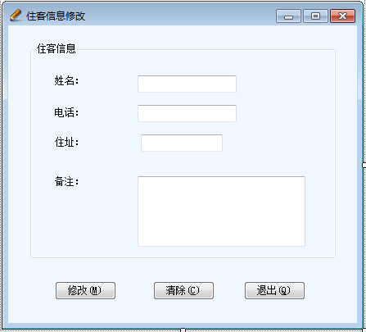
图11 住客信息修改界面
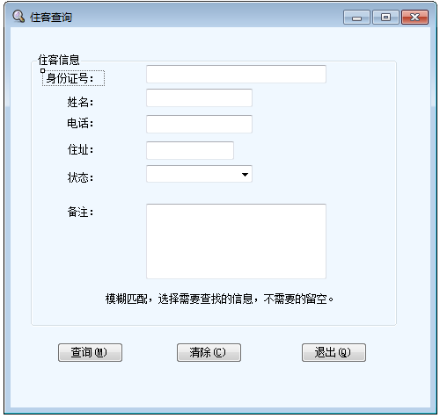
图11 住客信息查询界面
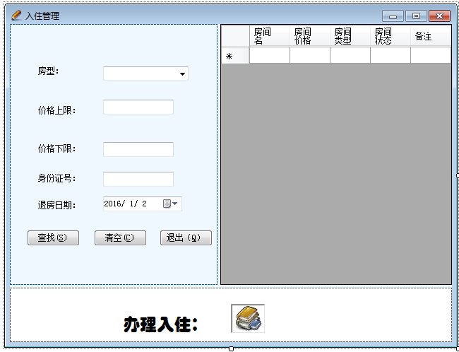
图13 入住管理界面
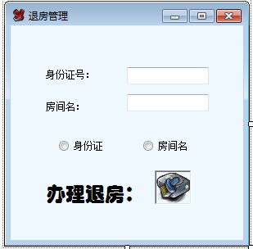
图14 退房管理界面
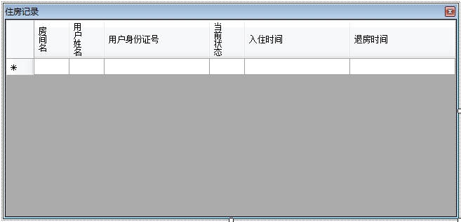
图15 住房记录界面
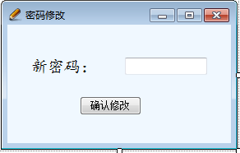
图16 密码修改界面

