Xiaosong Zhang

Math 2640

Prof. Biao Zhang

Due:

#3.32

a) Design outline:

Independent variable: Strength of marijuana (Weak or Strong)

Dependent variable: Work output (Amount)

The 20 objects should be randomly divided into 2 groups, 1 group will be use strong marijuana and the other group will be treat with the weak marijuana. The work output by each of the 20 individual should be measure and record.

b)

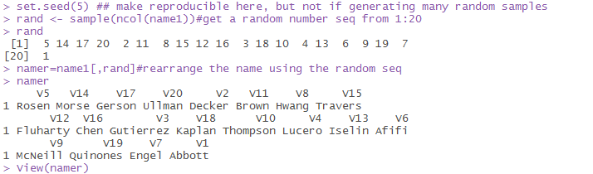

#3.59

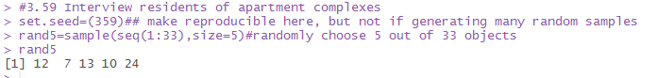

Thus, Country View, Brownstone, Country Villa, Chauncey Village and Nobb Hill had been selected.

#3.84

1. High bias high variability
2. Low bias, low variability
3. Low bias, low variability
4. High bias, low variability

#3.88

1. The population of the sample survey is 61239, the sample is those adults live in Ontario and been selected to conduct the survey.
2. The sample population is good enough for Ontario province, but unless we know the exact method and process of how the survey had been taken, the answer will remain uncertain. The method use to choose the survey takers is very important and likely to lead to a bias result away from truth.

#4.26

Both have type O: 0.52\*0.44=.23=23%

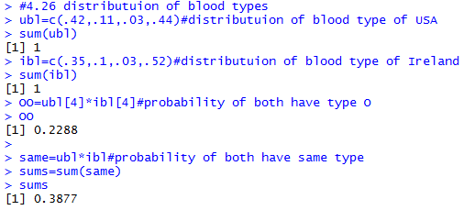

Both have same type = .3877= 38.8%

#4.28

1. .23=23%
2. 41%

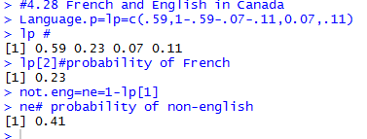

#4.42

1. Their children could have: A,B and AB
2. A=25%,B=25%,AB=50%

#4.44

1. One have A=0.5\*1=50%

Both have A=.5\*.5=25%

1. Both have B=.5\*.5=25%

Both have same= .25+.25=50%