Xiaosong Zhang

Math 2640

Prof. Biao Zhang

HW4

Due: February 12, 2014

**All the code are attached in the end of this assignment. Electronic copy of this Assignment and all the codes are available. Contact me at** [**Xiaosong.Zhang@utoledo.edu**](mailto:Xiaosong.Zhang@utoledo.edu)

**Questions and discussion about R programing are also welcome.**

#4.54

a)

> hist(ph,breaks=2,col="red",main="Histogram of probability of #4.54")

> #HW4 math 2640

> #4.54

> p=c(.8507,.1448,.0045) #data input

> #a

> total=sum(p)

> total#verify sum of probabilities

[1] 1

b) Predicted probability histogram for 10000 buyers

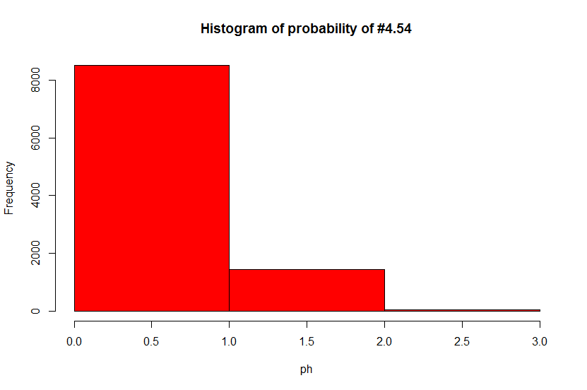

c)

> #c

> .1448+.0045# No.1

[1] 0.1493

> 1-.8507#No.2

[1] 0.1493

> #4.54

> #END

#4.59 DnD

> df# probability distribution

Sum Prob

1 NA 0.00000000

2 2 0.02083333

3 3 0.04166667

4 4 0.06250000

5 5 0.08333333

6 6 0.10416667

7 7 0.12500000

8 8 0.12500000

9 9 0.12500000

10 10 0.10416667

11 11 0.08333333

12 12 0.06250000

13 13 0.04166667

14 14 0.02083333

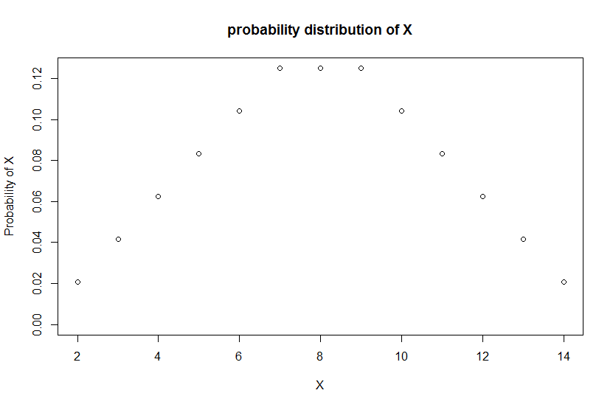

Code and explanation of R programing are attached at end of this assignment.

#4.62 Find the probabilities

1. P(X≥0.30)=0.7
2. P(X=0.30)= Unknown
3. 0.7
4. Unknown
5. Unknown

#4.73

For Full R-code please see attachment.

> #4.73 Servings of fruits and vegetables

> vs#variance of fruit servings

[1] 3.61

> Std.Servings=ss=sqrt(vs)

> ss#standard deviation of fruit servings

[1] 1.9

#4.76

> X

Errors Prob

1 0 0.4

2 1 0.3

3 2 0.2

4 3 0.1

> mean#mean for word error

[1] 1

> Var#for word error

[1] 1

> Std#standard deviation for word error

[1] 1

> #lib001 end of lib for mean,Var,Std

> #END#4.76

#4.82

> X

Errors Prob

1 0 0.1

2 1 0.3

3 2 0.3

4 3 0.2

5 4 0.1

> mean#mean for non-word error

[1] 1.9

> Var#for non-word error

[1] 1.29

> Std#standard deviation for non-word error

[1] 1.135782

> #lib001 end of lib for mean,Var,Std

a)

1. > X

Error Prob

1 0 0.04

2 1 0.15

3 2 0.23

4 3 0.24

5 4 0.19

6 5 0.10

7 6 0.04

8 7 0.01

> mean#mean for word error

[1] 2.9

> Var#for word error

[1] 2.29

> Std#standard deviation forword error

[1] 1.513275

b)

> #correlation

> correlation=co=0.5

> Varc=Varn^2+Varw^2+2*co*Stdn*Stdw #p271 Rule 3

> Stdc=sqrt(Varc)

> Varc

# Variance under influence of correlation co-efficiency 0.5

[1] 3.799882

> Stdc# Standard Deviation under influence of correlation coefficiency 0.5

[1] 1.949329

#4.130

a)

If Beth is Aa, the conditional probability is 2/3*1*1/2=1/3

If Beth is AA the children have 0% possibility to have albino (100% non-albino)

b)

2/3

#4.134 Work with a transformation

a)

> X

Value.of.X Prob

1 1 0.4

2 2 0.6

> mean#mean

[1] 1.6

> Var#Variance

[1] 0.24

> Std#standard deviation

[1] 0.4898979

b)

> X

Value.of.X Prob

1 1 0.4

2 4 0.6

> mean#mean

[1] 2.8

> Var#Variance

[1] 2.16

> Std#standard deviation

[1] 1.469694

c)

Ruled along transformation along Y=3X-2