**Instructions for Gathering Digit Points from Photos using VisualSFM**

Software needed: VisualSFM, MeshLab, Matlab

Sparse reconstruction

* Open VisualSFM (can only use on PC computers)
* Open folder with participant photos (click on the second one in the standard toolbar)
* Select all photos and load (takes a minute to load)
* Click on ‘Compute Missing Matches’. (takes long time; after this step, the folder with original photos will have many .sift files and .m files named after the relevant names of photos).
* Click on SFM > Reconstruct Sparse (will run algorithm and try to match the location of the photos to a 3d head; takes time)
* Result should look something like Picture 1
* If there exists more than one model, go to SfM-delete selected model (You can click on ‘show single/multiple models’ to make the picture show like below one, and tap right and left to show how many models are there.)

Picture 1Result of sparse reconstruction

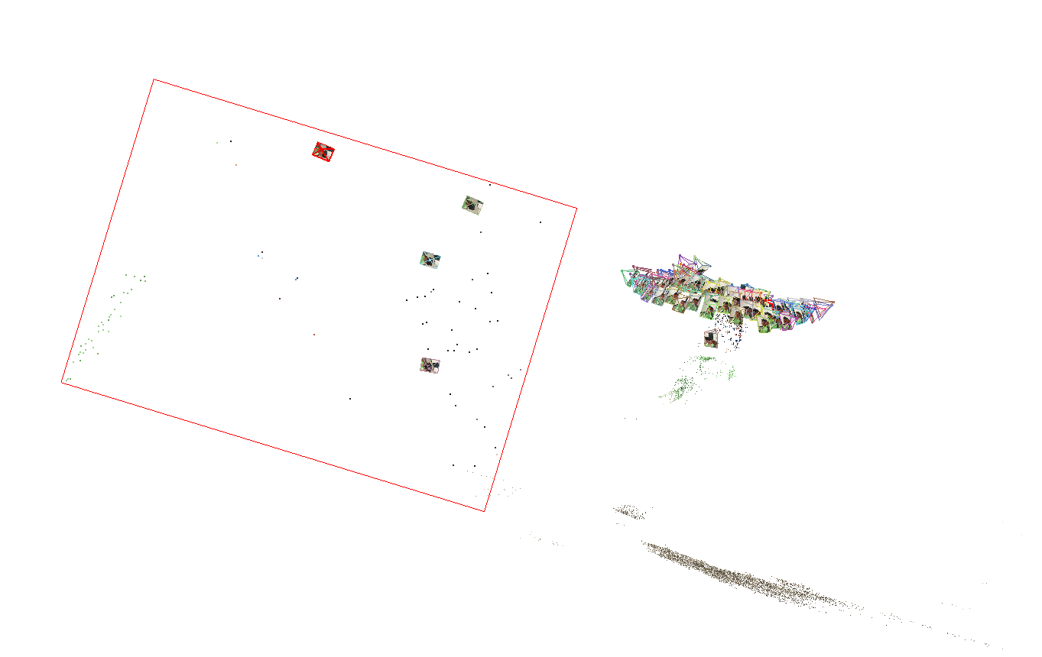

Dense reconstruction

* Click on SFM > Reconstruct Dense (takes long time, about half hour or more)
* There will be a dialog box ‘select work space for MVS’. Please name the folder which will be generated in this step, and click on save.
* Wait for reconstruction to complete (This time it ran for 77minutes.) and there will be a .nvm file and a folder you just generated.
* Reconstructed head image should show (Figure 2)

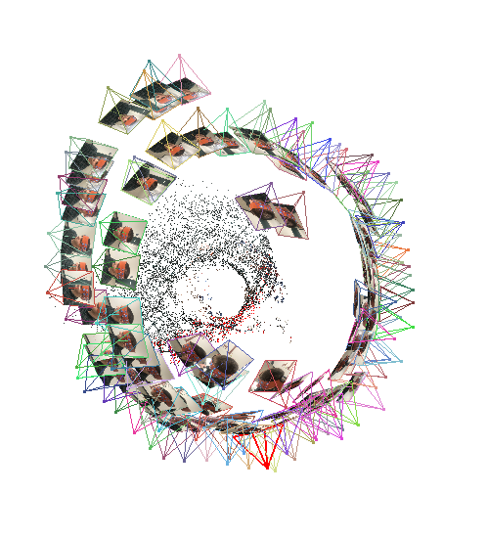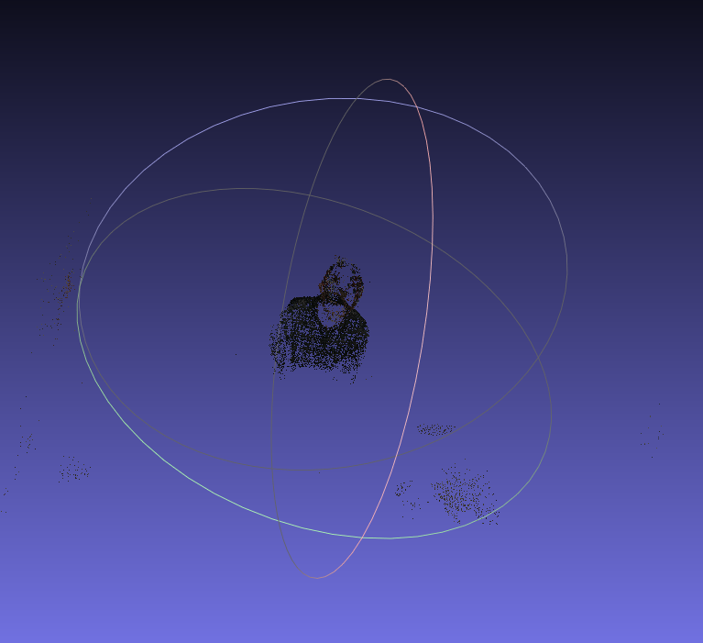Poisson Reconstruction

Picture 2 Result of dense reconstruction

Picture 3 Result of opening project files in MeshLab

* Open MeshLab (another software)
* Click on ‘Open Project Files’
* Navigate to folder where .nvm files generated from VisualSFM was saved
* Files should include a .nvm file. Open this file. There will be one layer on the right of the screen.
* Click on ‘select vertexes’ and highlight on noisy points that are far away from head.
* Be careful on this step!! Do not remove points that are near the head.
* Import the mesh: Click on File > Import Mesh
* Will open a folder that has .ply files. Select .ply file. (generated automatically by software and there may be more than one .ply file, if there is more than one model in reconstructing sparse). There will be two layers (one is model and the other one is a dense model) showed on the right of the screen.
* Rotate head around and remove additional “noisy” points that are far from head. Before the action of removing points, make sure you have chosen the right layer which you want to move the points from and then select the noisy points and cut them. **Attention**: you should move the points making up the body as many as possible but be careful and do not remove points that make up the head.
* Click on Filters > Remeshing Simplification and Reconstruction > Screened Poisson Surface Reconstruction
* Window should pop up: set Reconstruction Depth parameter to 12. (Make sure that you have chosen the dense layer.) Click Apply.
* Takes several minutes to apply. Result will look something like Picture 4. And there will be three layers on the right of the screen.

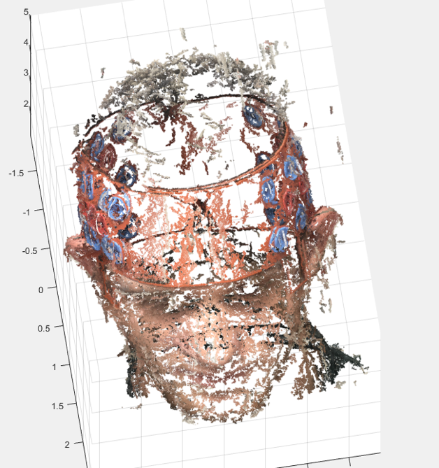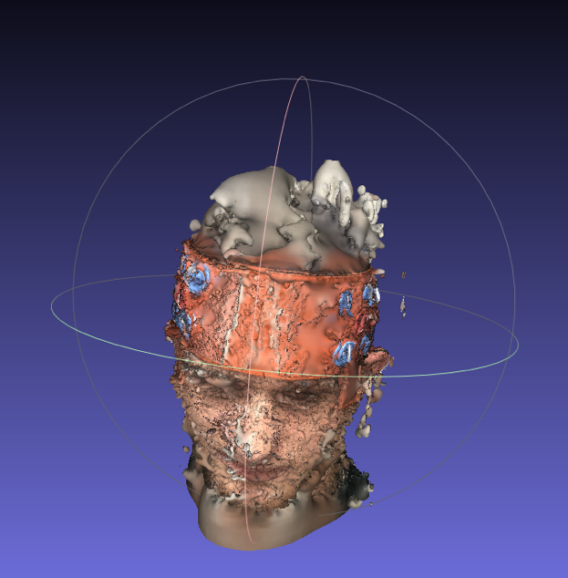

Picture 5 Result of showing it in Matlab

Picture 4 Result of Screened Poisson Surface Reconstruction

* Click ‘Export Mesh’. (Make sure that you have chosen the Poisson layer.) At the bottom left, click on ‘ALL’. Click OK. Will ask you to name the file. Saves as a .ply file.

Pinpointing

* Open Matlab.
* Transfer the .ply file from VisualSFM to Matlab folder.
* Open Photo_load.m file and run code up until for loop. Will ask to select file. Select .ply file.
* %%command of transferring and opening step are as following

pcread(‘filename.ply’)

pcshow(ans)

* Will load the reconstructed head file, Picture 5.
* VERY IMPORTANT STEP: estimate the 5 references points on the virtual head and click on ‘Data Cursor’ tool to pinpoint xyz coordinates. Try to be as accurate as possible. 5 reference points should be labeled on virtual head in this order: Nz, Cz, In, LA, RA.
* ATTENTION: Sometimes you may choose the point on the opposite side because there are poles on the surface of the head. You can click on Insert> X Label/ Y Label/ Z Label to make the Coordinate axis clear so that you can make sure that you have chosen the right position with the help of xyz coordinates.
* 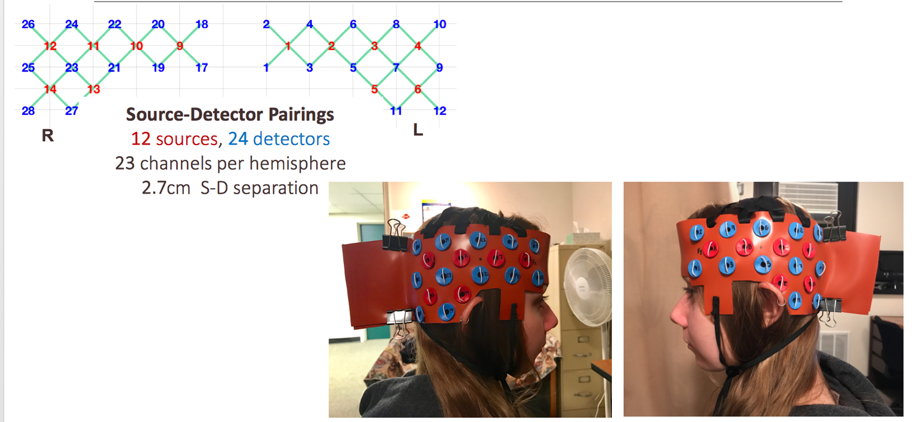Do the same thing with sources and detectors on the left side of head in this order: S1-S6, D1-D12. See probe setup and layout in Picture 5 below.
* Carefully check to see that xyz points are correctly located on each source and detector.
* After locating all reference points and sources and detectors, right click on coordinate label of whichever point and click on ‘Export Cursor Data to Workspace’
* Name the file: digptsID# (e.g. digpts44)
* In Matlab, in Photo_load mat file, run for loop to extract xyz points
* %%command of loading and running step are as following
* for i=1:length(digptsID#)
* position(i,:)= digptsID#(i).Position;
* end
* Create .txt file using same name as above. Copy and paste all xyz dig pts on to .txt file. SHOULD BE 23 points in the order of labeling (Nz, Cz, In, LA, PA, S1-S6, D1-D12)
* Transfer .txt file into folder where AtlasViewer GUI is and run Frank’s scripts.

Sanity check

* Under path ’C:\Users\jodiexyx\Documents\MATLAB\Matlab_files’
* Open ‘CI_data_estimation.m’
* Select %%reorganizing text files, right click > evaluate session
* Then select %%Atlas Viewer GUI process, select ‘formated.txt ’ file, right click > evaluate session
* Run ‘Sanitycheck.m’