1. Copy file from original folder > anatomy > t1spgr_208sl > t1spgr_208sl.nii and rename it by adding ‘Sub000XX_‘ in the front. For example, the ‘t1spgr_208sl.nii’ file of subject1 should be ‘Sub00001_t1spgr_208sl.nii’.
2. Open SPM12
   1. Find the folder ‘spm12’ in ‘Current Folder’ column and right click the folder> Add to path> Select Folders and Subfolders.
   2. Now change the Current Folder to the location where MRI files you want to Normalize are.
   3. Run spm (must be lower-case letters) in Command Window. SPM12 will pop up.
   4. Click ‘fMRI’. A window called ‘SPM12: Menu’ will pop up. 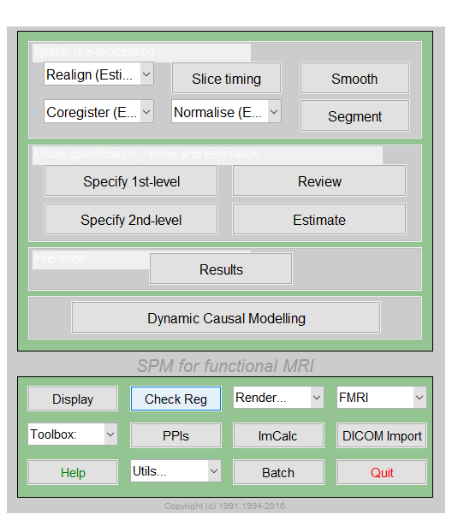
3. ACPC aligned
   1. Click ‘**Display**’ option at the bottom in the left. ‘Select image’ pops up. 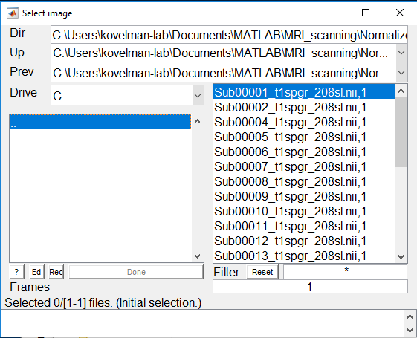
   2. Click the file you want to set origin in the right column, and it will appear in the ‘Selected files’ column. Click ‘Done’. Graphics window appears with the selected scan. 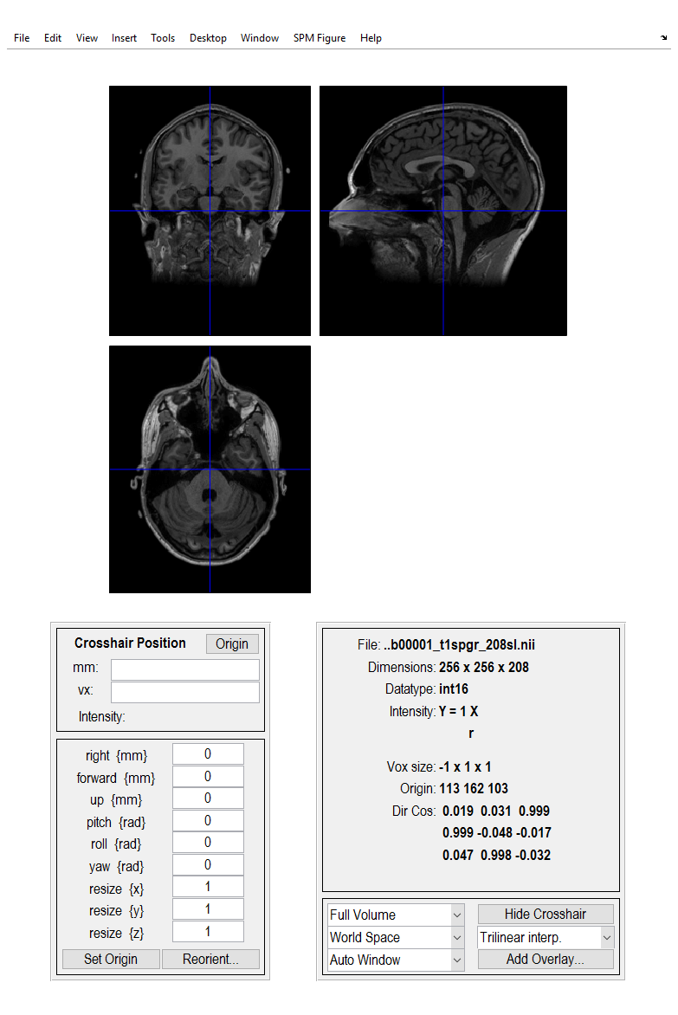
   3. Please check the orientation of the selected image. If the images are in the correct orientation, then
      1. Top-left image should be coronal with the top (superior) of the head displayed at the top and left side of the head shown on the left. This is as if the subject is viewed from behind)
      2. Bottom-Left image should be Axial with the front (anterior) of the head at the top and the left of the head shown on the left. This is as if the subject is viewed from above)
      3. Top-right image should be sagittal with the front (anterior) of the head at the left and the top of the head shown at the top. This is as if the subject is viewed from the left
   4. If the general orientation of the selected image is correct (as described above), proceed with the following steps
      1. roll {rad}--> Adjust roll value so that the vertical line of the crosshair passes roughly through the midline of the brain in the coronal view. Roll adjustment rotates the image about the y-axis (sagittal axis).
      2. [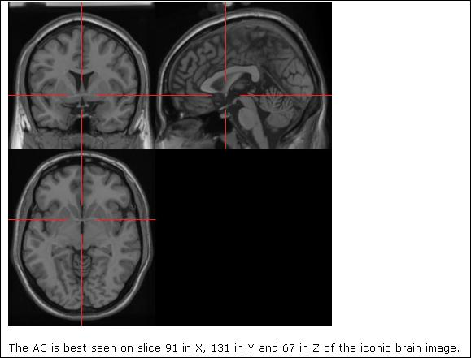](http://photo.blog.sina.com.cn/showpic.html#blogid=4d25466d0101ljtw&url=http://s10.sinaimg.cn/orignal/4d25466d4dfa9bbd96a39)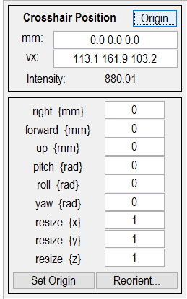yaw {rad}-- > Adjust yaw value so that the vertical line of the crosshair passes roughly through the midline of the brain in the axial view. Yaw adjustment rotates the image about the z-axis (vertical axis).
   5. Once you are happy with the roll and yaw adjustment, find the best mid sagittal slice in the sagittal view and move crosshair in that slice from anterior to posterior and look for Anterior commissure (AC) in the coronal view. In the coronal view, AC should be the clearest, longest and thickest bundle of nerve fibers (without break) and normally has a 'mustache' shape (as shown in figure1).
   6. 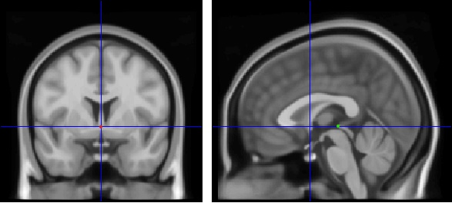Once AC is identified in the coronal view, place the crosshair at the superior edge along the midline of the AC. (If AC is properly marked, in the sagittal view, the crosshair would be around a small spot of white matter at the bottom level of corpus callosum, below fornix, as the red dot in Figure2).

Figure 2 coronal and sagittal view after adjusting pitch value,

the red dot is the AC point and the green dot is the PC point.

Figure 1 the 'mustache 'shape is yellow

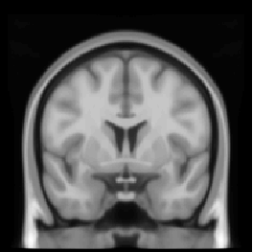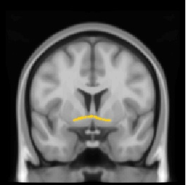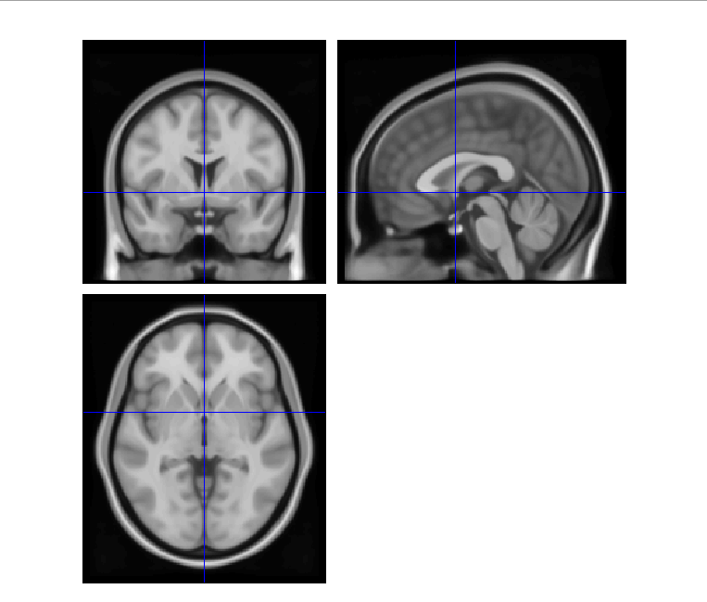

* 1. pitch {rad} --> Adjust pitch value so that the horizontal line that passes through AC also passes through Posterior Commissure (PC, the green dot in Figure2). Pitch adjustment rotates the image about the x-axis (PC will be at the top of the cerebral aqueduct in the sagittal view).
  2. Once we are happy with the pitch adjustment and if the crosshair is still on AC then set the origin (mm coordinate 0,0,0) of the image by clicking ‘Set Origin’ at the left bottom. **NOTICE**: make sure now the crosshair is on AC.
  3. [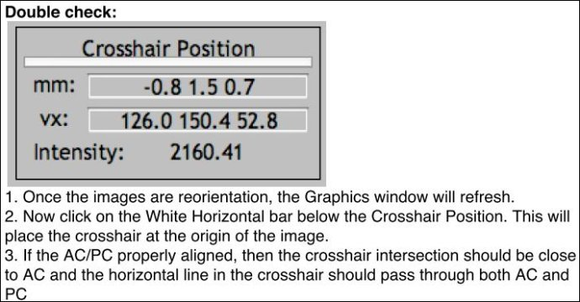](http://photo.blog.sina.com.cn/showpic.html#blogid=4d25466d0101ljtw&url=http://s10.sinaimg.cn/orignal/4d25466d4dfa93ff46e09)Now click Reorient images button and ‘File Selector Prompt’ window appears. Make sure the same image for which the reorientation parameters where adjusted is in the ‘Selected files’ column and click ‘Done’. Then click ‘No’ when it asks you to save matrix.

1. Normalization
   1. Click Normalise> Estimate& Write. Window ‘Batch Editor’ will pop up.
   2. Click ‘Data <-X’ in the ‘Current Module: Normalise: Estimate& Write’ column. Then click ‘New: Subject’ in the ‘Current Item: Data’ column, and there will be Subject (1). If you want to do normalization of MRI from many participants at one time, you can click ‘New: Subject’ to produce ‘Subject (2)’, ’Subject (3)’ and more.
   3. Now click ‘Image to Align’ of one subject in the Current Module column. Click ‘specify…’ at the bottom and ‘Image to Align’ window will pop up. Click the image file in the right column you want to normalize and click ‘done’ in the left. Now you have chosen the image to align in normalization.
   4. The same way to choose the image file to write. Click ‘Image to Write’ of one subject in the Current Module column. Click ‘specify…’ at the bottom and ‘Image to Write’ window will pop up. Click the image file in the right column you want to normalize and click ‘done’ in the left. Now you have chosen the image to write in normalization.
   5. NOTICE: make sure the file you chose to align and to write for one subject are the same!
   6. Find ‘Bounding box’ in ‘Current Module: Normalise: Estimate& Write’ column and click it. Click ‘Specify…’, and window ‘Bounding box’ will pop up. Change the number into ‘-120 -120 -120’ for the first line and ‘120 120 120’ for the second line. Click ‘OK’ to save.
   7. Click ‘Run Batch’ button (a small green triangle) at the top and wait. The Command Window in MATLAB will show the state.
2. Digitization in mricron
   1. 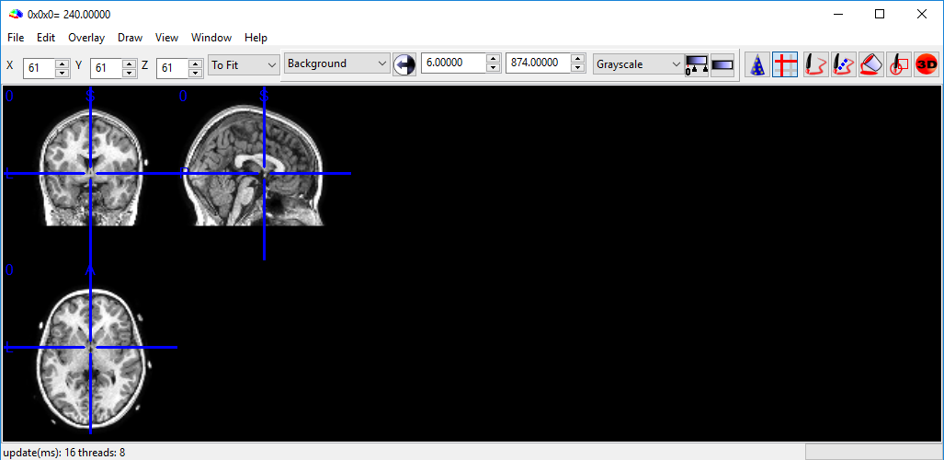Open mricron. When there’s a security warning window, you can choose ‘run’.
   2. Drag the normalized image file from folder to mricron window.
   3. 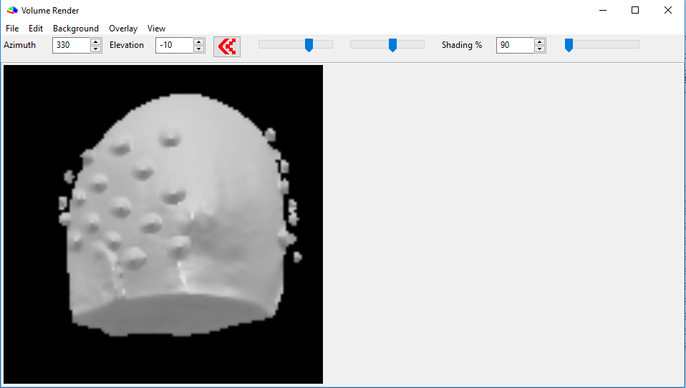Click Window > Render and ‘Volume Render’ window appears.
   4. You can change the parameter of Azimuth to rotate the head about the vertical axis and change parameter of Elevation to rotate the head about the sagittal axis.
   5. Move the crosshair to the point you want and the coordinate will be shown in the mricron window.
   6. Record the coordinate (X Y Z) in the Excel file and save. Meanwhile please write down the bounding box you choose to normalize the image for the current MRI file.