1. java基于场景化的示例

github: [demo](https://github.com/bumoproject/bumo-sdk-java/tree/master/examples/src/main/java/io/bumo/sdk/example)

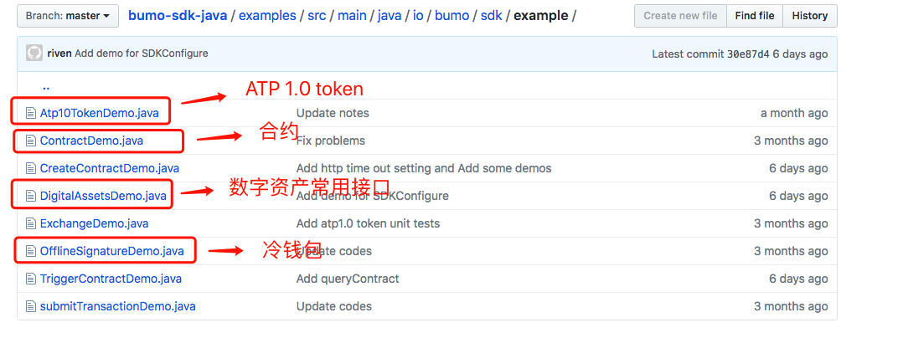

1. KeyPair (公钥私钥地址)

github: [keypair原理和示例](https://github.com/bumoproject/bumo/blob/master/docs/keypair_CN.md)

[C++源码](https://github.com/bumoproject/bumo/tree/master/src/common)

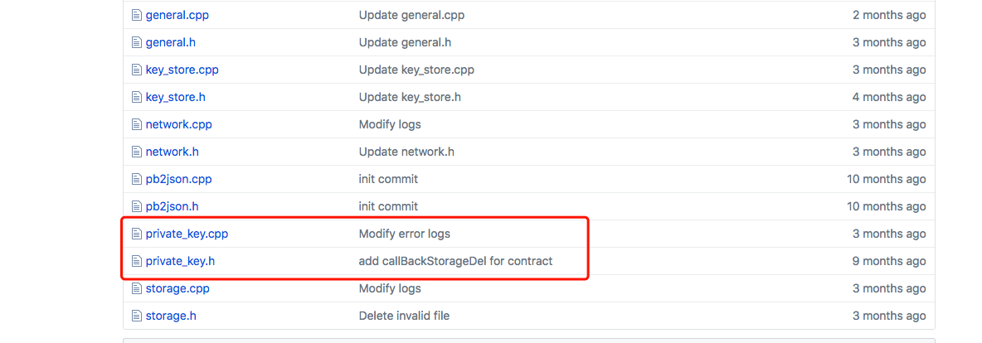

注意: private_key有一些算法依赖

1. atp 1.0 协议

github: [apt 1.0](https://github.com/bumoproject/bumo/blob/develop/docs/atp.md)

1. ctp 1.0 协议

github: [ctp 1.0](https://github.com/bumoproject/bumo/blob/master/docs/ctp.md)

ATP和CTP协议描述: [官网](https://bumo.io/technology)

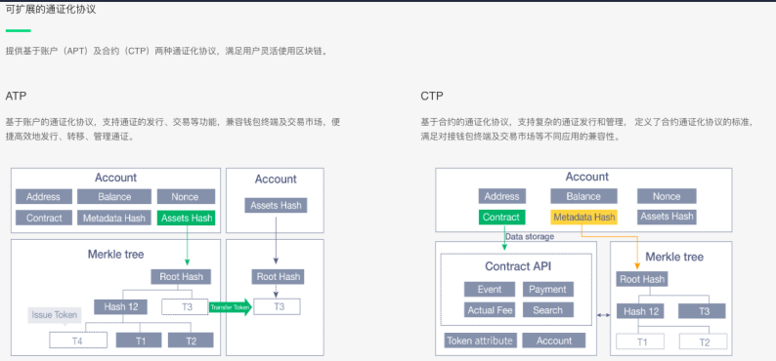

1. 节点部署

github: [节点部署](https://github.com/bumoproject/bumo/blob/master/docs/manual_CN.md)

1. rest接口文档

github: [rest接口文档](https://github.com/bumoproject/bumo/blob/master/docs/develop_CN.md)

1. nodejs的SDK

github: [nodejs](https://github.com/bumoproject/bumo-sdk-nodejs)

1. go的SDK

github: [go](https://github.com/bumoproject/bumo-sdk-go)