Step1：

a. It is kind of minimal, so we do need rolling maximum 8 dice and etc.it can be more minimal like end the program with 42 game or just end the game.  
b. Is this MVP really viable?

I don’t think it is really viable, according to the rule book, the game have 4 process in one rounds and 8 kind of fortune card need use:

1. Preparation(set up) Stage
2. Playing stage (rolling and rerolling)
3. Scoring stage
4. Final turn stage

It is not that viable  
c. Can some features be simplified?

End the game feature can be simplified and break,like scoring and end the game combine together, keeping dice as default in rolling the dice

Step2

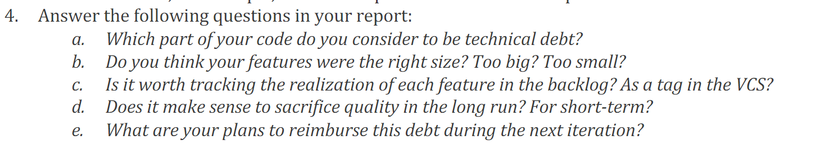

1. In this step I don’t think in have technical debt
2. Too big in main stage, since I put end game decision in main, it should be simplify
3. It is worth tracking the realization of each feature in back log as a tag in VCS, since by tracing as a tag, we can easy to know what job we need do in future now, and it is make revisit progress more easier if there are some mistake in the future.
4. In the short run it is make sense to sacrifice quality for more easier life, but in the long run not, sacrifice quality will cause lots trouble in long run.
5. There no technical debt in step2

Step3：

电脑屏幕的照片

1. pros is it is the quick way that make a simple delivery, and other people can check and make change to getting better product. And it saves lots of time from study in debt. Cons is there might have big change of code in future and the you might forget some ideal when delivering the MVP first. Miss the chance to do big Architecture.
2. It hard to measure what is less and what is more, some times a small technical debt might cause you whole day
3. Pros is it can save the memorize when you don’t need those trace, and you can choose the level you want see. Cons: no significant cons I think, it is simple and high efficient. For me I just create a class My logger to handle all the log.
4. Trace as normal development process, since it is kind of the tool we use to achieve the object, like arrays ,scanner those kind of class we use.

Step4：

1. Yes, it is challenging since I usually consider what in the future, I don’t want make trouble to following step
2. I think I don’t have technical debts in this project yet
3. So for scoring in use Polymorphic integration to different card subclasses, so different card have different scoring way, but we just calling card. Scoring to implement it. For strategy I design as attributes mode for aiplayer. It have public method that can change in outside. Those are base on object orientation.

Step5：

1. From this step I make some big change, before this, I check all the status in Player class, after this I done many things in the class Card and it’s child class, using more polymorphic to make the decision.
2. For easier to make more card, so base on what I do In a, it will be easier to make more card, like card in next step.
3. No, I trying to writing code with simple and effect way, so there is no debt in most of time.
4. So basically the strategy is the mode attributes of my AI player, the AI player create with the basic mode(strategy) provide when created, The program reserves the interface for automatic or manual policy changes.

文本

Step6：

1. More card will be new child class of abstract class Card, Implement different patterns by overriding the determination and calculation methods inside the card class. There might have technical difficulty by interface by different player, but it might be solve easy by create static list to store all the valid player object when it be create.
2. It is not big trouble, just make a new card, and limit and record the instance of player in one game. And decrease the mark for those player together.
3. no