Mo Nguyen, Jian Yu, Quan Bai, Sira Yongchareon, Yanbo Han:

Attentional Matrix Factorization with Document-context awareness and Implicit API Relationship for Service Recommendation. ACSW 2020: 17:1-17:10

<https://dl.acm.org/doi/10.1145/3373017.3373034>

注意力PMF; 根据内容相似度和调用历史，计算API之间的关系，作为概率图预测的正则项

 This paper improves the PMF model by distinguishing the importance of latent feature interactions. We present an Attentional PMF model, which leverages a neural attention network to learn the significance of feature interactions and uses Doc2Vec technique for mining the contextual information. We also exploit the relationship between APIs from both their contextual similarities and invocation history and add them to the prediction model as a regularization part.

基准算法：

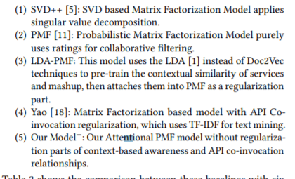

Chao Lei, Hongjun Dai, Zhilou Yu, Rui Li:

A service recommendation algorithm with the transfer learning based matrix factorization to improve cloud security. Inf. Sci. 513: 98-111 (2020)

<https://www.sciencedirect.com/science/article/pii/S0020025519309582?via%3Dihub>

将位置信息融合到LDA中；基于迁移学习和word2vec解决LDA的忽略词序和主题重叠的问题；LDA和word2vec结合，生成MF的初始化矩阵，以解决数据稀疏问题。

To alleviate data scarcity problem in cloud security environment, this work is to introduce similar domain knowledge based on the transfer learning. Besides, the content and location based methods have been proved that these ideas work under this situation. So, this work also employs latent dirichlet allocation (LDA) to analysis the service descriptions and explore the relationship between the content and location information. In this framework, the suitable combination of LDA and word2vec models will balance the accuracy and speed which benefit service recommendation particularly.

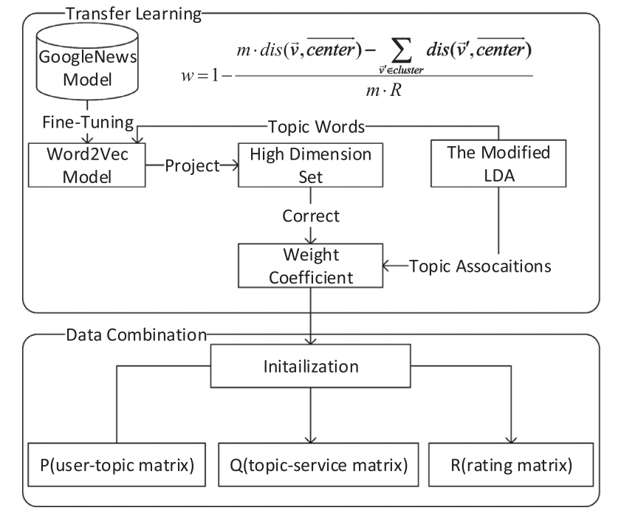

~~Giovanni Luca Cascio Rizzo, Marco De Marco, Pasquale De Rosa, Luigi Laura:~~

~~Collaborative Recommendations with Deep Feed-Forward Networks: An Approach to Service Personalization. IESS 2020: 65-78~~

~~大水文：简单对比了KNN,SVD和最简单的DNN的区别~~

~~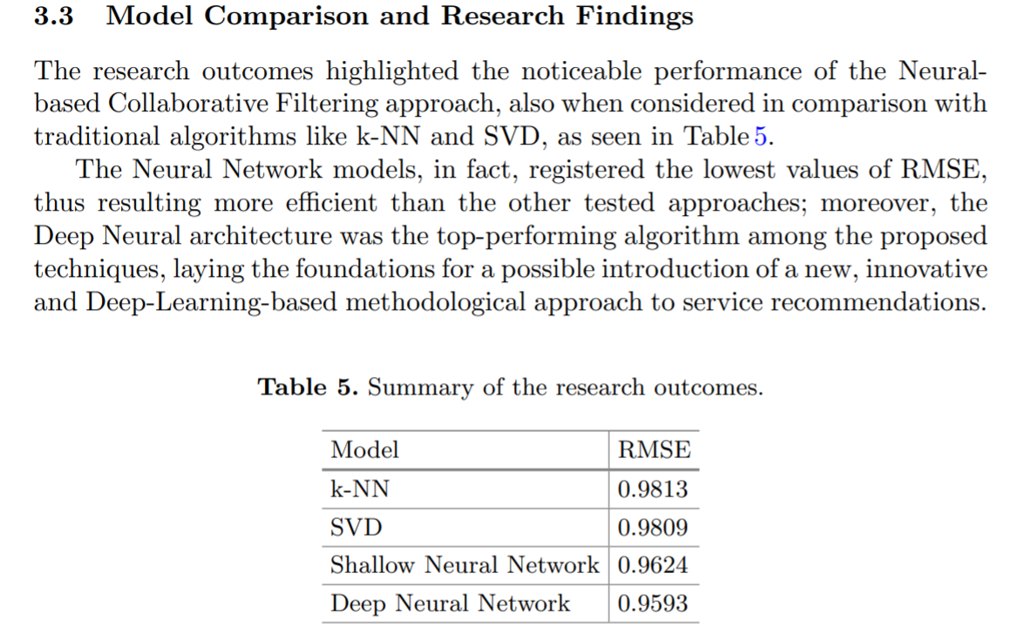~~

Buqing Cao, Xiaoqing Frank Liu, Md Mahfuzer Rahman, Bing Li, Jianxun Liu, Mingdong Tang:

Integrated Content and Network-Based **Service Clustering** and Web APIs Recommendation for Mashup Development. IEEE Trans. Serv. Comput. 13(1): 99-113 (2020)

1. 使用mashup之间的关联（公用相同服务，标签）来优化主题模型，进而优化mashup的聚类；
2. 使用API之间的公用关系，推荐流行度较低的服务. Actually, the implicit co-invocation records between Web APIs in common historical Mashups can be used to predict usage probability of unpopular Web APIs in Mashups. The prediction results can be used to diversify the Web APIs recommendation.

This method, first develop a two-level topic model by using the relationship among Mashup services to mine the latent useful and novel topics for better service clustering accuracy. Moreover, based on the clustering results of Mashups, it designs a collaborative filtering (CF) based Web APIs recommendation algorithm. This algorithm, exploits the implicit co-invocation relationship between Web APIs inferred from the historical invocation history between Mashups clusters and the corresponding Web APIs, to recommend diverse Web APIs for each Mashups clusters. The method is expected to not only find much better matched Mashups with high accuracy, but also diversify the recommendation result of Web APIs with full coverage.

关键词搜索：

interactive service recommendation？

<https://dblp.uni-trier.de/search?q=interactive%20service%20recommendation>

[Meriem Kasmi](https://dblp.uni-trier.de/pers/hd/k/Kasmi:Meriem)https://dblp.uni-trier.de/img/orcid-mark.12x12.png, [Yassine Jamoussi](https://dblp.uni-trier.de/pers/hd/j/Jamoussi:Yassine), [Henda Hajjami Ben Ghezala](https://dblp.uni-trier.de/pers/hd/g/Ghezala:Henda_Hajjami_Ben)https://dblp.uni-trier.de/img/orcid-mark.12x12.png:  
**Recommendation in Interactive Web Services Composition: A State-of-the-Art Survey.** [EC-Web 2016](https://dblp.uni-trier.de/db/conf/ecweb/ecweb2016.html#KasmiJG16): 170-182

[*~~Bo Wang~~*](https://dblp.uni-trier.de/pers/hd/w/Wang:Bo)*~~,~~*[*~~Jinqiao Wang~~*](https://dblp.uni-trier.de/pers/hd/w/Wang:Jinqiao)*~~,~~*[*~~Ling-Yu Duan~~*](https://dblp.uni-trier.de/pers/hd/d/Duan:Ling=Yu)*~~,~~*[*~~Qi Tian~~*](https://dblp.uni-trier.de/pers/hd/t/Tian_0001:Qi)*~~,~~*[*~~Hanqing Lu~~*](https://dblp.uni-trier.de/pers/hd/l/Lu:Hanqing)*~~:~~****~~Interactive service recommendation based on ad concept hierarchy.~~***[*~~ICIMCS 2010~~*](https://dblp.uni-trier.de/db/conf/icimcs/icimcs2010.html#WangWDTL10)*~~: 87-90~~*

~~商品推荐，借助video帧和tag；交互体现在系统给出建议的关键字，用户可以选择之后再精准推荐.~~

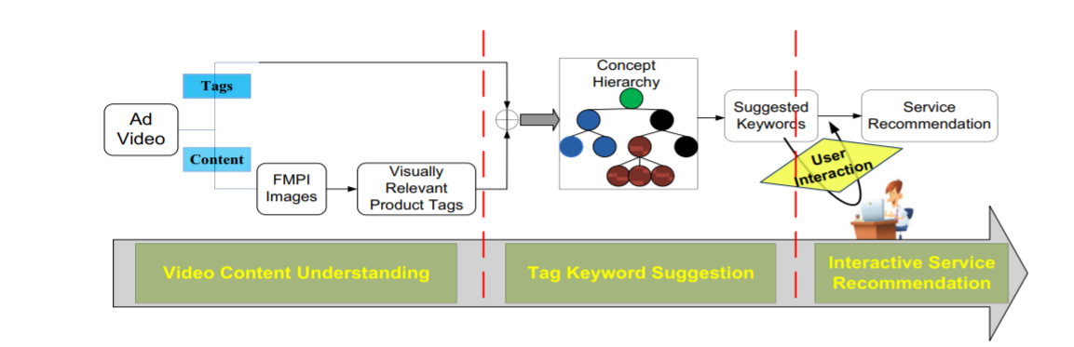

we aim to produce interactive service recommendation based on ad concept hierarchy by linking web videos, especially ad videos, with informative product details over the commercial websites. By introducing the domain based concept hierarchy, the recommendation quality is greatly improved. Given an ad video, we will try to semantically analyze it and conduct a contextual search from two aspects: video content and tags. For video content, we firstly extract its key frames and then make a visual search to find some relevant products. For video tags (if any) and relevant product tags gained by visual search, we will launch a textual search based on our ad concept hierarchy to judge the product category, generate some suggestion keywords, and give some recommended products to users. Users can also interactively select and adjust product categories and keywords to personalize their intentions by textual re-search.

[~~Jason J. Jung~~](https://dblp.uni-trier.de/pers/hd/j/Jung:Jason_J=)~~https://dblp.uni-trier.de/img/orcid-mark.12x12.png:~~**~~Contextualized mobile recommendation service based on interactive social network discovered from mobile users.~~**[~~Expert Syst. Appl. 36(9)~~](https://dblp.uni-trier.de/db/journals/eswa/eswa36.html#Jung09b)~~: 11950-11956 (2009)~~

移动推荐本身是一种服务，而不是服务推荐；交互式的搭建**social network，而不是交互式地推荐**

interactive mashup development

<https://dblp.uni-trier.de/search?q=interactive%20mashup%20development>

* [*~~Anis Nouri~~*](https://dblp.uni-trier.de/pers/hd/n/Nouri:Anis)*~~,~~*[*~~Florian Daniel~~*](https://dblp.uni-trier.de/pers/hd/d/Daniel:Florian)*~~https://dblp.uni-trier.de/img/orcid-mark.12x12.png:~~****~~Interactive, Live Mashup Development Through UI-Oriented Computing.~~***[*~~RMC@ICWE 2015~~*](https://dblp.uni-trier.de/db/conf/icwe/rmc2015.html#NouriD15)*~~: 31-49~~*

~~these resources can be wrapped with ad-doc UIs, suitably instrumented, and made accessible through the Surface Web. Doing so enables a UI-oriented computing paradigm that allows developers to implement mashups interactively and in a live fashion inside their Web browser, without having to program any line of code. The goal of this paper is to showcase UI-oriented computing in practice and to demonstrate its feasibility and potential.~~

面向UI的计算？有点像工业设计

[Xinyi Liu](https://dblp.uni-trier.de/pers/hd/l/Liu:Xinyi), [Hailong Sun](https://dblp.uni-trier.de/pers/hd/s/Sun_0001:Hailong), [Hanxiong Wu](https://dblp.uni-trier.de/pers/hd/w/Wu:Hanxiong), [Richong Zhang](https://dblp.uni-trier.de/pers/hd/z/Zhang:Richong), [Xudong Liu](https://dblp.uni-trier.de/pers/hd/l/Liu:Xudong):  
**Using Sequential Pattern Mining and Interactive Recommendation to Assist Pipe-like Mashup Development.** [SOSE 2014](https://dblp.uni-trier.de/db/conf/sose/sose2014.html#LiuSWZL14): 173-180

In this work, we aim at leveraging the expertise that can be mined from voluminous mashups on Internet to recommend appropriate mashup modules and their composition patterns to facilitate pipe-like mashup development. First, we crawl all the mashups available in Yahoo!Pipes and extract the meta-data of each mashup from original JSON data. Second, we use GSP (Generalized Sequential Pattern) algorithm to mine the frequent composition pattern of mashup modules, and design an interactive recommendation algorithm to assist mashup development. Third, we implement a system prototype based on the proposed method and evaluate its effectiveness with 848 Yahoo! mashups through cross-validation.

online service recommendation

<https://dblp.uni-trier.de/search?q=online%20service%20recommendation>

online mashup development 没有

conversational service recommendation/mashup development没有

session—based 没有