**前言**

现在市面上大部分的Web教程都是SpringBoot和Vue或者React的前后端分离的教程，但是很多的朋友都会遇到这样一种情况，就是去公司以后，还是会遇到这种混合模板开发的项目，甚至还要维护一些Jsp的老项目，这种情况就很头痛，很多人就会吐槽啊 2021年啦，还在用混合开发，其实技术是为业务服务的，有些项目有些情况就适合用混合开发，没得说的。

所以我最近的实战项目的Pc端使用Thymeleaf来构建，也算是用苦良心吧，但是直接实战，很多小伙伴没用过模板引擎，今天算是一个加餐篇，给大家带来一个Thymeleaf的快速入门教程 打个良心到公屏上！

**为什么是Thymeleaf**

目前Java比较流行的模板引擎有Thymeleaf和Freemarker，Thymeleaf的话更适合当前的人员分工问题，回忆一下以前的Jsp页面，必须要动态渲染才能看到真实的效果，写页面的和写后端的分工不太明确

Thymeleaf是动静分离的，页面中的动态标签是需要传递有数据的时候才会渲染，不然就是原本默认的静态的样子

举一个例子th:text="${title}"是一个动态标签，当传递了title这个数据，页面就会渲染这个标签，如果没有传递这个参数，就会显示原本的网页结构<title>默认的标题</title>,所以开发静态页面的时候的是前端工程师完全可以独立进行的

|  |
| --- |
|  |
| <html lang="ch" xmlns:th="http://www.thymeleaf.org"> | |
|  | |

|  |
| --- |
| <head> |
|  |

|  |
| --- |
| <title th:text="${title}">默认的标题</title> |
|  |

|  |
| --- |
| </head> |
|  |

|  |
| --- |
| </html> |

thymeleaf的语法和vue是有点类似的，很容易上手，下面就跟着我快速入门吧！

**创建项目**

直接创建一个springboot的模板项目就行了

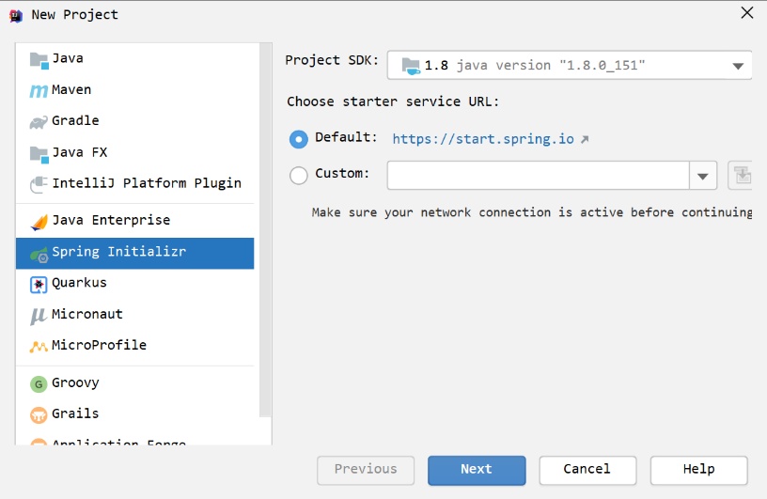

需要引入的依赖文件

|  |
| --- |
|  |
| <dependency> | |
|  | |

|  |
| --- |
| <groupId>org.springframework.boot</groupId> |
|  |

|  |
| --- |
| <artifactId>spring-boot-starter-thymeleaf</artifactId> |
|  |

|  |
| --- |
| </dependency> |
|  |

|  |
| --- |
| <dependency> |
|  |

|  |
| --- |
| <groupId>org.springframework.boot</groupId> |
|  |

|  |
| --- |
| <artifactId>spring-boot-starter-web</artifactId> |
|  |

|  |
| --- |
| </dependency> |
|  |

|  |
| --- |
| <dependency> |
|  |

|  |
| --- |
| <groupId>org.projectlombok</groupId> |
|  |

|  |
| --- |
| <artifactId>lombok</artifactId> |
|  |

|  |
| --- |
| <optional>true</optional> |
|  |

|  |
| --- |
| </dependency> |

**开启自动编译**

首先开发模式禁用页面缓存application.yml

|  |
| --- |
|  |
| server: | |
|  | |

|  |
| --- |
| port: 8001 |
|  |

|  |
| --- |
| spring: |
|  |

|  |
| --- |
| thymeleaf: |
|  |

|  |
| --- |
| cache: false |

然后修改一下运行配置

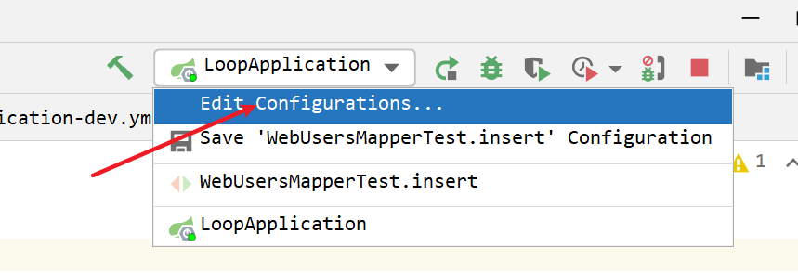

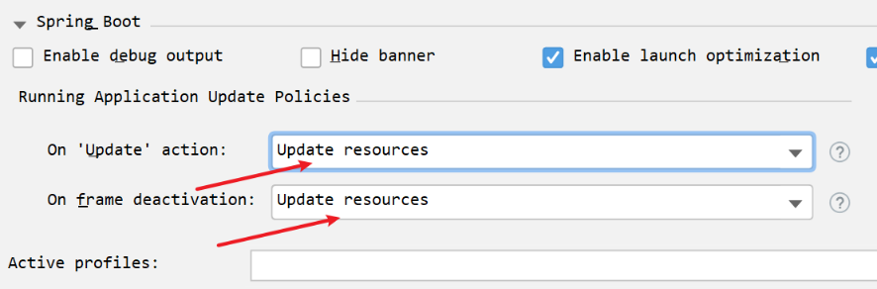

此时我们修改了页面文件后，直接刷新就能看到效果了

**创建IDEA的模板**

我们可以给IDEA创建一个页面模板，这样每次创建页面文件就带上基本的结构了

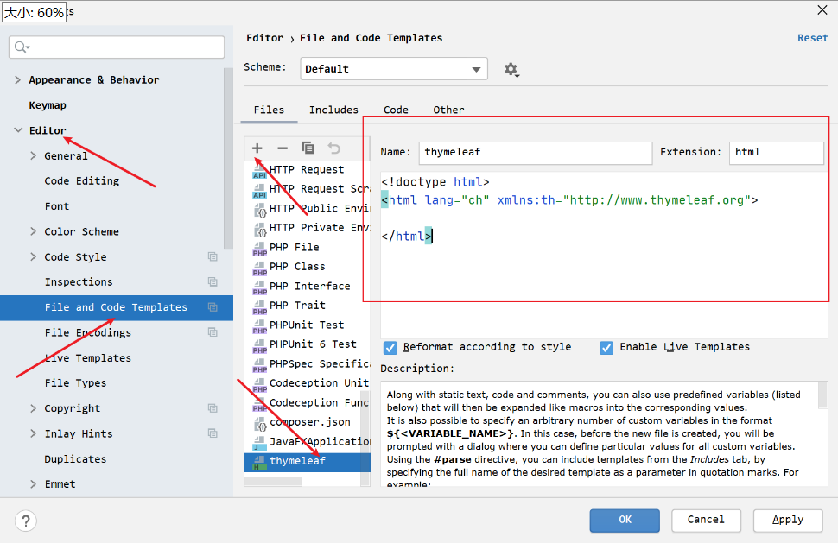

模板内容

|  |
| --- |
|  |
| <!doctype html> | |
|  | |

|  |
| --- |
| <html lang="ch" xmlns:th="http://www.thymeleaf.org"> |
|  |

|  |
| --- |
|  |
|  |

|  |
| --- |
| </html> |

这样我们在文件夹鼠标右键就多了一个选择

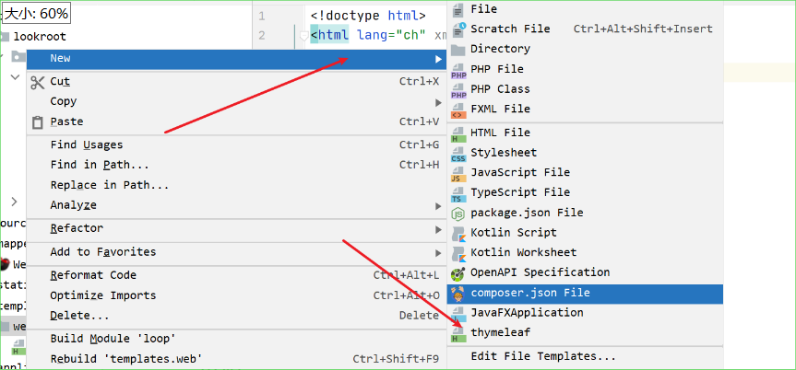

**Thymeleaf常用语法**

**语法标记**

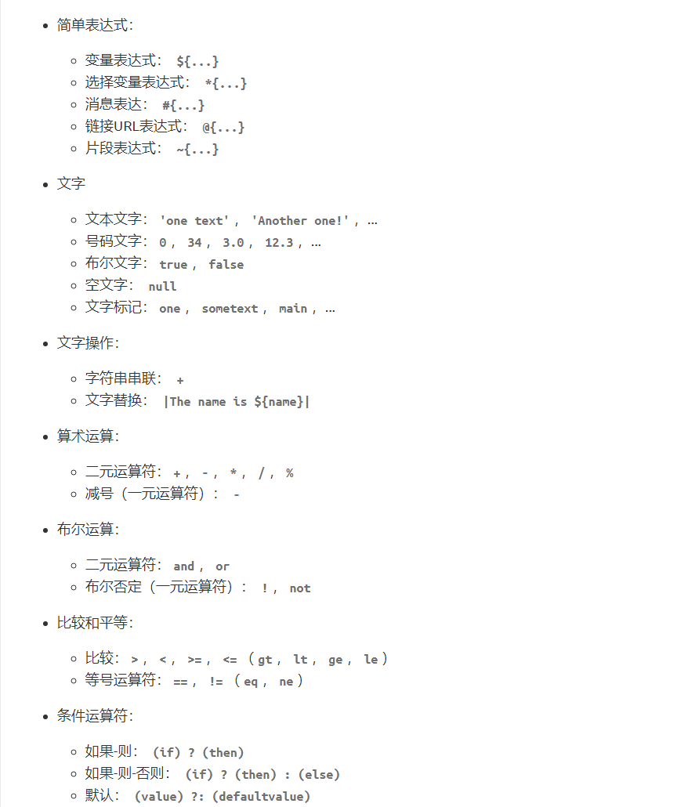

**th:text，th:content**

th:text可以动态替换标签原本的内容

在templates创建页面index.html,${}里面可以写

|  |
| --- |
|  |
| <!doctype html> | |
|  | |

|  |
| --- |
| <html lang="ch" xmlns:th="http://www.thymeleaf.org"> |
|  |

|  |
| --- |
| <head> |
|  |

|  |
| --- |
| <meta charset="UTF-8"> |
|  |

|  |
| --- |
| <title th:text="${title}">默认的标题</title> |
|  |

|  |
| --- |
| </head> |
|  |

|  |
| --- |
| </html> |

写一个测试控制器IndexController

|  |
| --- |
|  |
| @Controller | |
|  | |

|  |
| --- |
| public class IndexController { |
|  |

|  |
| --- |
| @GetMapping("/index") |
|  |

|  |
| --- |
| public String index(Model model) { |
|  |

|  |
| --- |
| model.addAttribute("title", "传递的标题"); |
|  |

|  |
| --- |
| return "index"; |
|  |

|  |
| --- |
| } |
|  |

|  |
| --- |
| } |

此时如果我们直接打开index.html这个文件而不是通过SpringBoot的控制器去打开它

看下源代码，可以发现动态标签是没有渲染出来的，这就是动静分离

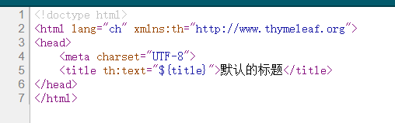

然后我们通过控制器打开http://localhost:8001/index,看看源码

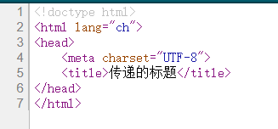

同理我们使用th:content标签来渲染页面描述和页面关键字，这是在昨天的实战里面讲到过的

|  |
| --- |
|  |
| <head> | |
|  | |

|  |
| --- |
| <meta charset="UTF-8"> |
|  |

|  |
| --- |
| <title th:text="${title}">默认的标题</title> |
|  |

|  |
| --- |
| <meta name="description" th:content="${description}"> |
|  |

|  |
| --- |
| <meta name="keywords" th:content="${keywords}"> |
|  |

|  |  |
| --- | --- |
| </head> | |
|  |

|  |
| --- |
| @GetMapping("/index") |
|  |

|  |
| --- |
| public String index(Model model) { |
|  |

|  |
| --- |
| model.addAttribute("title", "传递的标题"); |
|  |

|  |
| --- |
| model.addAttribute("description", "传递的描述"); |
|  |

|  |
| --- |
| model.addAttribute("keywords", "传递的关键字"); |
|  |

|  |
| --- |
| return "index"; |
|  |

|  |
| --- |
| } |

假如我们的 th:text 标签里面需要拼接字符串${title}可以使用||来包裹

<title th:text="|lookroot-${title}|">默认的标题</title>

**支持渲染的属性**

这类属性很多，每个属性都针对特定的HTML5属性：

| **th:abbr** | **th:accept** | **th:accept-charset** |
| --- | --- | --- |
| th:accesskey | th:action | th:align |
| th:alt | th:archive | th:audio |
| th:autocomplete | th:axis | th:background |
| th:bgcolor | th:border | th:cellpadding |
| th:cellspacing | th:challenge | th:charset |
| th:cite | th:class | th:classid |
| th:codebase | th:codetype | th:cols |
| th:colspan | th:compact | th:content |
| th:contenteditable | th:contextmenu | th:data |
| th:datetime | th:dir | th:draggable |
| th:dropzone | th:enctype | th:for |
| th:form | th:formaction | th:formenctype |
| th:formmethod | th:formtarget | th:fragment |
| th:frame | th:frameborder | th:headers |
| th:height | th:high | th:href |
| th:hreflang | th:hspace | th:http-equiv |
| th:icon | th:id | th:inline |
| th:keytype | th:kind | th:label |
| th:lang | th:list | th:longdesc |
| th:low | th:manifest | th:marginheight |
| th:marginwidth | th:max | th:maxlength |
| th:media | th:method | th:min |
| th:name | th:onabort | th:onafterprint |
| th:onbeforeprint | th:onbeforeunload | th:onblur |
| th:oncanplay | th:oncanplaythrough | th:onchange |
| th:onclick | th:oncontextmenu | th:ondblclick |
| th:ondrag | th:ondragend | th:ondragenter |
| th:ondragleave | th:ondragover | th:ondragstart |
| th:ondrop | th:ondurationchange | th:onemptied |
| th:onended | th:onerror | th:onfocus |
| th:onformchange | th:onforminput | th:onhashchange |
| th:oninput | th:oninvalid | th:onkeydown |
| th:onkeypress | th:onkeyup | th:onload |
| th:onloadeddata | th:onloadedmetadata | th:onloadstart |
| th:onmessage | th:onmousedown | th:onmousemove |
| th:onmouseout | th:onmouseover | th:onmouseup |
| th:onmousewheel | th:onoffline | th:ononline |
| th:onpause | th:onplay | th:onplaying |
| th:onpopstate | th:onprogress | th:onratechange |
| th:onreadystatechange | th:onredo | th:onreset |
| th:onresize | th:onscroll | th:onseeked |
| th:onseeking | th:onselect | th:onshow |
| th:onstalled | th:onstorage | th:onsubmit |
| th:onsuspend | th:ontimeupdate | th:onundo |
| th:onunload | th:onvolumechange | th:onwaiting |
| th:optimum | th:pattern | th:placeholder |
| th:poster | th:preload | th:radiogroup |
| th:rel | th:rev | th:rows |
| th:rowspan | th:rules | th:sandbox |
| th:scheme | th:scope | th:scrolling |
| th:size | th:sizes | th:span |
| th:spellcheck | th:src | th:srclang |
| th:standby | th:start | th:step |
| th:style | th:summary | th:tabindex |
| th:target | th:title | th:type |
| th:usemap | th:value | th:valuetype |
| th:vspace | th:width | th:wrap |
| th:xmlbase | th:xmllang | th:xmlspace |

| **th:async** | **th:autofocus** | **th:autoplay** |
| --- | --- | --- |
| th:checked | th:controls | th:declare |
| th:default | th:defer | th:disabled |
| th:formnovalidate | th:hidden | th:ismap |
| th:loop | th:multiple | th:novalidate |
| th:nowrap | th:open | th:pubdate |
| th:readonly | th:required | th:reversed |
| th:scoped | th:seamless | th:selected |

**渲染对象**

创建一个基本对象UserVO

|  |
| --- |
|  |
| @Data | |
|  | |

|  |
| --- |
| public class UserVO { |
|  |

|  |
| --- |
| private String username; |
|  |

|  |
| --- |
| private Integer age; |
|  |

|  |
| --- |
| private Integer sex; |
|  |

|  |
| --- |
| private Boolean isVip; |
|  |

|  |
| --- |
| private Date createTime; |
|  |

|  |
| --- |
| private List<String> tags; |
|  |

|  |
| --- |
| } |

新建一个方法basic，将user对象传输到页面中

|  |
| --- |
|  |
| @GetMapping("/basicTrain") | |
|  | |

|  |
| --- |
| public String basic(Model model) { |
|  |

|  |
| --- |
| UserVO userVO = new UserVO(); |
|  |

|  |
| --- |
| userVO.setAge(21); |
|  |

|  |
| --- |
| userVO.setSex(1); |
|  |

|  |
| --- |
| userVO.setCreateTime(new Date()); |
|  |

|  |
| --- |
| userVO.setTags(Arrays.asList("Java", "PHP", "Node")); |
|  |

|  |
| --- |
| userVO.setUsername("lookroot"); |
|  |

|  |
| --- |
| model.addAttribute("user", userVO); |
|  |

|  |
| --- |
| return "basic"; |
|  |

|  |
| --- |
| } |

新建basic.html，此时如果我们想渲染User这个对象的信息我们可以这样

|  |
| --- |
|  |
| <div> | |
|  | |

|  |
| --- |
| <h2 th:text="${user.getUsername()}"></h2> |
|  |

|  |
| --- |
| <p th:text="${user.getAge()}"></p> |
|  |

|  |
| --- |
| </div> |

也可以将User定义为临时变量，接着使用*{xxx}就能取到值了

|  |
| --- |
|  |
| <div th:object="${user}"> | |
|  | |

|  |
| --- |
| <h2 th:text="*{username}"></h2> |
|  |

|  |
| --- |
| <p th:text="*{age}"></p> |
|  |

|  |
| --- |
| </div> |

还可以不使用get的方式，直接使用属性名

<h2 th:text="${user.username}" ></h2>

**th:if**

th:if通过布尔值决定这个元素是否渲染

比如：

<p th:if="${user.isVip}">会员</p>

**th:each**

th:each可以迭代循环出数据，前面我们User对象里面的tags是一个数组，我们来渲染一下

|  |
| --- |
|  |
| <ul> | |
|  | |

|  |
| --- |
| <li th:each="tag:${user.getTags()}" |
|  |

|  |
| --- |
| th:text="${tag}"></li> |
|  |

|  |
| --- |
| </ul> |

状态变量在th:each属性中定义，并且包含以下数据：

* 当前的*迭代索引*，从0开始。这是index属性。
* 从1开始的当前*迭代索引*。这是count属性。
* 迭代变量中元素的总数。这是size财产。
* 每次迭代的*iter变量*。这是current财产。
* 当前迭代是偶数还是奇数。这些是even/odd布尔属性。
* 当前迭代是否是第一个。这是first布尔属性。
* 当前迭代是否为最后一次。这是last布尔属性。

**th:switch**

th:switch选择语句

|  |
| --- |
|  |
| <div th:switch="${user.getSex()}"> | |
|  | |

|  |
| --- |
| <p th:case="'1'">男</p> |
|  |

|  |
| --- |
| <p th:case="'2'">女</p> |
|  |

|  |
| --- |
| <p th:case="*">默认</p> |
|  |

|  |
| --- |
| </div> |

**url**

如果在springboot中需要引入static目录下的静态资源可以使用@{xxx}的方式

<link th:href="@{/app.css}" rel="stylesheet">

**JavaScript动态渲染**

|  |
| --- |
|  |
| <script th:inline="javascript"> | |
|  | |

|  |
| --- |
| const user = /*[[${user}]]*/ {}; |
|  |

|  |
| --- |
| console.log(user); |
|  |

|  |
| --- |
| </script> |

同理css也是可以的

|  |
| --- |
|  |
| <style th:inline="css"> | |
|  | |

|  |
| --- |
| .main\ elems { |
|  |

|  |
| --- |
| text-align: /*[[${align}]]*/ left; |
|  |

|  |
| --- |
| } |
|  |

|  |
| --- |
| </style> |

**碎片（组件）**

日常开发中呢我们经常将有些可以复用的部分抽离出来

新建一个component.html,一个文件里面可以写多个碎片，使用th:fragment来定义

|  |
| --- |
|  |
| <footer th:fragment="com1"> | |
|  | |

|  |
| --- |
| this is com1 |
|  |

|  |
| --- |
| </footer> |
|  |

|  |
| --- |
|  |
|  |

|  |
| --- |
| <footer id="com2"> |
|  |

|  |
| --- |
| this is com2 |
|  |

|  |
| --- |
| </footer> |

使用碎片主要有两种方式replace和insert,在index.html中编写

|  |
| --- |
|  |
| <!--replace--> | |
|  | |

|  |
| --- |
| <div th:replace="~{component::com1}"></div> |
|  |

|  |
| --- |
| <!--insert--> |
|  |

|  |
| --- |
| <div th:insert="~{component::com1}"></div> |

这两种方式的区别就是，replace会将新标签完全替换原本的标签，也就是说原本写th:replace属性的标签就不会渲染出来，insert是往这个地方插入标签

我们看下上面两种方式渲染出来的区别吧

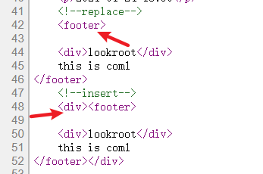

**直接通过选择器使用**

对于碎片，甚至可以不定义，我们再次添加一个 碎片

|  |
| --- |
|  |
| <footer id="com2"> | |
|  | |

|  |
| --- |
| this is com2 |
|  |

|  |
| --- |
| </footer> |

然后使用它

<div th:insert="~{component::#com2}"></div>

**注释类型**

在碎片里面，我们是可以使用控制传递的数据的，比如上面的User对象，但是开发工具在component.html页面中可能不能识别到User对象，我们可以打一个注释

|  |
| --- |
|  |
| <!--/*@thymesVar id="user" type="cn.lookroot.loop.thymeleafdemo.vo.UserVO"*/--> | |
|  | |

|  |
| --- |
| <div th:text="${user.getUsername()}"></div> |

**组件传递参数**

组件也是可以传递数据的

|  |
| --- |
|  |
| <div th:fragment="com3(message)"> | |
|  | |

|  |
| --- |
| <p th:text="${message}"></p> |
|  |

|  |
| --- |
| </div> |

使用的时候

<div th:insert="~{component::com3('传递数据')}"></div>

**局部替换组件**

我们使用一个组件的时候，想要局部替换掉这个组件里面的部分内容该怎么做呢？通过传递参数的方式传递一个组件过来，并把这个组件替换原本的一部分

|  |
| --- |
|  |
| <div th:fragment="com4(message)"> | |
|  | |

|  |
| --- |
| <p th:replace="${message}">原本的message</p> |
|  |

|  |
| --- |
| </div> |

使用的时候

|  |
| --- |
|  |
| <div th:insert="~{component::com4(~{::#message})}"> | |
|  | |

|  |
| --- |
| <p id="message">替换的message</p> |
|  |

|  |
| --- |
| </div> |

**基本对象**

**#ctx：上下文对象**

|  |
| --- |
|  |
| ${#ctx.request} | |
|  | |

|  |
| --- |
| ${#ctx.response} |
|  |

|  |
| --- |
| ${#ctx.session} |
|  |

|  |
| --- |
| ${#ctx.servletContext} |

**请求/会话属性**

|  |
| --- |
|  |
| ${session.xxx} | |
|  | |

|  |
| --- |
| ${application.xxx} |
|  |

|  |
| --- |
| ${#request.getAttribute('xxx')} |

**工具类**

在thymeleaf里面是可以直接使用一些Java的函数的，并且你可以通过传递参数的方式把一些自己写的方法传递给页面，在里面调用也是可以的

一些可以直接的使用函数

* #dates
* #calendars
* #strings
* #numbers
* #objects
* #bools
* #arrays
* #lists
* #sets
* #maps
* #aggregates

以日期格式化来举例

|  |
| --- |
|  |
| <!--日期格式化--> | |
|  | |

<p th:text="${#dates.format(user.createTime,'yyyy-MM-dd HH:mm')}"></p>