**开源硬件实战**

1. **双创周参与情况**

7月2日：介绍 Arduino IDE, Processing , fritzing这三款软件与github

作业：安装这三款软件并注册github账号。

7月3日：介绍Arduino。并开始编程。

作业：学习建立库函数。并使用建立的库函数完成数字与morse码的转换

代码：

|  |
| --- |
| #include <Morse.h> |
|  |  |
|  | Morse morse(13); |
|  |  |
|  | void xianshi(char a) |
|  | { |
|  | switch(a) { |
|  | case('a'):morse.dot(); morse.dash(); break; //A |
|  | case('b'):morse.dash(); morse.dot(); morse.dot(); morse.dot();break; //B |
|  | case('c'):morse.dash(); morse.dot(); morse.dash(); morse.dot();break; //C |
|  | case('d'):morse.dash(); morse.dot(); morse.dot(); break;//D |
|  | case('e'):morse.dot(); break; //E |
|  | case('f'):morse.dot(); morse.dot(); morse.dash(); morse.dot();break; //F |
|  | case('g'):morse.dash(); morse.dash(); morse.dot();break; //G |
|  | case('h'):morse.dot(); morse.dot(); morse.dot(); morse.dot();break; //H |
|  | case('i'):morse.dot(); morse.dot();break;//I |
|  | case('j'):morse.dot(); morse.dash(); morse.dash(); morse.dash(); break;//J |
|  | case('k'):morse.dash(); morse.dot(); morse.dash();break; //K |
|  | case('l'):morse.dot(); morse.dash(); morse.dot(); morse.dot(); break;//L |
|  | case('m'):morse.dash(); morse.dash();break;//M |
|  | case('n'):morse.dash(); morse.dot(); break; //N |
|  | case('o'):morse.dash(); morse.dash(); morse.dash(); break;//O |
|  | case('p'):morse.dot(); morse.dash(); morse.dash(); morse.dot(); break;//P |
|  | case('q'):morse.dash(); morse.dash(); morse.dot(); morse.dash();break;//Q |
|  | case('r'):morse.dot(); morse.dash(); morse.dot(); break; //R |
|  | case('s'):morse.dot(); morse.dot(); morse.dot(); break; //S |
|  | case('t'):morse.dash(); break; //T |
|  | case('u'):morse.dot(); morse.dot(); morse.dash(); break; //U |
|  | case('v'):morse.dot(); morse.dot(); morse.dot(); morse.dash();break; //V |
|  | case('w'):morse.dot(); morse.dash(); morse.dash();break; //W |
|  | case('x'):morse.dash(); morse.dot(); morse.dot(); morse.dash(); break;//X |
|  | case('y'):morse.dash(); morse.dot(); morse.dash(); morse.dash(); break;//Y |
|  | case('z'):morse.dash(); morse.dash(); morse.dot(); morse.dot();break; //Z |
|  | }; |
|  | } |
|  |  |
|  | void setup() { |
|  | Serial.begin(9600); |
|  | pinMode(13, OUTPUT); |
|  | } |
|  |  |
|  | void loop() { |
|  | String s = ""; |
|  | int i, te=0,n=0; |
|  |  |
|  | while (Serial.available() > 0) { |
|  | te = 1; |
|  | s += char(Serial.read()); |
|  | delay(2); |
|  | n++; |
|  | } |
|  | if(te==1) |
|  | { |
|  | for(i=0;i<=n;i++) |
|  | { |
|  | xianshi(s[i]); |
|  | } |
|  | } |
|  | delay(2); |
|  | } |

**7月4日**：讲解电机与数码管。

作业：使用cd4511完成数码管显示数字

代码：

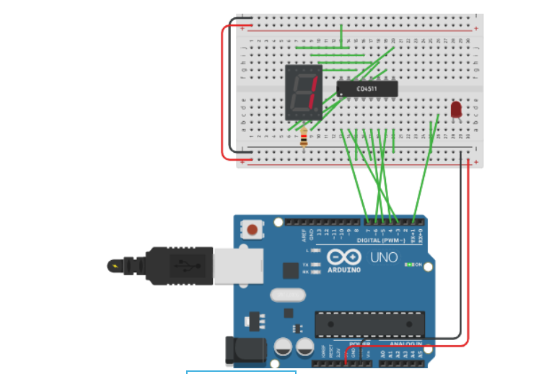

|  |
| --- |
| void xianshi(int a) |
|  | { |
|  | switch(a) |
|  | { |
|  | case(0):digitalWrite(6, LOW);digitalWrite(7, LOW);digitalWrite(3, LOW);digitalWrite(4, LOW);break; |
|  | case(1):digitalWrite(6, HIGH);digitalWrite(7, LOW);digitalWrite(3, LOW);digitalWrite(4, LOW);break; |
|  | case(2):digitalWrite(6, LOW);digitalWrite(7, HIGH);digitalWrite(3, LOW);digitalWrite(4, LOW);break; |
|  | case(3):digitalWrite(6, HIGH);digitalWrite(7, HIGH);digitalWrite(3, LOW);digitalWrite(4, LOW);break; |
|  | case(4):digitalWrite(6, LOW);digitalWrite(7, LOW);digitalWrite(3, HIGH);digitalWrite(4, LOW);break; |
|  | case(5):digitalWrite(6, HIGH);digitalWrite(7, LOW);digitalWrite(3, HIGH);digitalWrite(4, LOW);break; |
|  | case(6):digitalWrite(6, LOW);digitalWrite(7, HIGH);digitalWrite(3, HIGH);digitalWrite(4, LOW);break; |
|  | case(7):digitalWrite(6, HIGH);digitalWrite(7, HIGH);digitalWrite(3, HIGH);digitalWrite(4,LOW);break; |
|  | case(8):digitalWrite(6, LOW);digitalWrite(7, LOW);digitalWrite(3, LOW);digitalWrite(4, HIGH);break; |
|  | case(9):digitalWrite(6, HIGH);digitalWrite(7, LOW);digitalWrite(3, LOW);digitalWrite(4, HIGH);break; |
|  |  |
|  | } |
|  | } |
|  | void setup() |
|  | { |
|  | pinMode(6, OUTPUT); |
|  | pinMode(7, OUTPUT); |
|  | pinMode(3, OUTPUT); |
|  | pinMode(4, OUTPUT); |
|  | pinMode(5, OUTPUT); |
|  | Serial.begin(9600); |
|  |  |
|  | } |
|  |  |
|  | void loop() |
|  | { |
|  |  |
|  | String str = ""; |
|  | String shu = ""; |
|  | int i, t , temp = 0,n=0; |
|  | while (Serial.available() > 0) |
|  | { |
|  | str += char(Serial.read()); |
|  | delay(2); |
|  | n++; |
|  | } |
|  | for(i=0;i<n;i++) |
|  | { |
|  | xianshi(int(str[i]-48)); |
|  | delay(1000); |
|  | } |
|  | } |

**7月5日：对第一天内容进行仿真**

答疑环节

交流和总结

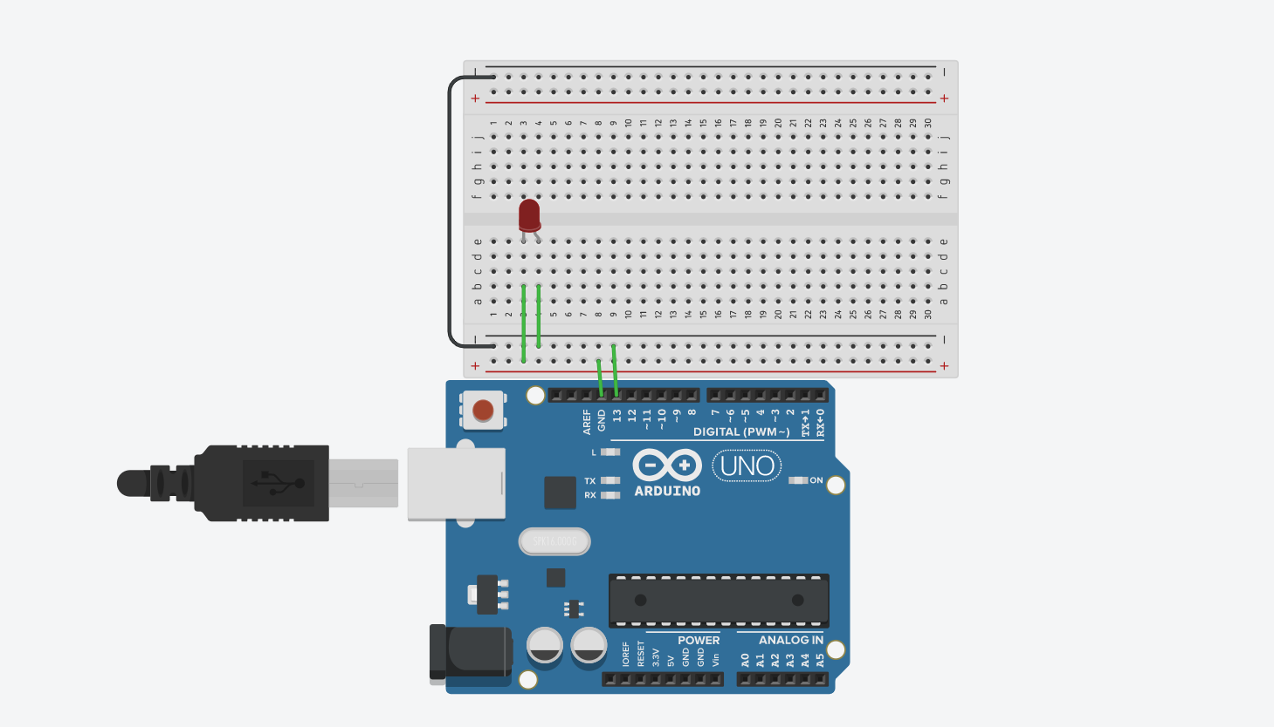

代码：

|  |
| --- |
| int pin = 13; |
|  | void dot() { digitalWrite(pin, HIGH); delay(250); digitalWrite(pin, LOW); delay(250); } |
|  | void dash() { digitalWrite(pin, HIGH); delay(1000); digitalWrite(pin, LOW); delay(250); } |
|  | void setup() { |
|  |  |
|  | Serial.begin(9600); |
|  | pinMode(pin, OUTPUT); |
|  | } |
|  |  |
|  | void loop() |
|  | { |
|  | char MOR[][4] = { |
|  | {'.', '-', '*', '*'}, //A |
|  | {'-', '.', '.', '.'}, //B |
|  | {'-', '.', '-', '.'}, //C |
|  | {'-', '.', '.', '*'}, //D |
|  | {'.', '*', '*', '*'}, //E |
|  | {'.', '.', '-', '.'}, //F |
|  | {'-', '-', '.', '*'}, //G |
|  | {'.', '.', '.', '.'}, //H |
|  | {'.', '.', '*', '*'}, //I |
|  | {'.', '-', '-', '-'}, //J |
|  | {'-', '.', '-', '*'}, //K |
|  | {'.', '-', '.', '.'}, //L |
|  | {'-', '-', '*', '*'}, //M |
|  | {'-', '.', '*', '*'}, //N |
|  | {'-', '-', '-', '*'}, //O |
|  | {'.', '-', '-', '.'}, //P |
|  | {'-', '-', '.', '-'}, //Q |
|  | {'.', '-', '.', '*'}, //R |
|  | {'.', '.', '.', '*'}, //S |
|  | {'-', '*', '*', '*'}, //T |
|  | {'.', '.', '-', '*'}, //U |
|  | {'.', '.', '.', '-'}, //V |
|  | {'.', '-', '-', '*'}, //W |
|  | {'-', '.', '.', '-'}, //X |
|  | {'-', '.', '-', '-'}, //Y |
|  | {'-', '-', '.', '.'} //Z |
|  | }; |
|  | String s = ""; |
|  | String morse = ""; |
|  | int i, t , te = 0,n=0; |
|  |  |
|  | while (Serial.available() > 0) |
|  | { |
|  | te = 1; |
|  | s += char(Serial.read()); |
|  | delay(2); |
|  | n++; |
|  | } |
|  |  |
|  | if (te) { |
|  | for (i = 0; i < n; i++) |
|  | { |
|  | for (t = 0; t < 4; t++) |
|  | { |
|  | if (s[i] >= 97 && s[i] <= 122) |
|  | { |
|  | morse += char(MOR[int(s[i] - 97)][t]); |
|  | } |
|  | } |
|  | morse += ' '; |
|  | } |
|  | Serial.println(morse); |
|  | for(i=0;i<=4*n;i++) |
|  | {if(morse[i]=='.') |
|  | dot(); |
|  | if(morse[i]=='-') |
|  | dash(); |
|  | } |
|  | } |
|  | delay(2); |
|  | } |

**二．双创周主要收获**

了解了开源硬件，对Arduino有初步认识。

完成了一些小功能，提升了我对开源硬件的兴趣。