[Github官网跳转链接](https://github.com/)

<https://github.com/>

Username may only contain alphanumeric characters or single hyphens,

用户名只能包含字母、数字字符或单个连字符

**Github账户**

and cannot begin or end with a hyphen

并且不能以连字符开头或结尾

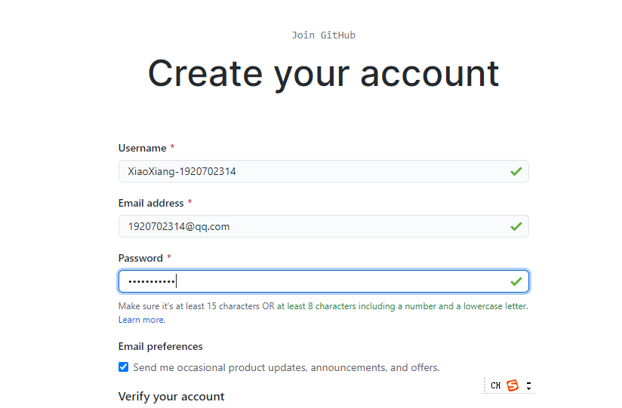

516619zhqzh

XiaoXiang-1920702314

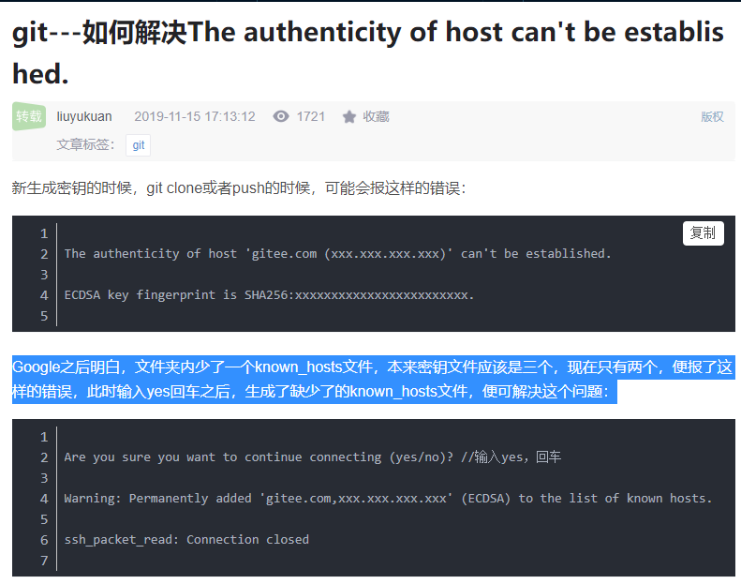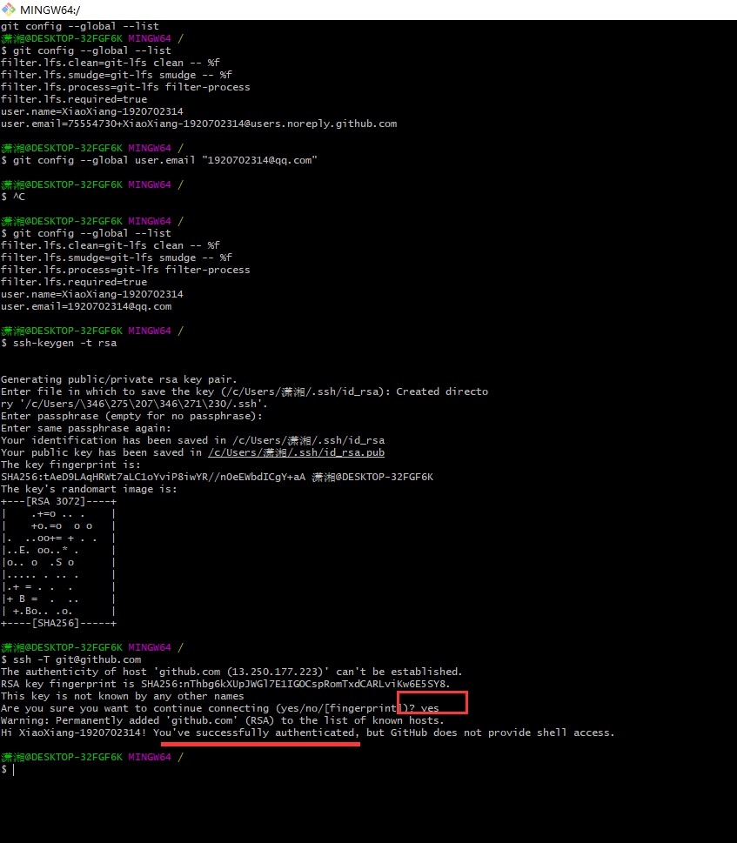

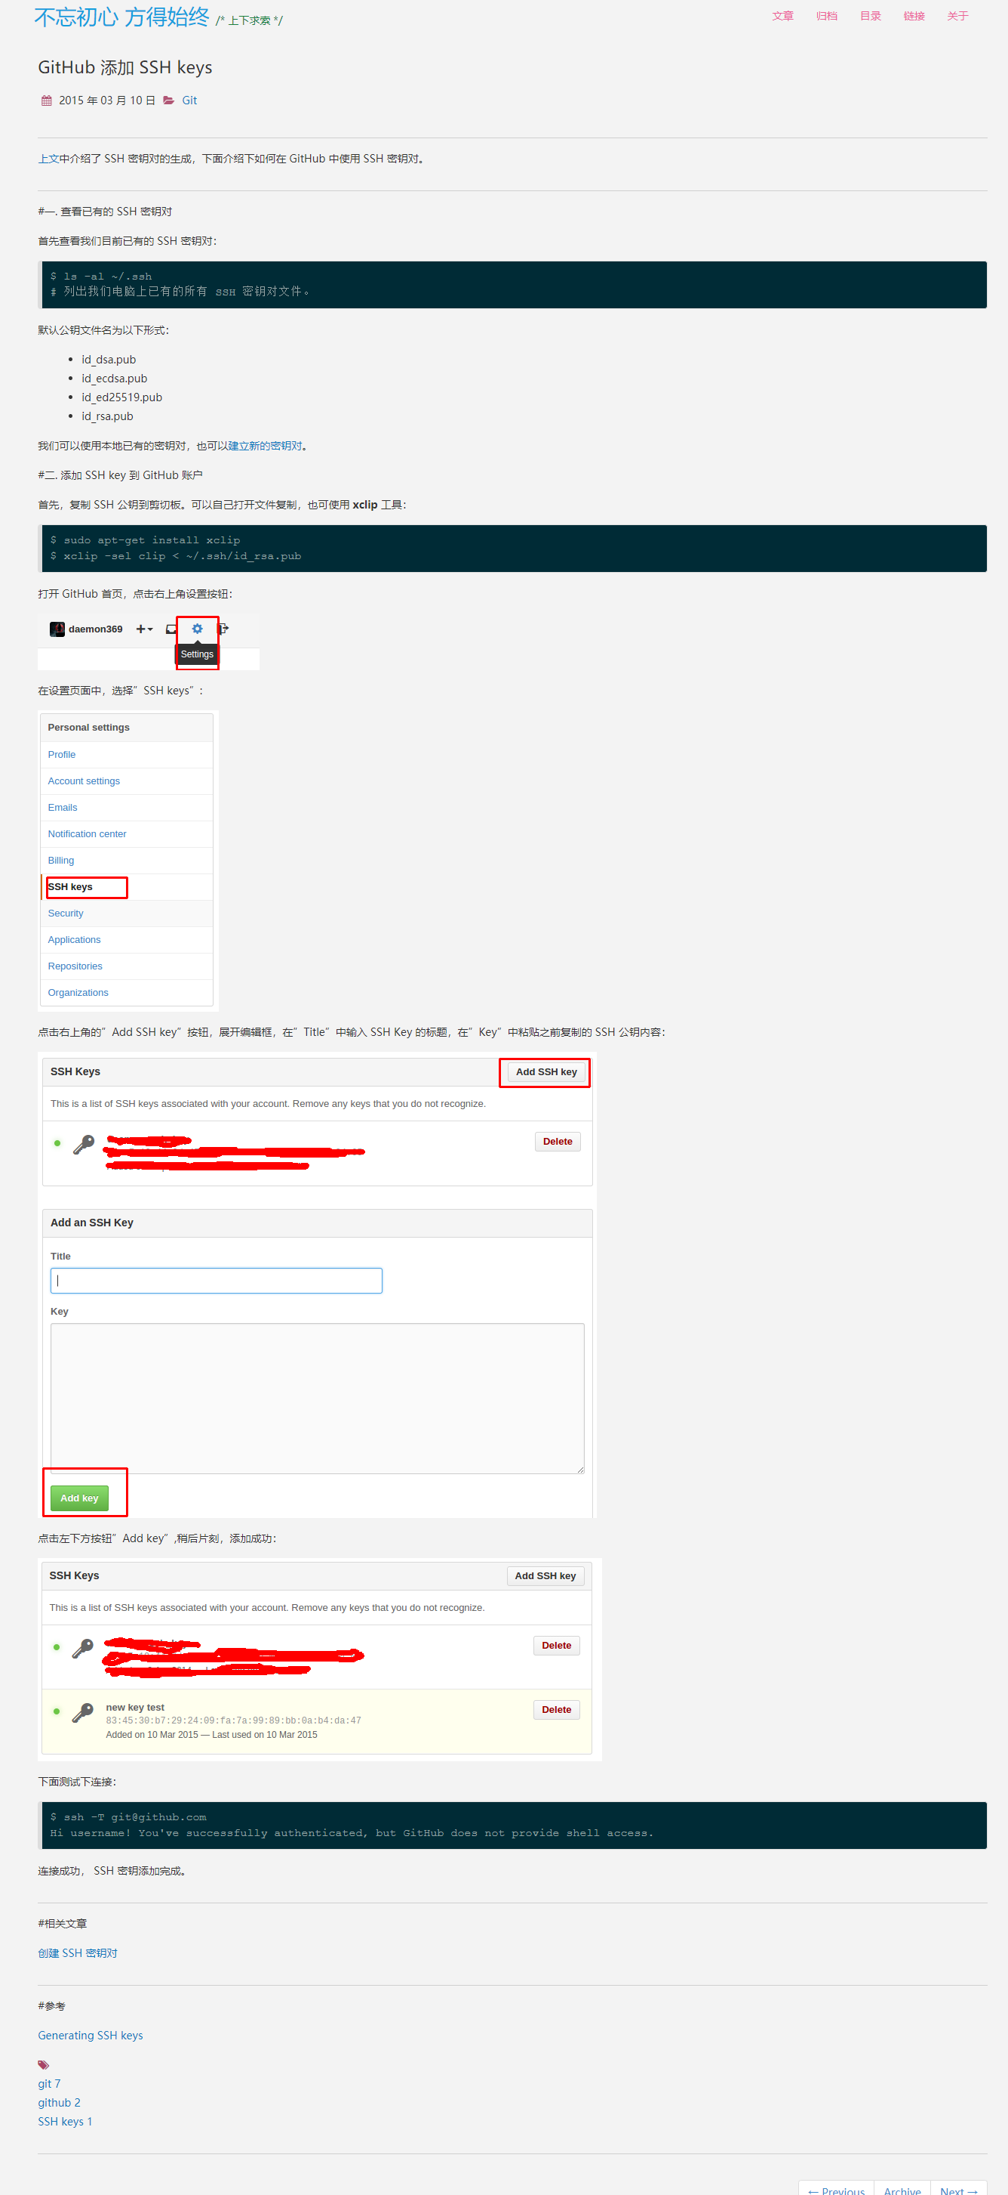

## 博客园

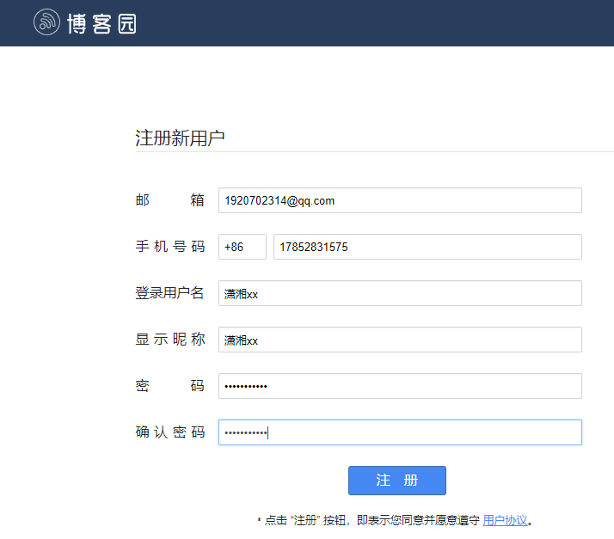

**操作github步骤**

**01上传文件**

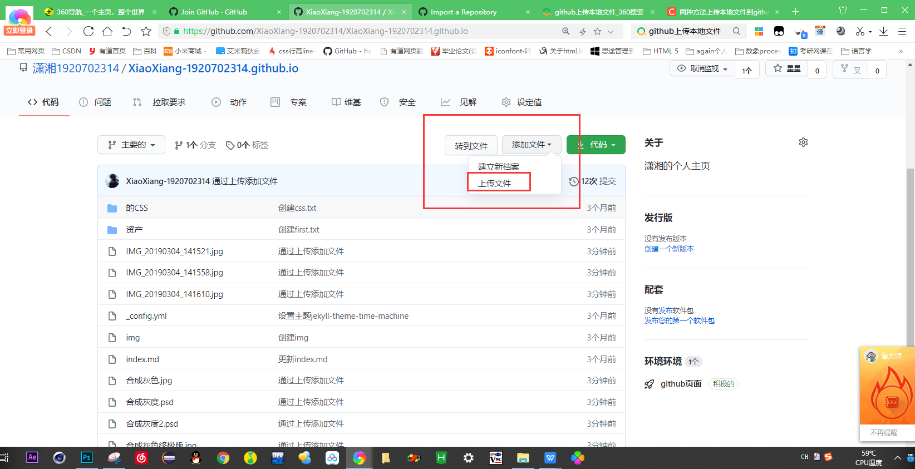

**01.进入自己的主页**

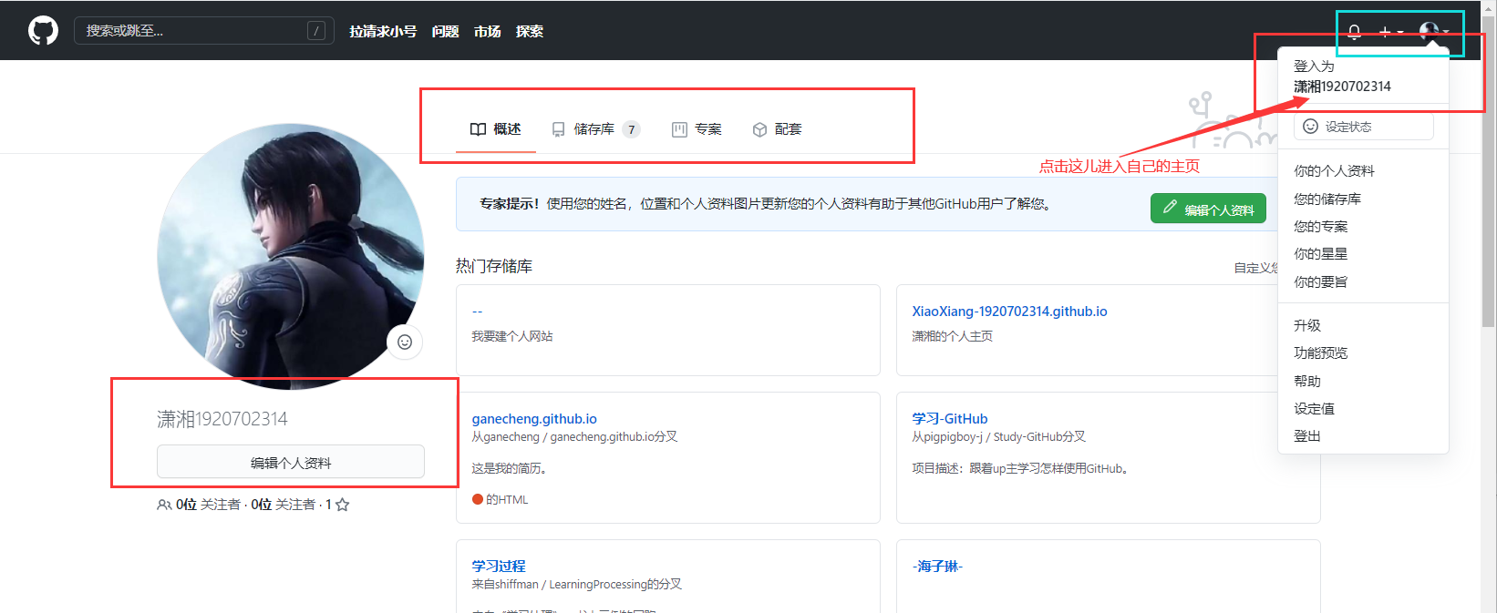

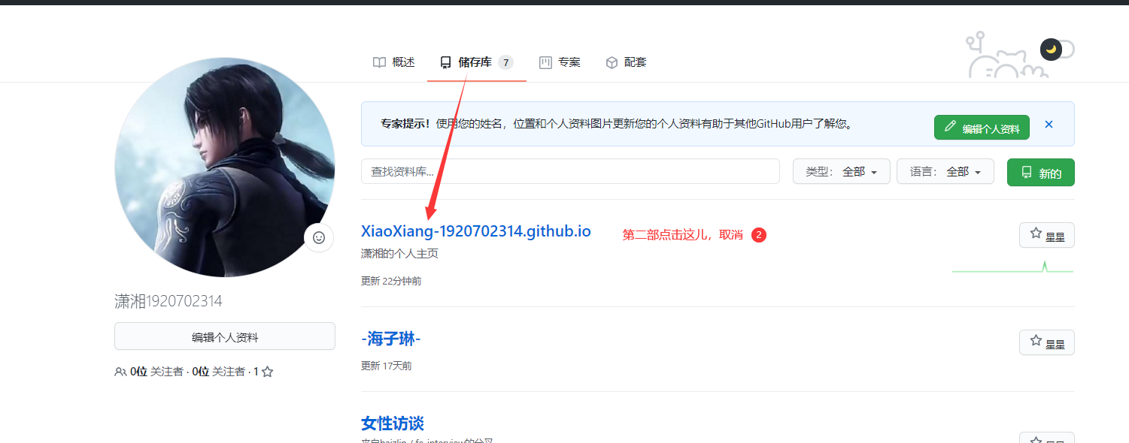

03修改用户名

<https://blog.csdn.net/qq_36667170/article/details/79067306>

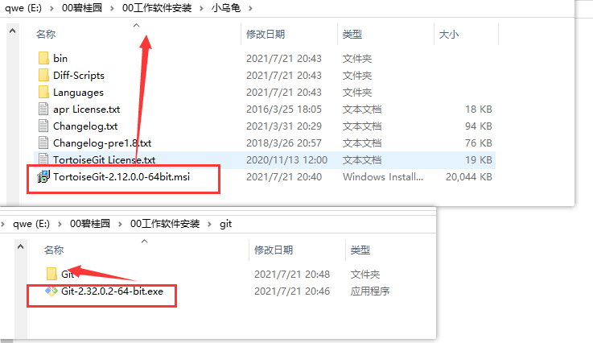

# [Git下载](https://gitforwindows.org/)



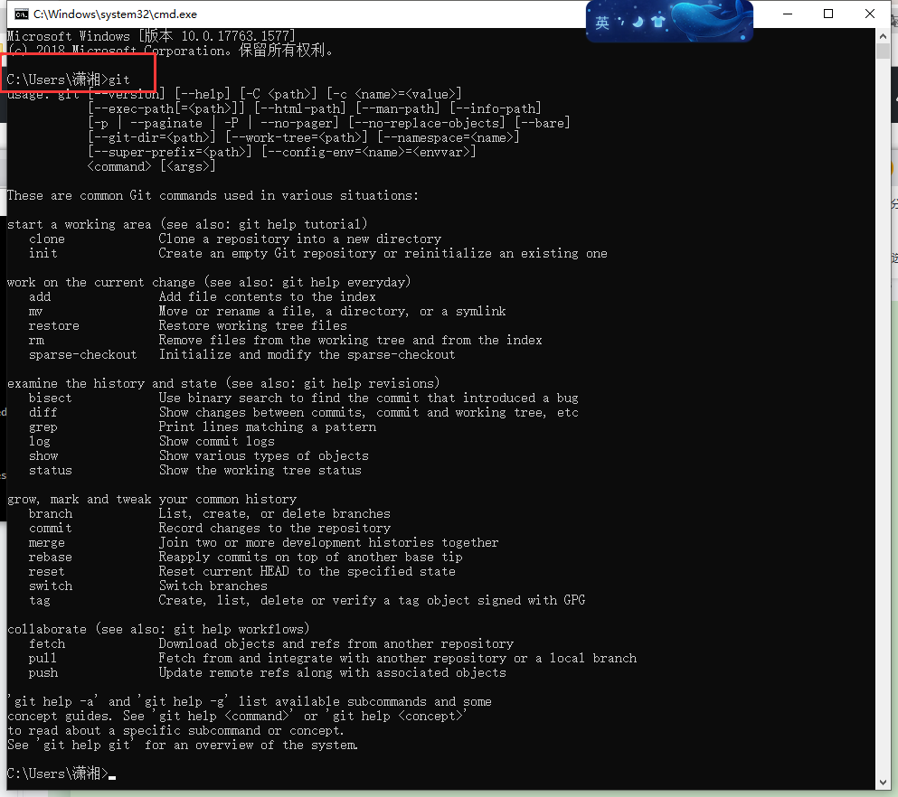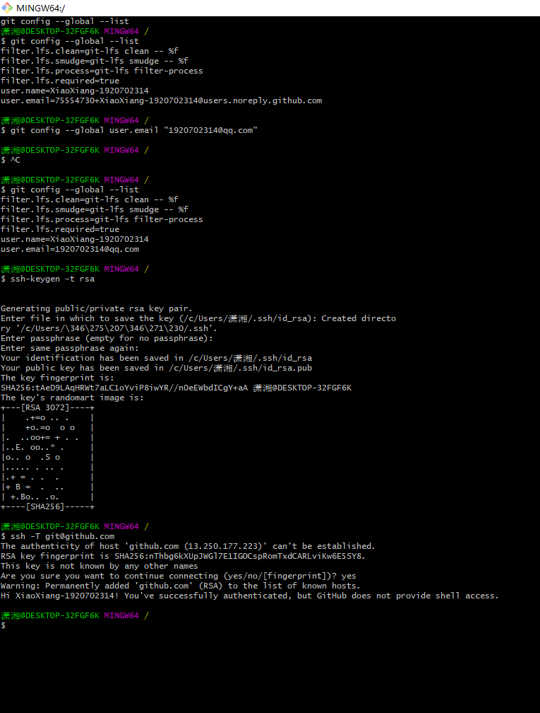

# [小乌龟下载](https://tortoisegit.org/download/)

